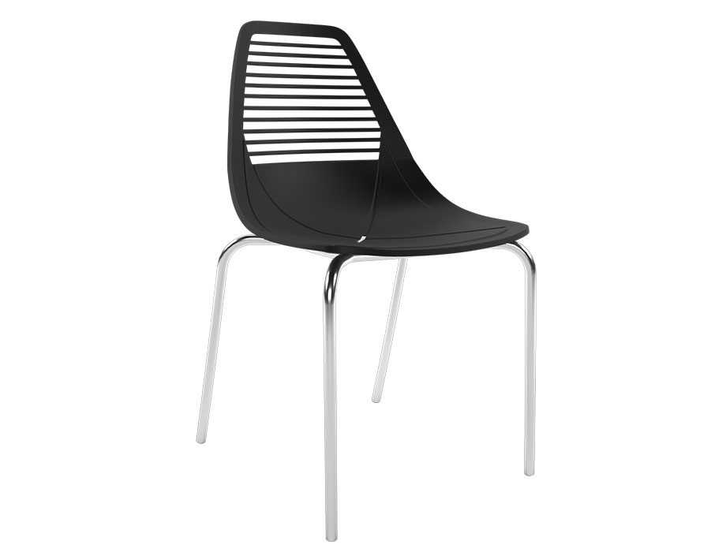

**Minimalist** Lounge

The Minimalist Lounge chair embodies simplicity and elegance. With its clean lines and minimalist design, this chair exudes a sense of calm and sophistication. The sleek silhouette and streamlined structure make it a versatile choice for various interior styles. The Minimalist Lounge chair is crafted with premium materials, ensuring both comfort and durability. Its ergonomic design provides optimal support for your body, making it an ideal spot for relaxation. Whether you place it in the living room, study, or lounge area, this chair effortlessly blends functionality and style. Experience the beauty of minimalism with the Minimalist Lounge chair.

Price: $139.99

Availability: In Stock

Location: Lahore