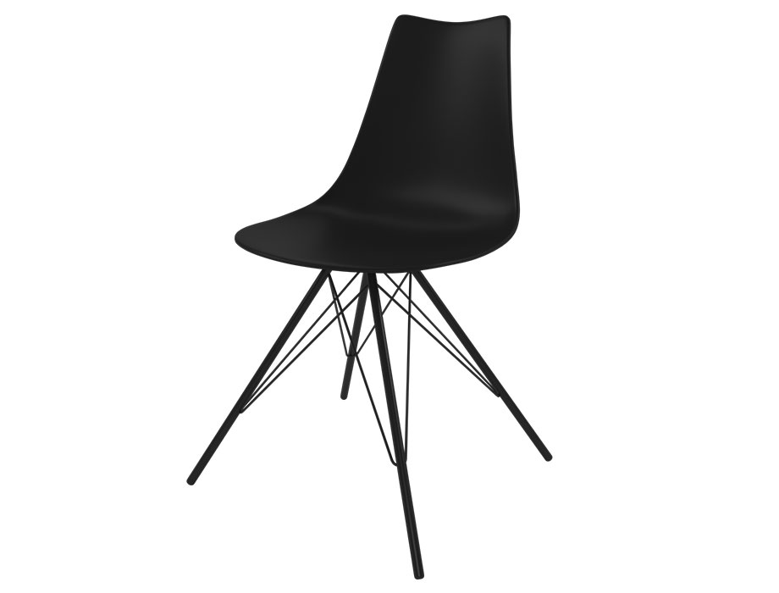

**Simple Accent** Chair

The Simple Accent Chair is a statement piece that adds a pop of style to any room. With its unique design and attention to detail, this chair becomes the focal point of your space. The clean lines and subtle curves create a modern and inviting aesthetic. The Simple Accent Chair is not only visually appealing but also comfortable. It features a cushioned seat and backrest, providing a cozy seating experience. Whether you use it as a standalone piece or pair it with other furniture, this chair enhances the overall ambiance of your interior. Elevate your decor with the charm of the Simple Accent Chair.

Price: $149.99

Availability: Out of Stock

Location: Multan