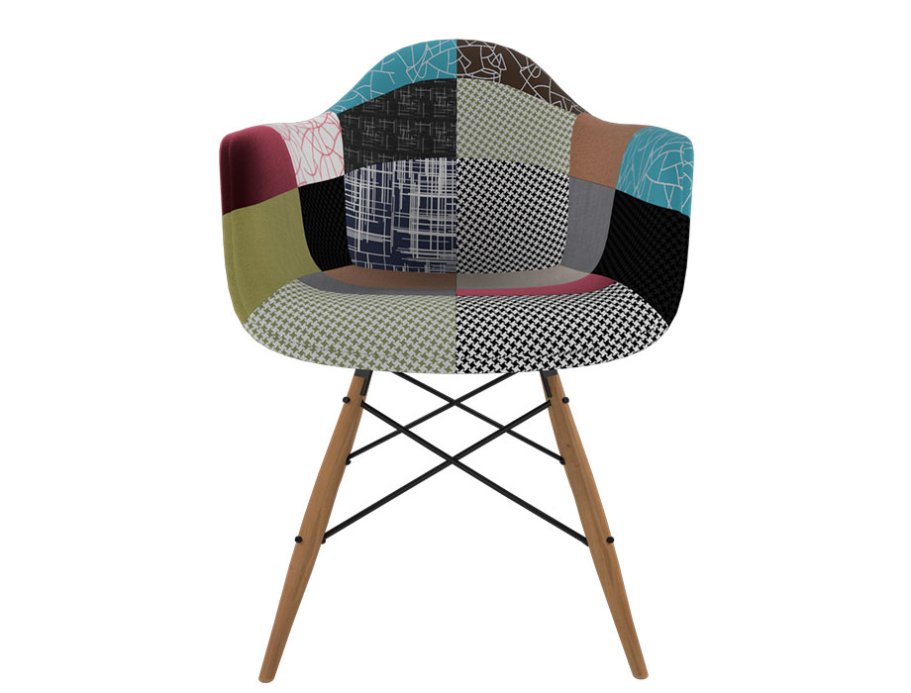

**Cozy Lounge** Chair

The Cozy Lounge Chair is all about comfort and relaxation. With its oversized and enveloping design, it invites you to sink in and unwind. This chair is perfect for lounging, reading, or simply taking a nap. The plush cushioning and soft upholstery create a cozy and inviting atmosphere. The Cozy Lounge Chair features a contemporary style with a touch of warmth and coziness. Its sturdy construction ensures long-lasting durability, allowing you to enjoy its comfort for years to come. Treat yourself to a moment of serenity with the indulgent comfort of the Cozy Lounge Chair.

Price: $138.99

Availability: In Stock

Location: Lahore