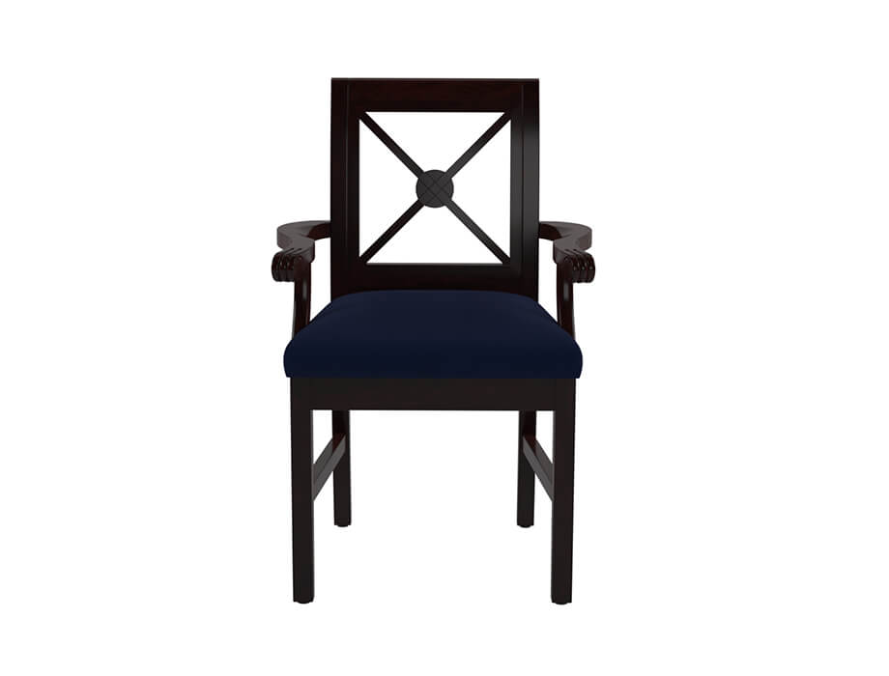

**Classic** Chair

The Classic Chair embodies timeless elegance and sophistication. With its graceful curves, intricate detailing, and luxurious upholstery, this chair exudes a sense of grandeur. The Classic Chair is inspired by traditional designs, bringing a touch of nostalgia to your space. Crafted with precision and attention to detail, it showcases the finest craftsmanship. This chair is not only a visual masterpiece but also offers exceptional comfort. The generously cushioned seat and backrest provide a cozy and supportive seating experience. Whether you place it in the living room, study, or library, the Classic Chair adds an air of sophistication to your interior.

Price: $188.99

Availability: In Stock

Location: Multan