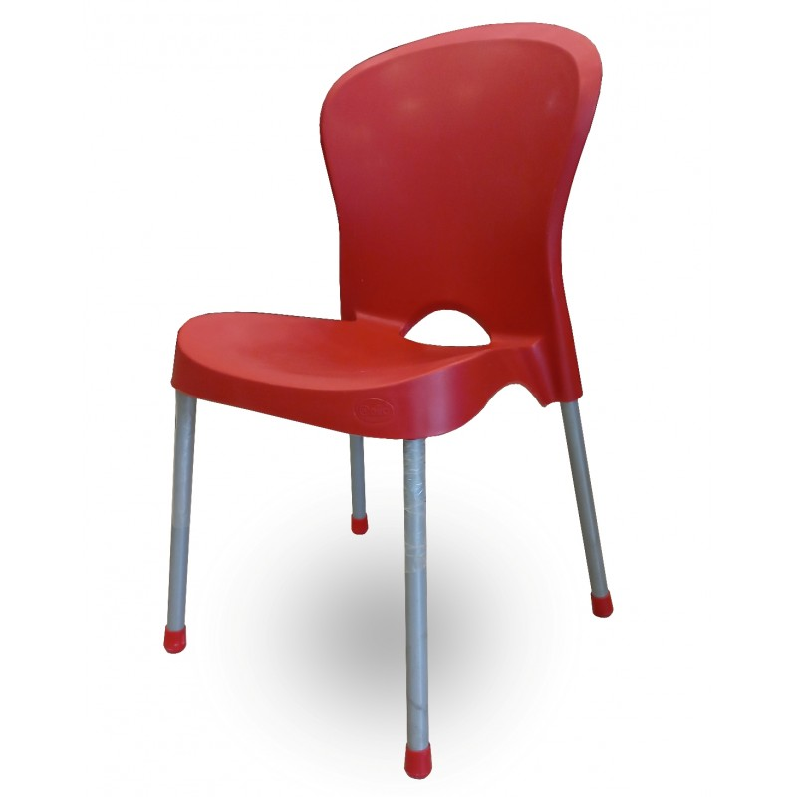

**Basic** Seating

The Basic Seating chair is a versatile and functional addition to any space. Its simple yet practical design makes it suitable for a variety of settings, from offices to living rooms. This chair features a sturdy frame and a comfortable seat, making it a reliable choice for everyday use. The clean lines and understated aesthetics blend seamlessly with different decor styles. Whether you need extra seating for guests or a functional chair for your workspace, the Basic Seating chair delivers functionality without compromising on style. Experience the beauty of simplicity with the Basic Seating chair.

Price: $169.99

Availability: Out of Stock

Location: Lahore