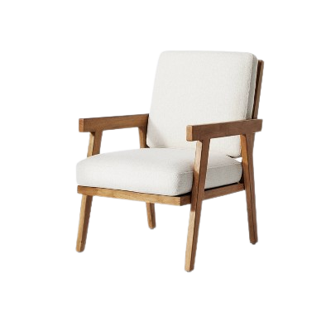

# Relaxation Chair

The Relaxation Chair is designed to provide a haven of relaxation and tranquility. With its ergonomic design and thoughtful features, this chair promotes ultimate comfort and well-being. It boasts a reclining mechanism, allowing you to adjust the chair to your preferred position. The Relaxation Chair also includes features such as a built-in footrest and padded armrests for enhanced comfort. Sink into the plush cushioning and let go of the day's stress as you enjoy a moment of serenity. Whether you use it in your living room or dedicated relaxation space, the Relaxation Chair offers a luxurious escape from the demands of daily life.

Price: $99.99

Availability: In Stock

Location: Karachi