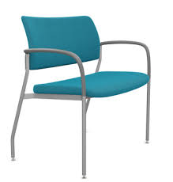

**Casual** Armchair

The Casual Armchair is the epitome of laid-back comfort and effortless style. With its relaxed design and casual vibe, this chair creates a cozy and inviting atmosphere. The soft upholstery and plush cushions make it the perfect spot to lounge and unwind. The Casual Armchair features gently sloping armrests and a generous seat, ensuring optimal comfort. Whether you're enjoying a movie night or chatting with friends, this chair provides a comfortable and relaxed seating experience. Add a touch of casual elegance to your space with the Casual Armchair.

Price: $129.99

Availability: Out of Stock

Location: Karachi