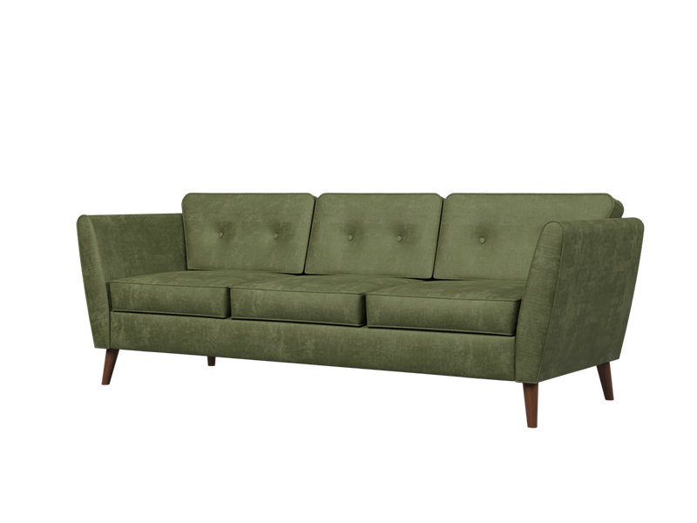

**Simple Comfort** Sofa

The Simple Comfort Sofa offers a perfect balance between style and comfort. With its clean lines and contemporary design, this sofa enhances any living space. It features plush cushioning and generous seating area, ensuring a cozy lounging experience. The sofa is upholstered in high-quality fabric that is both durable and soft to the touch. Whether you're relaxing with a book or entertaining guests, the Simple Comfort Sofa provides a welcoming and comfortable seating option.

Price: $99.99

Availability: In Stock

Location: Karachi