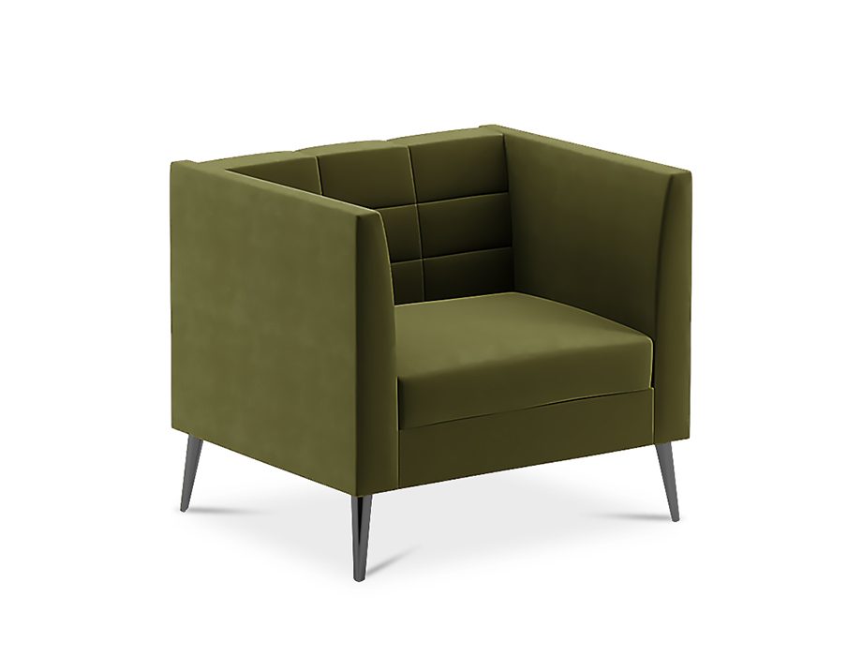

# Modern Minimalist Sofa

The Modern Minimalist Sofa is a sleek and stylish piece that adds a touch of elegance to your living room. Its minimalist design features clean angles and a streamlined silhouette, making it a perfect fit for modern interior aesthetics. The sofa is crafted with high-quality materials and upholstered in premium leather or fabric, providing durability and sophistication. Its ergonomic design offers ample support, making it ideal for both relaxation and socializing. Experience the perfect blend of contemporary design and comfort with the Modern Minimalist Sofa.

Price: $159.99

Availability: In Stock

Location: Multan