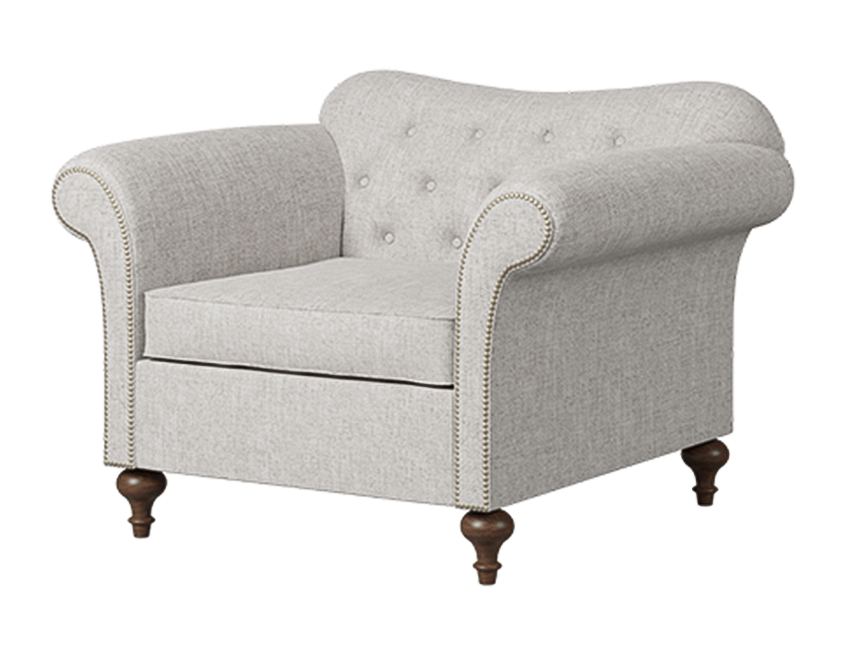

**Noble** Sofa

The Noble Sofa is a luxurious statement piece that exudes elegance and charm. Its classic design features intricate detailing, including tufted upholstery and carved wooden accents. This sofa creates a regal atmosphere in any space, making it a focal point of your living room. The Noble Sofa is crafted with the utmost attention to detail and upholstered in rich, high-quality fabric or leather. Its plush cushioning and deep seating provide unmatched comfort and support. Enhance your living area with the timeless beauty and grandeur of the Noble Sofa.

Price: $139.99

Availability: In Stock

Location: Karachi