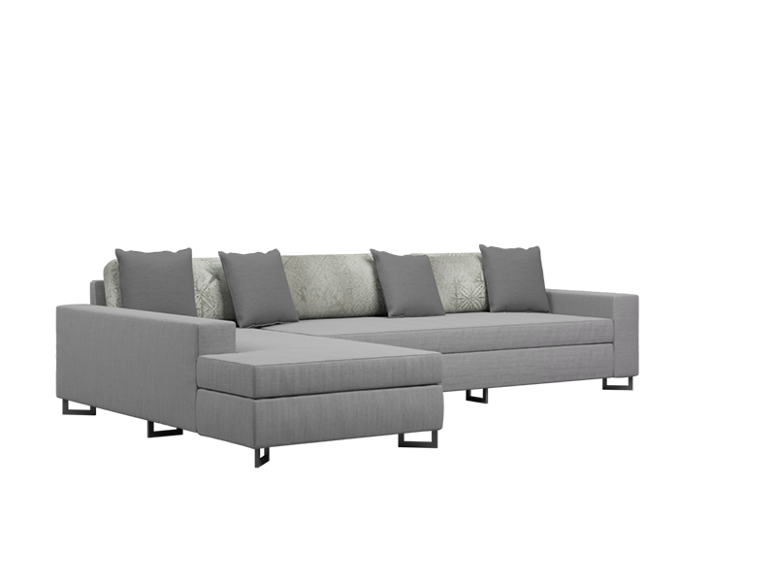

**L Shape** Sofa

The L Shape Sofa is a versatile and space-saving furniture option that adds functionality to your living room. Its unique design allows for customizable seating arrangements, making it perfect for both small and large spaces. The sofa features a modern and contemporary style that complements various interior aesthetics. With its ergonomic design and plush cushioning, the L Shape Sofa offers optimal comfort for lounging and socializing. This sofa is available in a range of materials and colors, allowing you to personalize your living space with ease.

Price: $149.99

Availability: Out of Stock

Location: Karachi