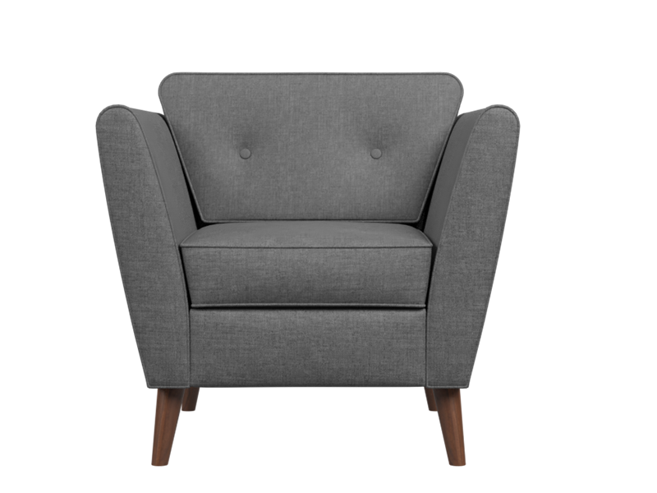

# Kessel Sofa

The Kessel Sofa is a stylish and sophisticated choice for modern living rooms. Its clean lines, minimalistic design, and sleek silhouette create a chic and contemporary look. Crafted with attention to detail, the Kessel Sofa offers exceptional comfort and durability. It is upholstered in high-quality fabric or leather, ensuring both style and longevity. The sofa's cushioning provides optimal support, making it an inviting seating option for relaxation and entertainment. Elevate your living room with the sleek elegance of the Kessel Sofa.

Price: $138.99

Availability: In Stock

Location: Karachi