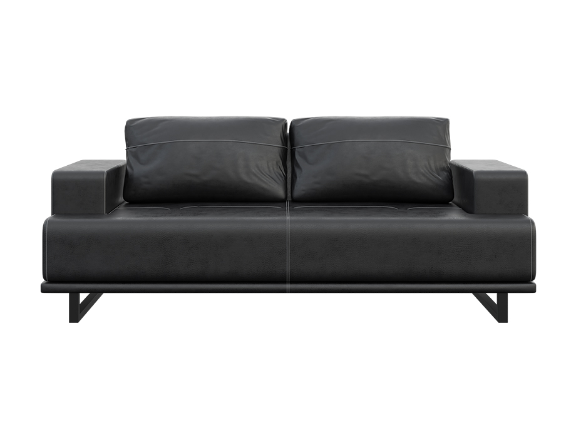

**Astor** Sofa

The Astor Sofa combines comfort and elegance to create a luxurious seating experience. Its timeless design features a blend of traditional and contemporary elements, making it a versatile addition to any interior decor. The sofa is expertly crafted with attention to detail, using premium materials and upholstery. Its deep, plush cushions and wide armrests offer exceptional comfort and relaxation. The Astor Sofa is available in a variety of fabric or leather options, allowing you to customize it to suit your style and preferences.

Price: $188.99

Availability: In Stock

Location: Multan