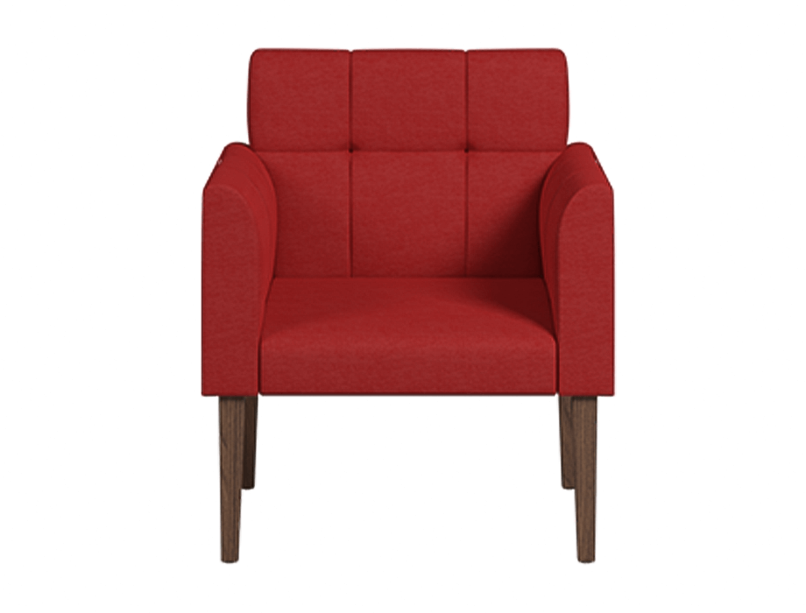

# Urban Chair Sofa

The Urban Chair Sofa is a modern and chic seating option that combines style and comfort effortlessly. Its sleek design and compact size make it ideal for urban living spaces or as an accent piece in any room. The chair sofa features clean lines, contemporary upholstery, and a sturdy frame, ensuring both durability and aesthetic appeal. With its plush cushioning and ergonomic design, the Urban Chair Sofa offers a cozy and inviting seating experience. Whether you're enjoying a cup of coffee or reading your favorite book, this chair sofa provides the perfect spot to relax and unwind. Its versatility allows it to blend seamlessly with various interior styles, making it a versatile addition to your home decor.

Price: $169.99

Availability: Out of Stock

Location: Multan