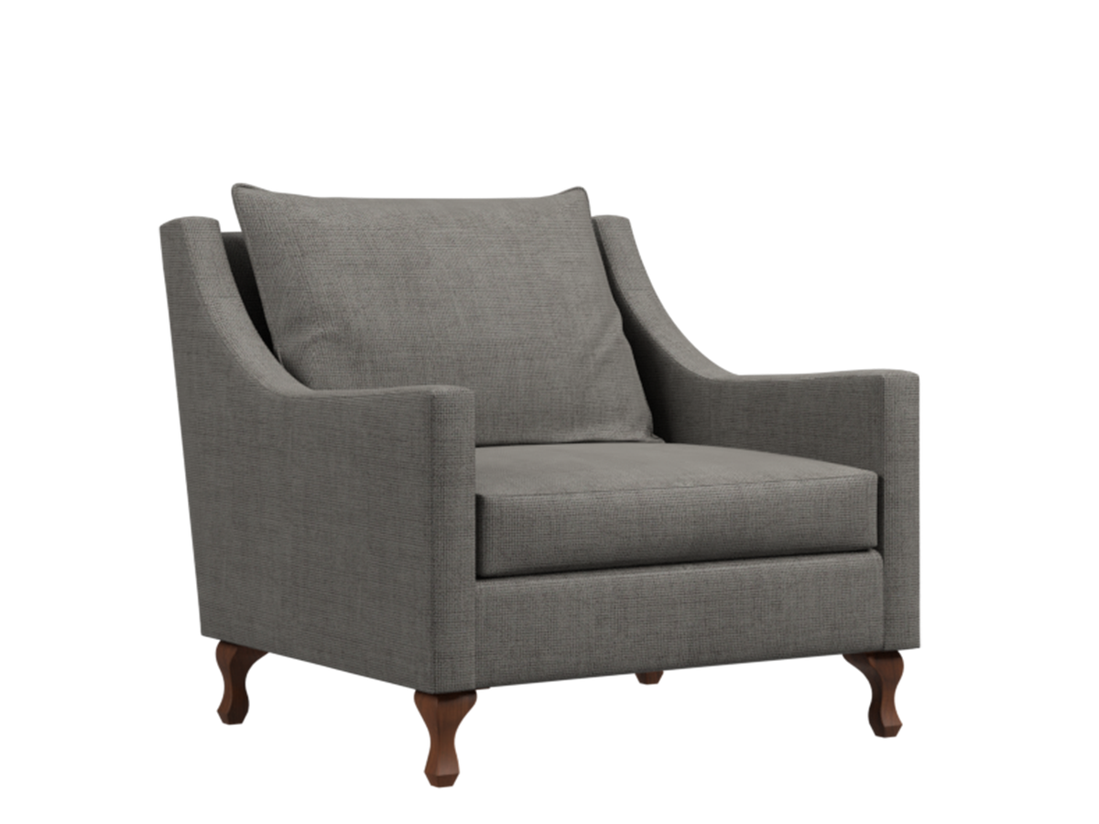

**Frea** Sofa

The Frea Sofa is a modern and trendy choice that brings a sense of style and sophistication to your living space. Its unique design features sleek lines and a distinctive shape, making it a statement piece in any room. The sofa is crafted with high-quality materials, ensuring durability and longevity. Its plush cushioning and ergonomic design provide optimum comfort and support. Available in a range of vibrant colors and upholstery options, the Frea Sofa allows you to showcase your personal style and create a contemporary focal point in your home.

Price: $152.99

Availability: In Stock