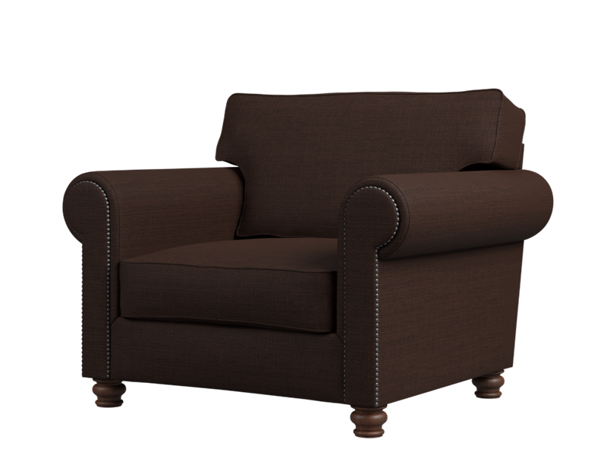

# Sero Sofa

The Sero Sofa is designed for those seeking both comfort and functionality. Its contemporary style and modular design allow you to customize the seating arrangement to suit your needs. The sofa features plush cushioning and soft upholstery, ensuring a cozy lounging experience. With its versatile configuration options, the Sero Sofa adapts to different spaces and offers ample seating for family and guests. Whether you prefer a traditional setup or a more relaxed arrangement, the Sero Sofa delivers both style and comfort.

Price: $129.99

Availability: Out of Stock