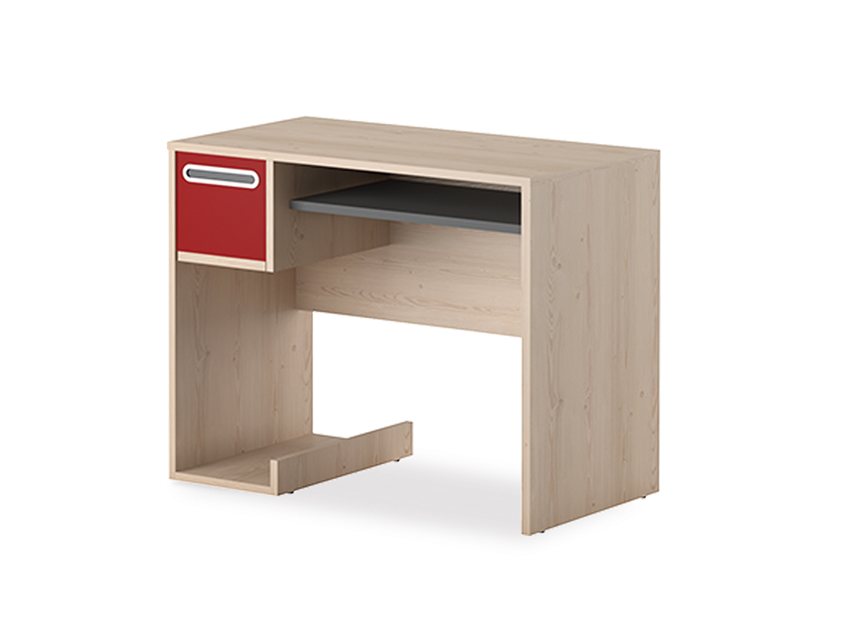

**Computer Wilson** Table

The Computer Wilson Table is a sleek and modern desk designed specifically for computer use. It features a spacious tabletop that can accommodate a computer monitor, keyboard, and other accessories. The desk also includes a built-in cable management system to keep your workspace organized and clutter-free. With its sturdy construction and contemporary design, the Computer Wilson Table is a practical and stylish choice for any home office or study.

Price: $149.99

Availability: In Stock

Location: Karachi