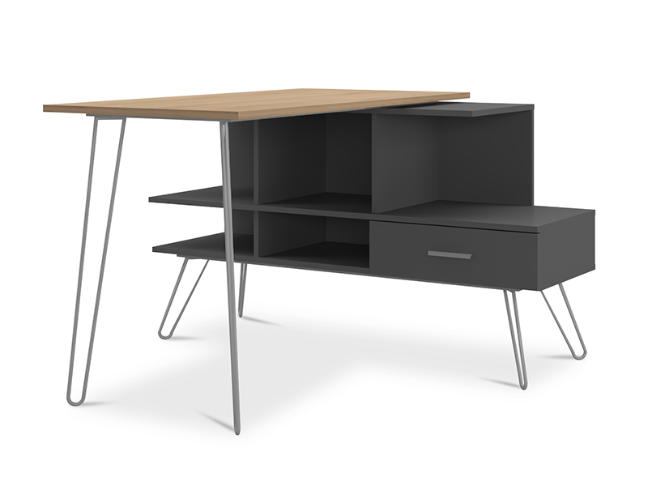

**Sydney Study** Desk

The Sydney Study Desk is a functional and versatile desk ideal for students and professionals alike. It offers a generous tabletop surface that provides ample space for studying, working, or crafting. The desk features multiple storage options, such as drawers and shelves, to keep your supplies and materials organized and within reach. Its clean and simple design makes it a seamless addition to any study or home office environment.

Price: $159.99

Availability: In Stock

Location: Multan