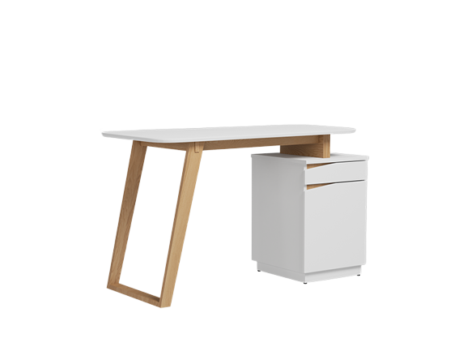

**Austen Study** Table

The Austen Study Table is a classic and timeless piece that combines functionality with elegance. It features a spacious work surface that allows for comfortable studying or working sessions. The desk includes drawers and compartments to store books, papers, and stationery, keeping your workspace tidy and organized. With its traditional design and quality craftsmanship, the Austen Study Table adds a touch of sophistication to any study or office space.

Price: $139.99

Availability: In Stock

Location: Multan