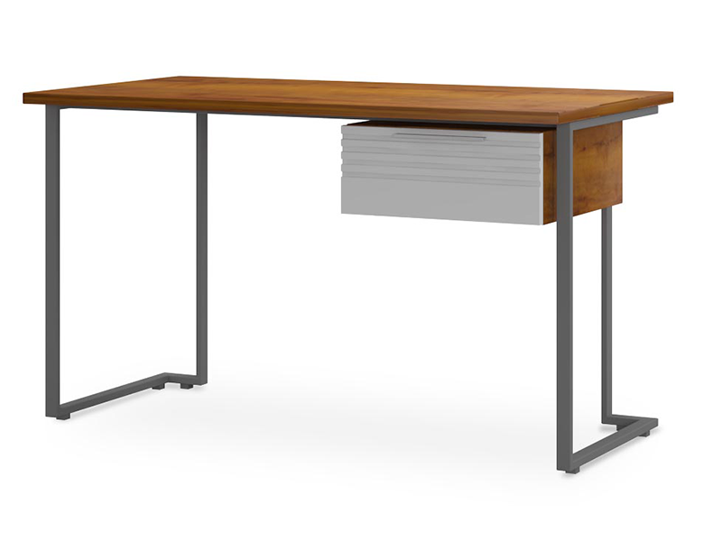

**Fresco Study** Table

The Fresco Study Table is a contemporary and stylish desk designed for modern study spaces. It boasts a minimalist design with clean lines and a sleek finish. The desk offers a wide tabletop that provides ample room for laptops, books, and other study essentials. It also includes built-in storage compartments and shelves to keep your belongings organized and easily accessible. The Fresco Study Table is a perfect blend of functionality and aesthetics, making it an excellent choice for any modern study or home office.

Price: $99.99

Availability: Out of Stock

Location: Multan