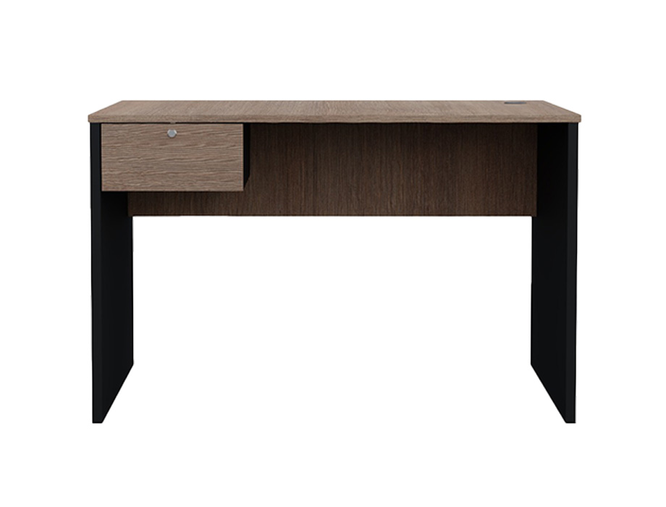

**Topwell Compact** Desk

The Topwell Compact Desk is a space-saving solution for small rooms or offices. Its compact size allows it to fit seamlessly into tight spaces without compromising on functionality. The desk features a streamlined design with a pull-out keyboard tray and additional shelves for storage. Despite its small footprint, it offers enough space for a computer, paperwork, and other essentials. The Topwell Compact Desk is an ideal choice for those looking to maximize their workspace without sacrificing style.

Price: $138.99

Availability: In Stock

Location: Lahore