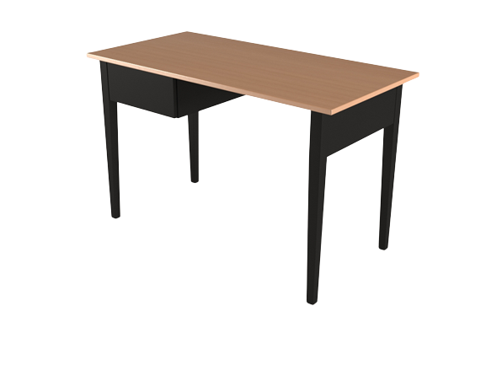

**Morris Study** Table

The Morris Study Table is a versatile and practical desk suitable for various study or work environments. It features a sturdy construction and a spacious tabletop for comfortable studying or working sessions. The desk offers ample storage space with drawers, cabinets, and open shelves to keep your supplies and materials organized. Its contemporary design and neutral color palette make it a versatile addition to any study or office space.

Price: $188.99

Availability: In Stock

Location: Lahore