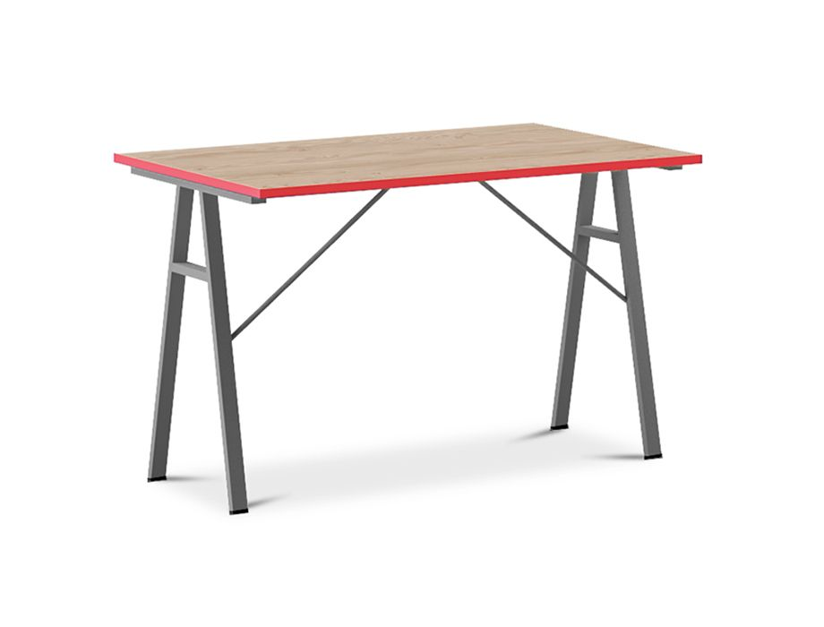

**Willow Red Study** Table

The Willow Red Study Table is a vibrant and eye-catching desk that adds a pop of color to your study area. It features a red finish that creates a bold and energetic atmosphere. The desk offers a functional workspace with a wide tabletop and storage options, such as drawers or shelves, to accommodate your study needs. The Willow Red Study Table is a statement piece that combines style and functionality, making it a standout choice for those who appreciate vibrant design.

Price: $169.99

Availability: Out of Stock

Location: Lahore