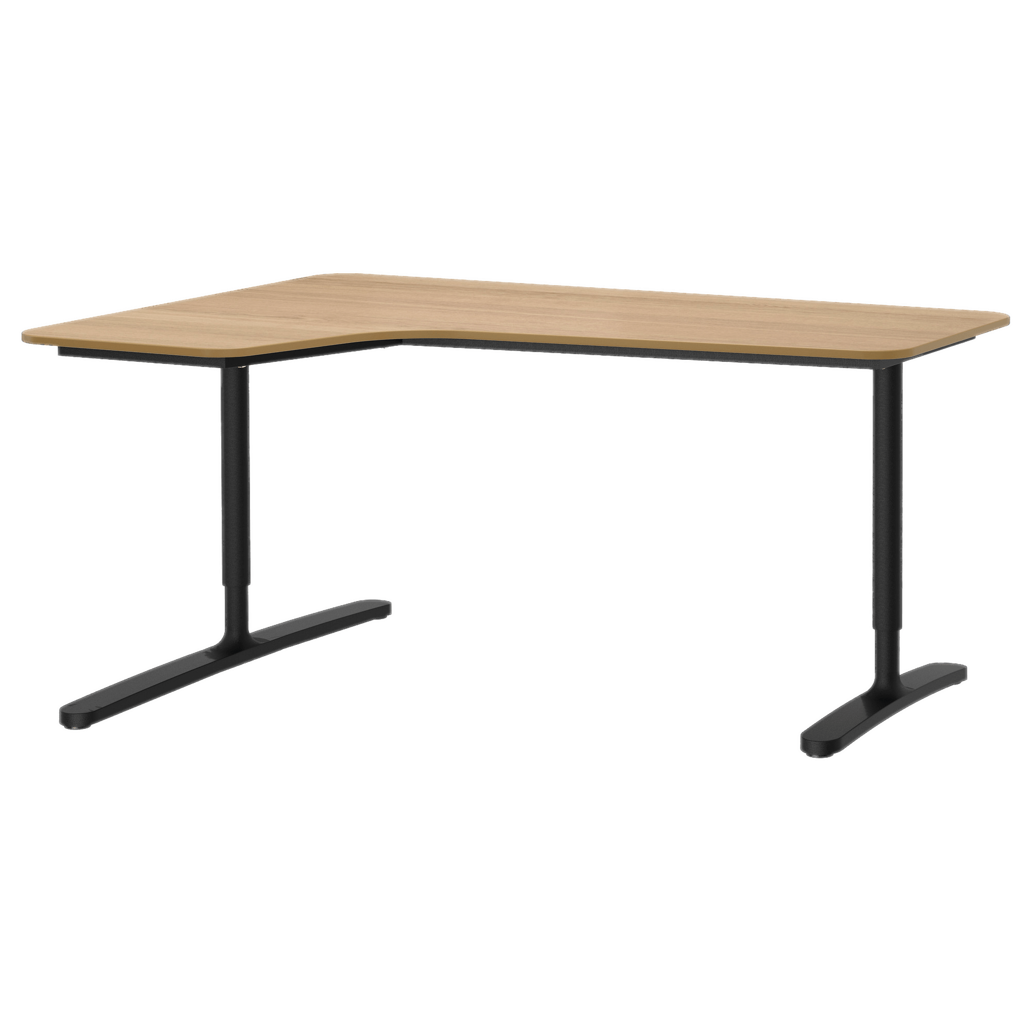**Computer** Table

The Computer Table is a versatile and practical desk designed specifically for computer use. It features a spacious tabletop that can accommodate a desktop computer or laptop along with other peripherals. The desk often includes additional features such as a keyboard tray, cable management system, and storage compartments to enhance usability and organization. With its ergonomic design and focus on technology integration, the Computer Table is an excellent choice for a dedicated computer workstation.

Price: $152.99

Availability: In Stock

Location: Karachi