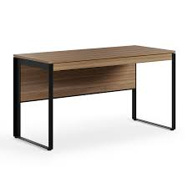

**Ariel Office** Desk

The Ariel Office Desk is a professional and sophisticated desk designed for productivity in the workplace. It features a spacious and sturdy tabletop that provides ample space for work materials, documents, and technology devices. The desk often includes storage options, such as drawers or cabinets, to keep your office essentials organized and within reach. With its elegant design and attention to detail, the Ariel Office Desk creates a professional and inspiring environment for productive work.

Price: $129.99

Availability: Out of Stock

Location: Lahore