**SEGMENTATION**

Instance segmentation is a computer vision task that combines object detection and image segmentation. Its goal is to identify and delineate each individual object within an image at the pixel level, distinguishing between different instances of the same object class.

**Key Concepts:**

1. **Segmentation**: Segmentation divides an image into regions that correspond to objects or parts of objects. In **semantic segmentation**, each pixel is classified as belonging to a particular object class, but all objects of the same class are treated identically.
   * Example: In an image with five cars, semantic segmentation would label all the car pixels the same way, without distinguishing between different cars.
2. **Object Detection**: Object detection involves identifying and locating objects within an image by drawing bounding boxes around them. It tells you *where* objects are but doesn't provide fine-grained pixel-level information.
3. **Instance Segmentation**: Instance segmentation not only tells you which pixels belong to a particular class but also separates different instances of the same class. It detects and segments each individual object separately.
   * Example: In an image with five cars, instance segmentation would generate a unique mask for each car, labeling each one as a separate instance, even though they all belong to the "car" class.

**Use Cases:**

* **Autonomous Driving**: Instance segmentation can help autonomous vehicles recognize and distinguish between different pedestrians, cars, cyclists, etc.
* **Medical Imaging**: In medical images (e.g., X-rays, MRIs), instance segmentation can isolate individual organs, tumors, or cells.
* **Image Editing**: Instance segmentation allows precise selection and manipulation of objects in images for editing purposes.
* **Agriculture**: It can be used for counting and segmenting individual plants or fruits in a field for yield analysis.

**FOR EXAMPLE:**

If there are six girls in an image, here's how each type of model would treat them:

**1. Semantic Segmentation:**

* **What happens**: Semantic segmentation would classify every pixel that belongs to a "girl" as part of the same "girl" class. All six girls would be labeled as the same entity, without distinguishing between individual girls.
* **Result**: All the girls are treated as one large group, and the model does not attempt to identify which pixels belong to which specific girl. The model outputs one mask for the class "girl."
* **Example**: Imagine you have a label for the "girl" class in your model; every pixel corresponding to any girl would have the same color or label.

**Visualization**:

* Six girls = One mask for all girls (class "girl").

**2. Object Detection:**

* **What happens**: Object detection would detect and localize each girl by drawing a **bounding box** around each one, identifying the location and class of the object (in this case, "girl").
* **Result**: You would get six bounding boxes, one around each girl, but there’s no precise outline of each individual girl—just rectangular boxes around them.
* **Example**: The model would output bounding boxes with labels like "girl 1," "girl 2," and so on, but without pixel-level precision.

**Visualization**:

* Six girls = Six bounding boxes, but no detailed outline of each girl.

**3. Instance Segmentation:**

* **What happens**: Instance segmentation would **both detect and separate** each of the six girls by creating a **pixel-wise mask** for each one. This means the model identifies each girl as a separate entity (or "instance") and gives each girl her own segmented region in the image.
* **Result**: You get **six unique masks**, one for each girl, with every mask outlining the exact shape of each girl. Even if the girls are standing close together or overlapping, the model differentiates between them, creating distinct masks for each.
* **Example**: The model would output six different masks, one for each girl, where every girl is uniquely identified and segmented at the pixel level.

**Visualization**:

* Six girls = Six unique masks, each representing one specific girl, accurately outlining their individual shapes.

**Summary of Behavior:**

* **Semantic Segmentation**: Treats all six girls as one entity ("girl" class), no differentiation between individual girls.
* **Object Detection**: Detects and draws bounding boxes around each of the six girls but without pixel-level precision.
* **Instance Segmentation**: Identifies and segments each of the six girls individually, creating a pixel-wise mask for every girl.

Instance segmentation provides the most detailed result, as it not only locates but also precisely separates each instance of an object (in this case, each girl) from the others.

**Key Differences in Output:**

1. **Object Detection**:
   * Provides **bounding boxes** (rectangular areas) around objects.
   * Does not segment the exact shape of objects; just locates them.
   * Useful for tasks where rough localization is sufficient, e.g., object counting or tracking.
2. **Instance Segmentation**:
   * Provides **pixel-wise masks** that follow the exact contours of each object.
   * More detailed and accurate representation, especially for irregular shapes.
   * Useful for tasks that require fine-grained detail, like image editing, medical imaging, or detailed scene understanding.

**Example Visualization:**

* **Object Detection**: You see rectangles drawn around the cat, dog, and car.

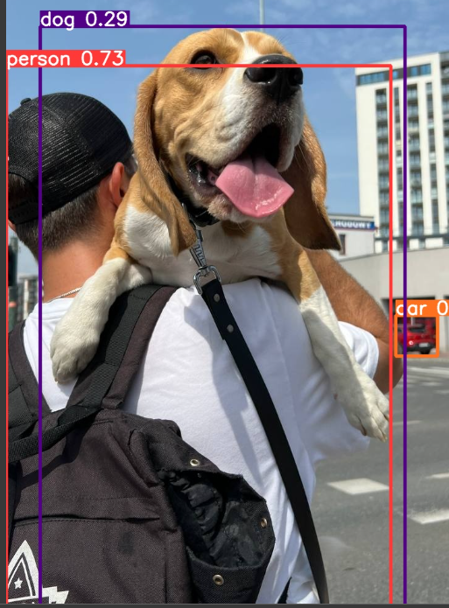

* **Instance Segmentation**: You see precise outlines around the cat, dog, and car, differentiating their shapes more accurately than a box could.

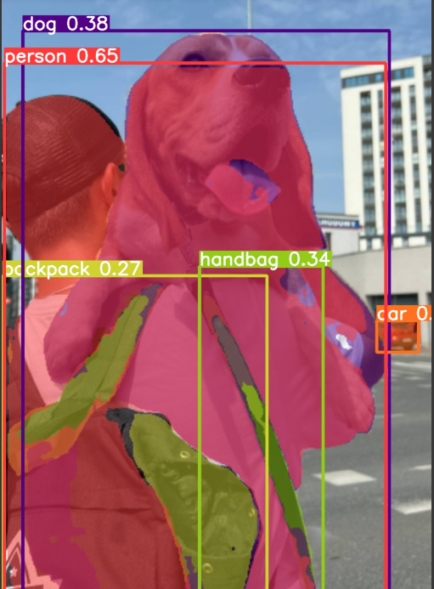

In summary:

* **Object detection** locates and labels objects with bounding boxes.
* **Instance segmentation** locates, labels, and provides the exact pixel boundaries of each object.