* 2 Candle Concept:

When we see that ,

2nd candle’s high and low is within the 50% of 1st candle , the smaller candle will be the trend.

Both the candles will be of opposite colours in such case.

For example ,

A big green candle is the first candle and the second candle is the red candle , then the trend will be down trend.

This trend will be activated only if the next candle closed below the lower wick of the second candle.

Similairly ,

A big red candle is the first candle and second candle is a smaller green candle , then the trend will be up trend.

This trend will be activated only if the next candle closed above the upper wick of the second candle.

The target can be calculated by finding the difference between its high and low. That difference will be added and subtracted respectively from its upper and lower wick.

Example:

Opening large candle , with the next candle trading within the opening candle of its 50 % then the trend will be of the second candle .

The Difference between the high and low of open candle will be added to the upper wick and subtracted to the lower wick.

This is some bank ,

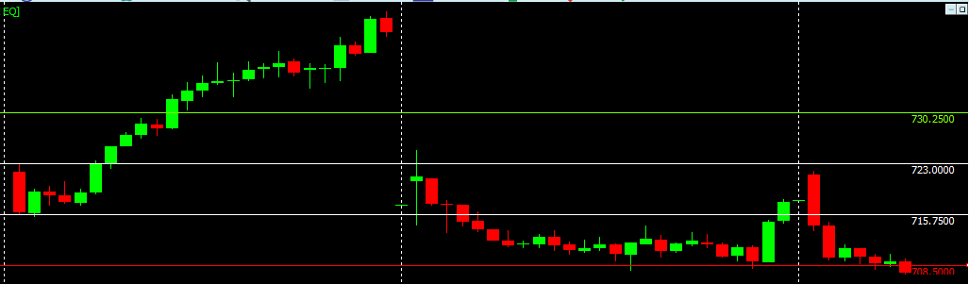

* Opening 3 Candle Concept:

Out of 100% only 60% to 70% it works out , when it works out it give big profit.

How it works is ,

First candle is very big when compared to 2 & 3rd candle, but both the candles should be in range of first big candle .

Then concentrate on 3&4th candle movement, if the cross day high or low and give close .

Then when the 5th candle crosses the 4th candle , (5th candle should be the 10.30 candle) then it indicates the trend reversal.

This concept will activiate after 10.30 only.

After this 12.15 only should do trade based on Revolution timing.

Again the difference needs to be added and subtracted to get the target.

Below is an example.

