Alphabets:



we can predict trade when we spot below 6 alphabets,



1st is called as alphabet M or double top.

2nd is called as alphabet U.

3rd is called as alphabet W or double bottom.

4th is called as inverted U or alphabet A.

5th is called as alphabet V or violated zone.

6th is called as inverted V or inverse violated zone.

When market closes above the highs of u,w,v it indicates uptrend.

When market closes below the lows of m,n,and inverted v it indicated downtrend.

Nifty50

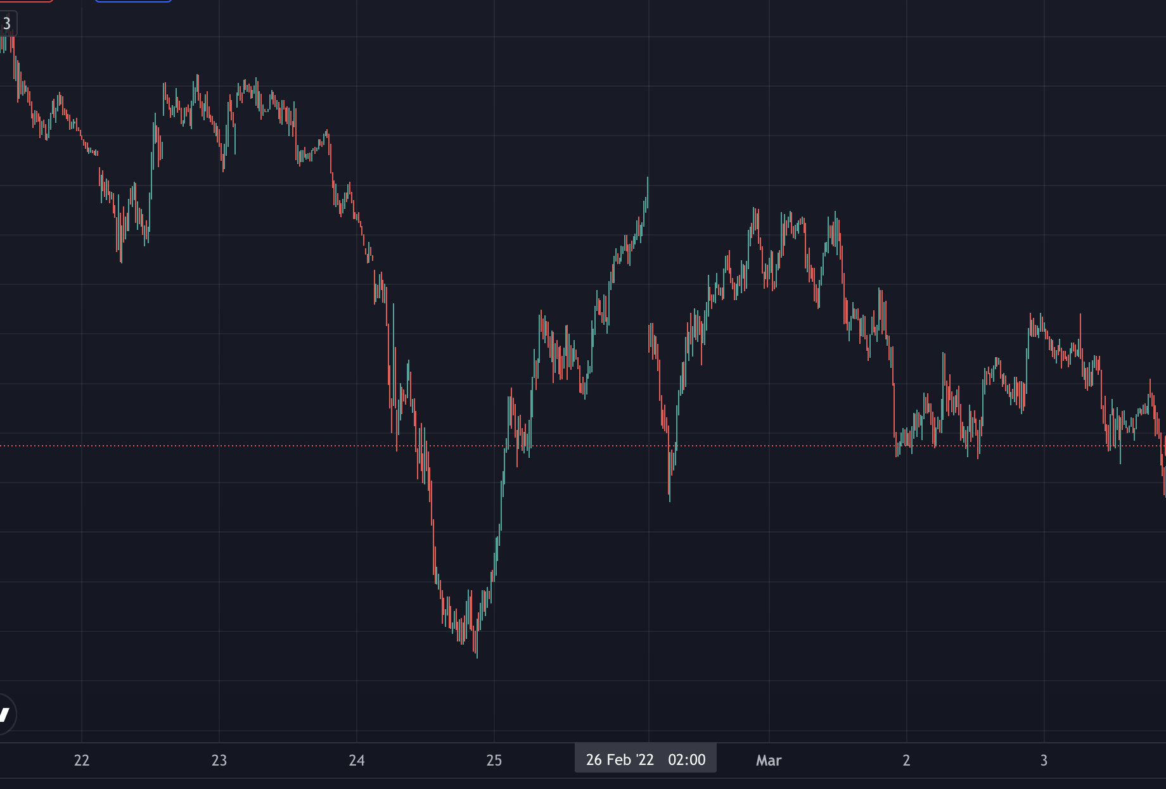



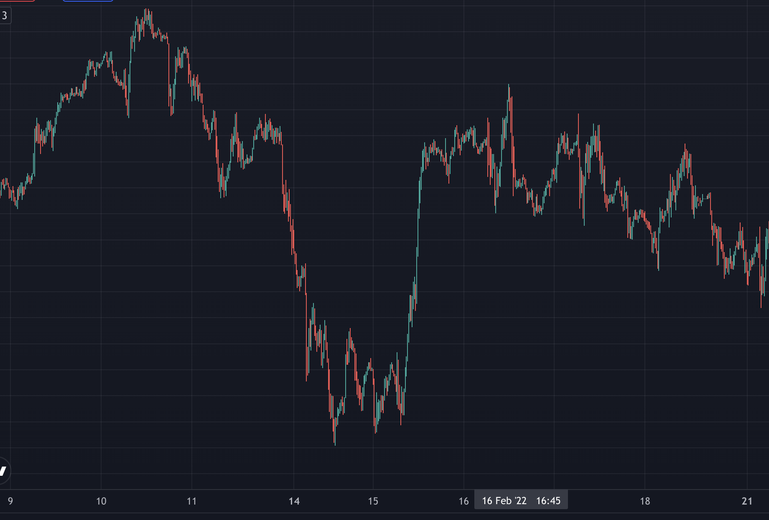



LTI

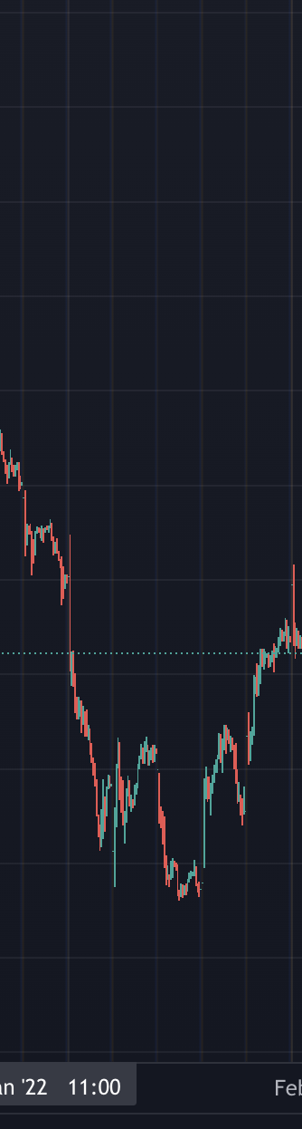



INFY

