Band :

Measures the weekly target ( targets for entire week).

Calculations depends on Thursdays and Fridays.

Need to consider the highest high and lowest low of these 2 days as the range for the band.

We can set 3 targets for buy and sell based on the difference which we get from the highs and lows.

Like,

|  |  |  |  |  |  |  |  |  |  |  |
| --- | --- | --- | --- | --- | --- | --- | --- | --- | --- | --- |
| Highest High | Lowest Low | Difference | Half of The Difference | B1 | B2 | B3 | S1 | S2 | S3 | Band-Mid |
| 786 | 520 | 266 | 133 | 786+133=919 | 919+133=1052 | 1052+266=1318 | 520-133=387 | 387-133=254 | 254-266=-12 | 786-133=653  (or)  520+133=653 |
|  |  |  |  |  |  |  |  |  |  |  |

Based on above calculations we are setting targets,

Band mid gives us a hint of the trend.

If the Opening price of the week is above the mid-band, then is a bullish trend, or if the opening price is below the mid-band, then it’s a bearish trend.

But if the opening price is near to the mid-band, we need to consider-

If the opening candle is at/near to the mid-band then look at the next candle if it closes below the low of the opening candle then its bearish trend or if it closes above the high of the opening candle then it’s a bullish trend.

NOTE:

* If band difference is big -more volatile , if band difference is less – can expect big moves/candles.
* If candle closes above the band’s high or below the band’s low, and next candle did not successfully cross the band and closes within the band then there is no confirmation for trend to sustain above or below the band
* We need to consider alphabets, when in band.
* If the Opening of the week candle opens at 2 or 3rd target , we cannot be sure that it might continue the same trend in such case we need to consider other factors to ensure on the trend.

Example:

BankNifty- march 10&11

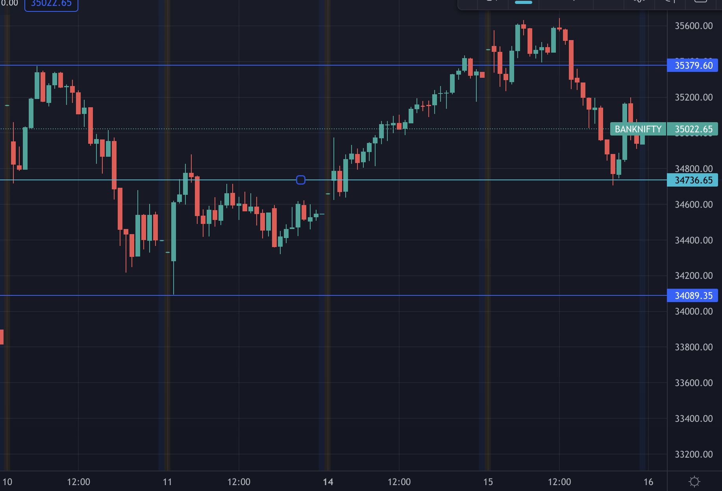

BankNifty: march 3&4

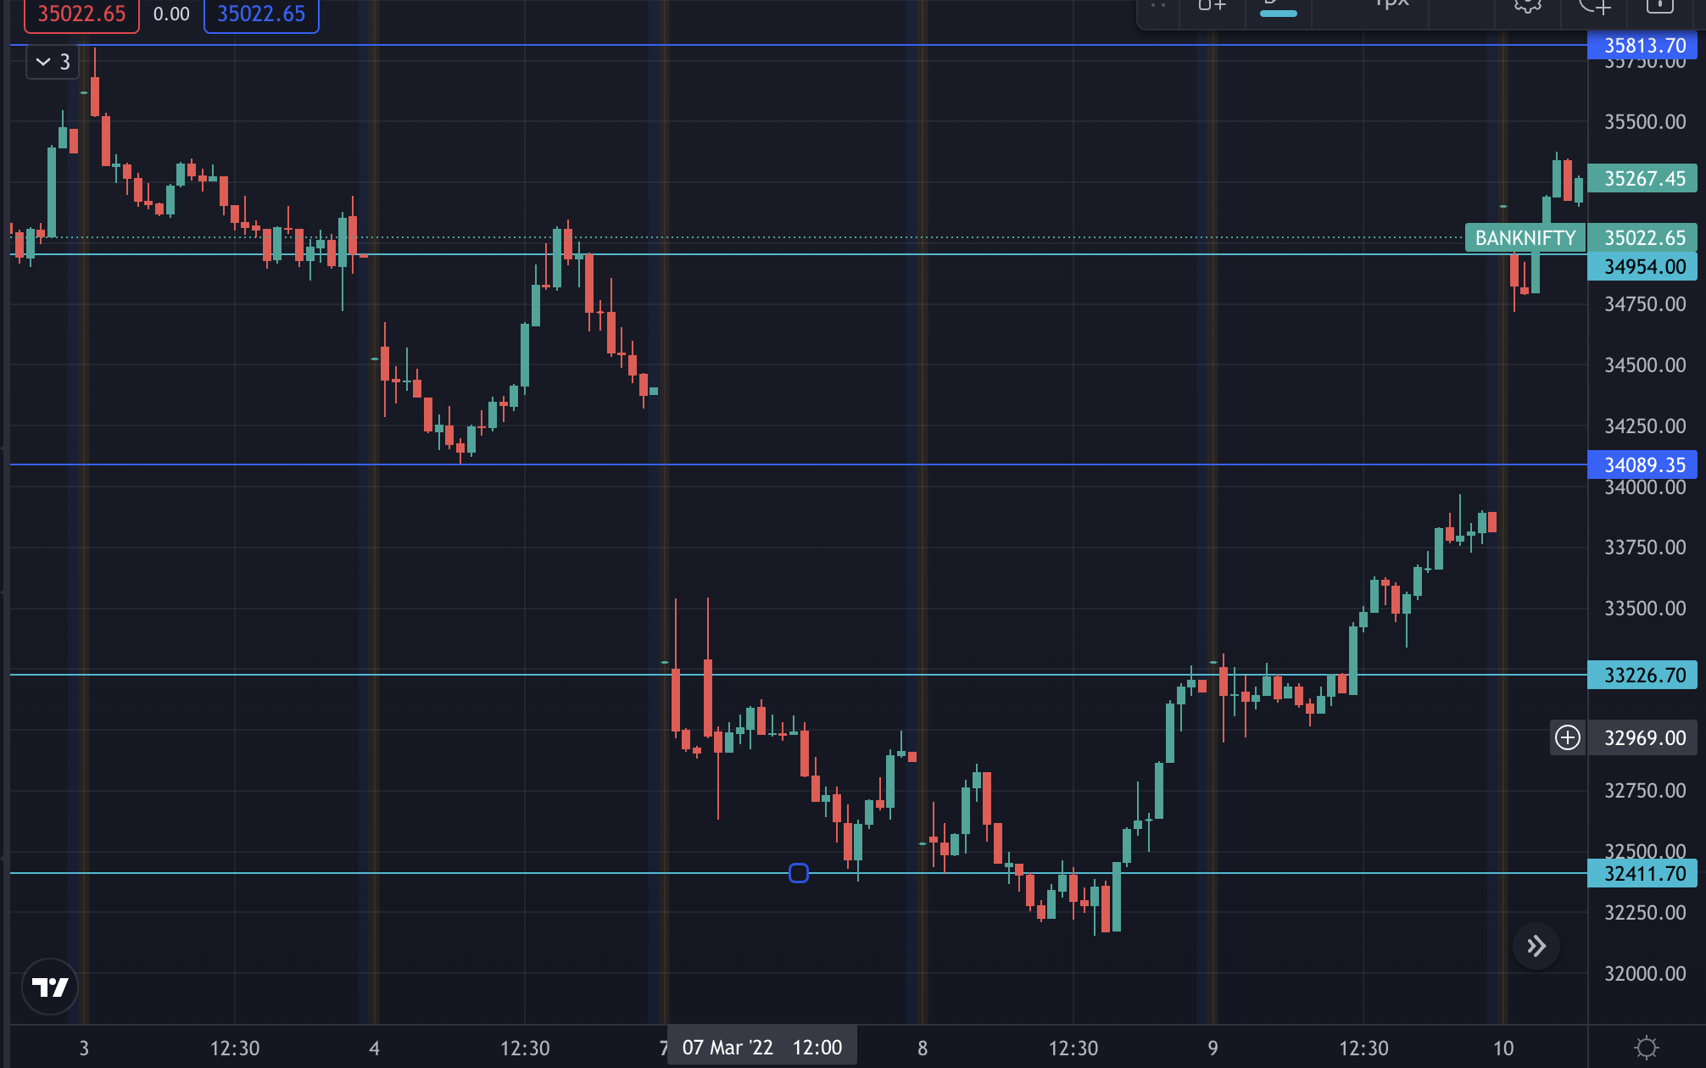

Double bottom has been formed on 8th march.