Candle Concepts

1. Opening Candle

Open High and Open Low  
  
When we spot a huge opening candle whose open and low are of same level , it’s a huge green candle which is open low candle.

When the next candle closes above the high of open low candle it indicates that its gonna take a bearish trend.

When we spot a huge opening candle whose open and hig are of same level, then it’s a huge red candle which is a open high candle.

When the next candle closes below the low of open high candle it indicates that bullish trend is gonna take place.

1. Hammer and Inverted Hammer.  
     
   When a market is in bullish trend,and we spot a hammer like candle at its low , which indicates a trend reversal.

Bullish trend can reverse to bearish trend if the next candle close above the high of hammer candle  
When the market is in bearish trend, we spot a inverted hammer like candle at its high, it indicates that trend reversal can happen.

Bearish trend can reverse to bullish trend if the next candle close below the low of the inverted hammer candle.

 

1. Wing Candle

Wing candle concept is to confuse us, here a candle will be form in shape of a wing.

Its upper wick and lower wick will be of same size.

Here the buyers and sellers are equal hence we will not be able to analyse the trend which will take place .

Its better we ignore this candle.



Charts:

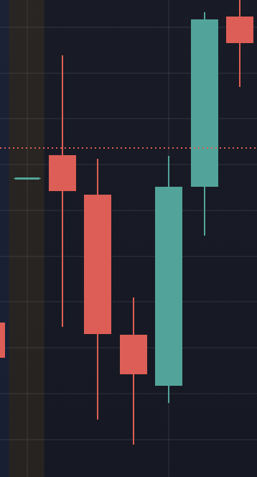

We spot a wing shaped candle , hence cannot predict the trend hence neeed to ignore the trend.

A bullish trend had taken place and a hammer was spot at the lowest point after which trend reversal took place.

Open high failure-

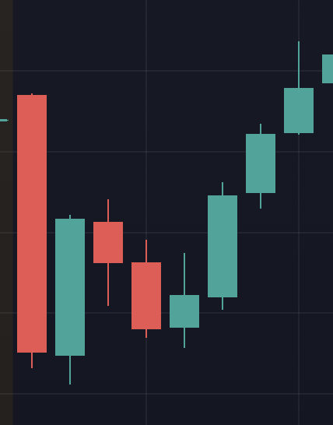

We spot a huge open high candle , but the next candle dint close below the lower wick of open high candle hence that condition failed.

But if we notice when trend was turning down a inverted hammer was spotted and hence uptrend took place.

Open low success:

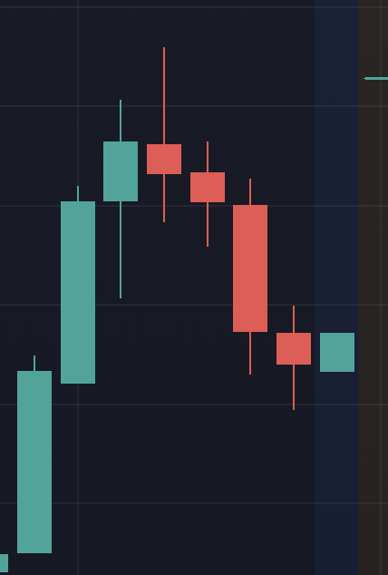

We spot a huge open low candle and next candle also closed above the upper wick hence uptrend took place , but and inverted hammer was formed when changed the trend .