Revolution Timings

In Indian share market we have a certain timing , which can help us decide on our trade which is Revolution Timing.

This Revolution Timing is nothing but trend analyser, based on these particular timings performance we can decide the momentum of the market.

We have 3 timings ,

11.45 – 12.00

15.45 – 16.00

19.45 – 20.00

The candles formed at these timings can help us analyse the trend,

But how ?

The lowest low of these two candles and highest high we will the range once the next candles closes above or below the range , that will be the trend.

Previous 2 candles, performance will be a added advantage in deciding the trend.

Like if it’s a 2 candle concept or hammer /inverted hammer or alphabets.

But this trend should close by 1.30 as 1.30 candle is ego breaker candle. We have 50-50 chance the trend to continue after that .

Again we should also see if the market is trading between shadow , cause if its so then its 50-50 chance of this case to success.

For example,

Here 3.45 to 4.00 candle has been measured and waiting for it to breach since its within the shadow its 50-50 chance.

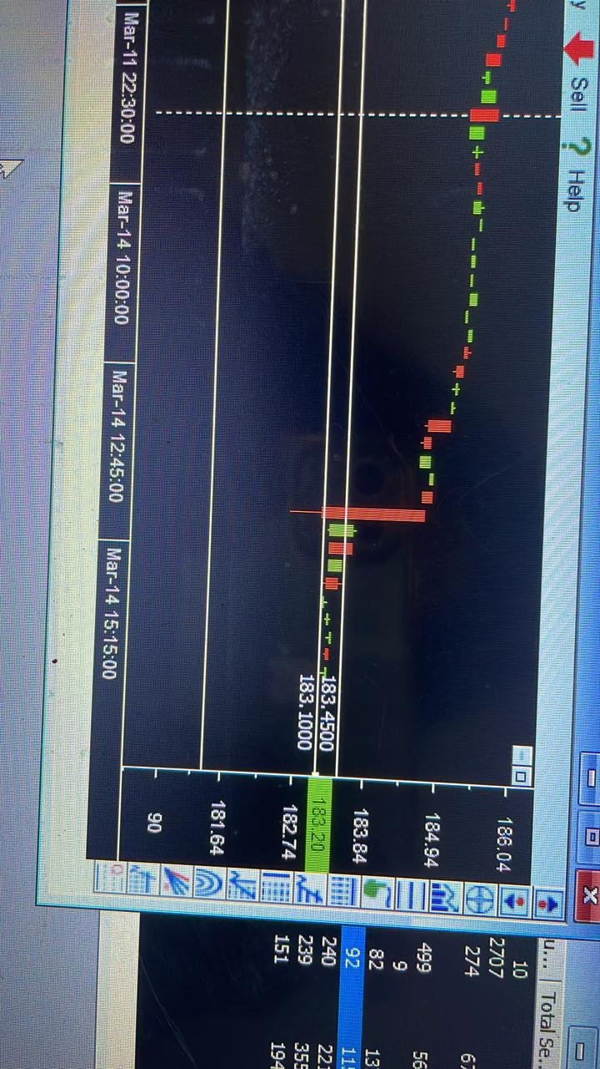

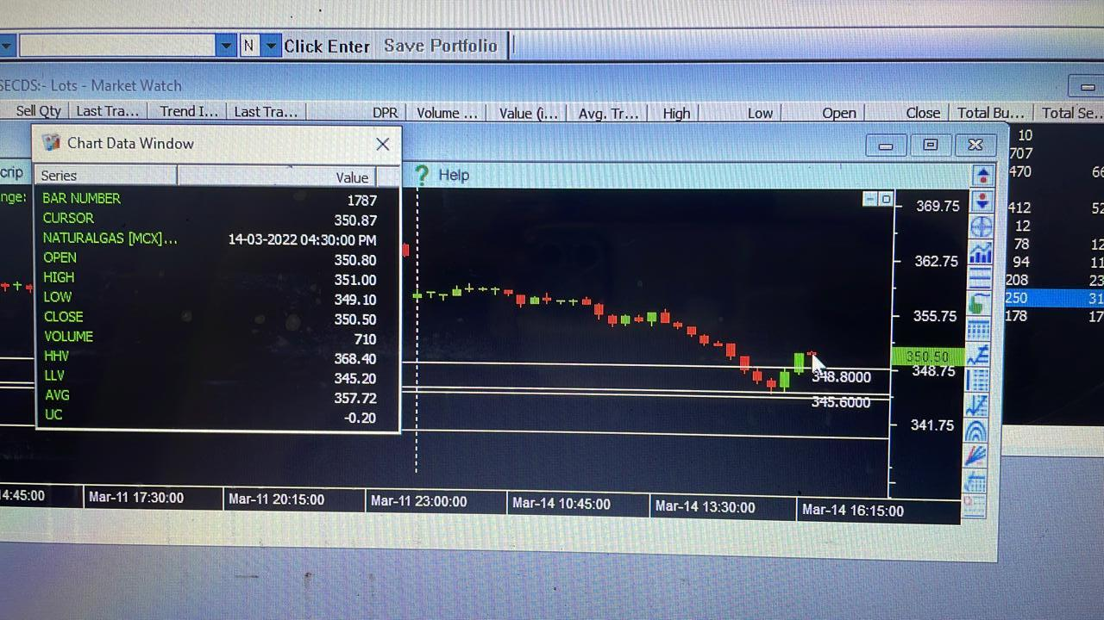

This is natural gas , candle closed above the upper wick hence can buy now.