1. A volatile Market , booked a trade and loss happened.

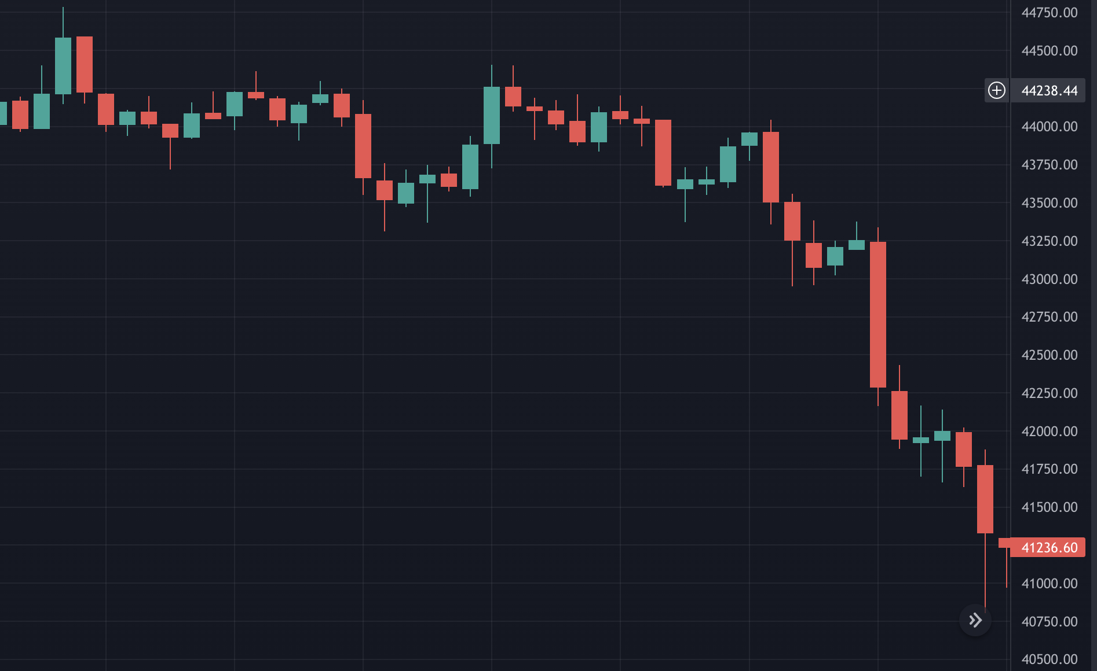



This is a volatile market , when analysing the highlighted point has been a bearish trend expected it to go high as it as gone to its lowest range and booked a trade for instant order.

Instant Order was placed for 43000, but in few mins unexpected of what expected happened and market had gone down and still going down.

I had Placed a StopLoss Sell Order at 42500 and had to bear Loss of 500.  
  
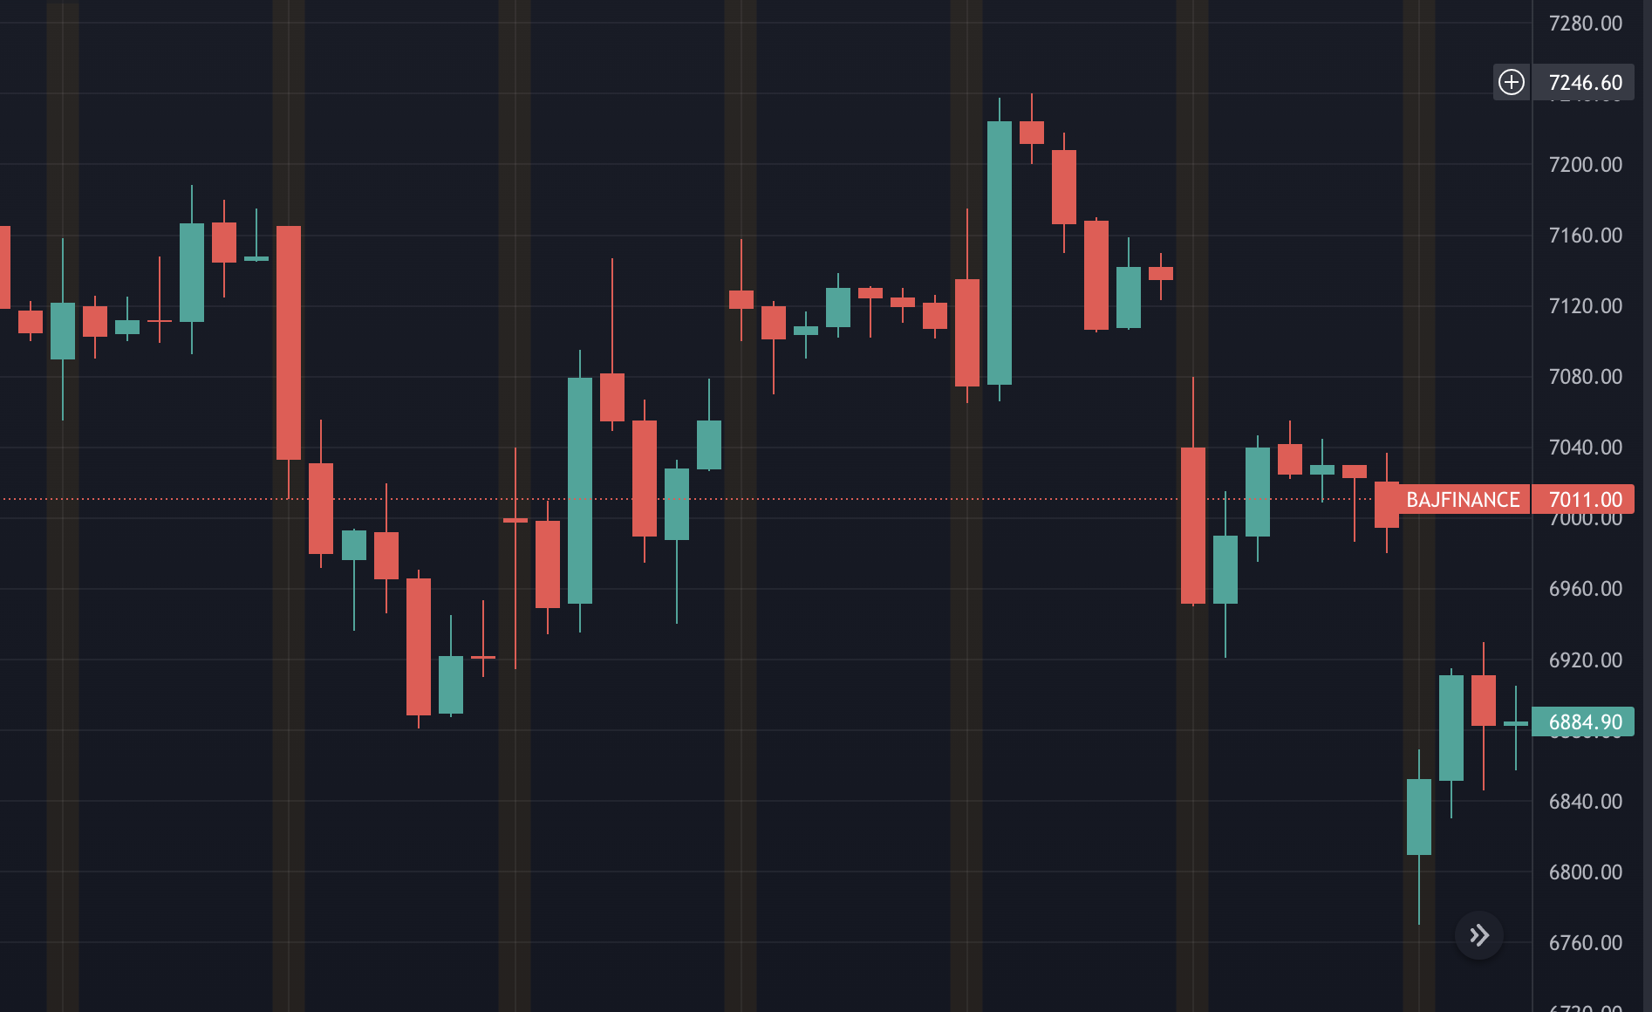



1. A Scalper and Momentum Trader – Difference along with its Buying and selling stragergy  
     
     
   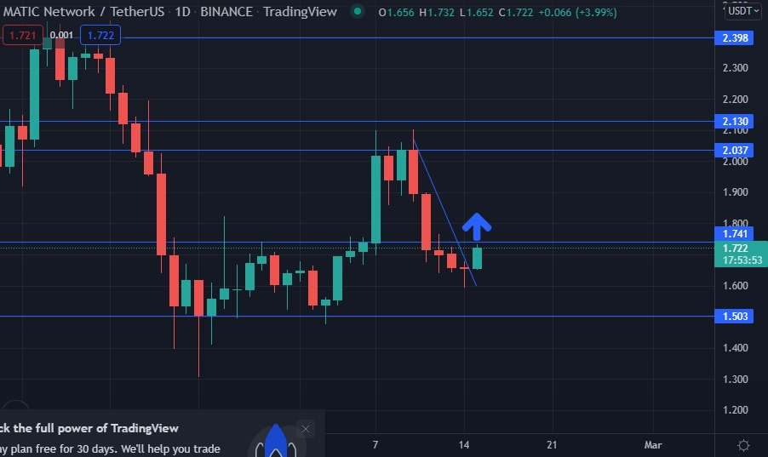

The Range for this chart is between 2.398 and 1.503 and current market trend is at 1.722

So as a Scalper ,

I will book Limit Buy Order at 1.503 and wait for this order to execute

Along with it I will make sure that I Place a Stop Loss Sell order at 1.300

As a scalper I can afford to bear a loss of .200.While I wait for the market to Reach its Range , I also place a limit Sell Order at 2.398 to obtain the maximum Profit of .400.

Meanwhile a momentum Trader will analyse that when the market reaches at 1.72 it will reach upto 2.07 so I will make advantage of that moment and place a StopLoss Buy order at 1.72 and Limit Sell Order at 2.037.

So a Momentum Trader will always target to close the trade within a short span of time approx. of 1 to 1.5 hours.Their target will be 1:1 Ratio with respect to Risk and Reward.Momentum Traders will always Target to trade within the limits or at the Limits

But a Scalper will always trade at the upper and lower limits for approx. of 4 to 5 hours of duration and aim to have 1:2 Ratio of Risk and Reward.

1. Trends  
     
   # UpTrend- Up trend is when the buyers are dominating which is also called as Bullish trend.

# DownTrend- Down trend is when the sellers are dominating which is also called as Bearish trend.

# Side ways Trend- Its when the market is within its upper and lower limits.  
Always sell at upper Limit and Buy at lower Limit , reason is to attain maximium profit with minimal risk.  
Momentum traders will buy within the limits or at the limits , whereas Scalpers will buy and sell at its upper and lower limits.

# Volatile- Volatile market is when we are not able to predicte its next move.

When the market movement is not within the limits and not sustainable

This market creates a confusion, and hence suggested not to trade .

1. Cycle Of A Market.

When an IPO Enters into Market , it will never give a direct 90 degree trend either uptrend or downtrend.

It goes through a cycle of Trends, which has many possibilities.

To Begin with it can be a volatile market -> then be a side ways market -> then be a trending which can be either uptrend or down trend.

Below are the different Possibilities of the trend.

S -> V -> T(up)

S -> V -> T(down)

S -> T(up) -> V

S -> T(down) -> V

V -> S -> T(up)

V -> S -> T(down)

V -> T(up) -> S

V -> T(down) -> S

T(up) -> V -> S

T(down) -> V -> S

T (up)-> S -> V

T(down) -> S -> V

1. Technical Keywords  
     
   -> Entry : The point where we start our trade (Buy)

* Exit : The point where we close our trade (Sell)
* StopLoss : The point were we limit or loss , ever trade should have a stop loss booked without which we should not proceed.
* Cost to Cost/BreakEven : The Buy and Sell happens at same point and closes the trade without any profit or loss.

1. Types of Order  
     
   -> Instant Order : When we buy a share at current market price immediately.

* Limit Order : Limit Buy Order and Limit sell Order   
  When we want to buy a share which is below the current market value its Limit buy order.( which will have to wait for the market to come down, will not be executed immediately )

When we want to sell a share which is above the current market value and it books a profit when we sell then its limit sell order

* Stop Loss Order : Stop Loss buy and Stop Loss sell

When we want to buy a share at a value which is above the current market trend then its Stop Loss buy order.

When we want to sell a share at a value which is below the market trend then its Stop Loss sell order.