BankNifty:

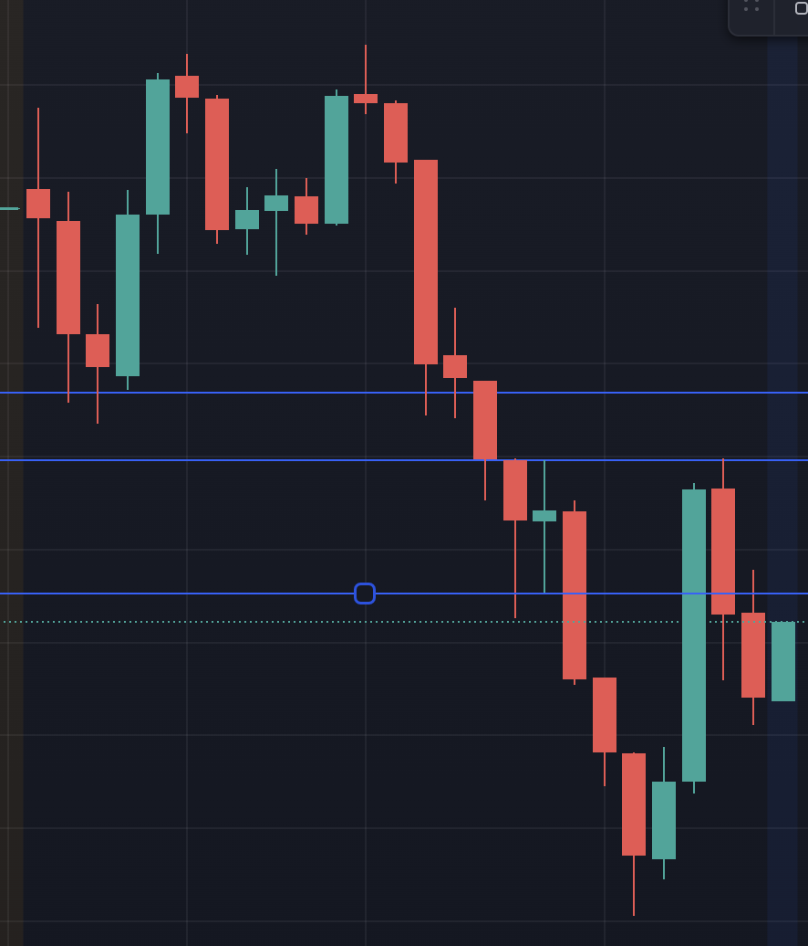

BankNifty opened with a wing candle and took a down trend, 9.45 candle gave a inverted hammer in down trend,

At 11.45 and 12.00 hammer was formed and the next candle closed below its lowest of lower wick.

Also if we see a double top has been formed , candles started to close below it , hence trend continues.

Candle closes below the lower wick of 1.30 candle hence down trend still continues.

Infosys:

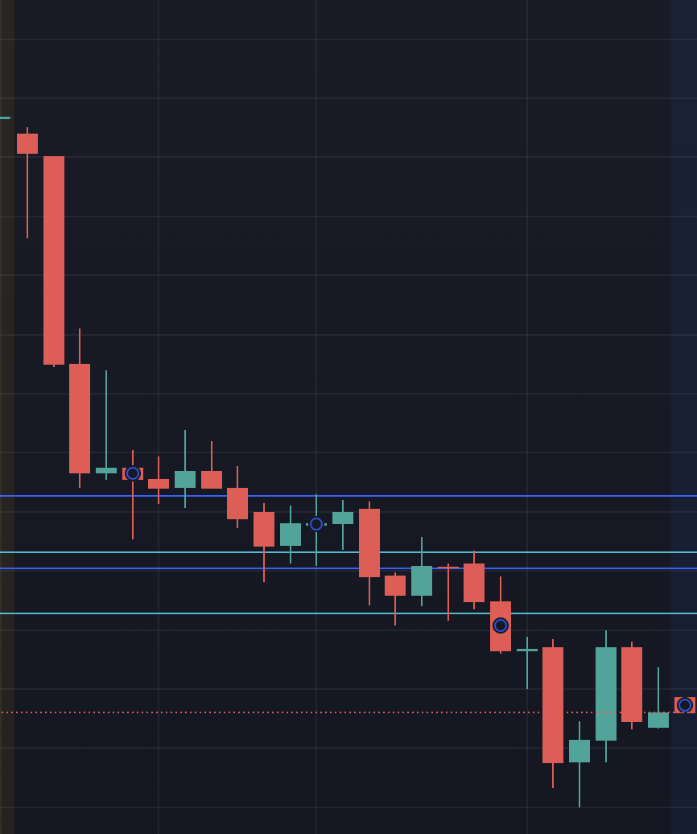

At 11.45 12.00 wing was formed , candle closed below the lowest of lower wick and took a down trend.Again at 1.30 candle closed below the lower wick.

LTI:

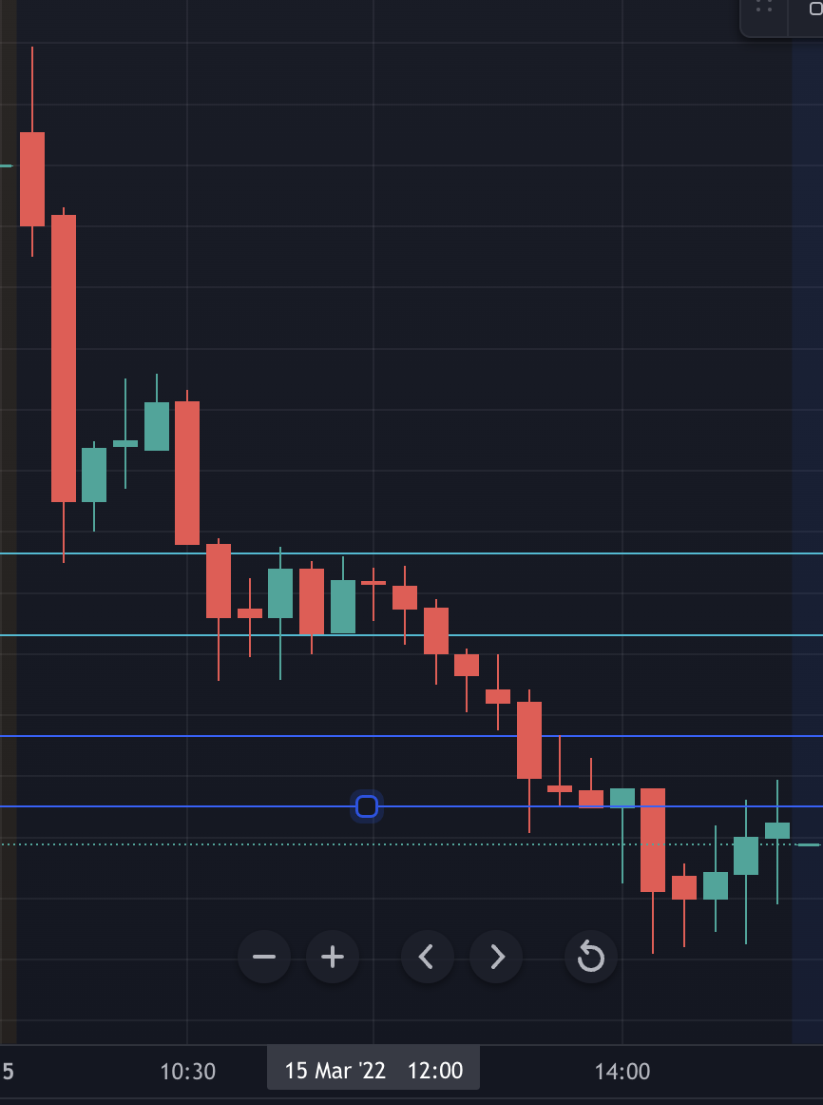

Similarly with LTI.candles closed below the lower wick.

BPCL

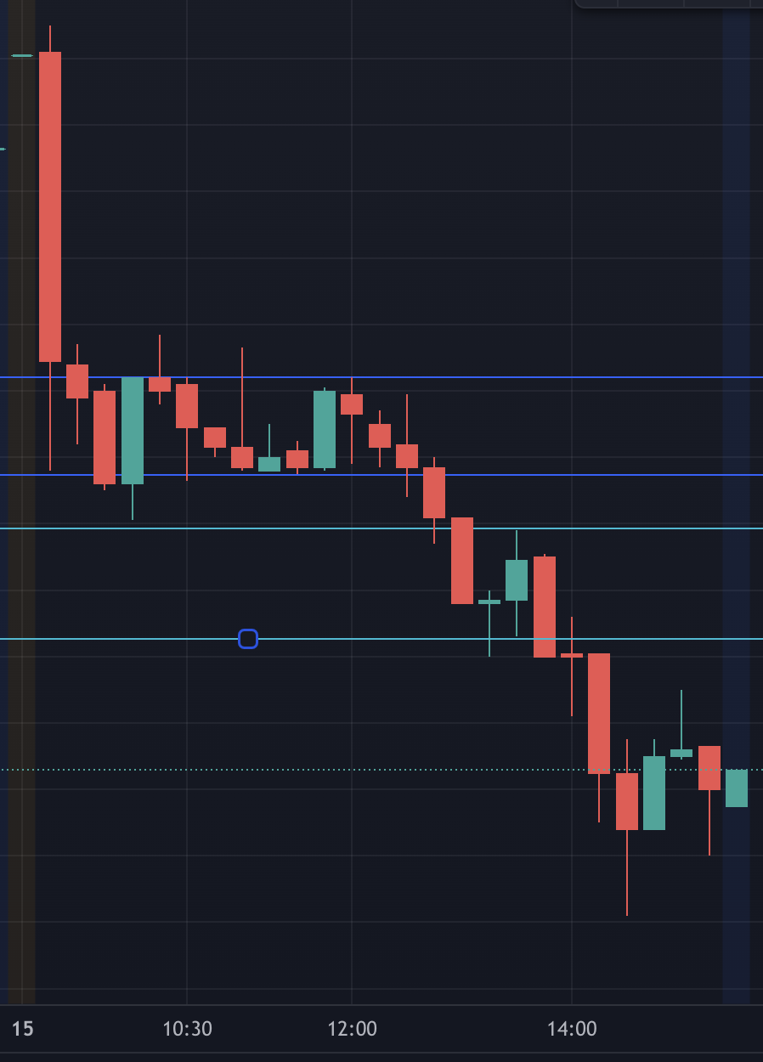

Hindustan Petroleum:

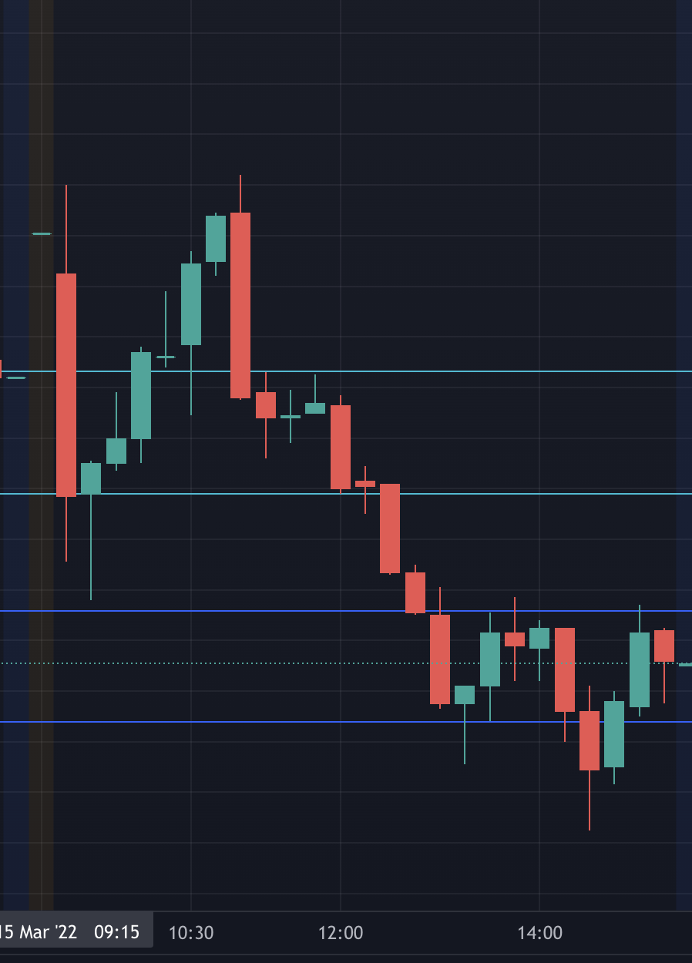

RELIANCE:

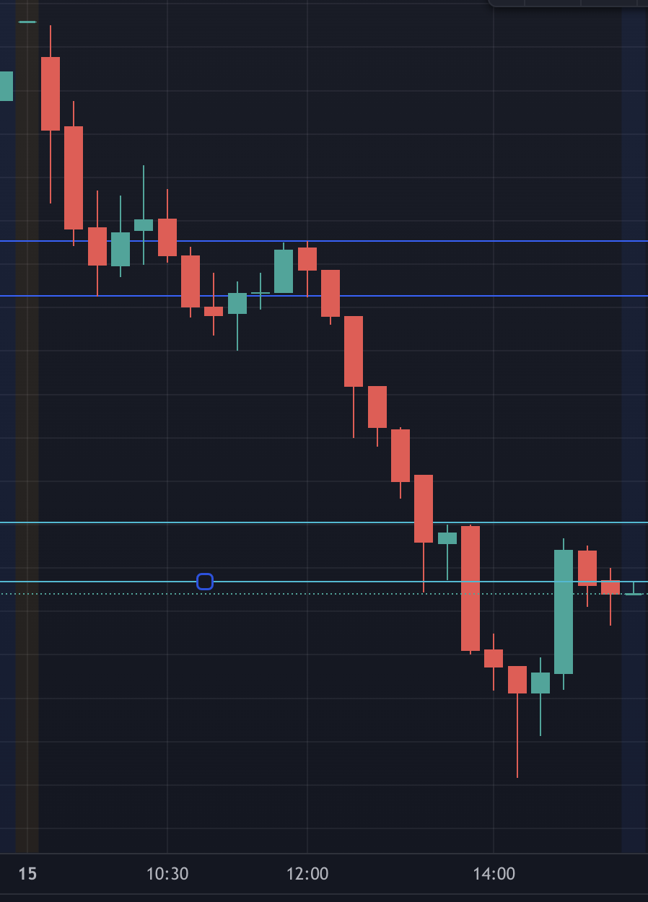

HDFC BANK:

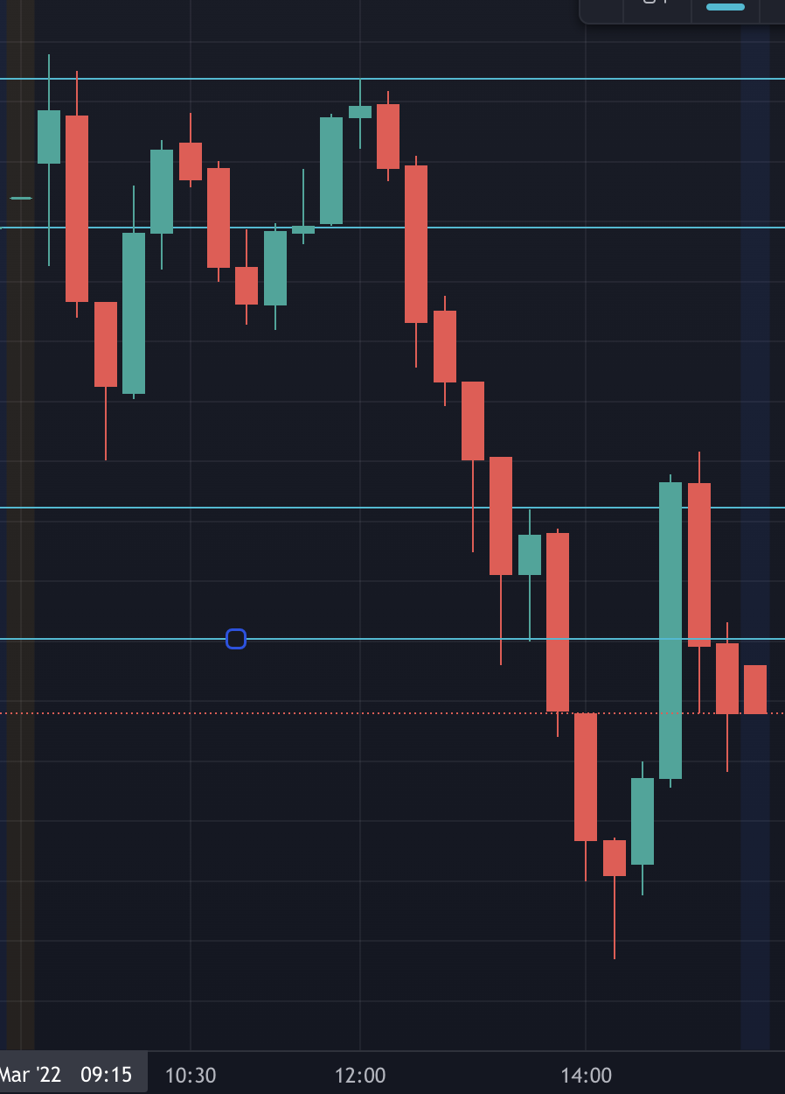

AXIS BANK:

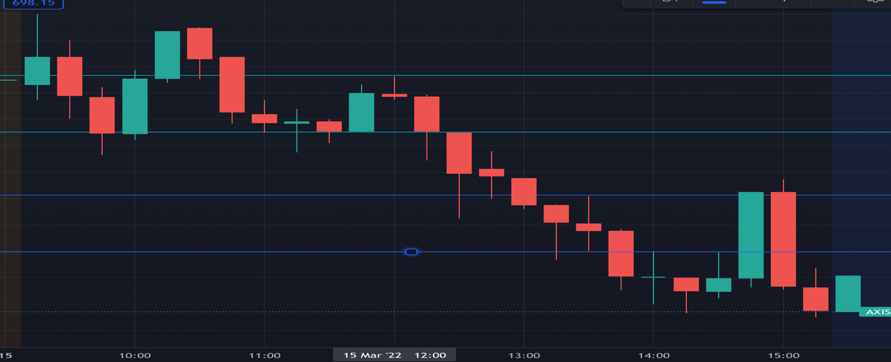

ICICI BANK:

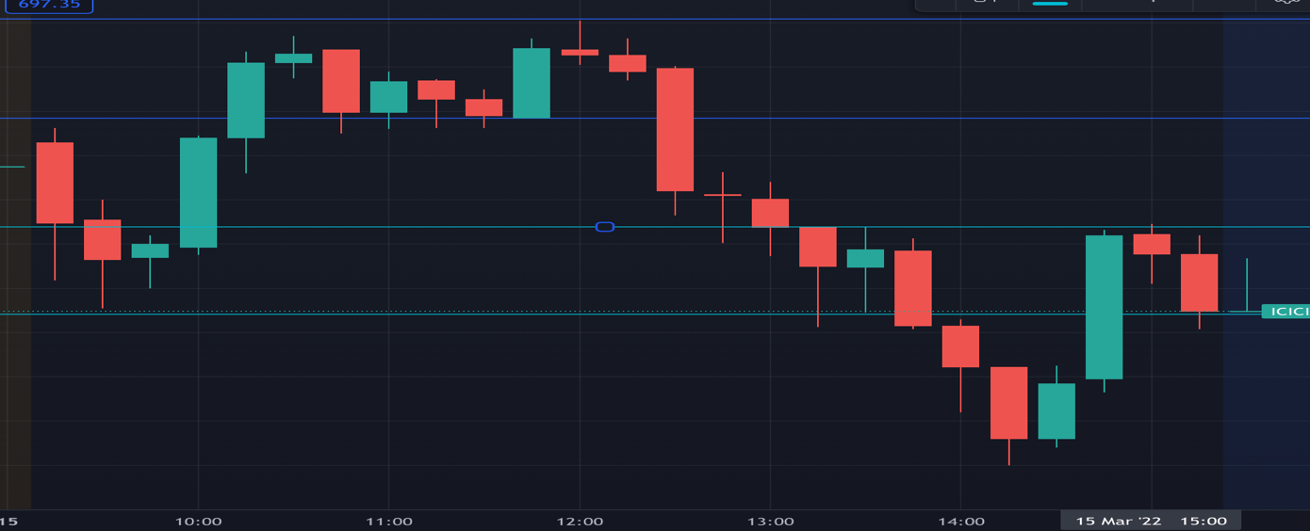

KOTAK:

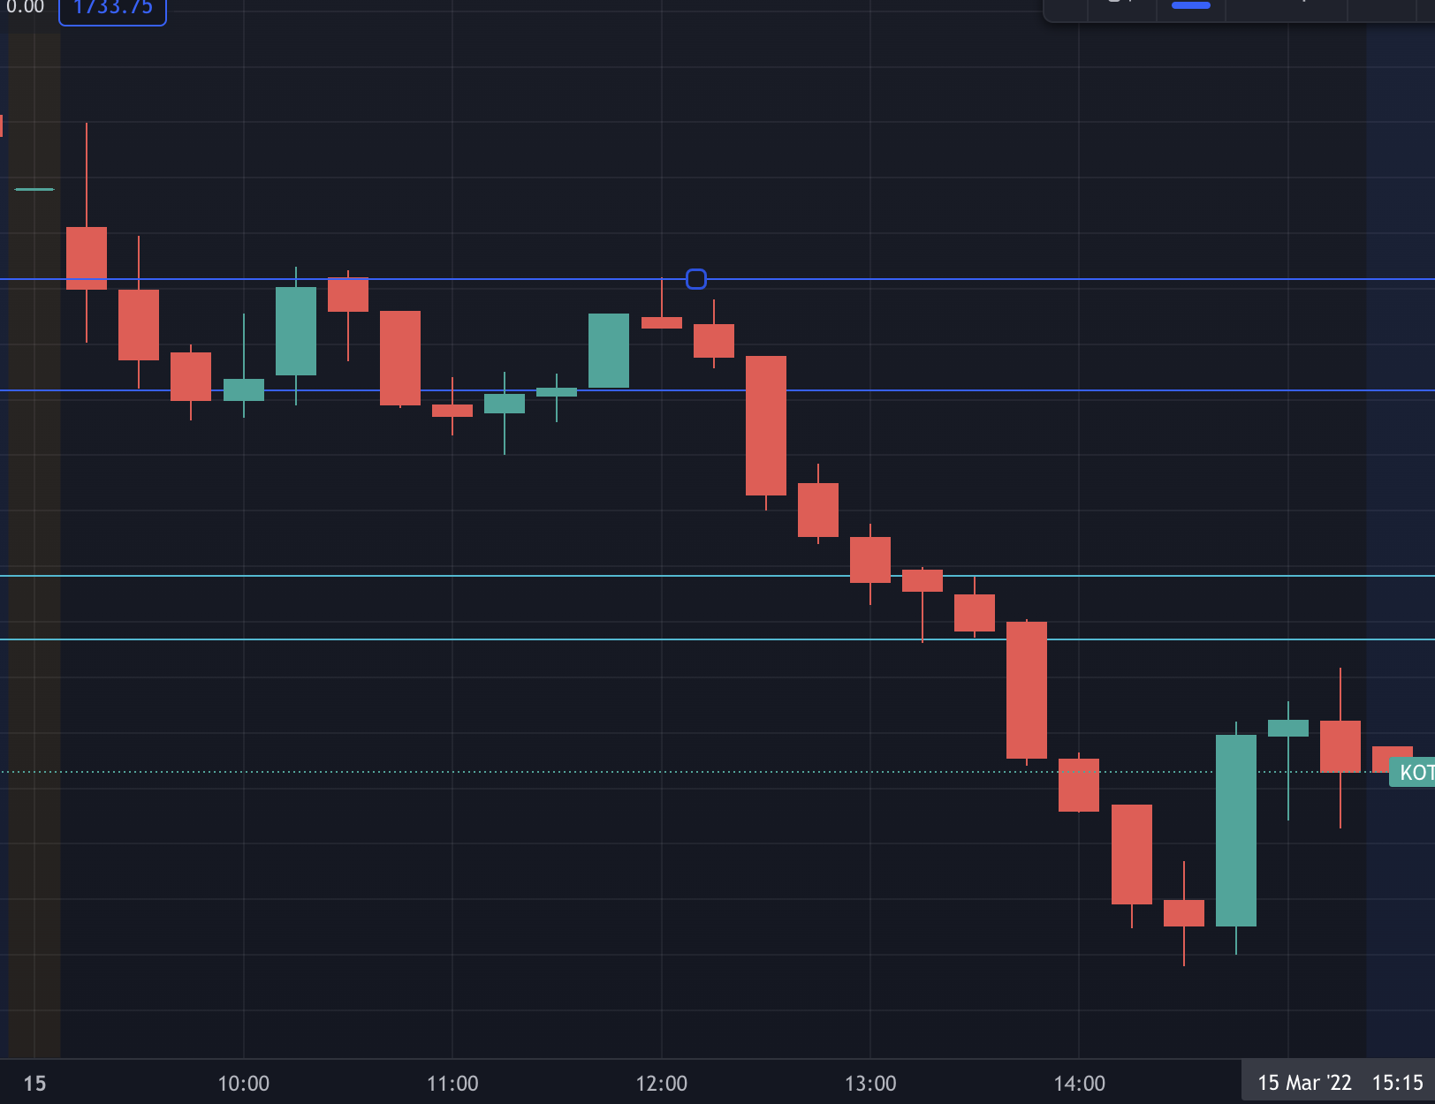

HCL TECH:

