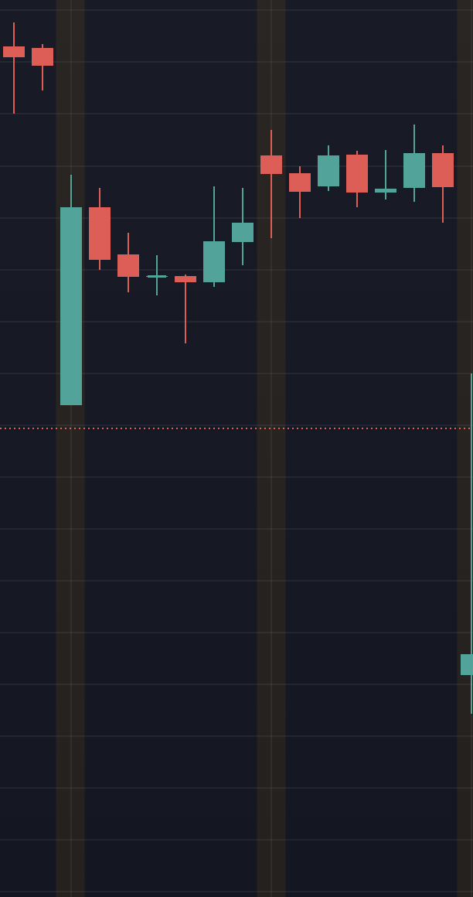

This is open low candle ,

When we spot a OL candle we should wait for next candle to cross the high wick of OL candle then only it indicates a bullish trend.

But in this case , the next candle did not cross the high of previous OL candle hence we should not initiate a buy as it may or may not be a bullish trend

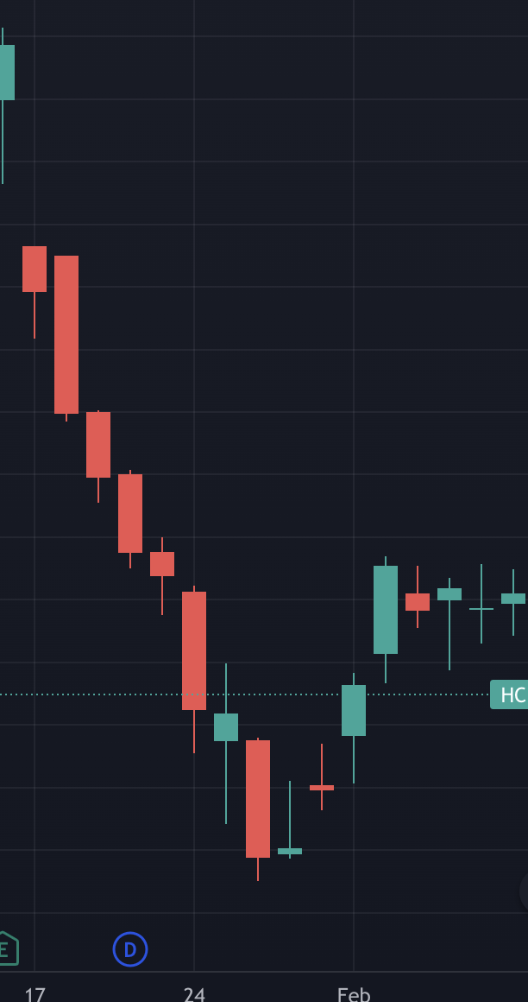

When a open high candle is spotted and when its next candle closes below the lower wick then it will be bearish trend when can sell the stock.

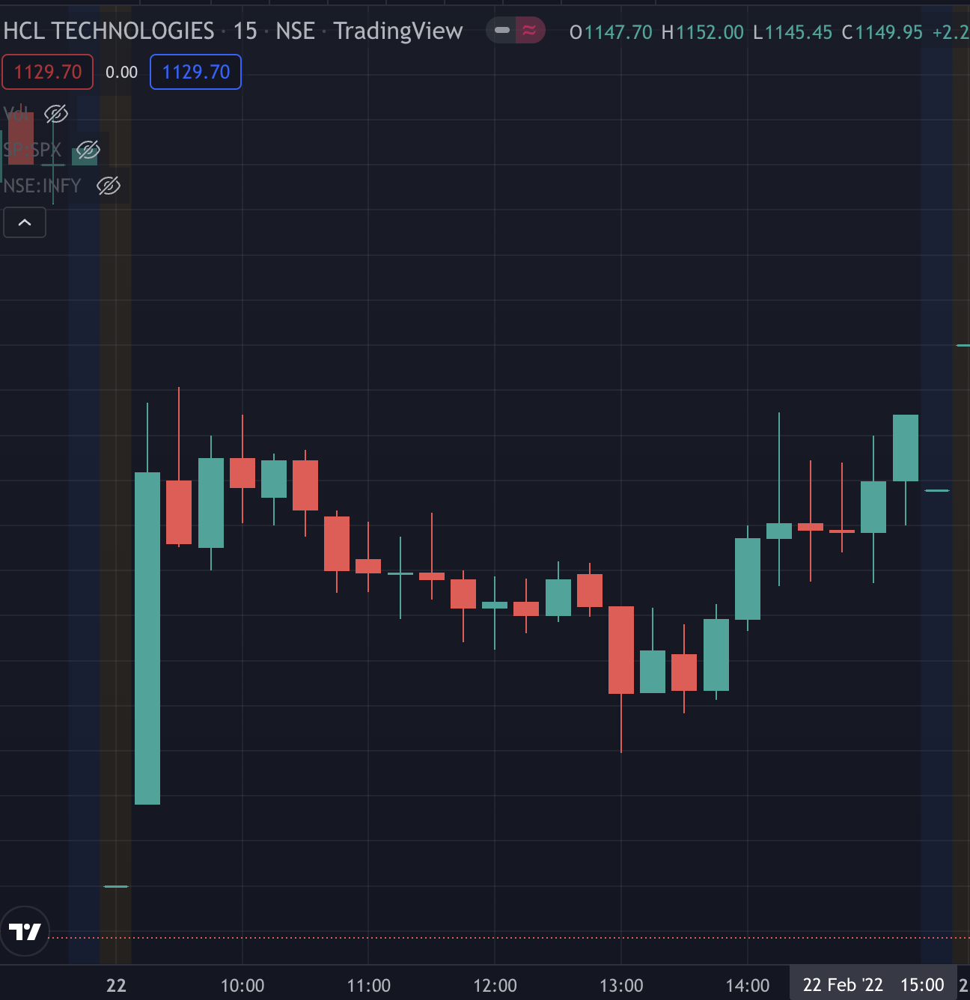

This is a chart of HCL Tech on 22nd Feb with 15 min Timeframe.

The Market opened with a very big open Low candle , but the next candle formed did not close after the high wick of previous open Low candle hence it did not sustain the uptrend

We also notice that at 11.15 a wing candle is formed , recommended not to trade as it might confuse us.If we see it’s a side ways trend after the wing.

At 13.00 a open high candle has been formed , but the next candle did not close below the lower wick of the open high candle so we should not go for any sell option and wait for the market .

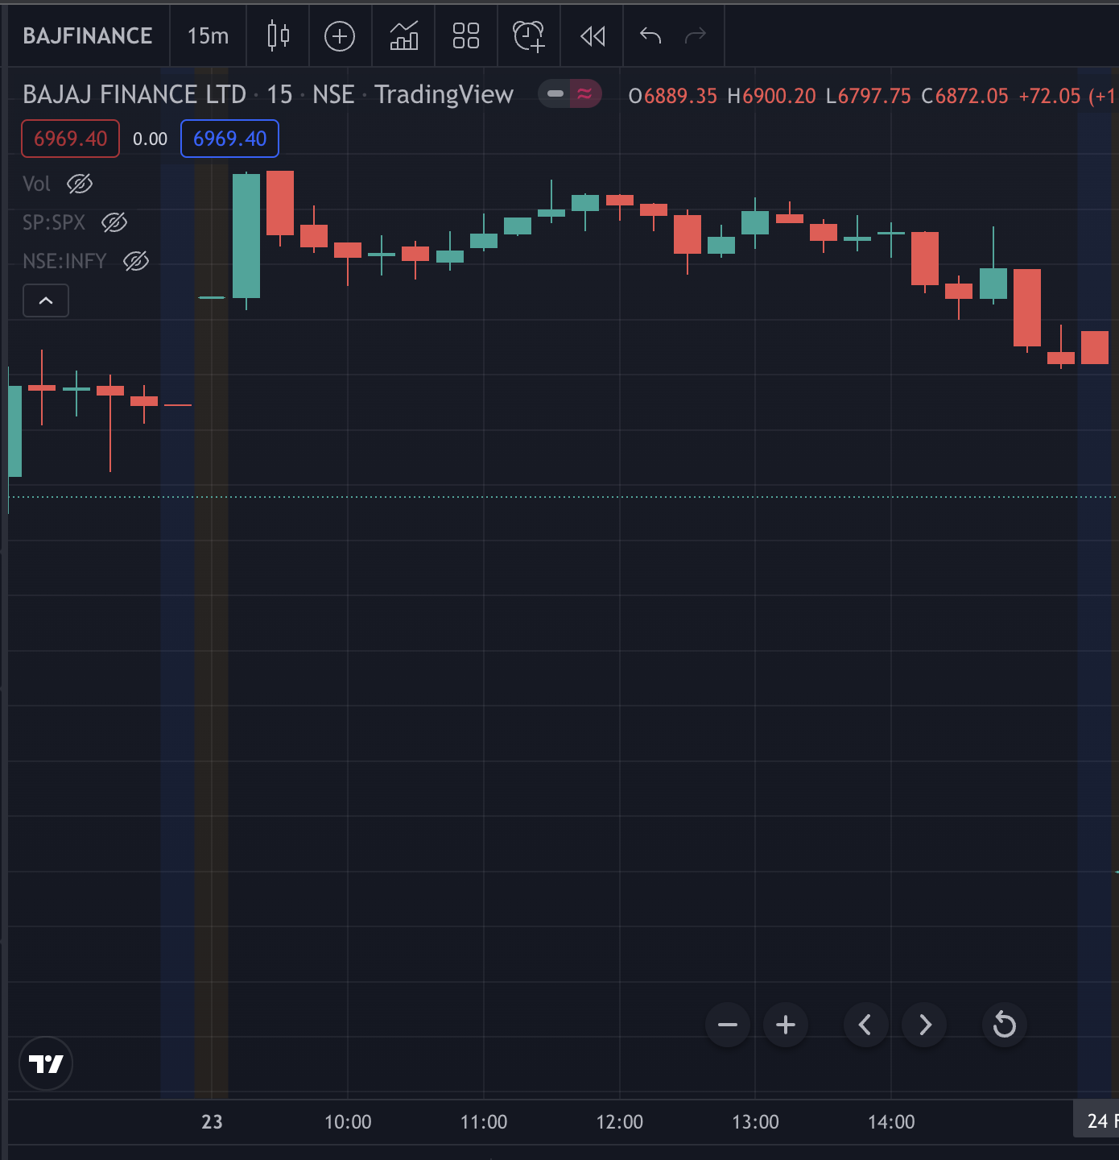

The opening open low candle had failed as the next candle formed did not close above the upper wick of previous candle and

immediately a open high candle is formed after which the candle closes below the lower wick of OH Candle and downtrend follows.

At 10.15 a wing candle is formed after which a hammer , which indicated trend reversal and hence a bullish trend forms.

As the uptrend follows, an inverted hammer is formed after which bearish trend follows.

At 2 pm a wing candle is formed after which a OH Candle is formed (the next candle formed has closed after the lower wickand goes the bearish trend.