Lab 5: Build, Test, and Package Applications with IntelliJ IDEA and Docker

Name | SIDRA LIAQAT
Registration number | 23-20911-083
Course / Section | DevOps / A
GitHub username | sidraliaqat
Lab | Lab 5 (DevOps_F26)

Task 1: Clone and Launch IntelliJ IDEA

intellij_repo_clone.png
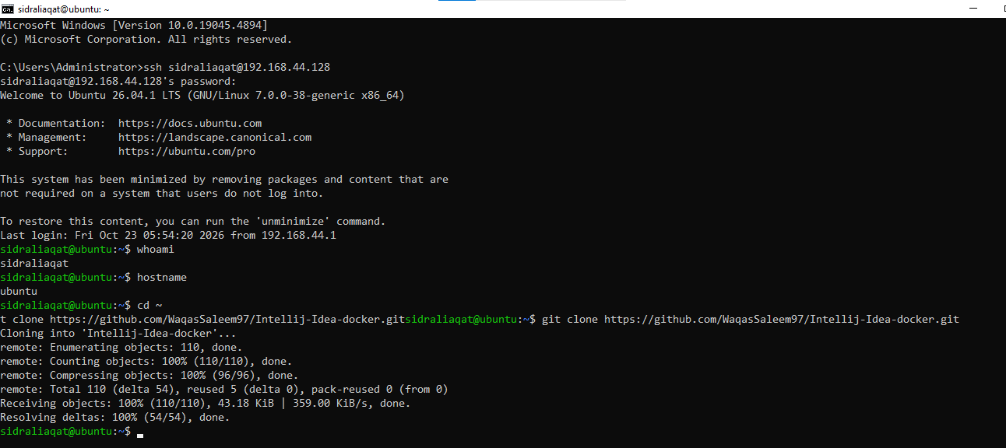
Cloned the Intellij-Idea-docker repository on the Ubuntu host.

intellij_running.png
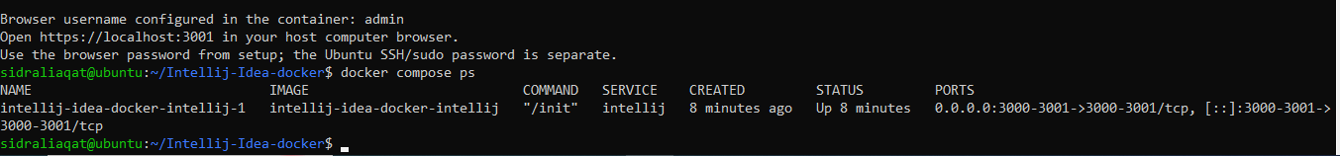
docker compose ps shows the intellij service running with desktop port 3001.

intellij_desktop.png
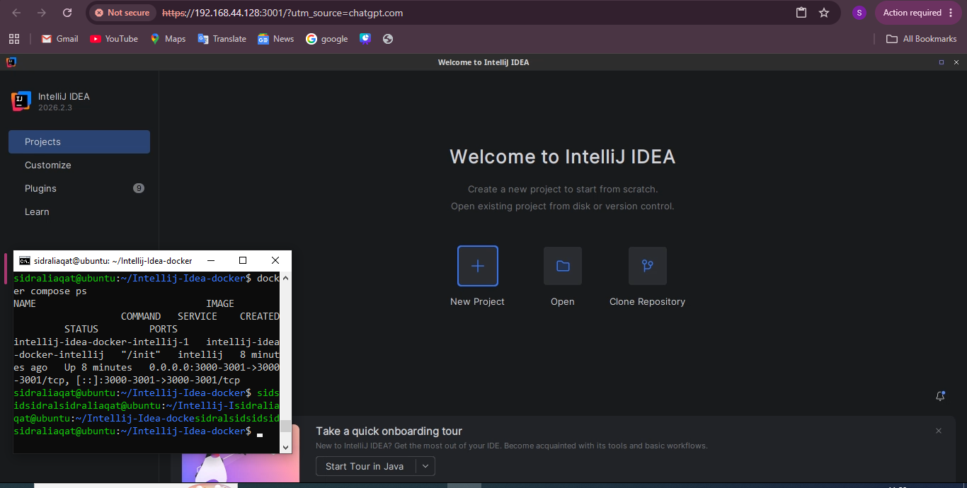
IntelliJ IDEA open in the browser desktop beside the Ubuntu host terminal.

Task 2: Build and Run the Maven Project

maven_project_clone.png
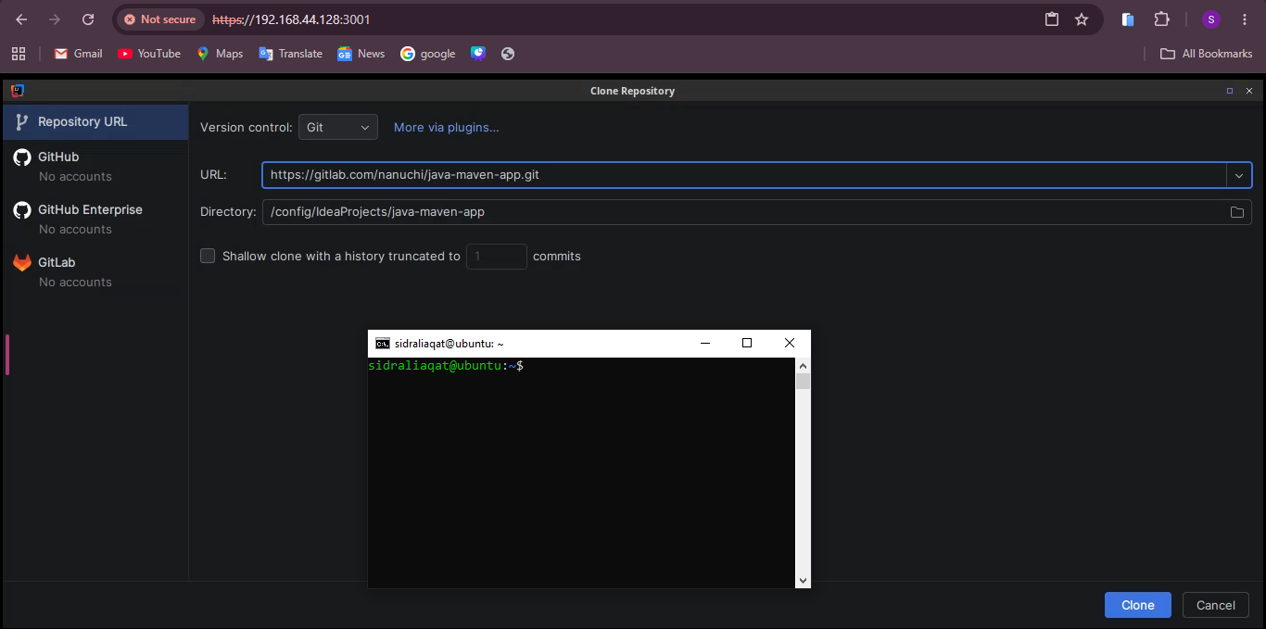
Clone dialog with the java-maven-app URL and /config/IdeaProjects/java-maven-app as the destination.

maven_installed.png
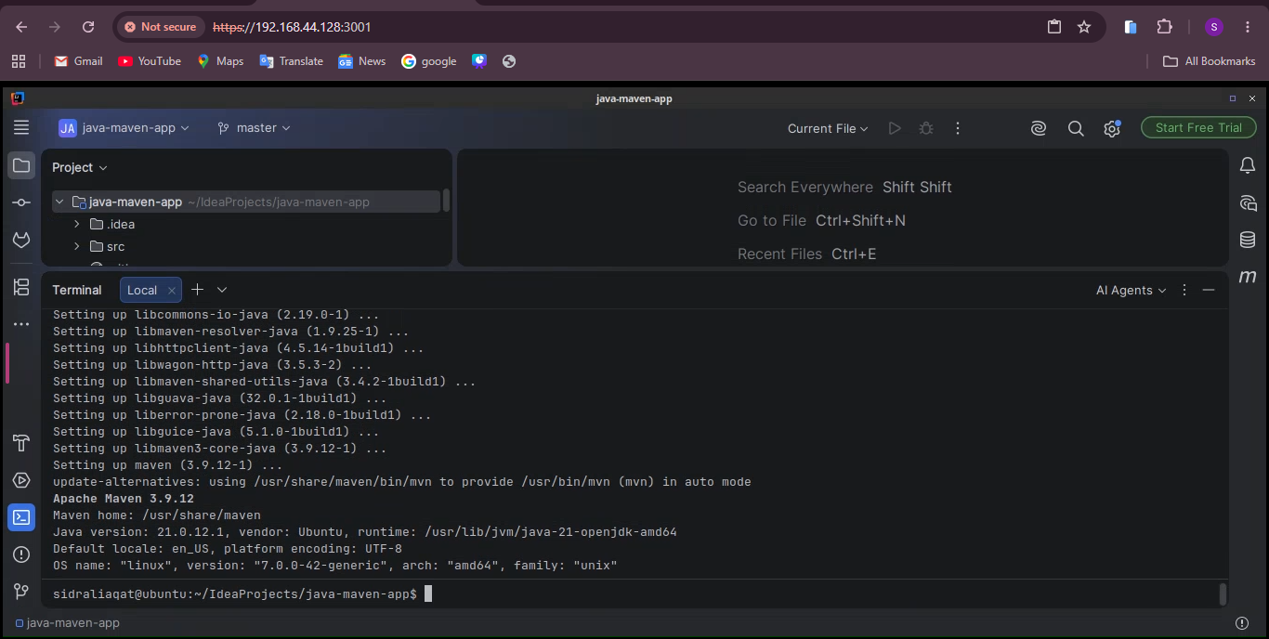
Maven installed; mvn --version output in IntelliJ's terminal.

maven_package.png
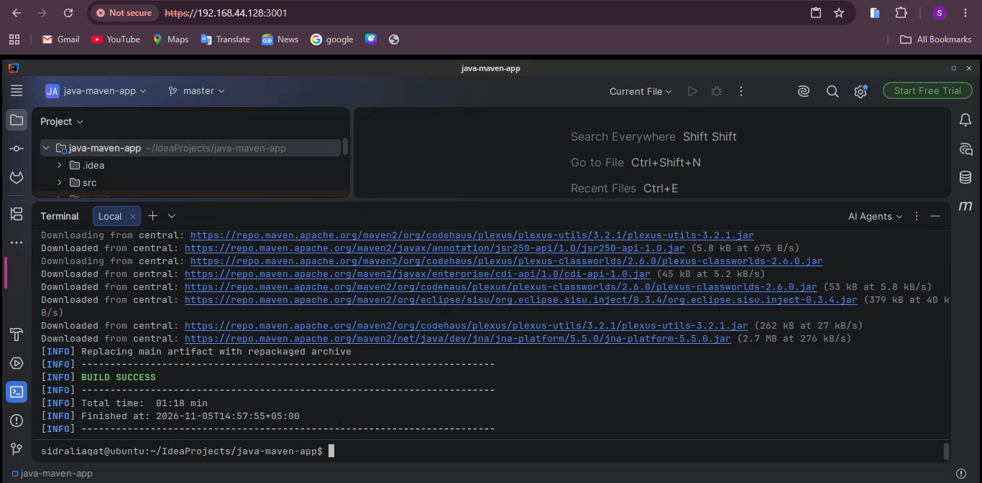
mvn package finished with BUILD SUCCESS.

maven_elasticsearch_dependency.png
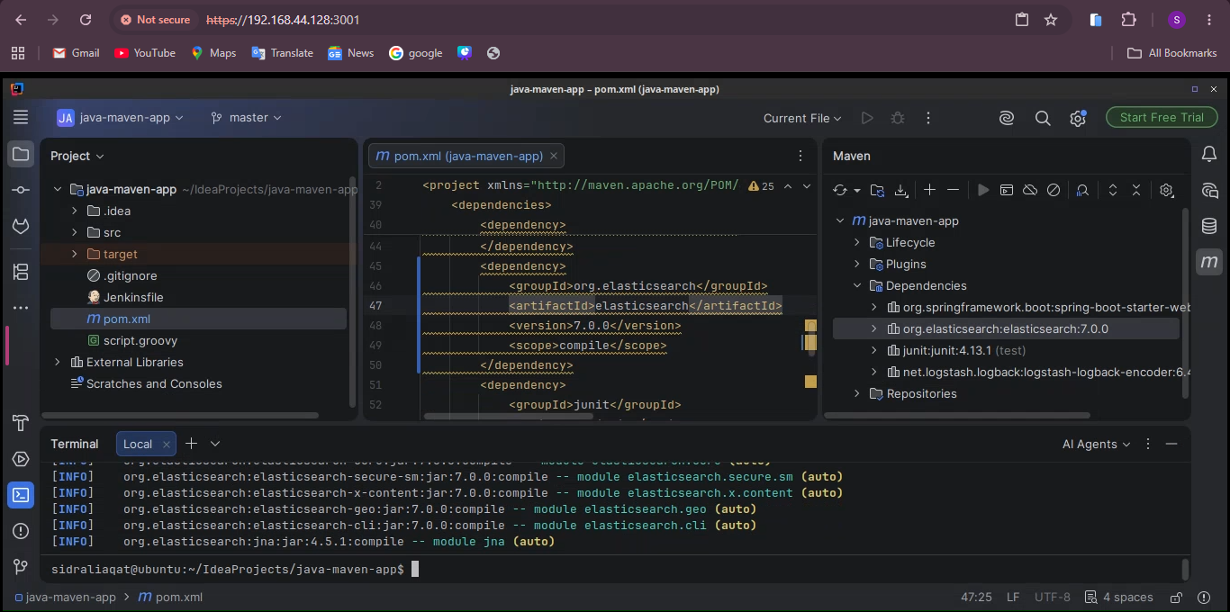
Elasticsearch 7.0.0 added to pom.xml and shown in the synchronized Maven dependencies.

maven_repackage.png
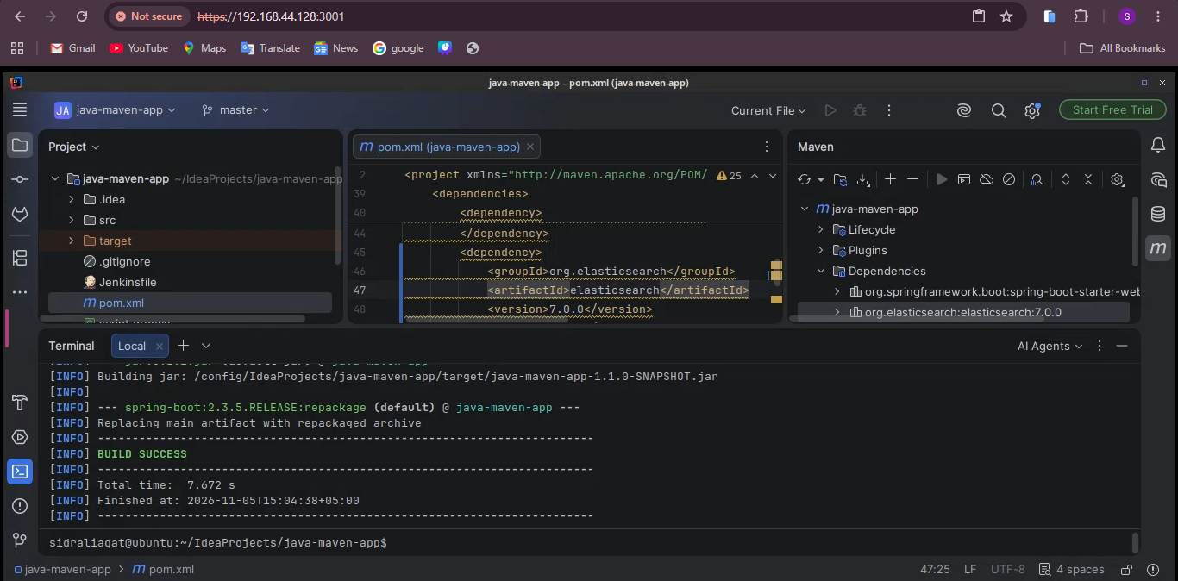
mvn package after adding the dependency, again with BUILD SUCCESS.

maven_test.png
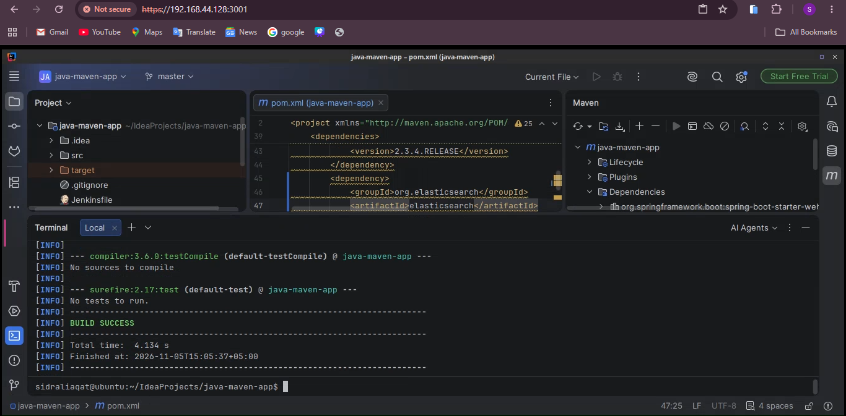
mvn test output and build result.

maven_jar.png
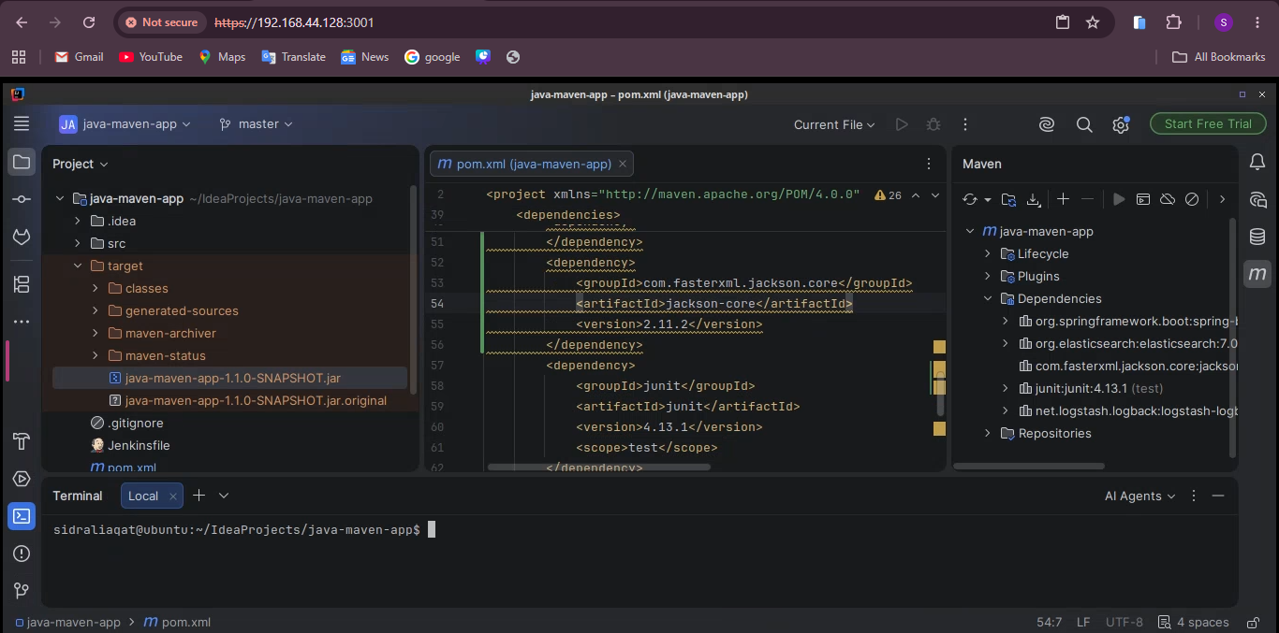
target/java-maven-app-1.1.0-SNAPSHOT.jar in the Project pane.

maven_running.png
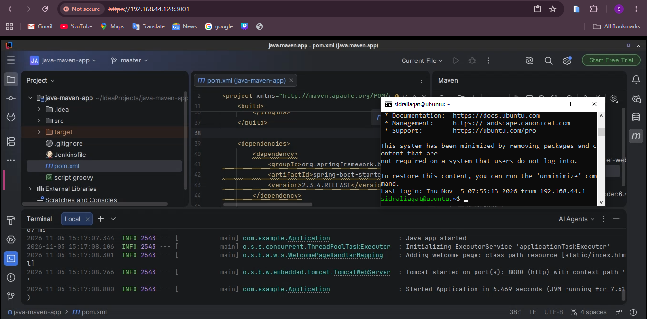
The JAR started with java -jar and the application came up.

maven_stopped.png
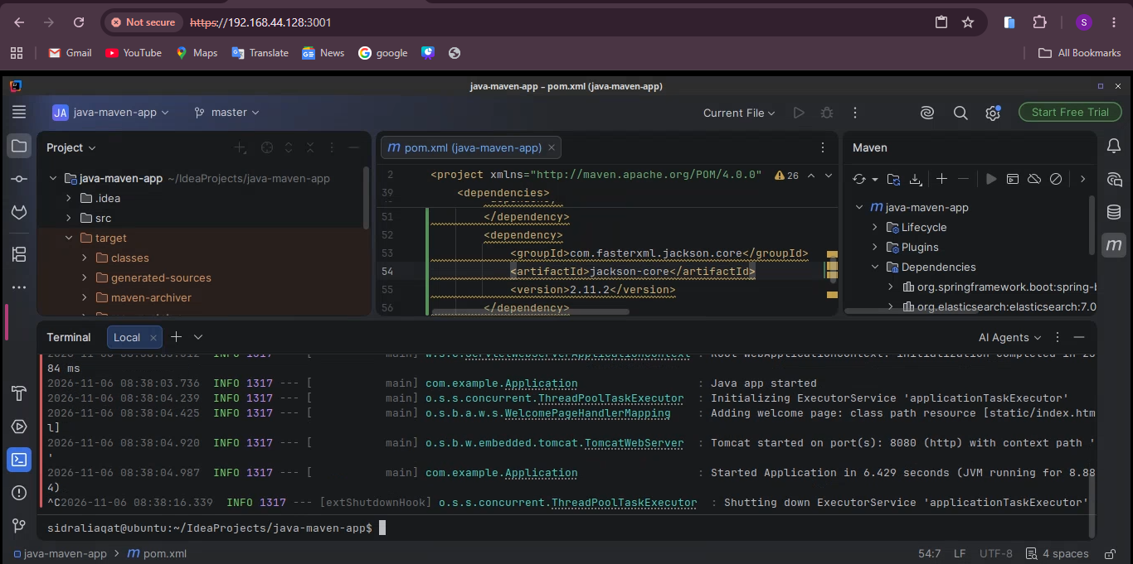
Application stopped with Ctrl+C and the prompt returned.

maven_project_closed.png
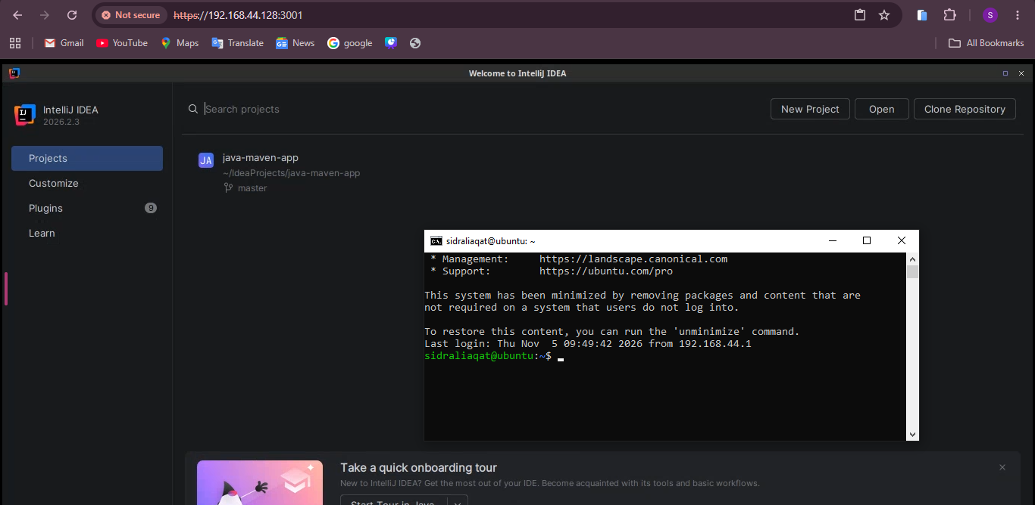
Maven project closed, back at the Welcome screen.

Task 3: Build and Run the Gradle Project

gradle_project_clone.png
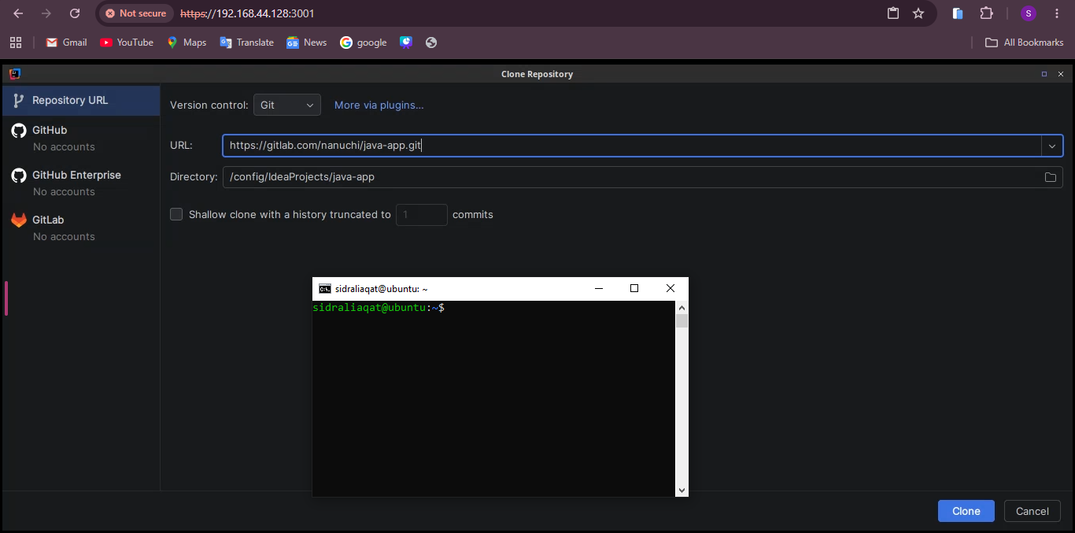
Clone dialog with the java-app URL and /config/IdeaProjects/java-app as the destination.

gradle_build.png
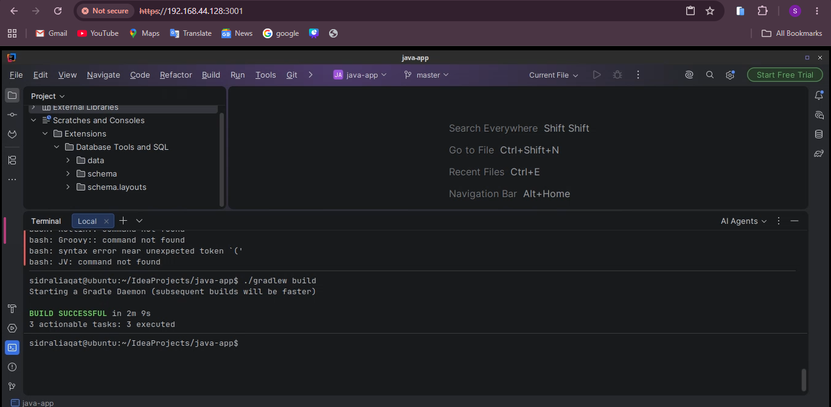
./gradlew build finished with BUILD SUCCESSFUL on JDK 16.

gradle_elasticsearch_dependency.png
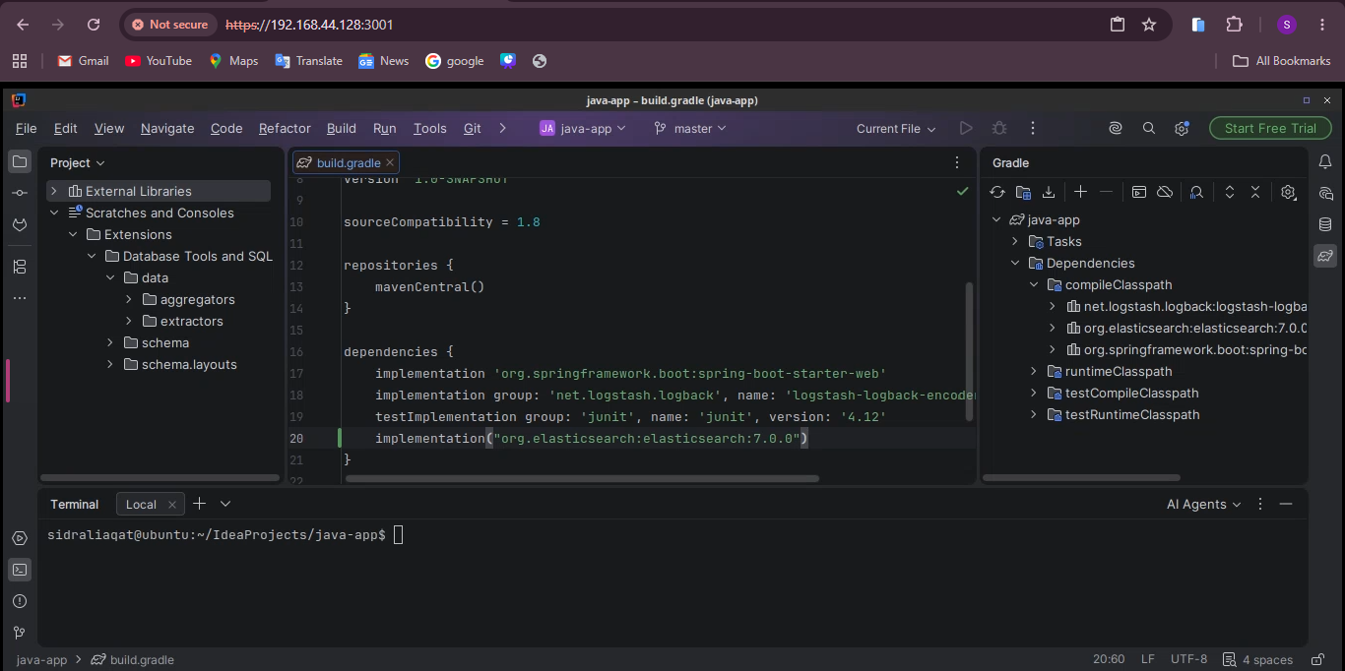
Elasticsearch 7.0.0 added to build.gradle and visible in External Libraries after sync.

gradle_rebuild.png
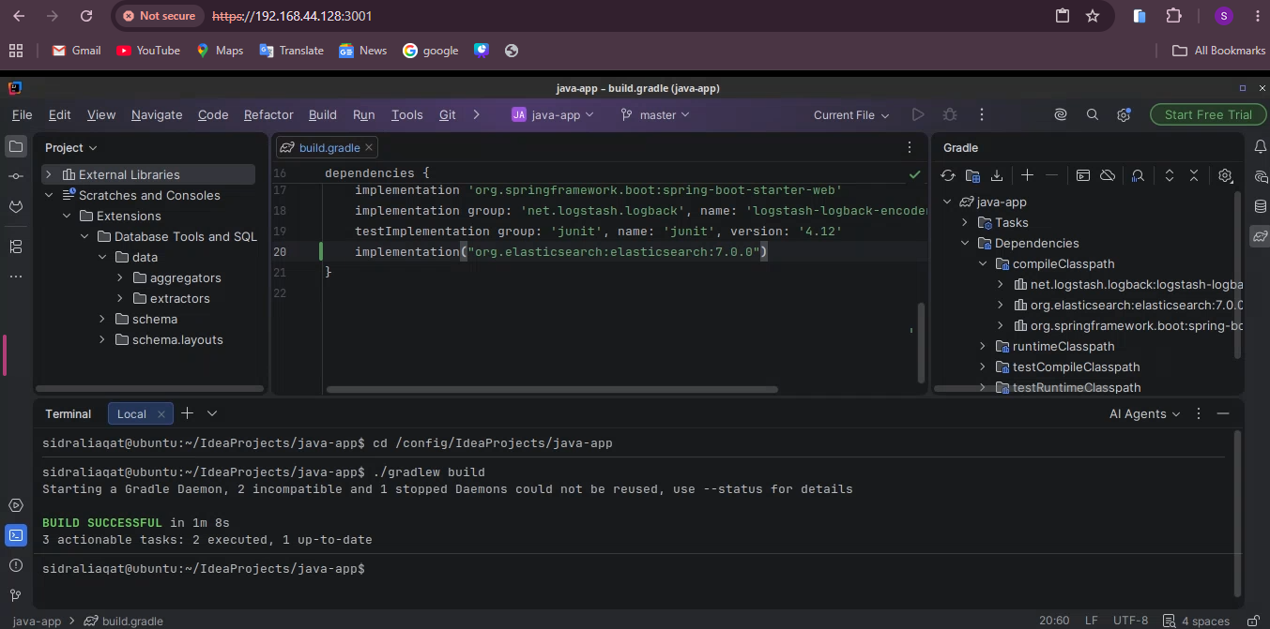
./gradlew build after the dependency change, again successful.

gradle_jar.png
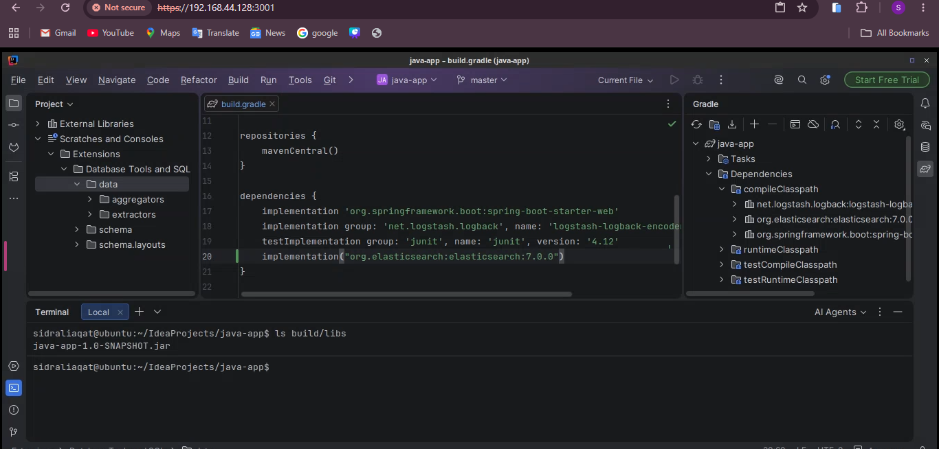
build/libs/java-app-1.0-SNAPSHOT.jar in the Project pane.

gradle_running.png
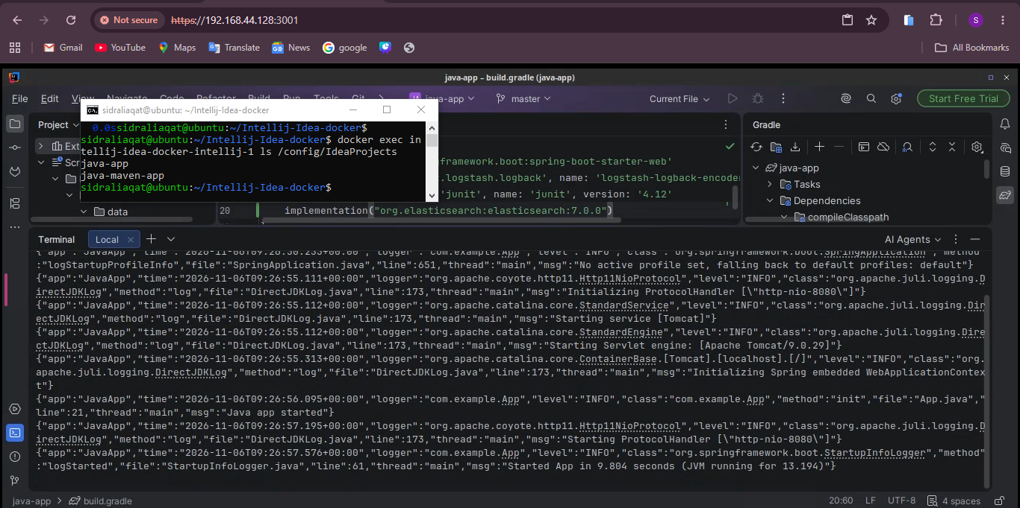
The Gradle JAR started with java -jar.

gradle_stopped.png
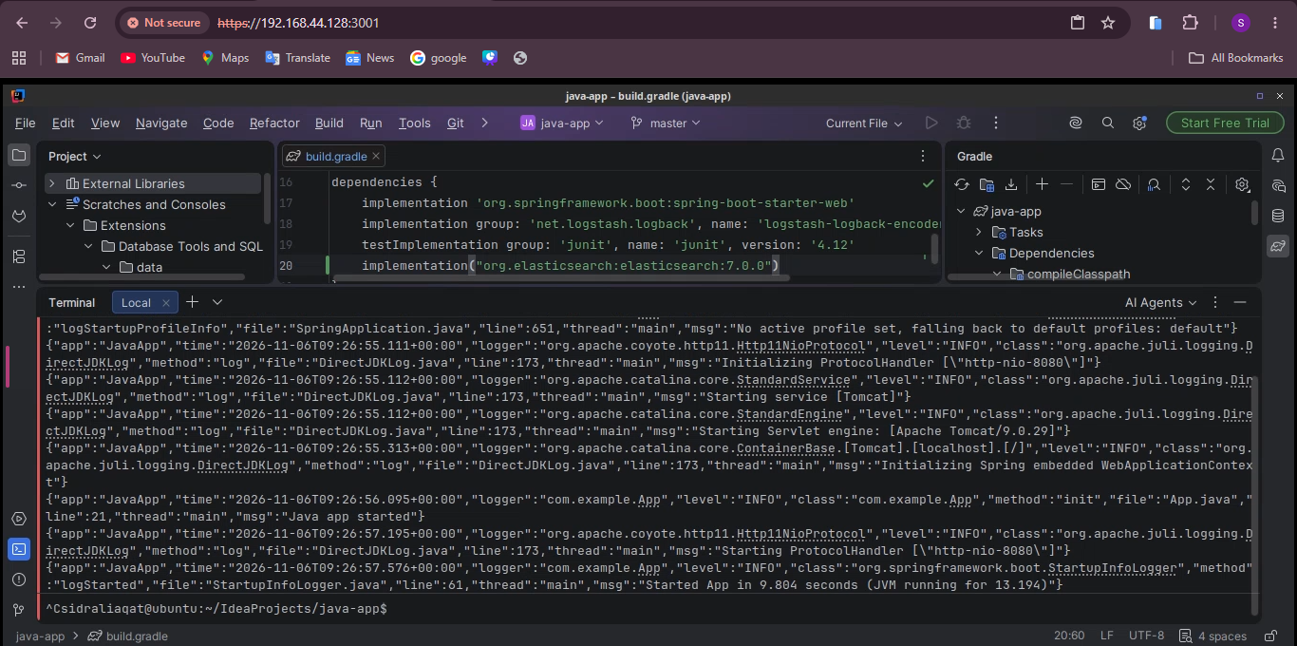
Application stopped with Ctrl+C and the prompt returned.

gradle_project_closed.png
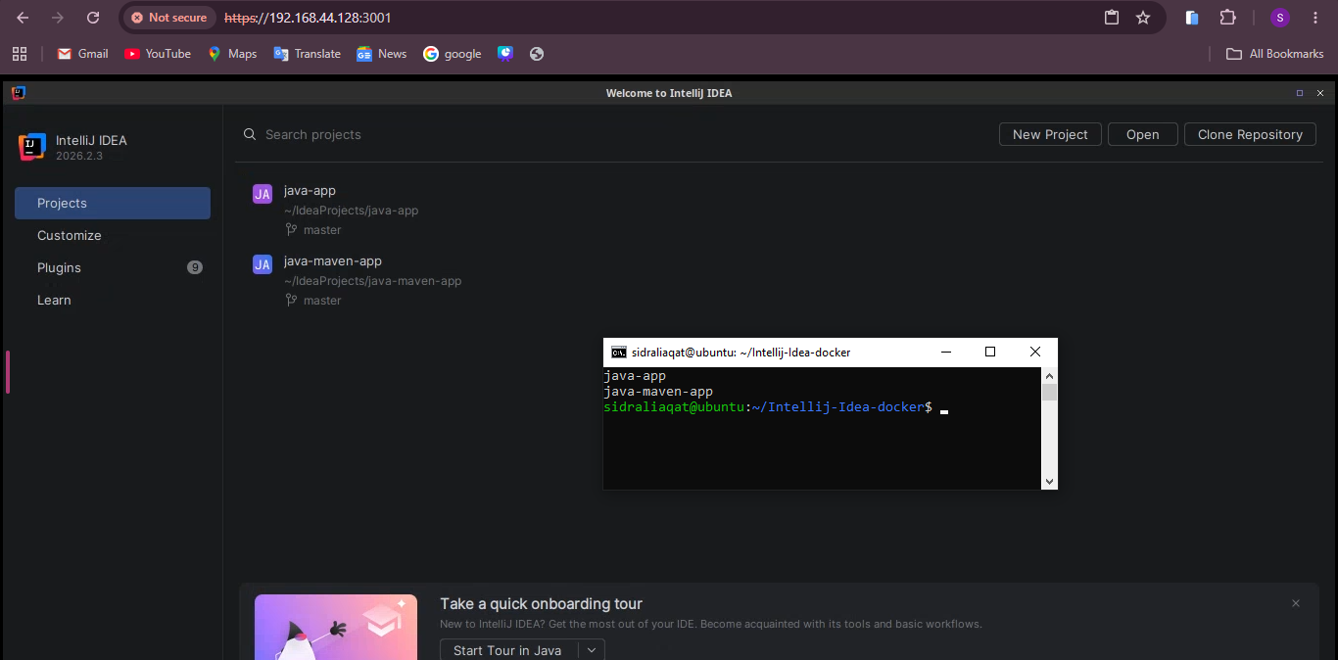
Gradle project closed, back at the Welcome screen.

Task 4: Install and Run the Node.js Project

node_project_clone.png
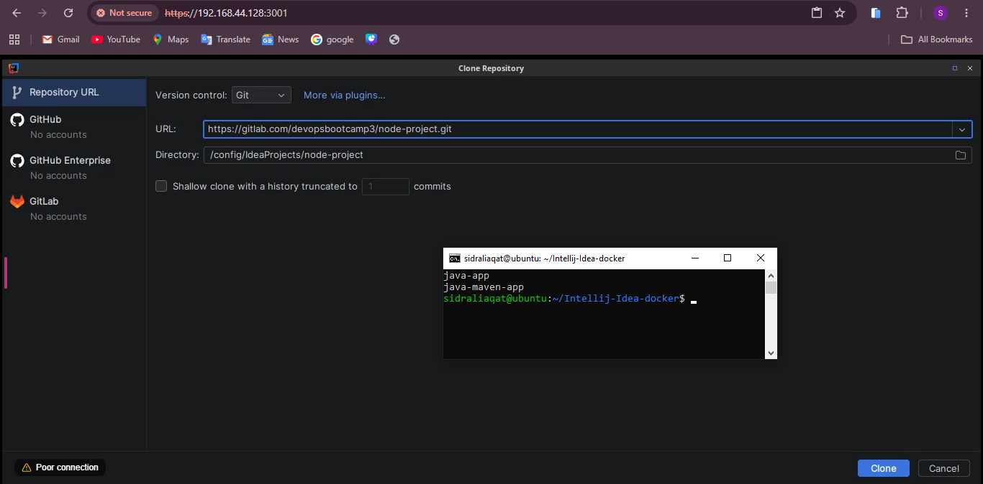
Clone dialog with the node-project URL and /config/IdeaProjects/node-project as the destination.

nodejs_installed.png
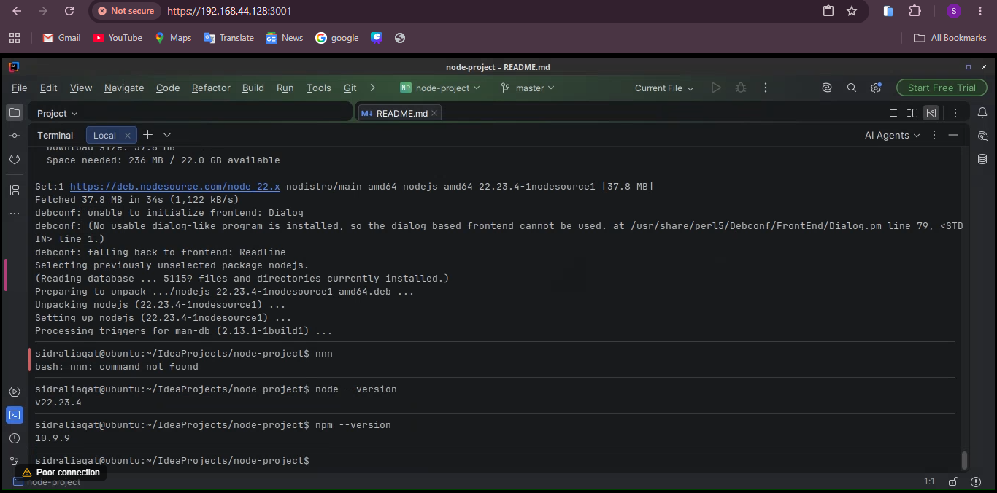
Node.js and npm installed; both versions shown.

npm_install.png
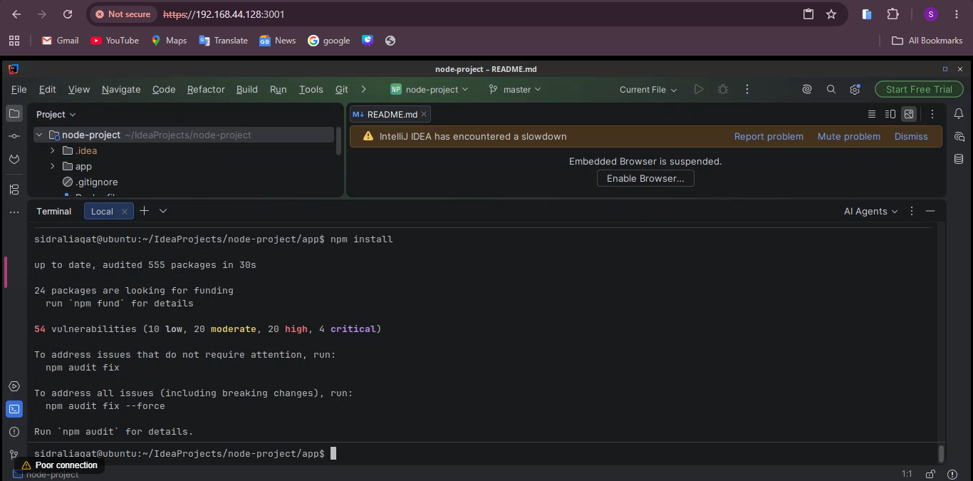
npm install completed in the app directory.

node_running.png
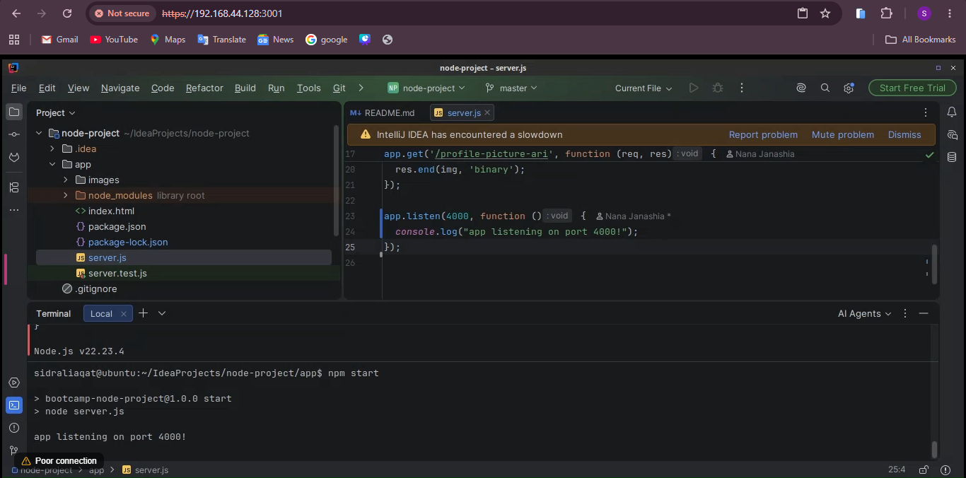
npm start with the app listening on port 4000.

node_browser.png
The Node.js page at http://localhost:4000 in the container's browser.

npm_test.png
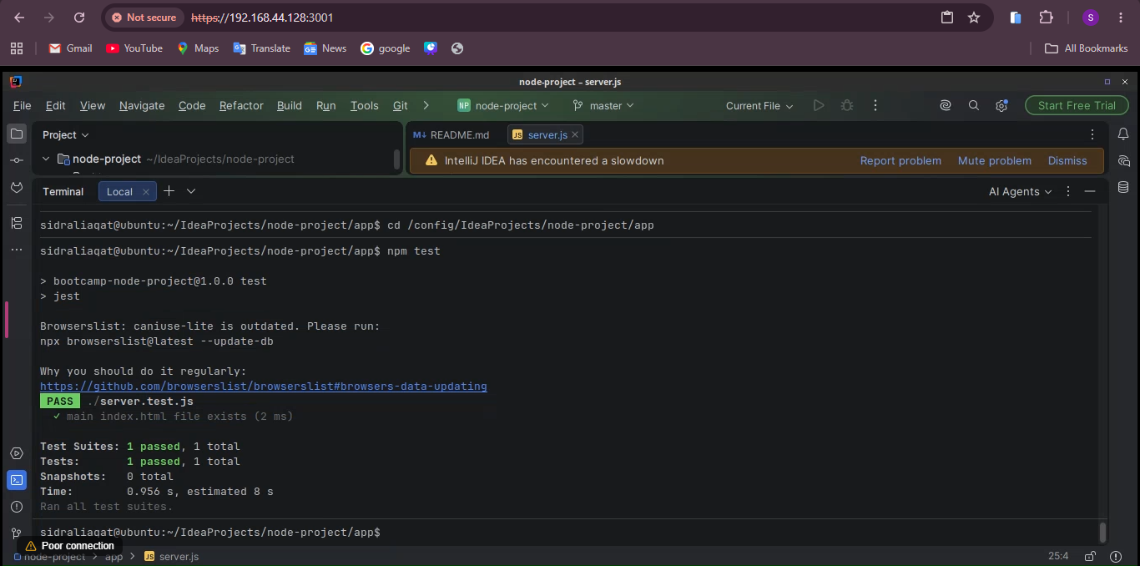
npm test passing.

npm_pack.png
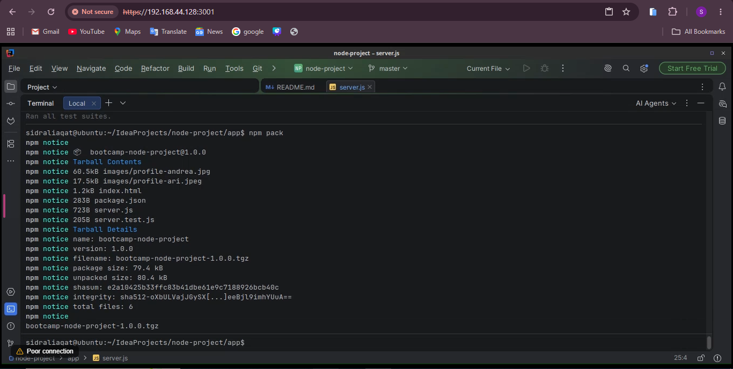
npm pack created bootcamp-node-project-1.0.0.tgz.

Task 5: Build the React and Node.js API Artifact

react_node_project_clone.png
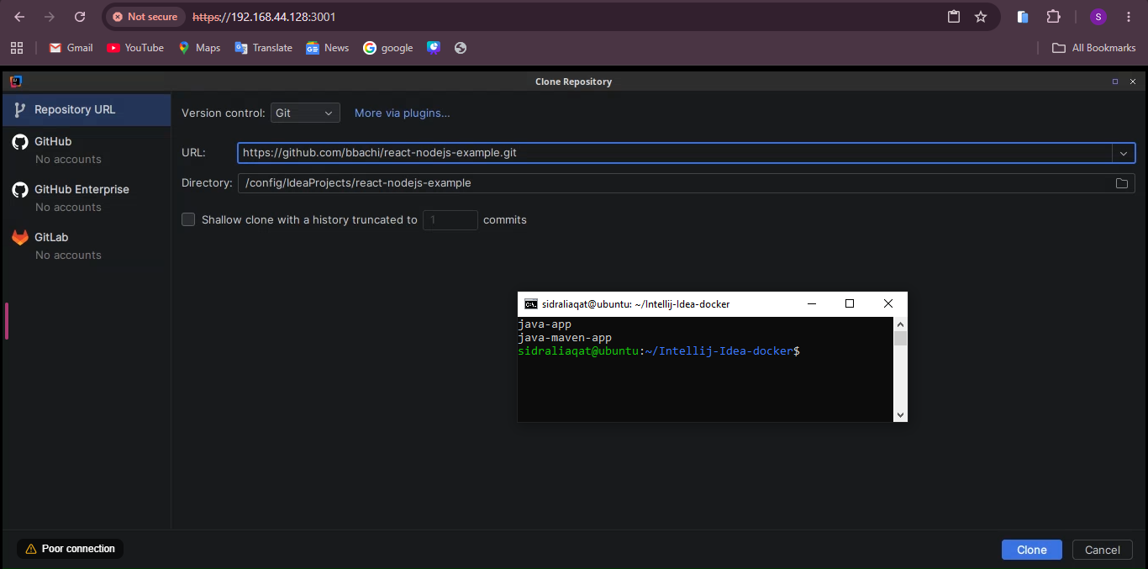
Clone dialog with the react-nodejs-example URL and /config/IdeaProjects/react-nodejs-example as the destination.

react_api_dependencies.png
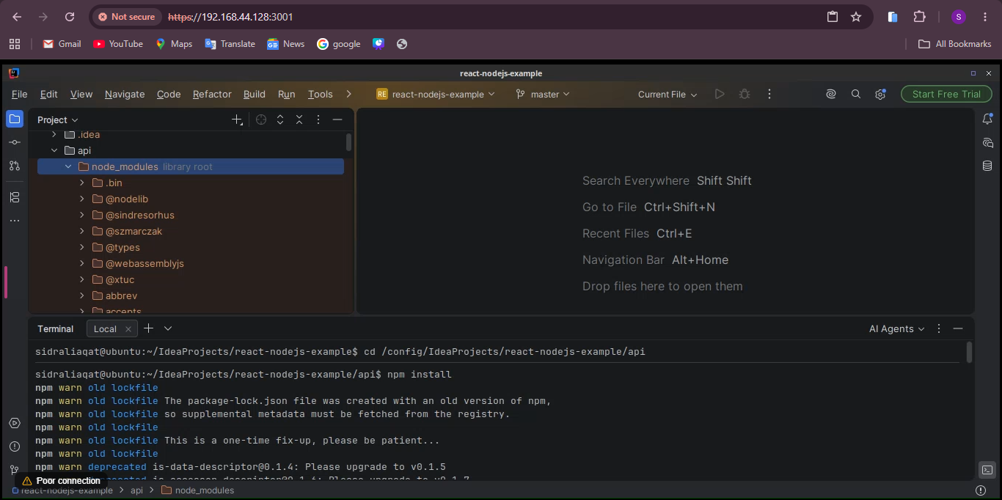
npm install completed in api; node_modules is present.

react_api_build.png
npm run build output with server.bundle.js in the api directory.

react_api_bundle.png
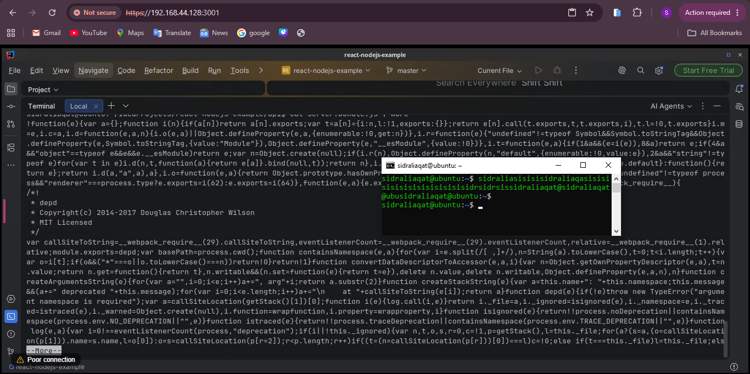
cat server.bundle.js | more showing the bundled JavaScript.

Task 6: Build a Docker Image for the Node.js Project

docker_installed.png
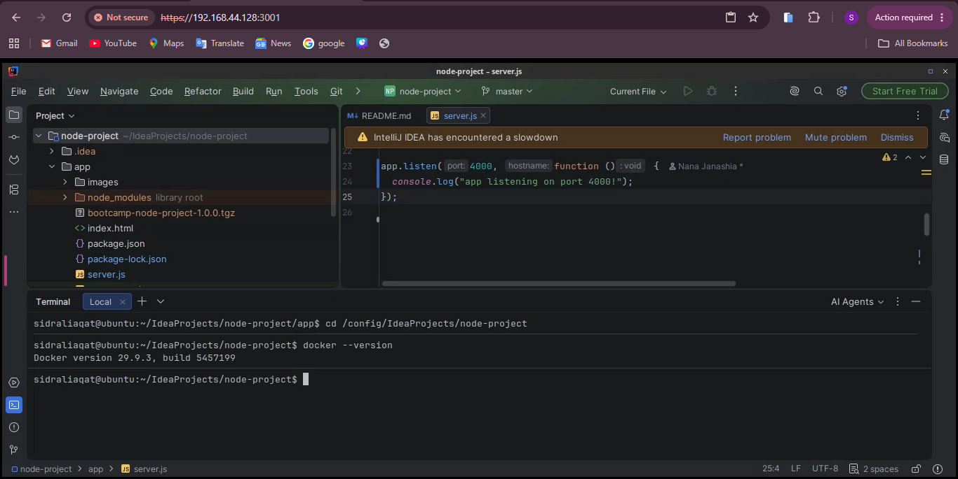
docker --version output.

dockerfile_exists.png
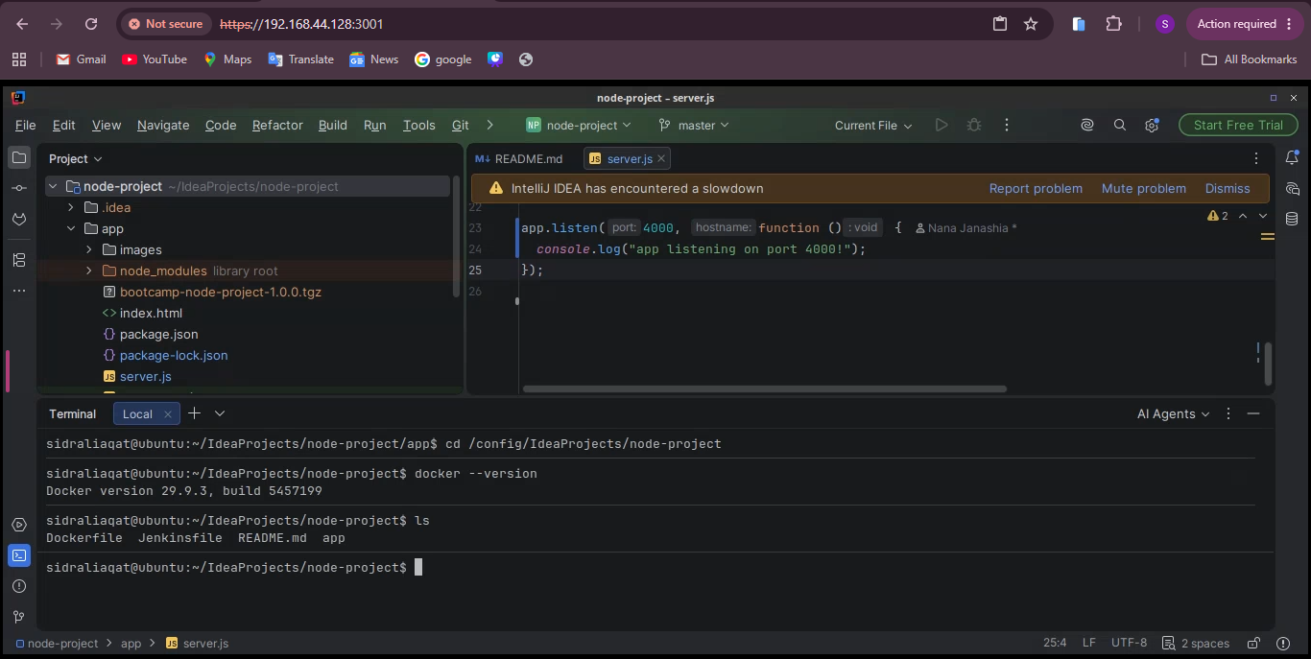
ls in the repository root shows the Dockerfile.

docker_images_before.png
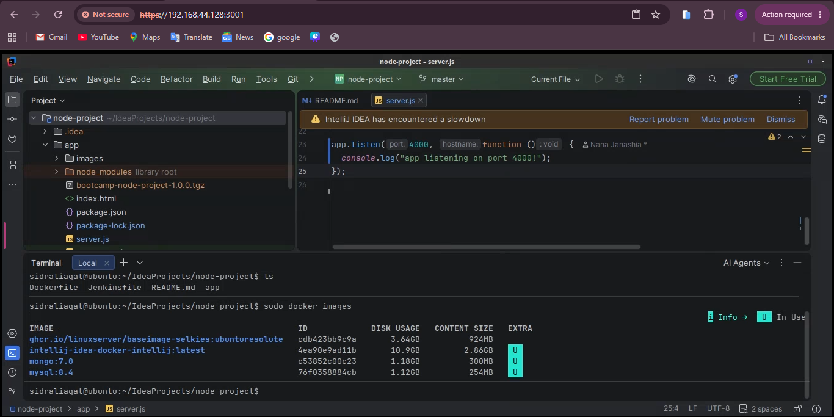
sudo docker images before the build.

docker_build.png
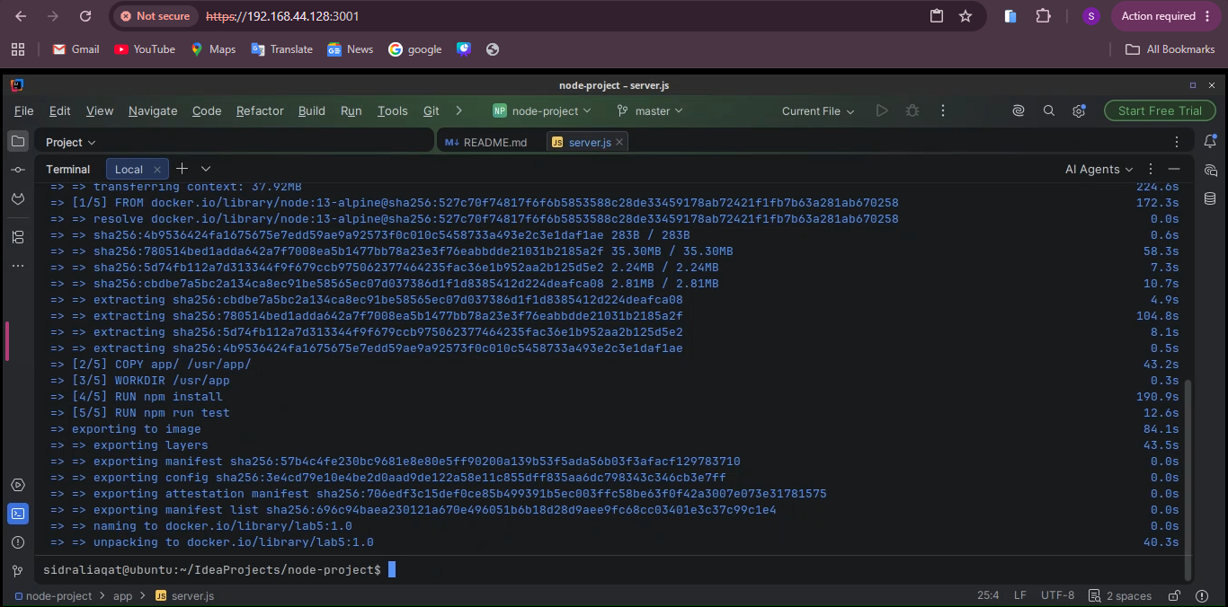
sudo docker build -t lab5:1.0 . finished successfully.

docker_images_after.png
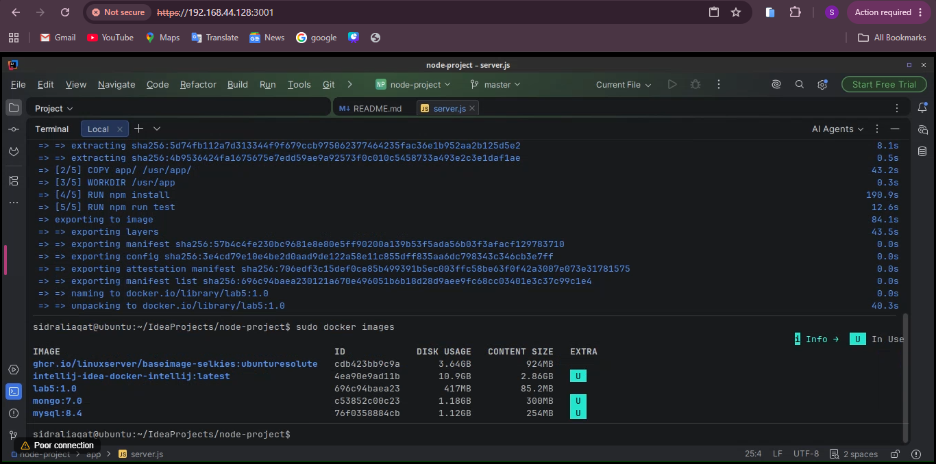
sudo docker images now lists lab5 with tag 1.0.

Exam Evaluation Questions (practice)
1. Maven built java-maven-app-1.1.0-SNAPSHOT.jar. Which values in pom.xml determine this name, and what does the package phase do?
The name is <artifactId>-<version>.jar, so artifactId java-maven-app and version 1.1.0-SNAPSHOT. The package phase runs every earlier lifecycle phase (validate, compile, test) and then bundles the compiled classes and resources into the JAR under target.
2. Why can ./gradlew build work without a separate system-wide Gradle installation? Which JDK settings would you check if this sample reports an unsupported Java version?
The Gradle Wrapper (gradlew plus gradle/wrapper) downloads the exact Gradle version the project needs on first run, so nothing has to be installed globally. For an unsupported Java version error, check Project SDK under File → Project Structure, the Gradle JVM under Settings → Build Tools → Gradle, and run ./gradlew --version to confirm it reports Java 16, not 21.
3. Why does EADDRINUSE occur on port 3000 in this environment, and how does changing the application listener to port 4000 let the container's browser open it?
The Webtop desktop inside the container already uses port 3000, so a second process cannot bind to it. Changing app.listen to port 4000 binds the app to a free port, and the container's browser can then reach it at http://localhost:4000.

