

Lab 02
Git and GitHub – Branching, Merging, and Pull Request Workflow
Name: Sidra Liaqat
Registration Number: 2023-BCS-083
BCS-7A
Instructor Name: Sir Waqas
GitHub Username: sidraliaqat

Getting Started and Tasks 1 to 2: Setup
All commands were run on the Ubuntu VM, where the prompt reads sidraliaqat@ubuntu.

Install Git
sudo apt install git -y
git --version
Screenshot: git_installation.png
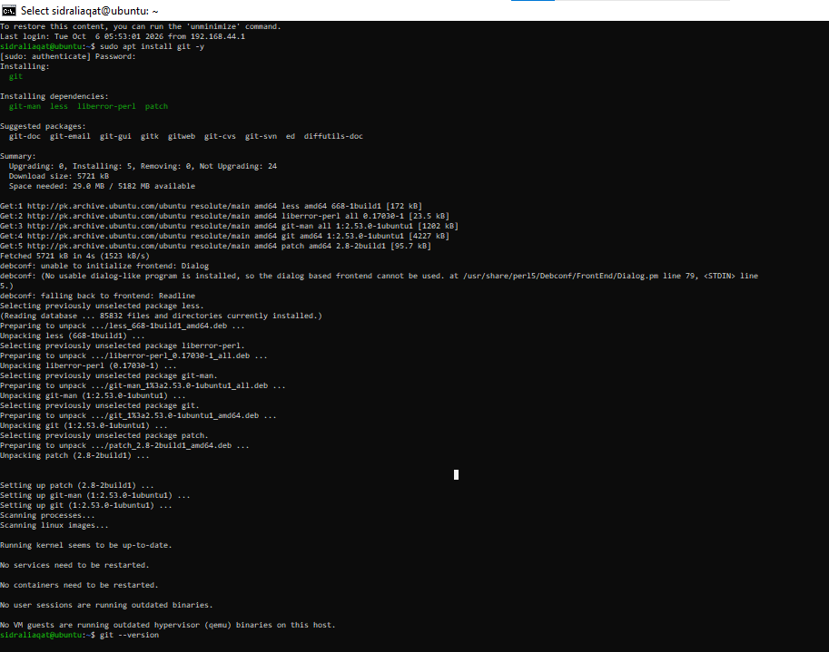

Task 1: Create a private GitHub repository
Created a private repository named DevOps_Lab2_Practice on GitHub.
Screenshot: repo_private.png
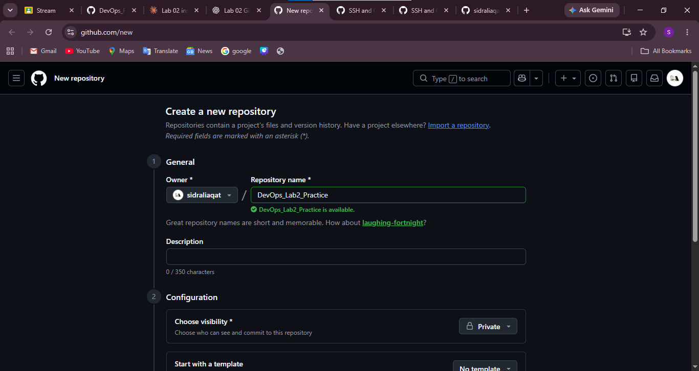

Task 2: Connect the repository via SSH
Generated an ed25519 key and displayed the public key.
ssh-keygen -t ed25519 -C "sidraliaqat204@gmail.com"
cat ~/.ssh/id_ed25519.pub
Screenshot: ssh_keygen.png
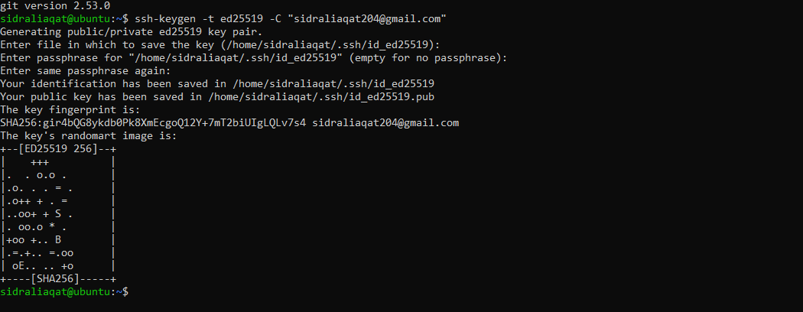
Added the public key to GitHub under Settings > SSH and GPG keys and tested it.
ssh -T git@github.com
Screenshot: github_sshkey.png
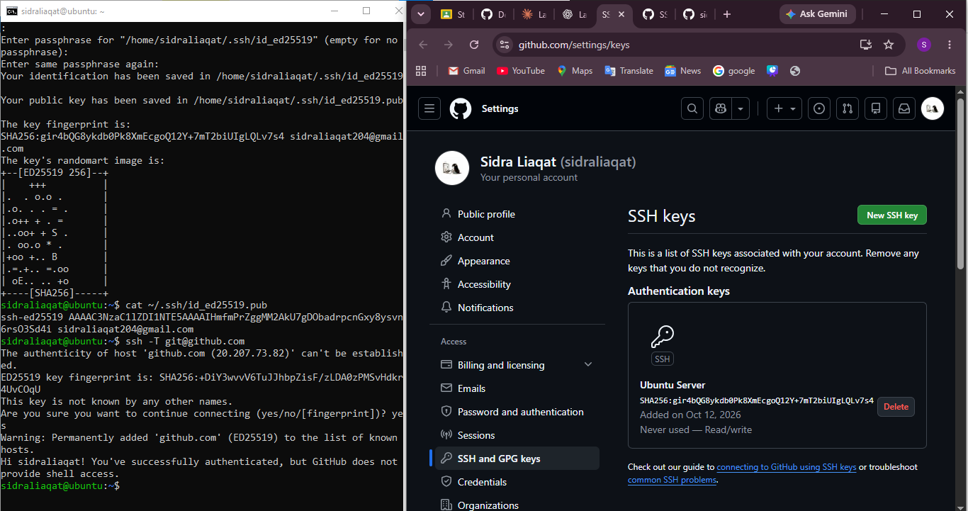Cloned the repository over SSH.
git clone git@github.com:sidraliaqat/DevOps_Lab2_Practice.git
Screenshot: ssh_clone.png

Tasks 3 to 6: Identity, .git Folder, Local Repo, Staging

Task 3: Configure Git username and email
git config --global user.name "Sidra Liaqat"
git config --global user.email "sidraliaqat204@gmail.com"
Screenshot: git_identity.png
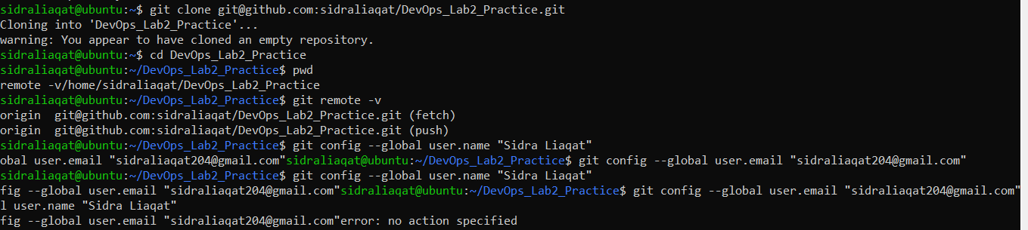Verified the configuration.
git config --list
Screenshot: git_config_list.png

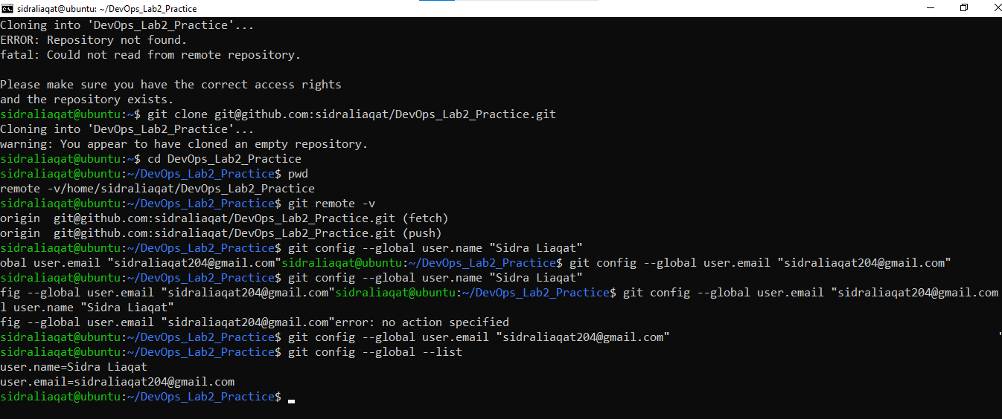Task 4: Explore the .git folder
cd DevOps_Lab2_Practice
ls -a .git
Screenshot: git_folder.png
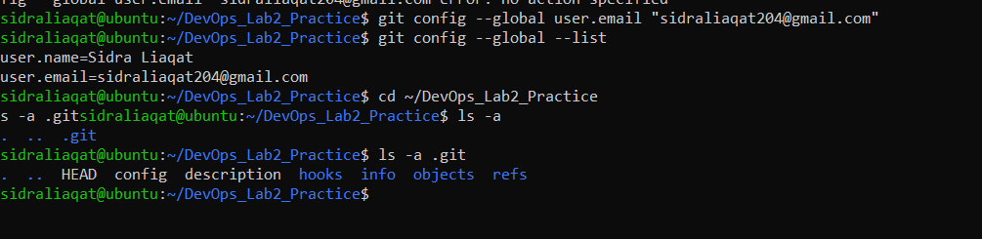The .git folder holds the repository's history, objects, refs, logs and config.

Task 5: Local repository management
Deleted the .git folder and ran git status.
rm -rf .git
git status
git status fails with fatal: not a git repository because the .git folder is what makes a directory a Git repository. Without it, Git has no history or tracking data to report on.
Screenshot: delete_git.png
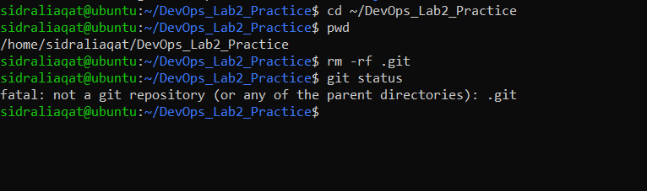
Re-initialized the repository.
git init
Screenshot: git_init.png
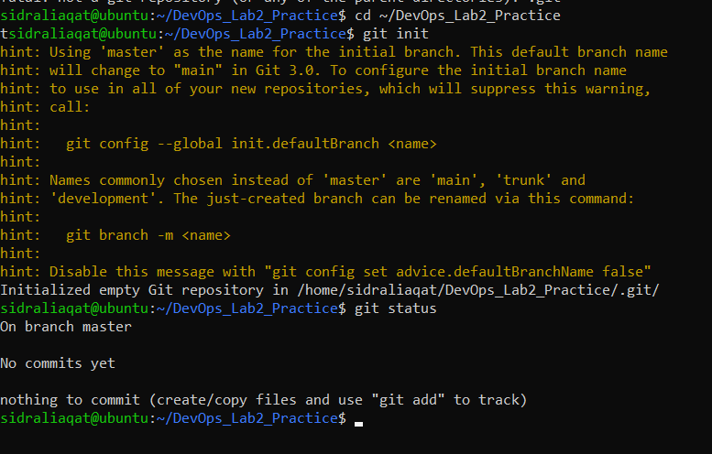
Created README.md and made the first commit.
echo "# Lab02 Git Practice" >> README.md
git add README.md
git commit -m "Initial commit"
Screenshot: first_commit.png
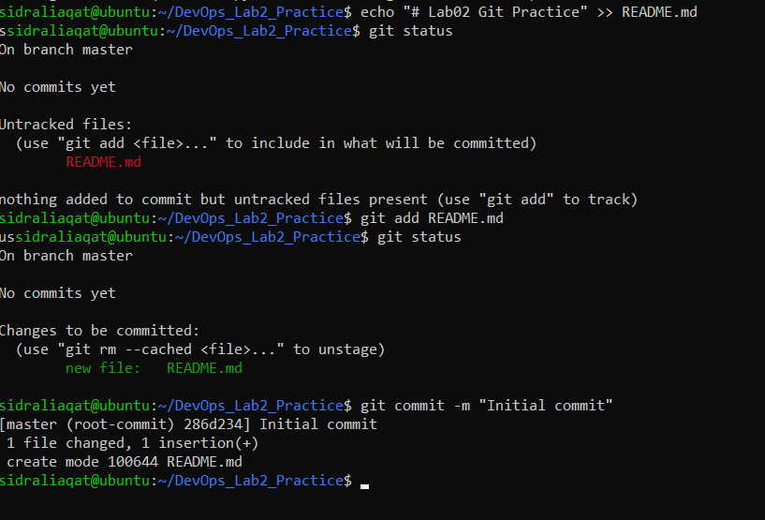
Connected the local repository to GitHub and pushed.
git remote add origin git@github.com:sidraliaqat/DevOps_Lab2_Practice.git
git branch -M main
git push -u origin main
Screenshot: first_push.png

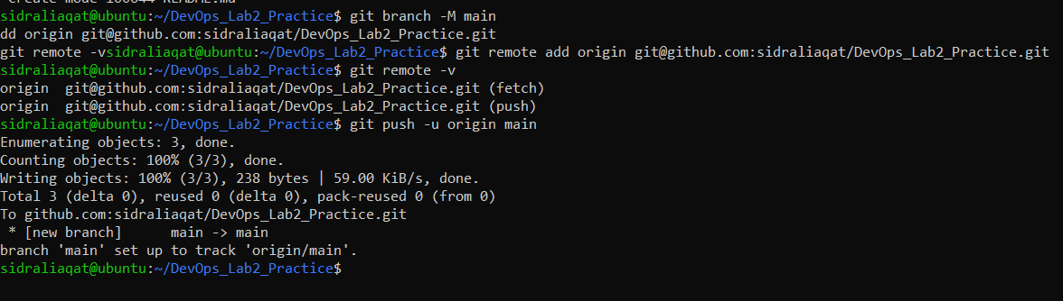Task 6: File status and staging
Created notes.txt and checked the status.
echo "Adding some test notes" >> notes.txt
git status
Screenshot: status1.png
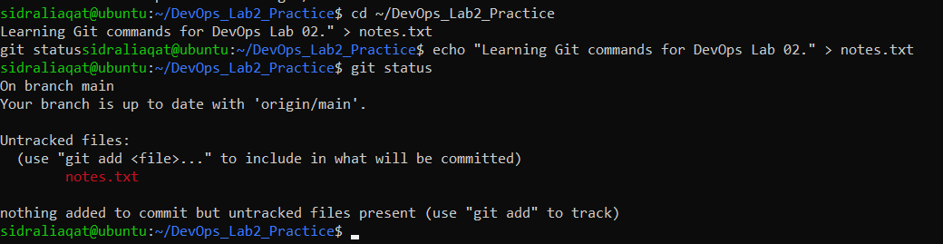
Staged and committed the file.
git add notes.txt
git commit -m "Add notes.txt"
Screenshot: commit_notes.png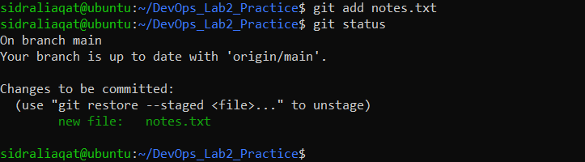

Tasks 7 to 9: Branching and Merging

Task 7: Branch creation using the GitHub GUI
Created bugfix/user-auth-error on GitHub.
Screenshot: bugfix_branch_gui.png
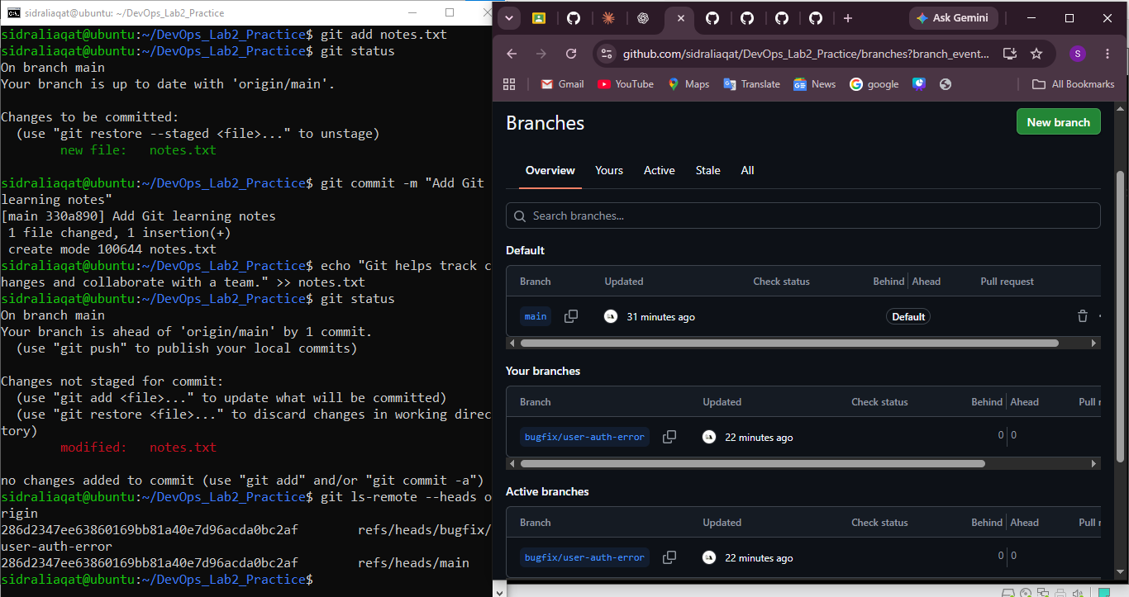Pulled the branch into the local repository and listed the branches.
git pull origin bugfix/user-auth-error
git branch -a
Screenshot: bugfix_branch_local.png

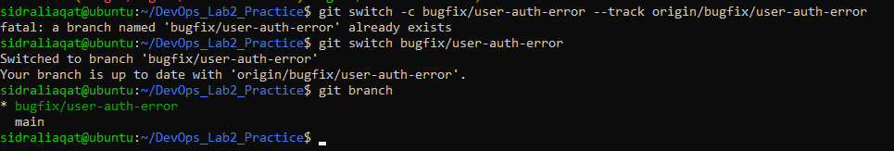Task 8: Branch creation and push using Git Bash
git checkout -b feature/db-connection
git push origin feature/db-connection
Screenshot: feature_db_branch.png

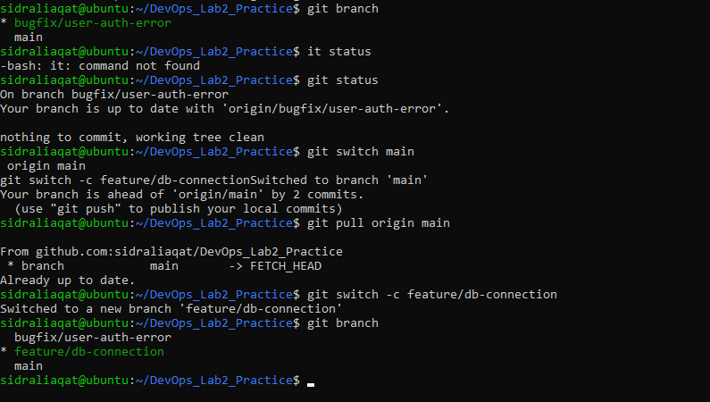

Task 9: Branching and merging
Created and switched to feature-1.
git checkout -b feature-1
Screenshot: branch_create.png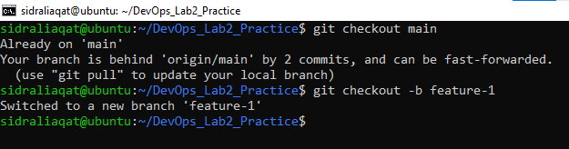
Added a function to main.py and committed it.
git add main.py
git commit -m "Add new function to main.py"
Screenshot: feature_commit.png
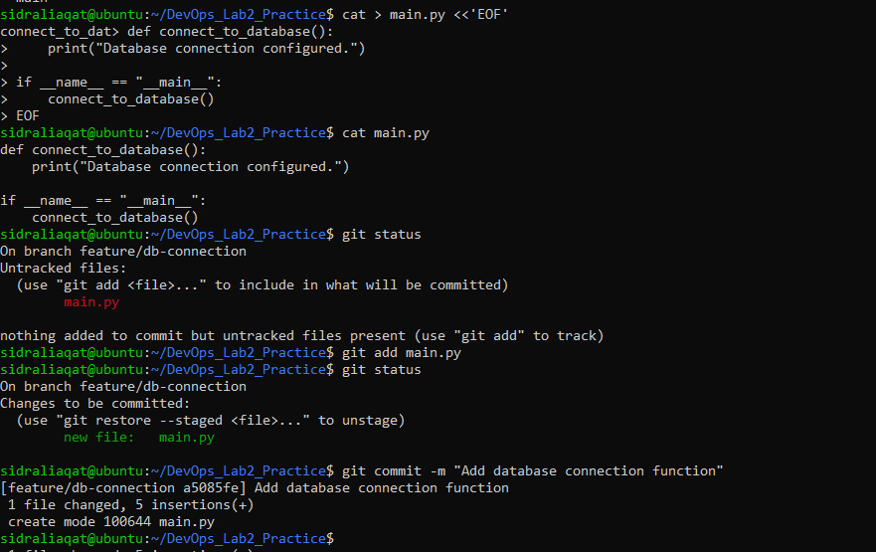Switched back to main and merged feature-1.
git checkout main
git merge feature-1
Screenshot: merge.png
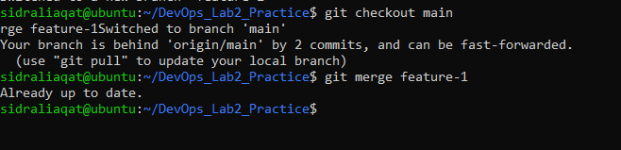
Merging straight into main from a local terminal is risky on a team, because nobody reviews the change first. A Pull Request lets others review it before it reaches main, which is why Task 10 uses one.
Pushed both branches.
git push origin main
git push origin feature-1
Screenshot: push_branches.png

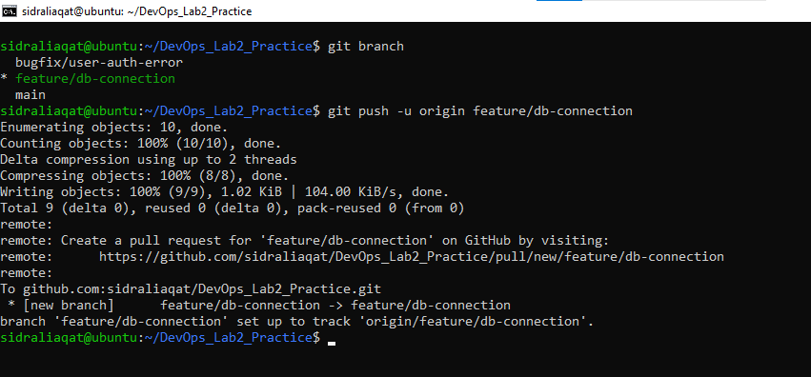Tasks 10 and 11: Pull Requests and Branch Strategy

Task 10: Pull request and branch review (GitHub GUI)
Opened PR #1, "Add database connection function", from feature/db-connection into main.
Screenshot: pr_creation.png
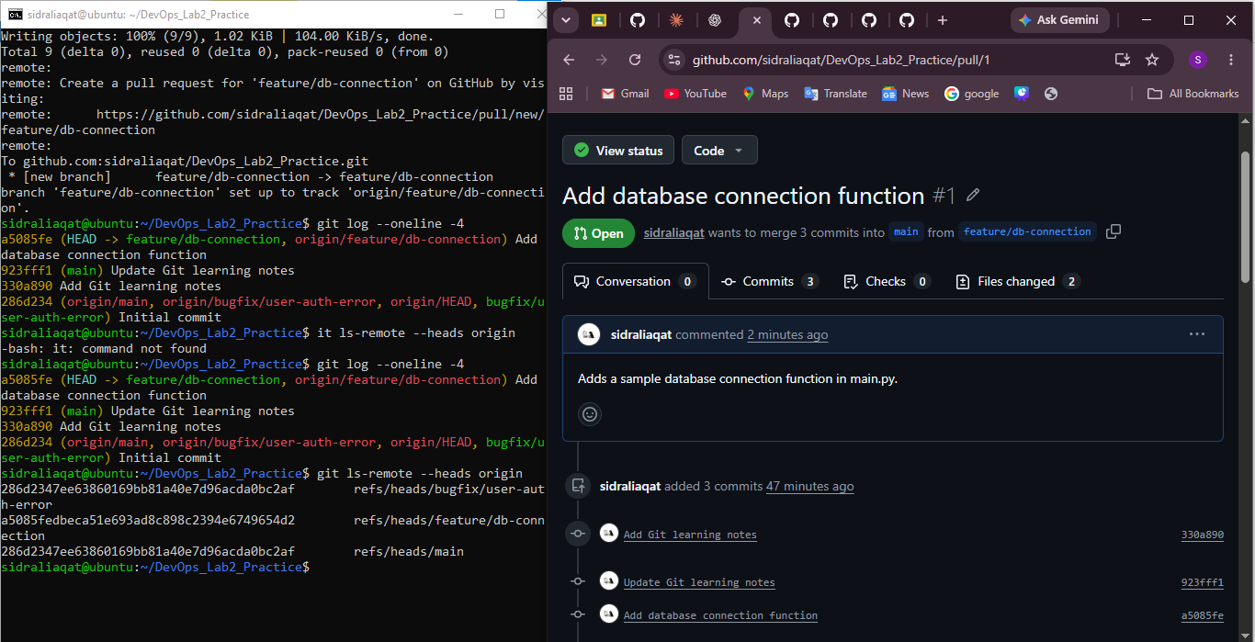Reviewed the PR and merged it with the GitHub GUI.
Screenshot: pr_merge.png
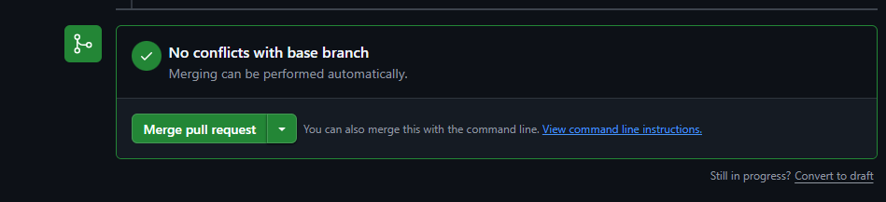
Deleted the feature/db-connection branch after the merge.
Screenshot: branch_delete.png
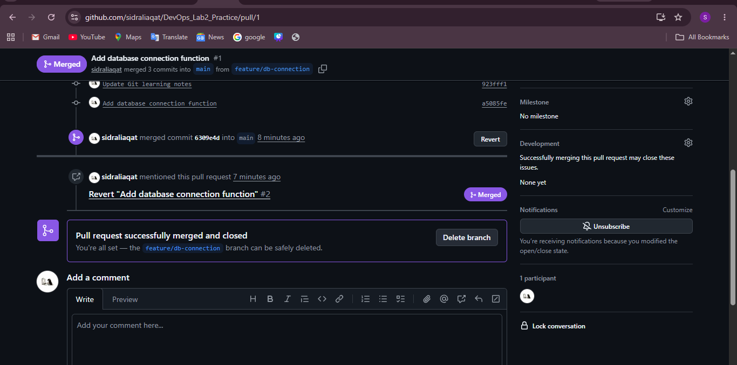

Task 11: Detailed branch strategy (develop and staging)
Workflow: developers work on feature/* and bugfix/* branches, which merge into develop. develop merges into staging for testing, and staging merges into main (production).
Created the develop and staging branches and listed all branches.
git checkout main
git checkout -b develop
git push origin develop
git checkout -b staging
git push origin staging
git branch -a
Screenshot: branch_strategy.png
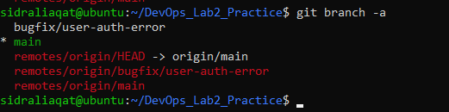
Merged a feature branch into develop, then develop into staging.
git checkout develop
git merge feature-1
git checkout staging
git merge develop
Screenshot: branch_merges.png
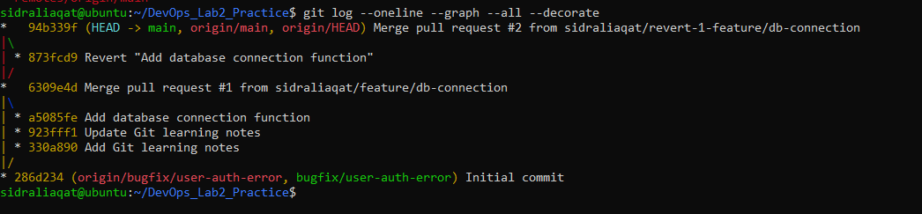Merged staging into main and pushed.
git checkout main
git merge staging
git push origin main
Screenshot: final_merge.png

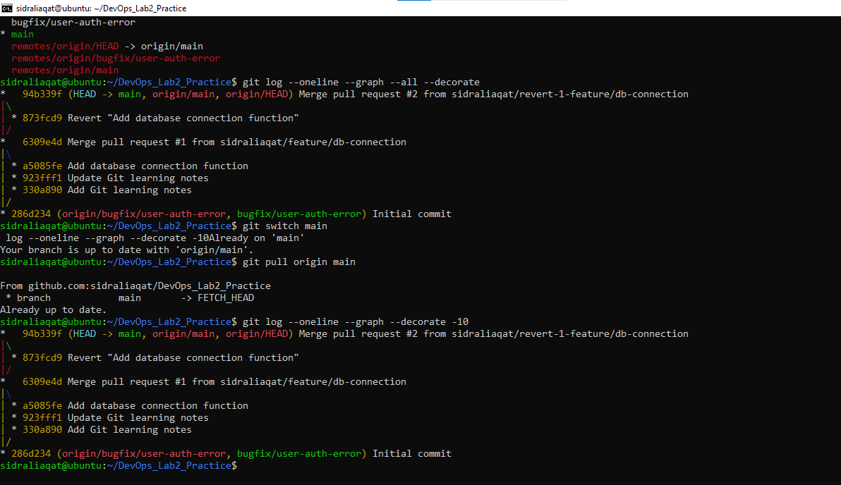Tasks 12 and 13: Code Review and Branch Cleanup

Task 12: Code review workflow
Created a PR from a feature branch into main with a clear title and description.
Screenshot: pr_create_details.png
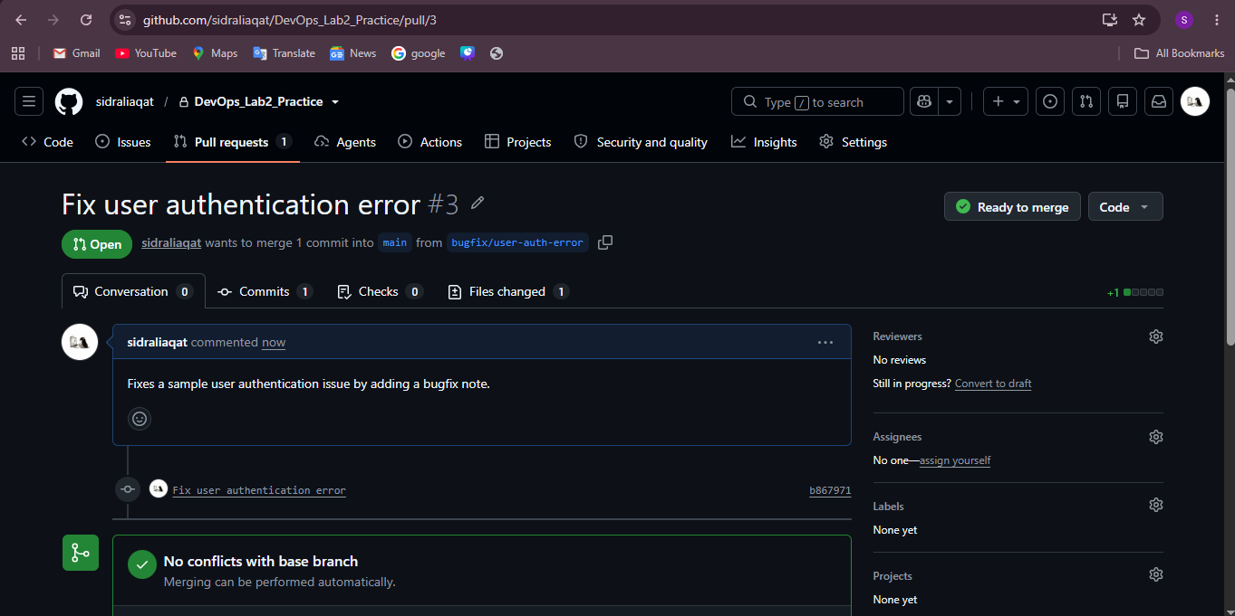
Assigned a reviewer.
Screenshot: pr_assigned_reviewer.png
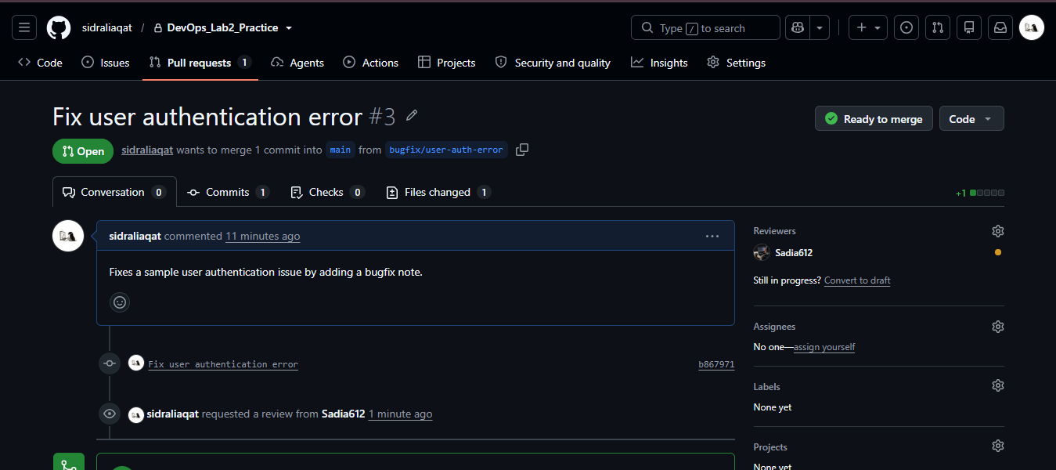Reviewer requested changes and left comments.
Screenshot: pr_request_changes.png
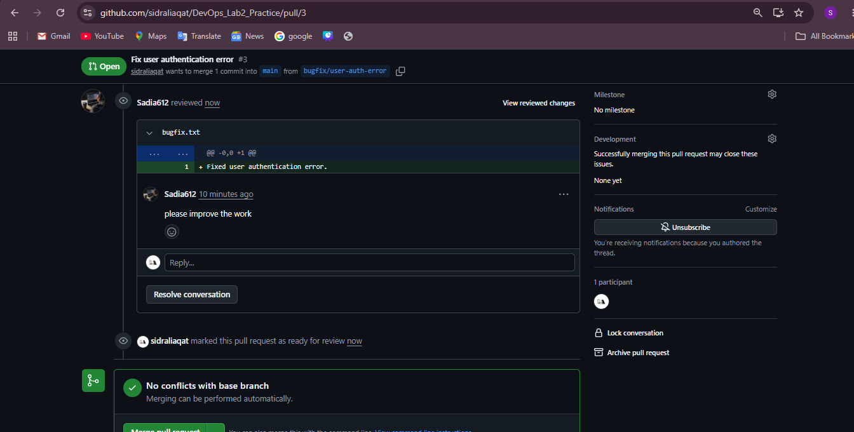Closed a separate practice PR without merging it.
Screenshot: pr_updated_with_commits.png
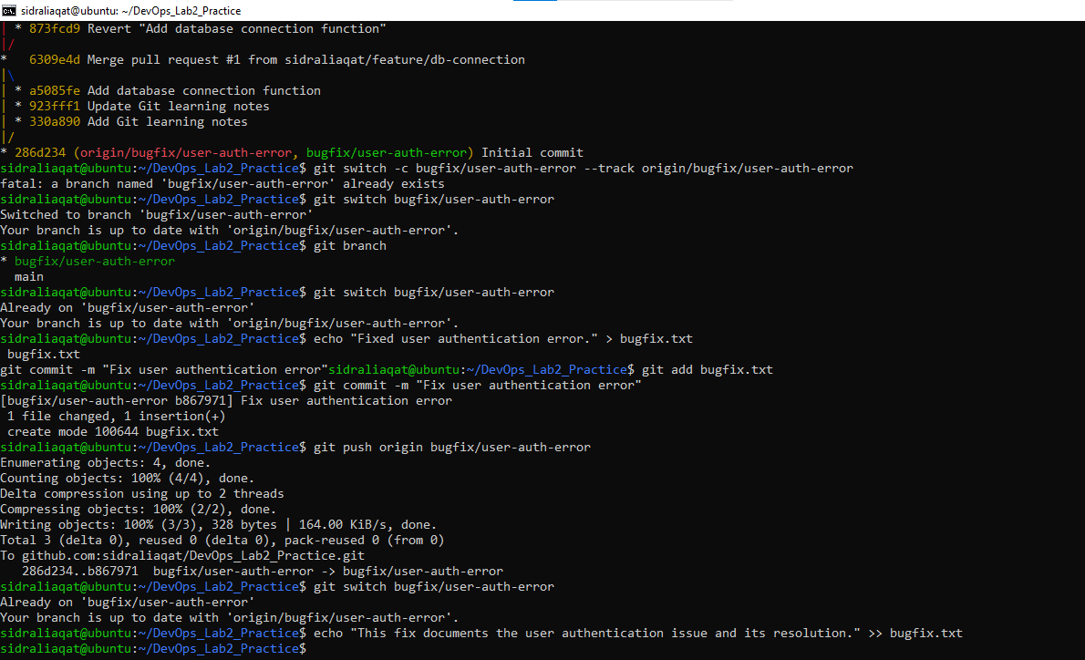
Merged the PR after approval. Merge style used: merge commit.
Screenshot: pr_merge_confirm.png
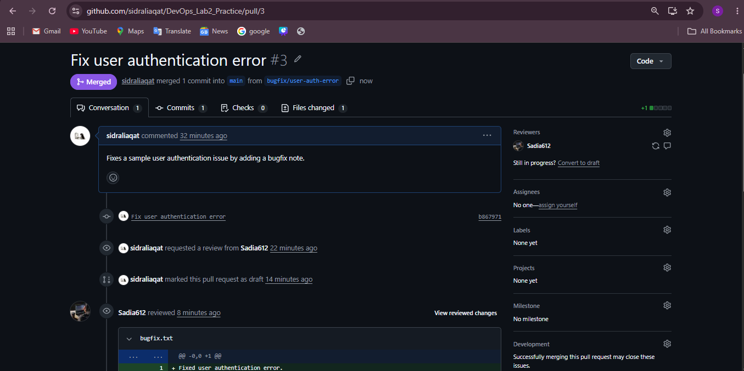
Screenshot: pr_merged.png
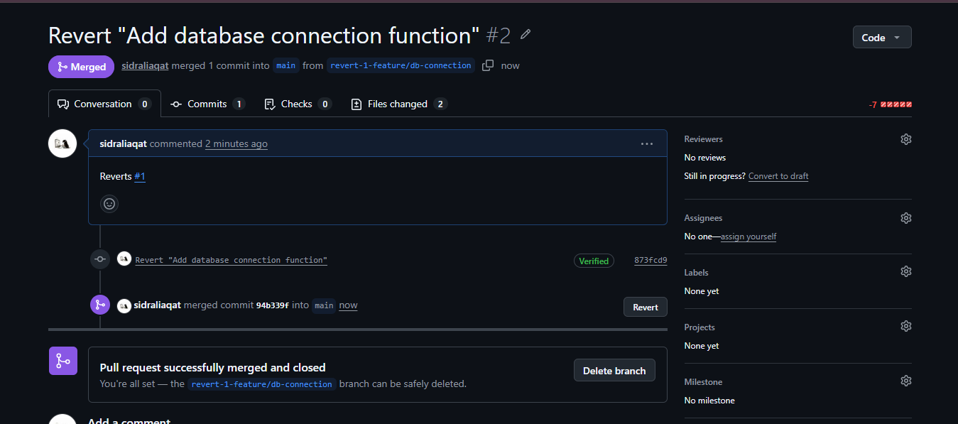
Deleted the merged PR branch.
Screenshot: pr_branch_deleted.png
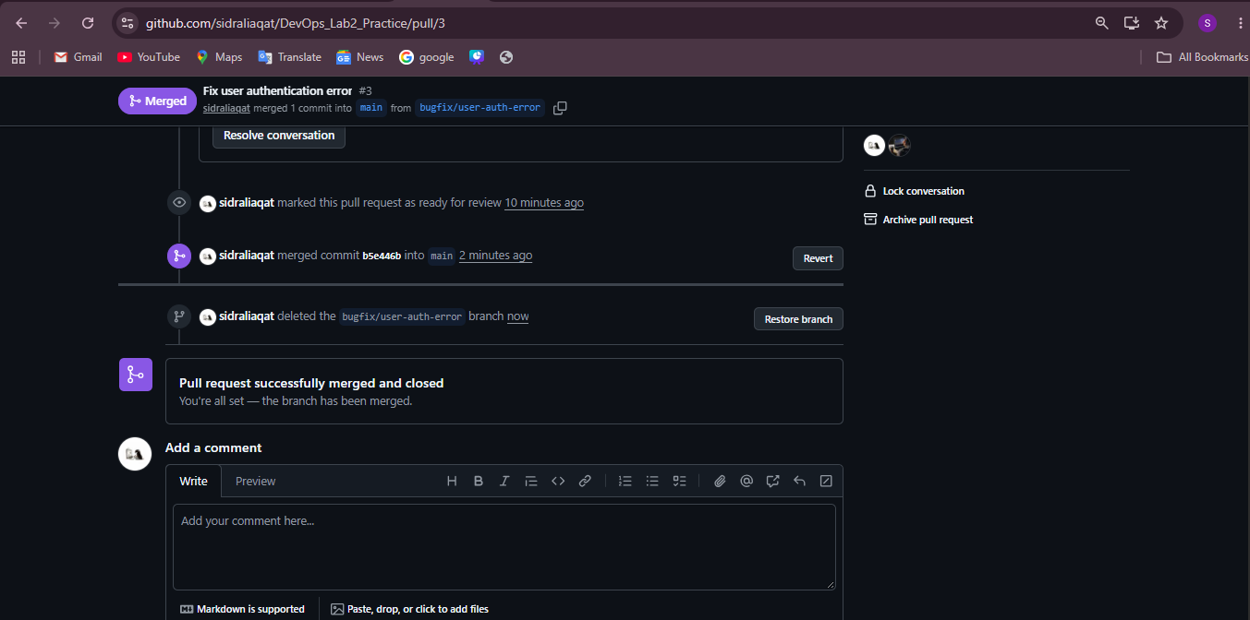

Task 13: Branch cleanup best practices
Deleted a merged branch through the GitHub UI.
Screenshot: remote_branch_deleted.png
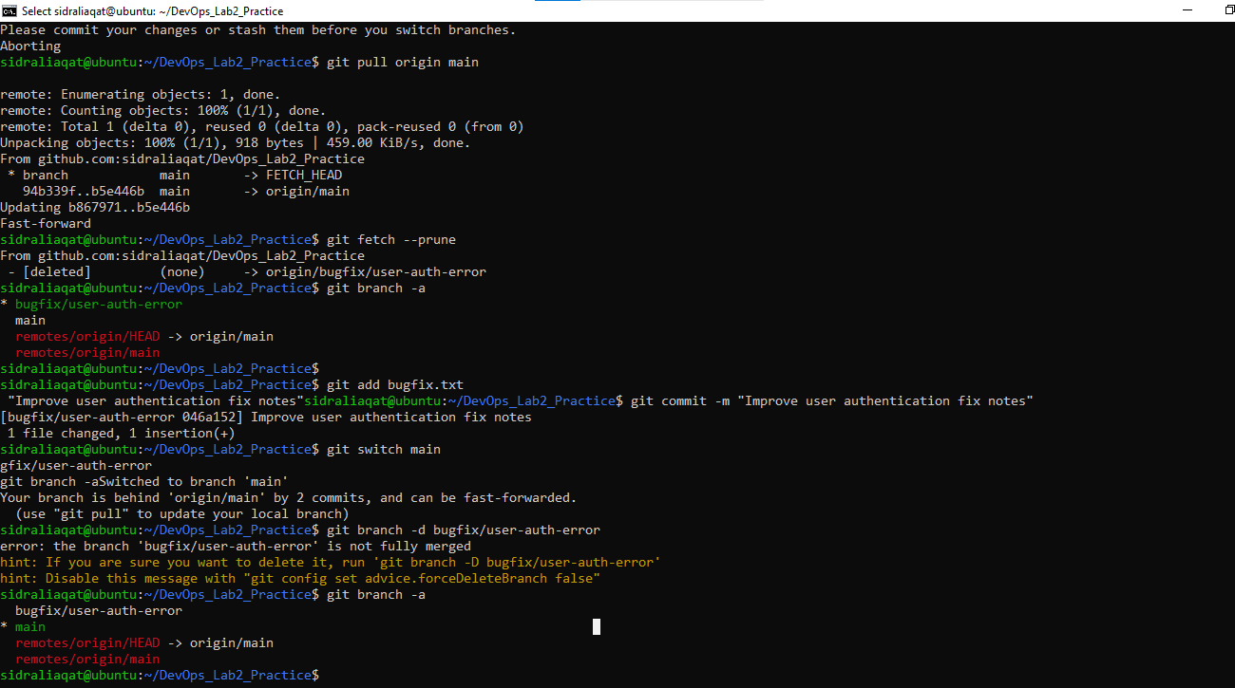Deleted another completed remote branch from the terminal.
git push origin --delete <branch-name>
Screenshot: remote_branch_delete_cmd.png
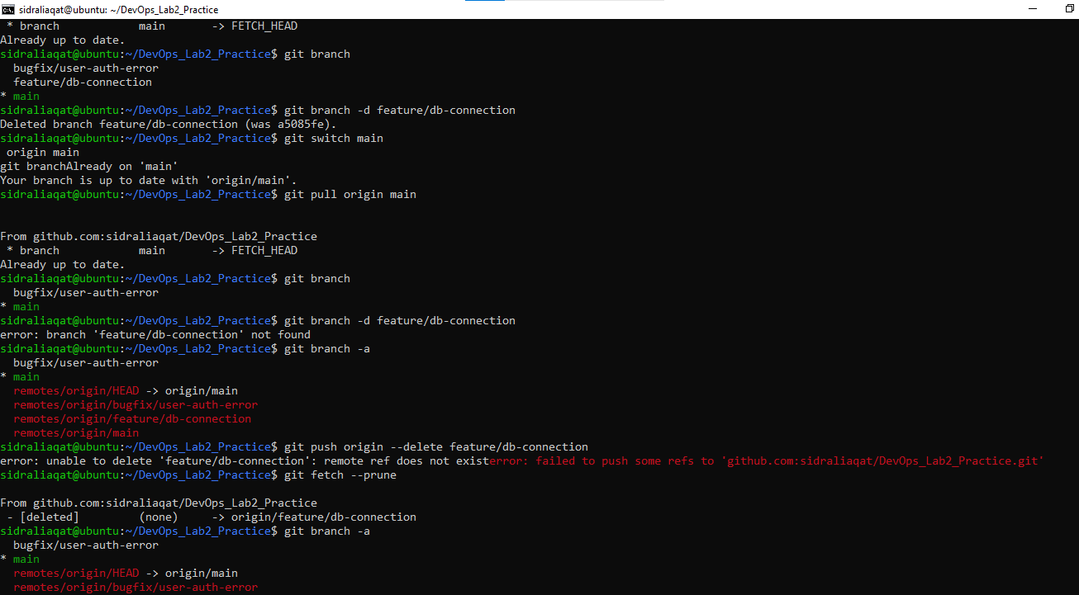Updated the local repository.
git checkout main
git pull origin main
git branch -d <branch-name>
git branch
Deleting merged branches keeps the repository tidy and avoids confusion about which branches are still active.

