
Lab 01
GitHub Identity, Student Portal Registration, and Ubuntu Server Installation
Name: Sidra Liaqat
Registration Number: 2023-BCS-083
BCS-7A
Instructor Name: Sir Waqas
GitHub Username: sidraliaqat

Getting Started: Folder Structure
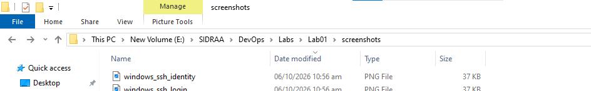
Figure: Created Labs/Lab01/screenshots directory structure.

Task 1: Create and Configure Your GitHub Account
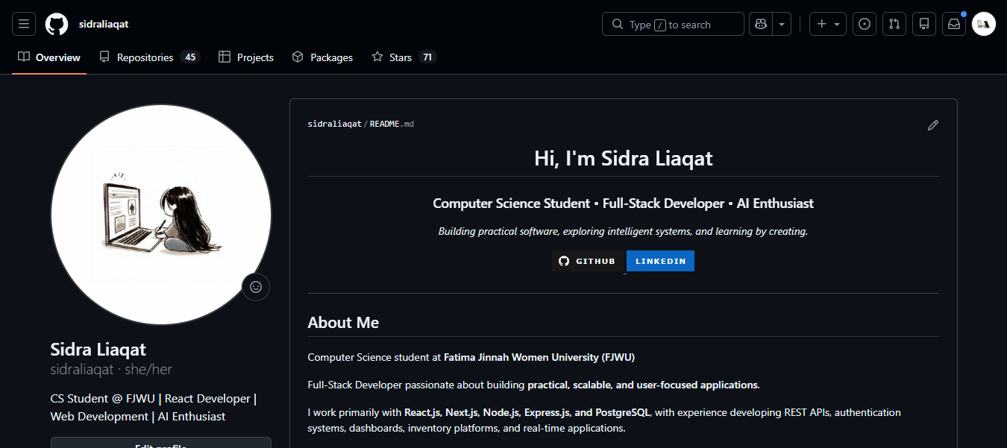
Figure: GitHub profile showing my name and username.
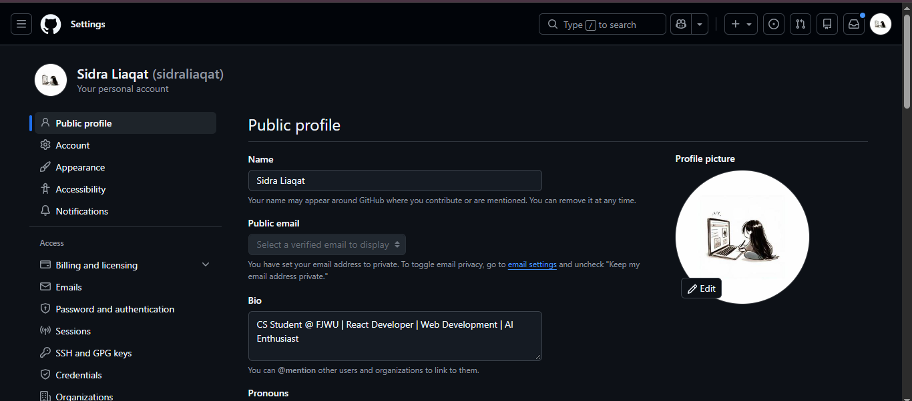
Figure: Complete actual name entered in the GitHub Name field.

Task 2: Register in the Student Marks Portal
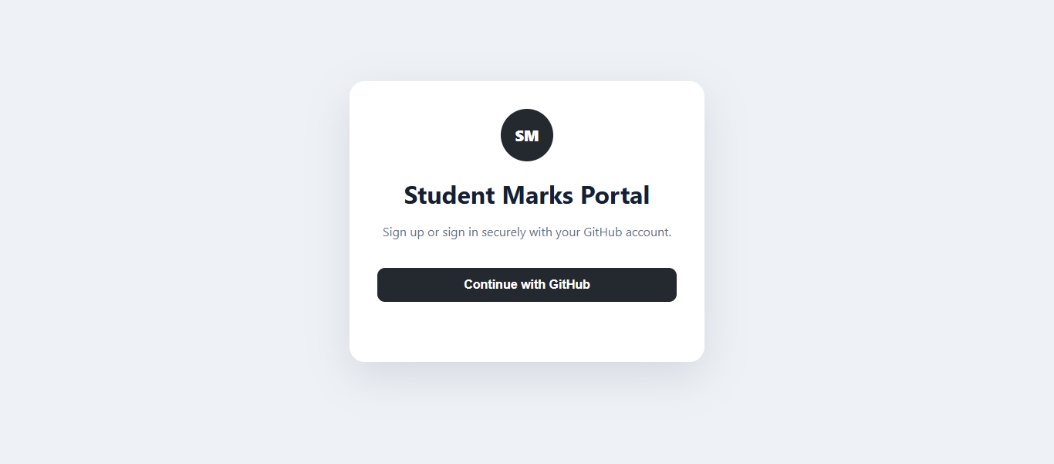
Figure: Student Marks Portal login page.
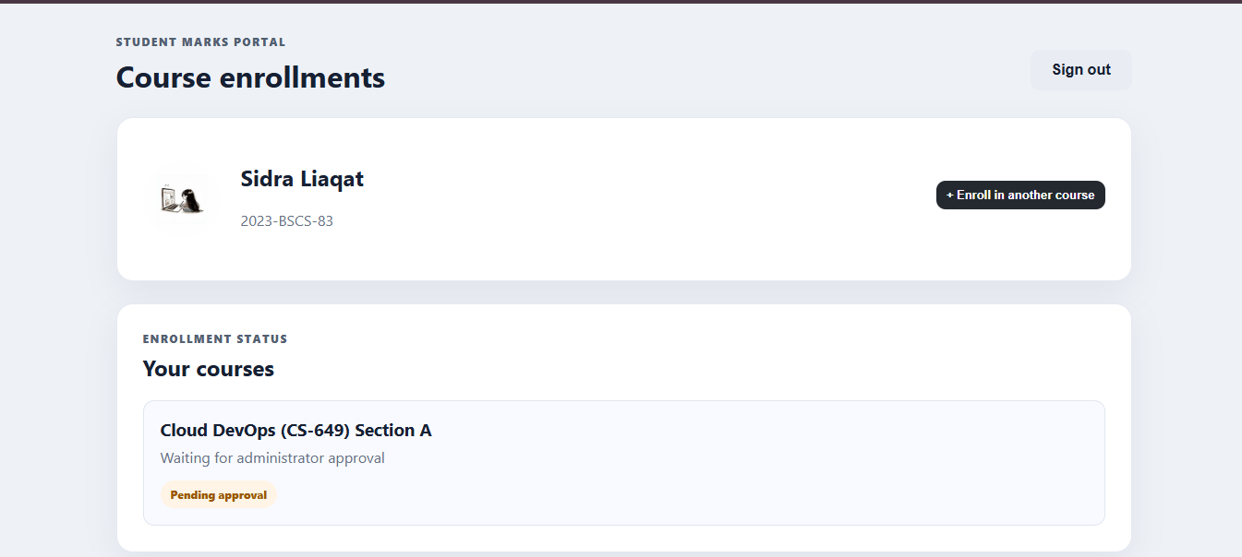
Figure: GitHub profile information shown inside the portal.
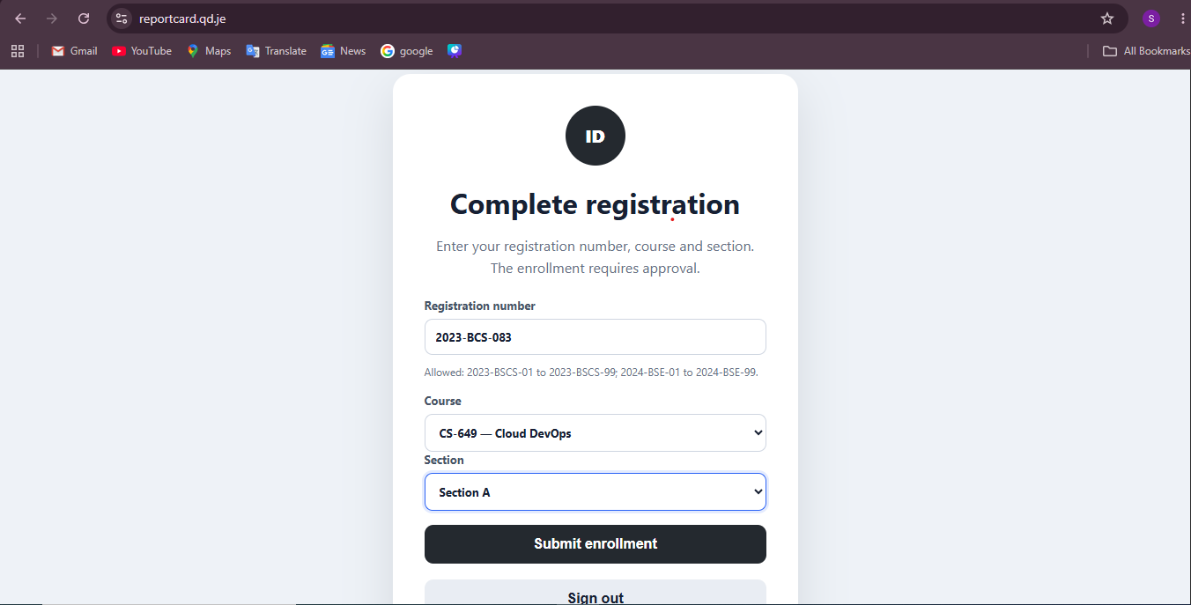
Figure: Submitted enrollment pending approval.

Task 3: Download VMware Workstation Pro and Ubuntu Server
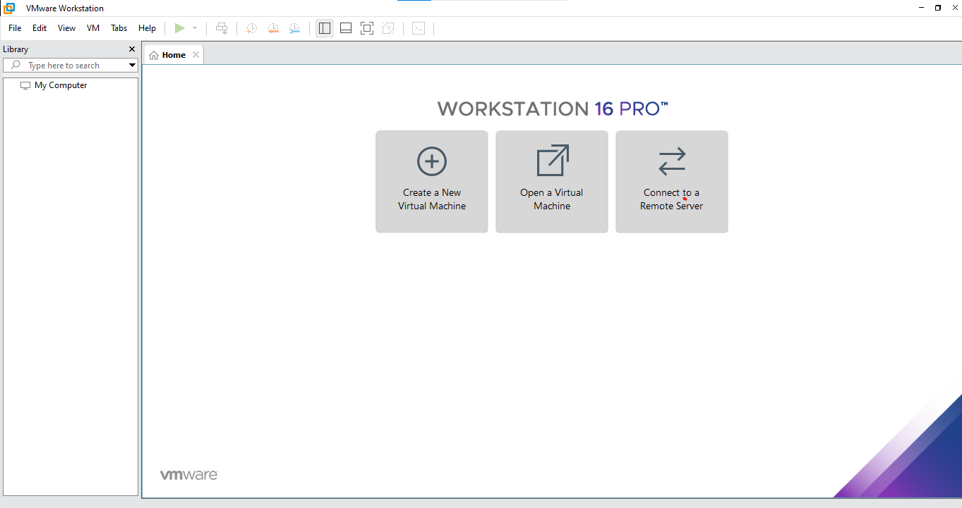
Figure: VMware Workstation Pro running on Windows.
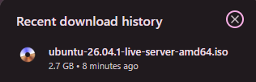
Figure: Downloaded Ubuntu Server ISO file.
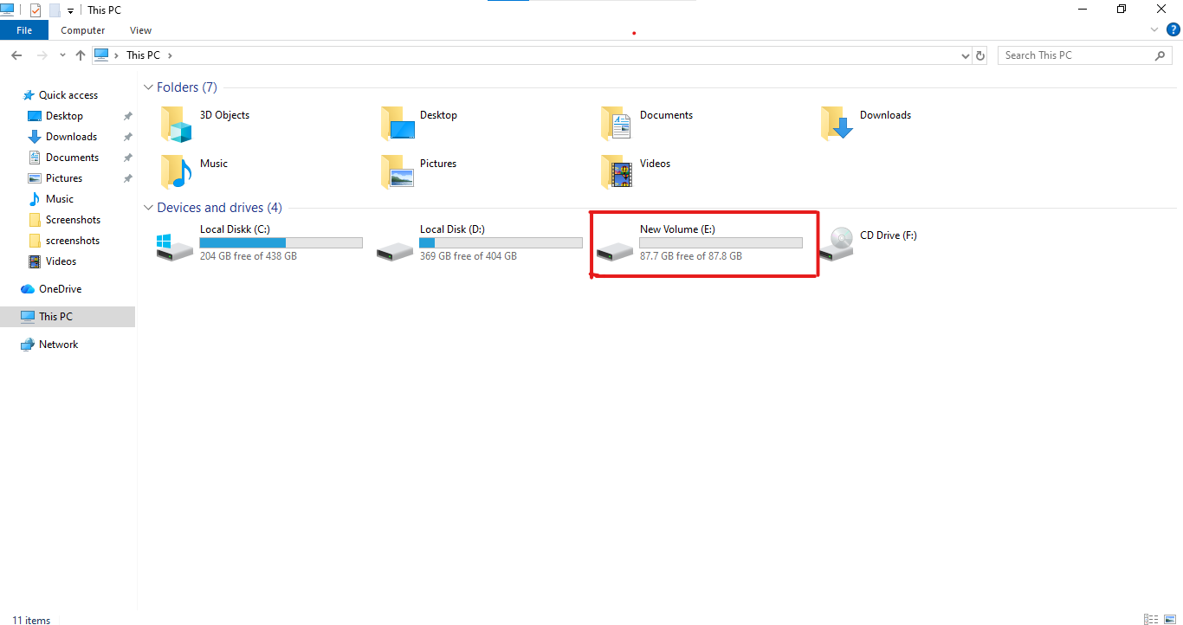
Figure: Available storage of at least 20 GB.

Task 4: Create the Ubuntu Server Virtual Machine
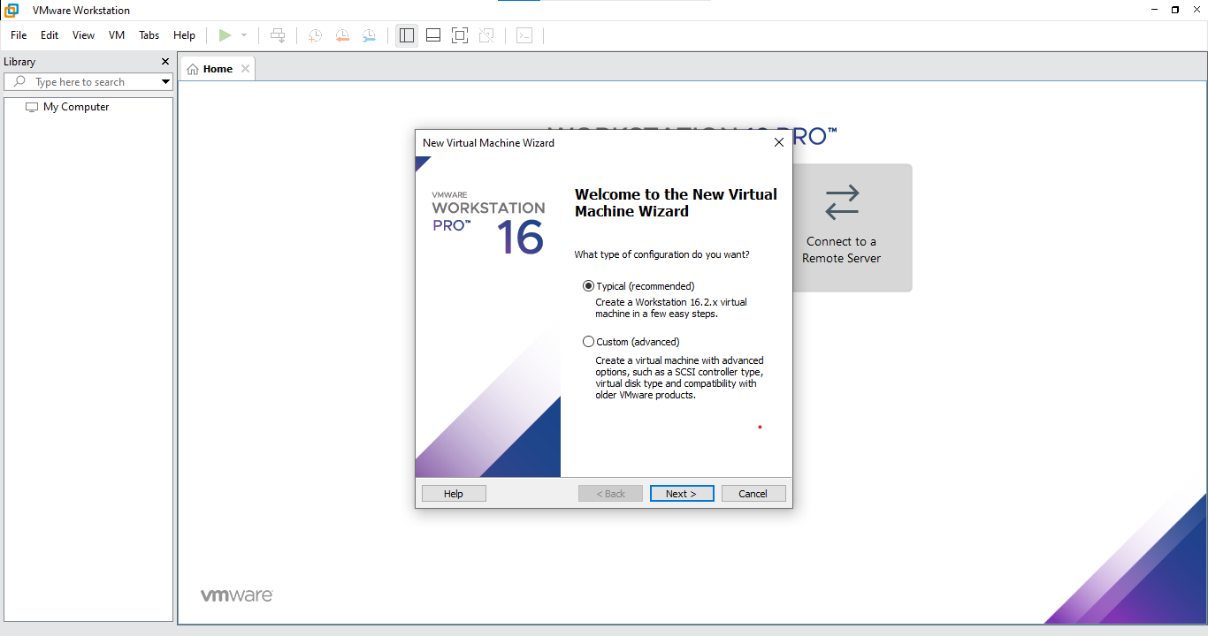
Figure: New Virtual Machine Wizard.
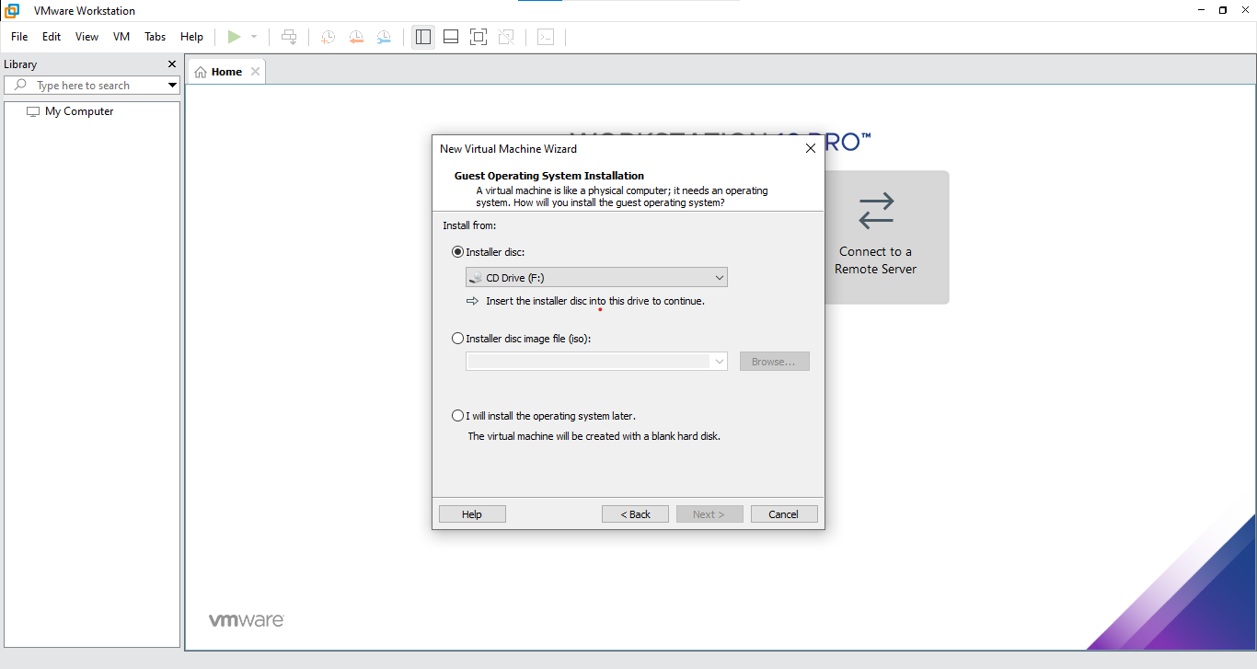
Figure: Typical (recommended) configuration selected.
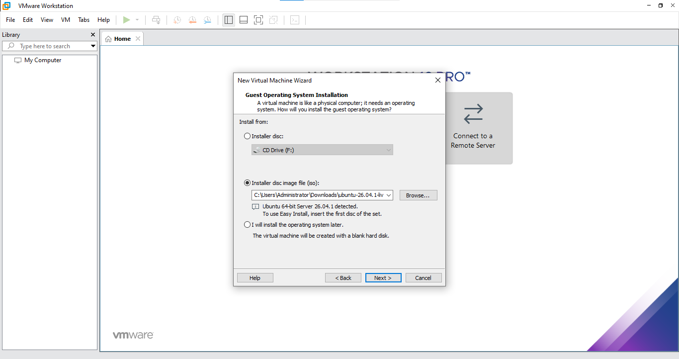
Figure: Ubuntu ISO path selected as installer disc image.
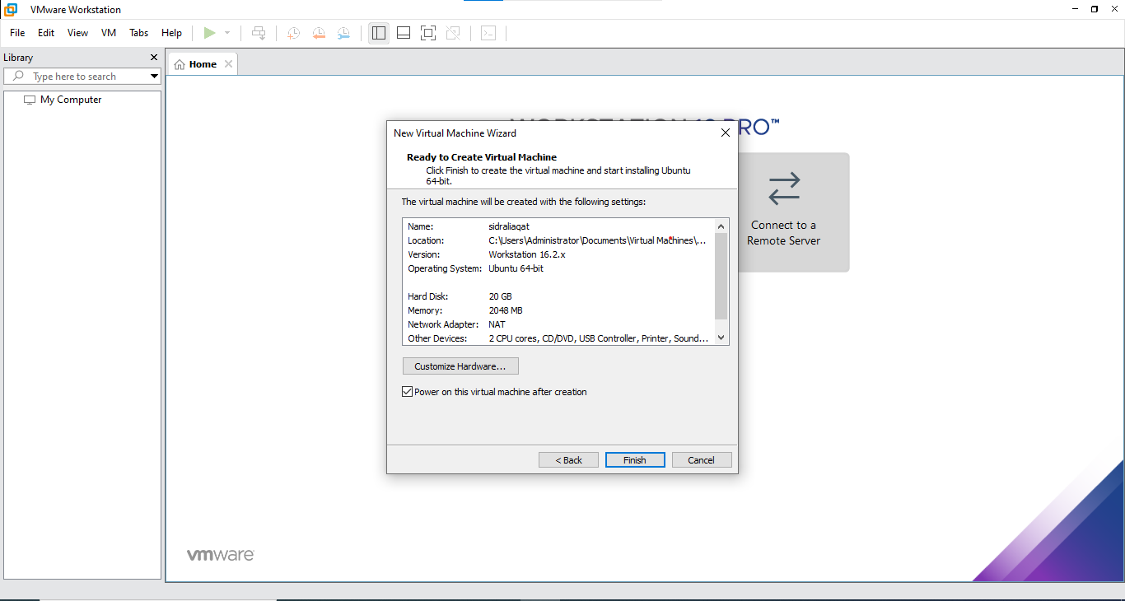
Figure: Final virtual machine configuration summary.
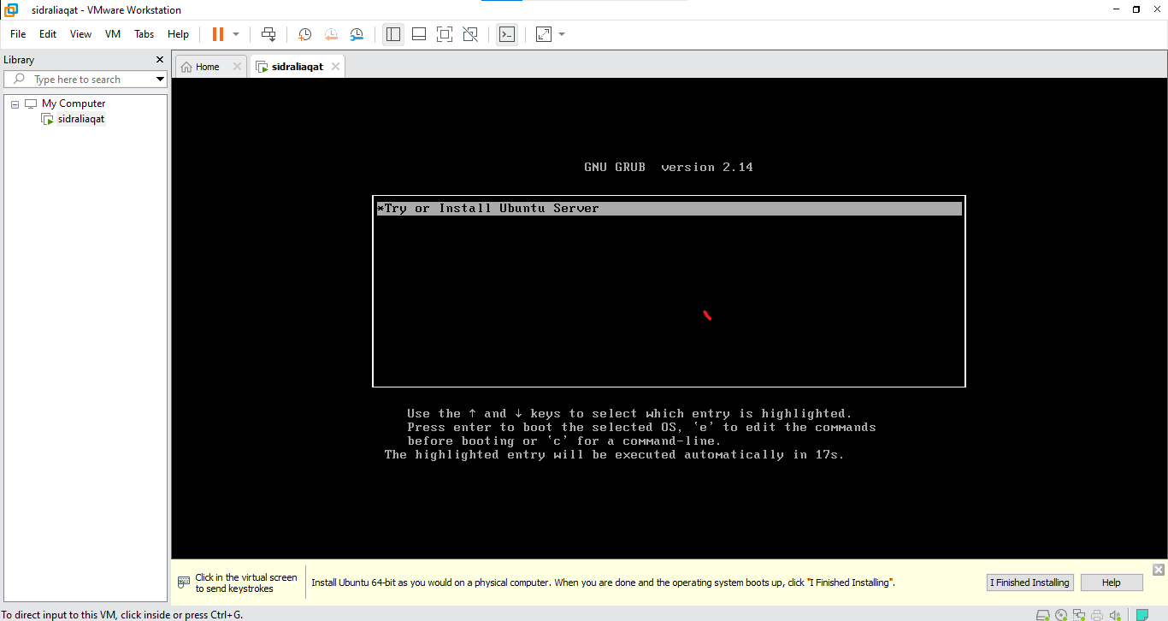
Figure: Ubuntu Server installer boot screen.

Task 5: Choose the Installation Language
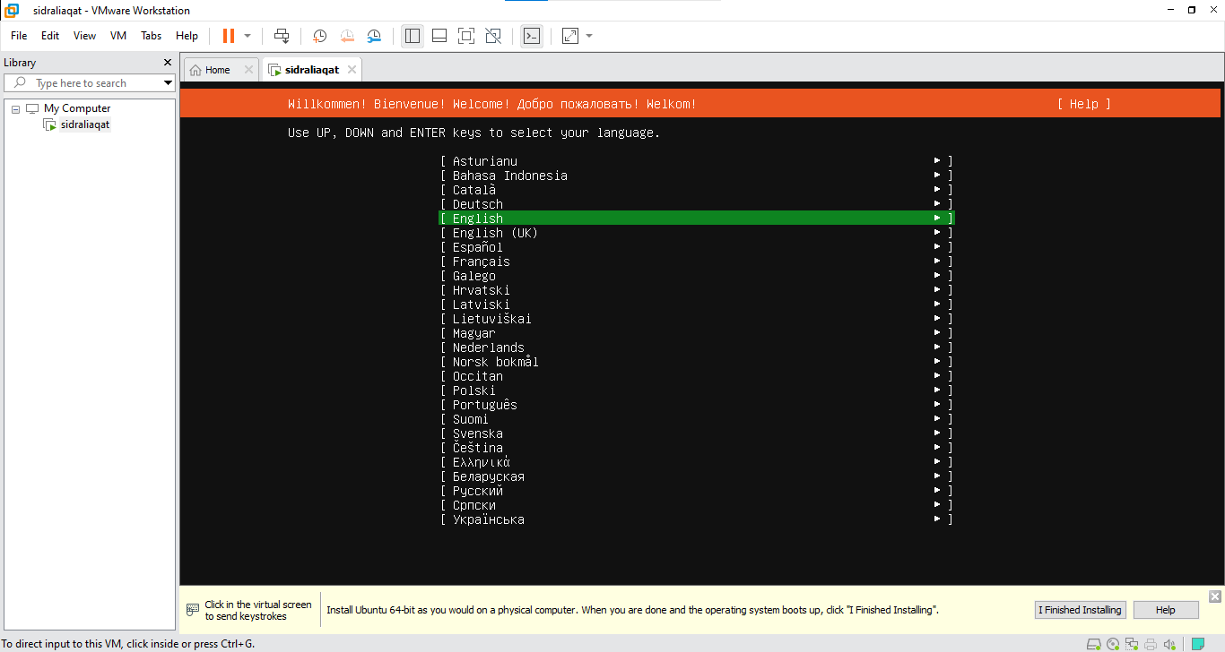
Figure: English selected as the installation language.

Task 6: Configure the Keyboard Layout
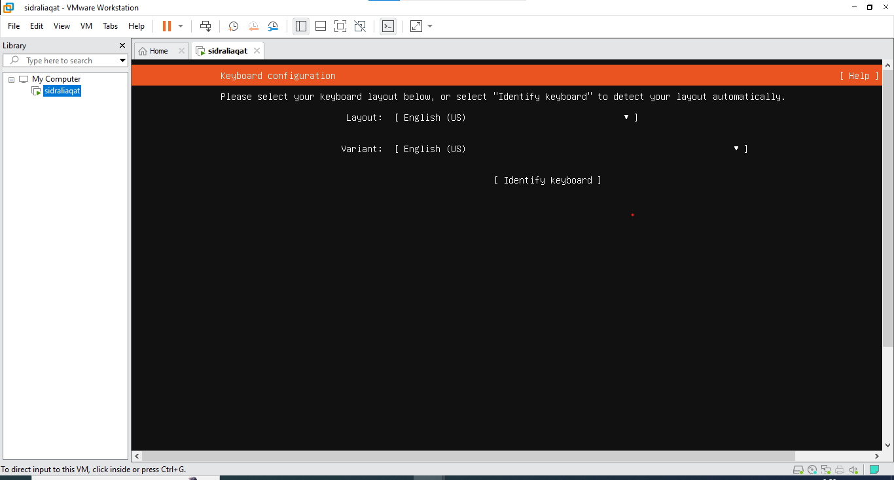
Figure: Keyboard layout selected.
Figure: Keyboard variant selected.

Task 7: Choose the Ubuntu Server Installation Type
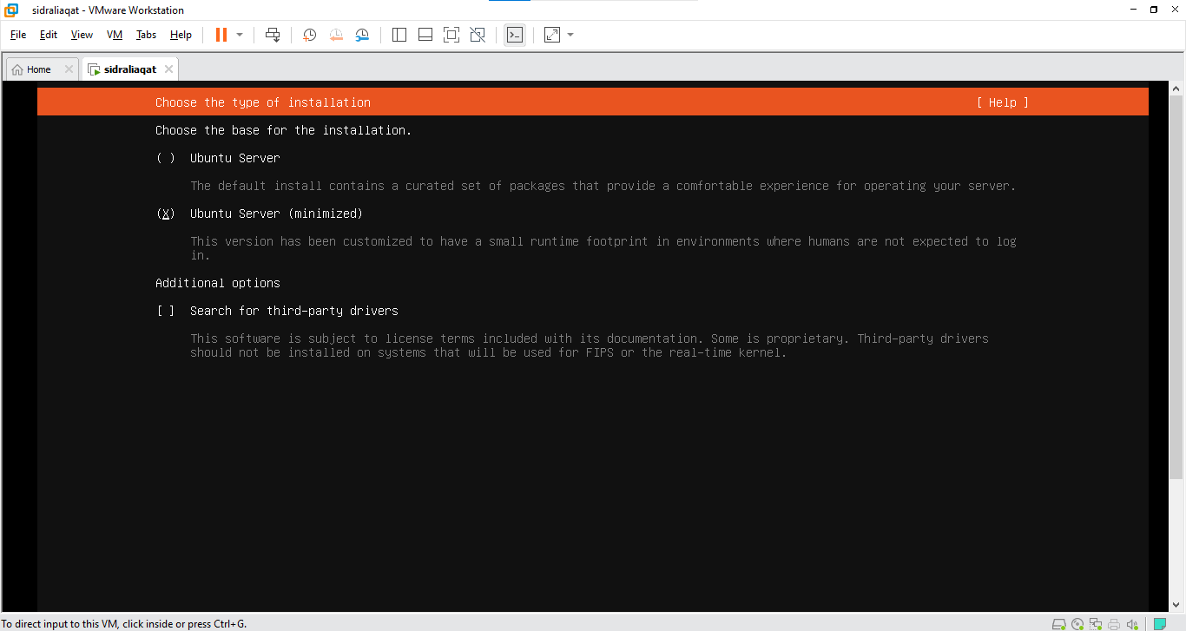
Figure: Normal Ubuntu Server installation type selected.

Task 8: Configure the Network
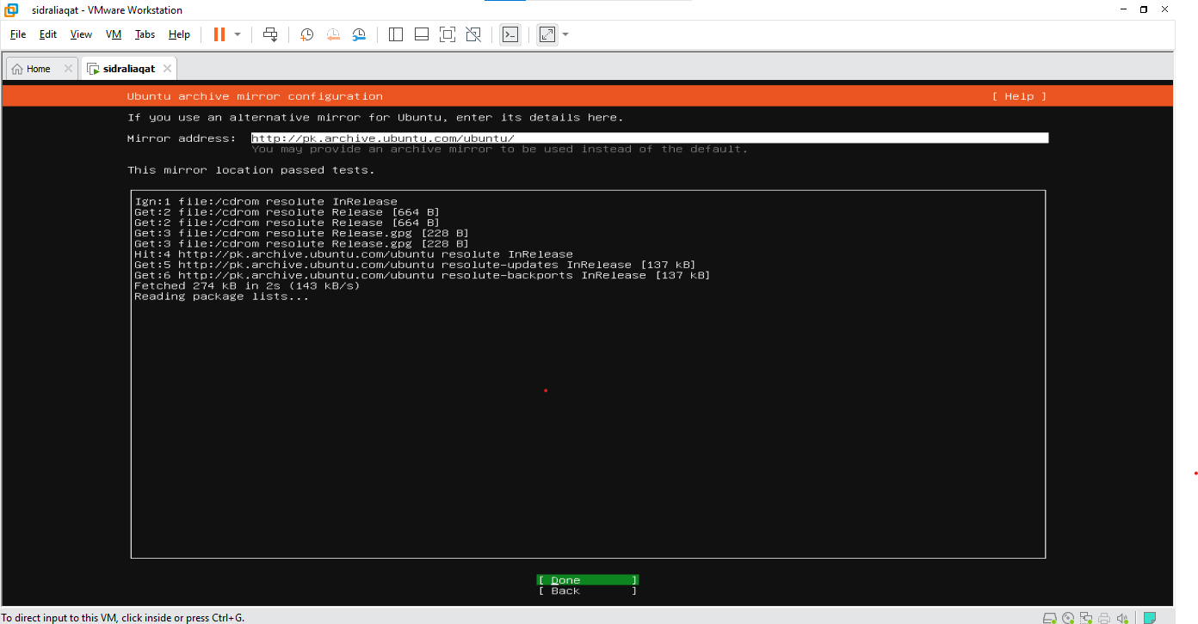
Figure: Network interface detected by the installer.
Figure: IP address assigned automatically through DHCP.

Task 9: Configure Storage
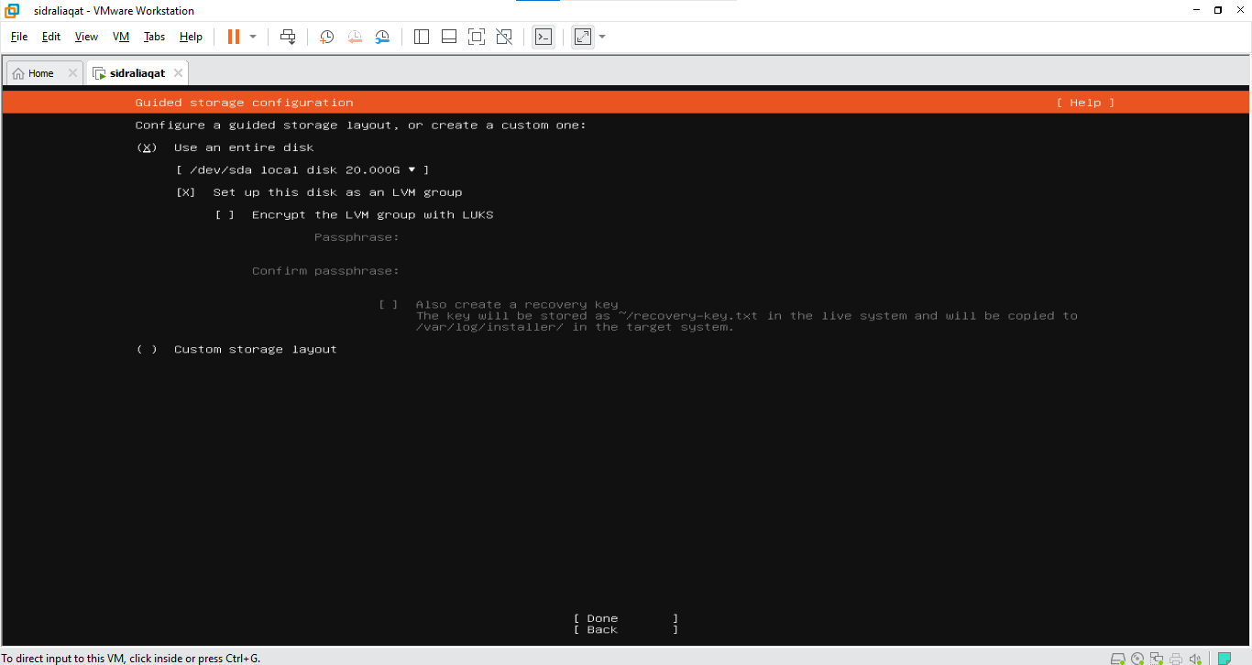
Figure: Guided storage option using the entire VMware virtual disk.
Figure: Storage configuration summary before continuing.

Task 10: Select the Installation Disk
Figure: Selected /dev/sda virtual disk.
Figure: Disk name and size (20 GB) confirming it is the VMware virtual disk.

Task 11: Review the Partitions
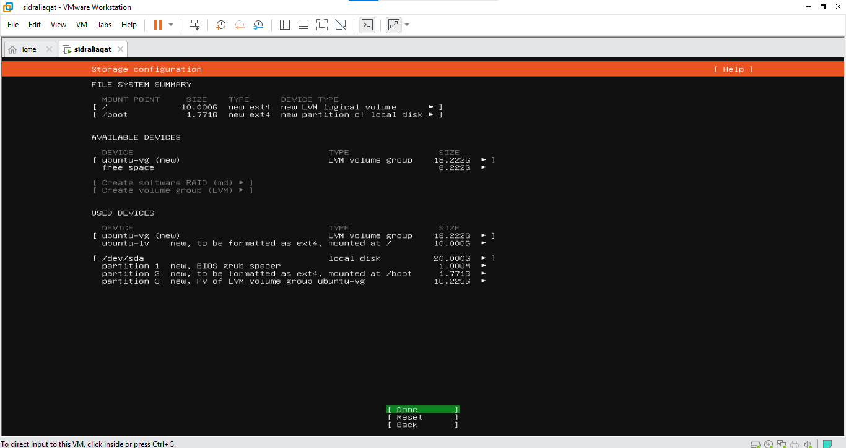
Figure: Proposed partition layout on the virtual disk.

Task 12: Confirm the Storage Changes
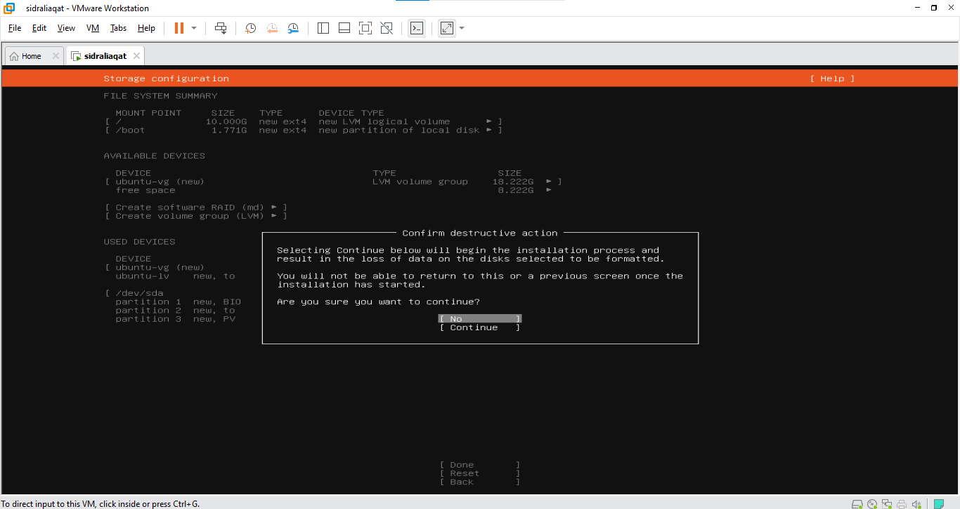
Figure: Destructive-action warning for the virtual disk.
Figure: Storage changes confirmed.

Task 13: Configure the Ubuntu Profile
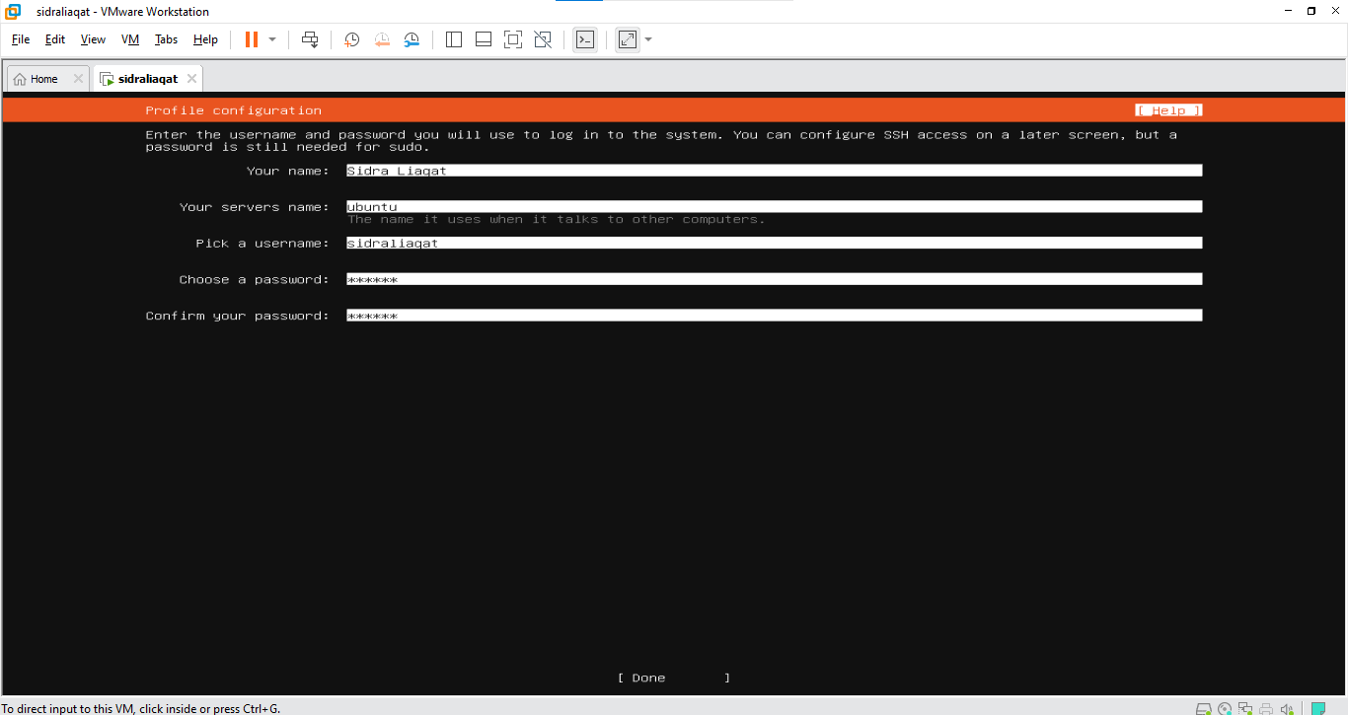
Figure: Complete actual name entered in the profile.
Figure: Server name set to ubuntu.
Figure: Ubuntu username matching my GitHub username.
Figure: Completed profile page (password hidden).

Task 14: Complete the Software Installation
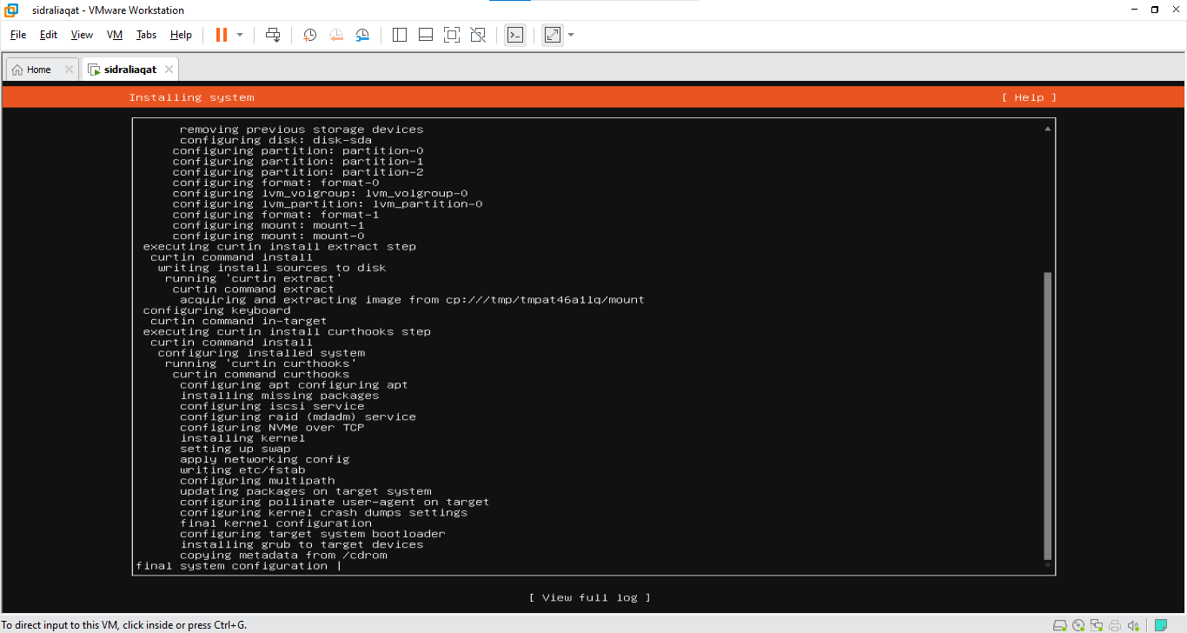
Figure: Installation progress screen.

Task 15: Reboot and Verify the Ubuntu Identity
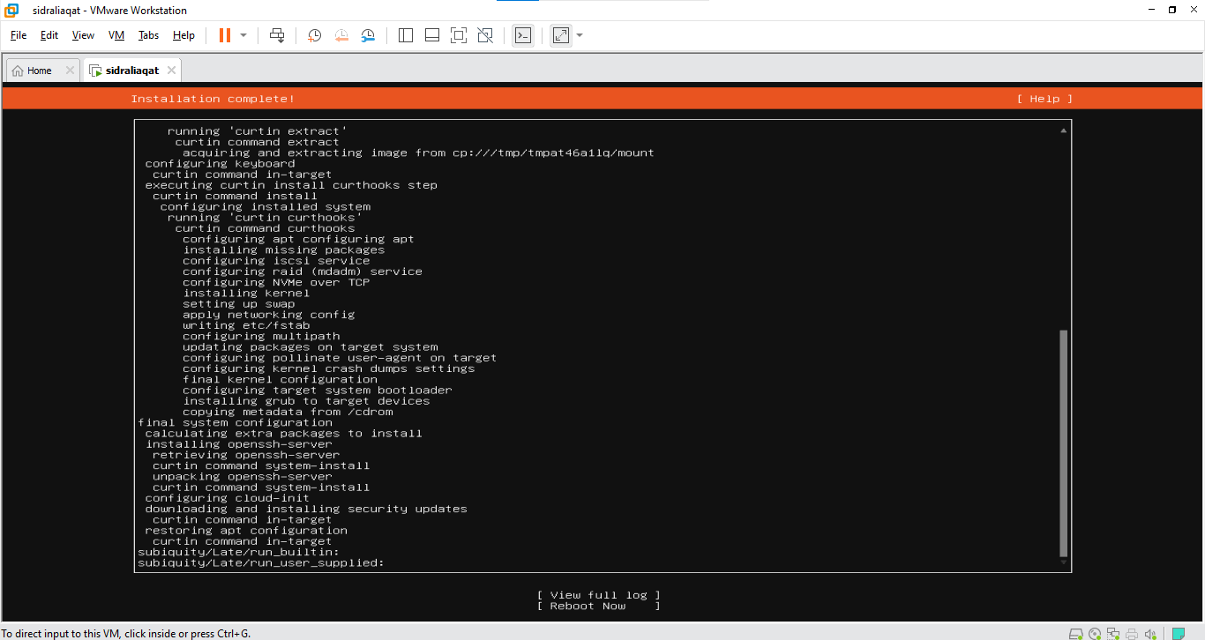
Figure: Installation complete screen.
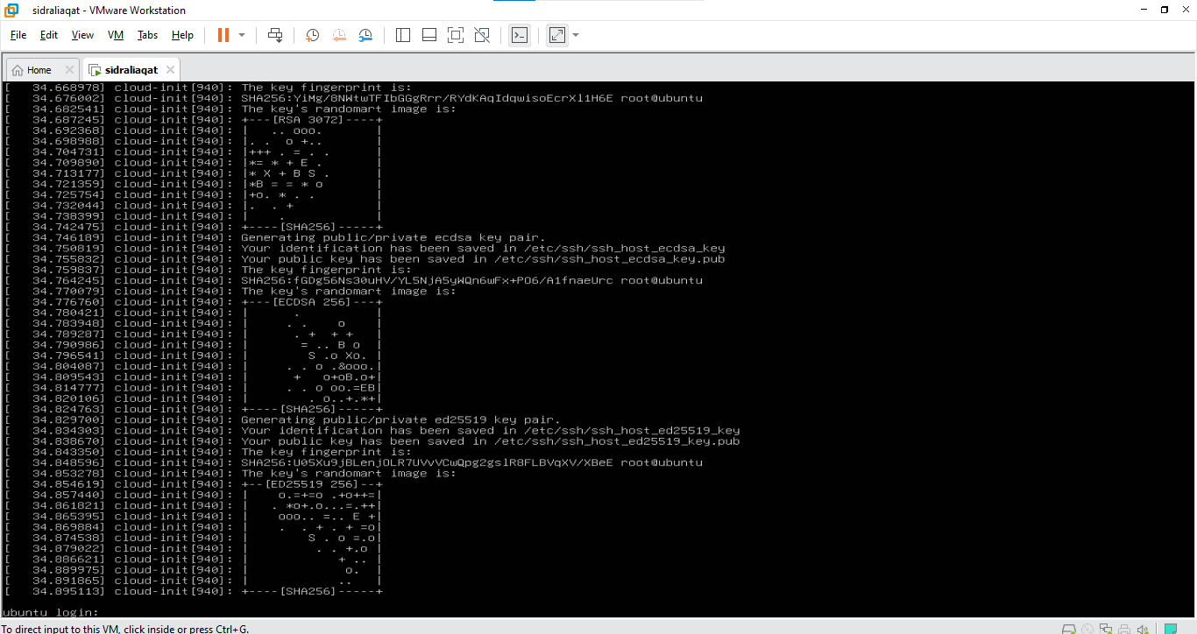
Figure: Ubuntu login screen after reboot.
Figure: Successful terminal login.
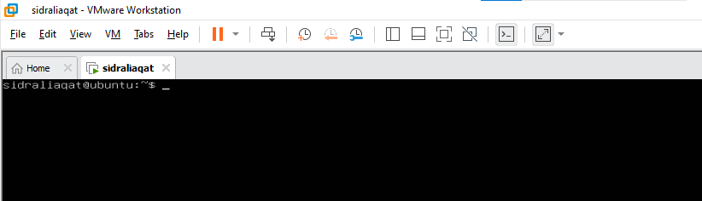
Figure: Prompt showing sidraliaqat@ubuntu:~$.

Task 16: Find the Ubuntu Server IP Address
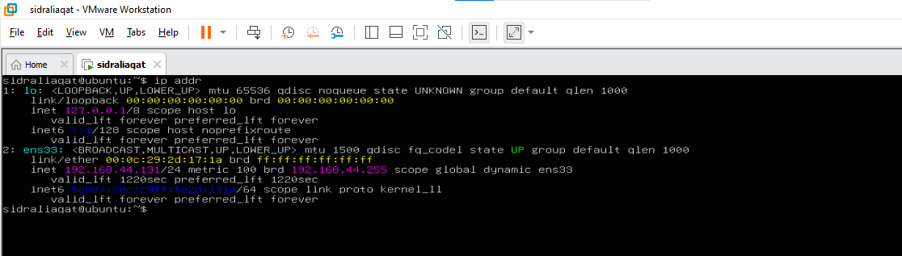
Figure: ip addr command and its output.
Figure: IPv4 address 192.168.44.131 on interface ens33.

Task 17: Connect to Ubuntu Server from Windows
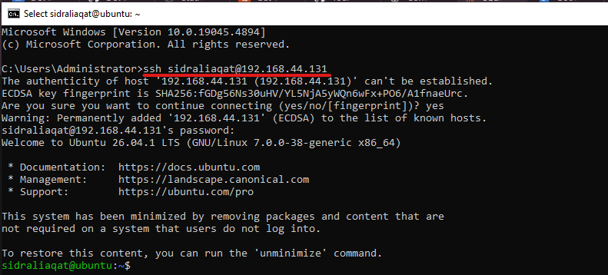
Figure: SSH command run from Windows.
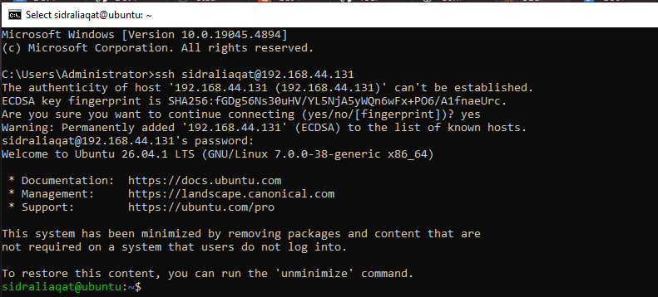
Figure: Server fingerprint accepted.
Figure: Successful SSH session.
Figure: Remote prompt showing sidraliaqat@ubuntu.

