Government College for Women University Faisalabad



Computer Organization and Assembly Language
CSI – 509
BS Computer Science
5th Semester
(2016-2020)
Submitted by
Name Sidra Sultana

Submitted to
Momina Tayyaba
Lecturer
Government College for Women University Faisalabad

Lab Task No. |  | Submission Date:
Lab Objective:

Marks/ Remarks |  | Signature

Bubble sort using subroutine

CODE::
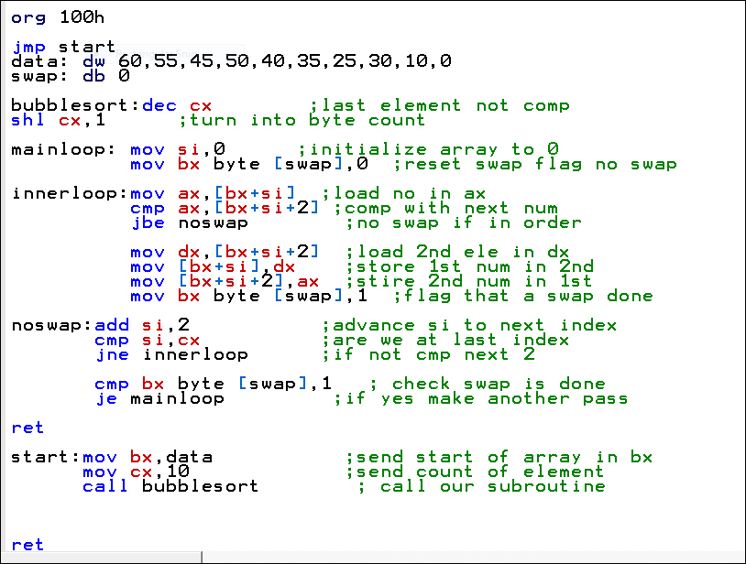
OUTPUT::
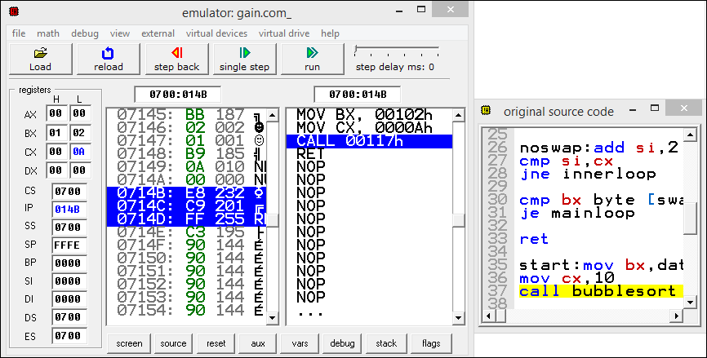
Bubble sort subroutine called twice....

CODE::
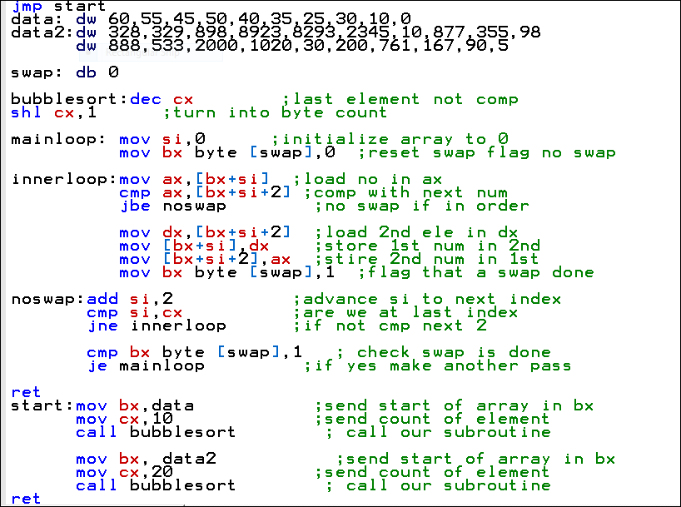

OUTPUT::
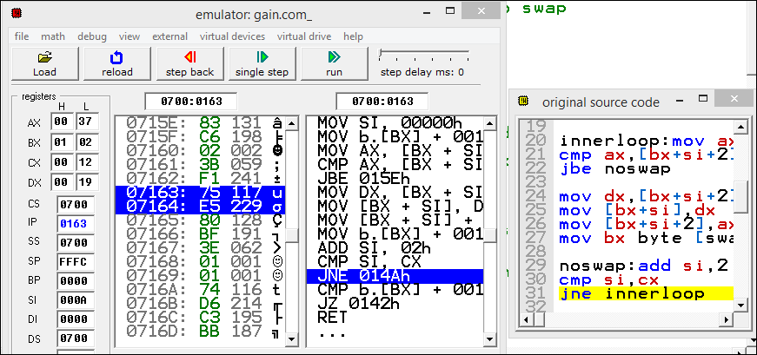
Bubble Sort Subroutine using swap subroutine
CODE::
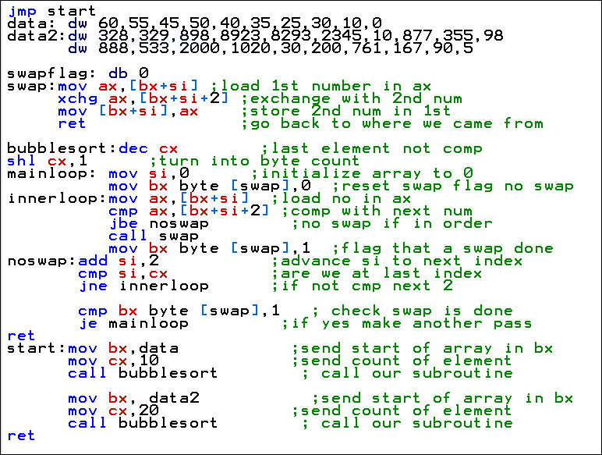

OUTPUT::
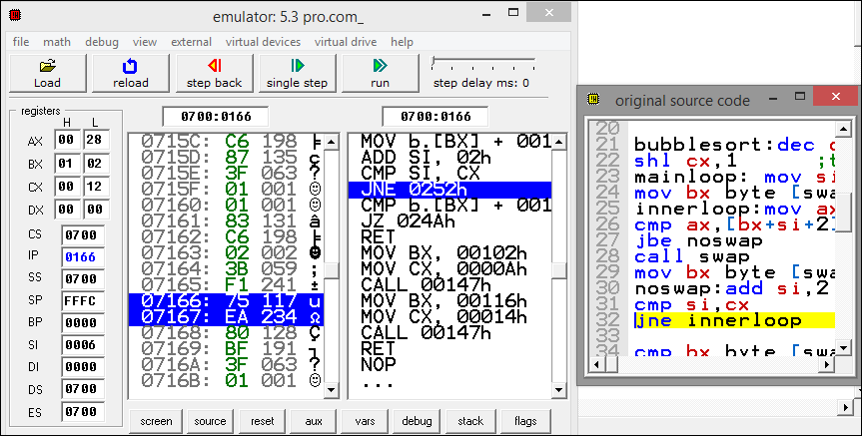

Bubble sort & swap subroutines saving and restoring registers….
CODE::
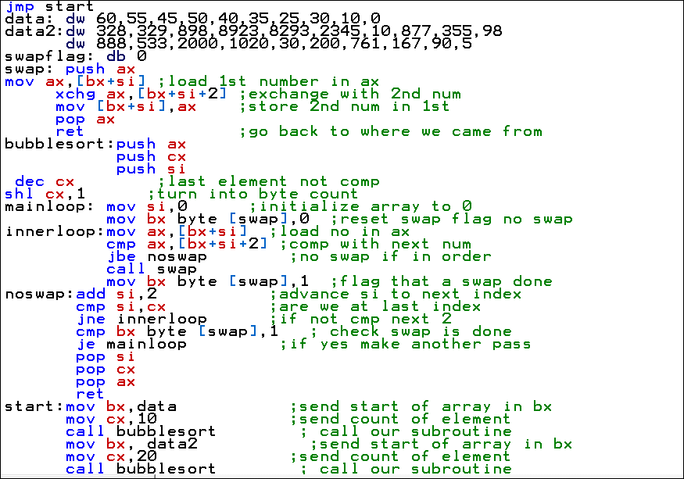
OUTPUT ::
