Smart Retail POS & AI Business Reporting System - PRD

1. Document Overview
Field | Value
Product Name | Smart Retail POS & AI Business Reporting System
Product Type | Web-based POS and retail management application
Frontend | React.js, TypeScript
Backend | Python, FastAPI, SQLAlchemy, Pydantic
Database | Microsoft SQL Server, accessed via SQLAlchemy ORM
API Documentation | OpenAPI / Swagger
Authentication | JWT

2. Product Vision
Give a single retail store a web-based point-of-sale and business management system that covers the complete retail workflow end to end:
Products -> Purchasing -> Inventory -> POS Sales -> Payments -> Customer Due -> Invoices -> SMS -> Loyalty -> Reports -> AI Assistant.
The goal is to build a realistic, coherent POS system that looks like something an actual small/medium retail store could use, with an AI Manager Assistant as its main differentiator.

3. Product Goals
- Allow authorized users (Admin, Manager, Cashier) to access the application securely by role.
- Allow users to manage products, including catalog attributes, pricing, VAT, and barcodes.
- Allow users to manage suppliers, customers, categories, brands, and units.
- Allow users to create and manage purchases, with correct discount/tax/shipping-free calculations and supplier due tracking.
- Allow customers to be sold on a cash/card/digital basis.
- Allow users to monitor inventory and stock movements, including stock-in, stock-out, manual adjustment, and expiry alerts.
- Support a configurable, reusable Tax/VAT rate layer applied consistently across sales.
- Support invoice generation, numbering, and optional SMS invoice notification.
- Support a tier-based customer loyalty program with automatic point earning and discounting.
- Provide a management dashboard and a set of sales, purchase, inventory, expiry, and customer reports.
- Maintain an activity log of significant user actions across the system.
- Provide an AI Manager Assistant that answers natural-language business questions from verified system data.
- Provide a reliable, well-structured REST API between the web frontend and the database.
- Control functionality access through roles and permissions.

4. Target Users & Roles
Role | Primary needs
Admin | Manage users, roles, products, categories, suppliers, customers, VAT configuration, loyalty configuration, store settings; full visibility into reports, activity logs, and the AI Assistant.
Manager | Manage products and suppliers; create purchases and pay supplier dues; manage inventory and stock adjustments; manage customers, view and receive customer due payments; configure loyalty; view sales, reports, and expiry alerts; use the AI Assistant.
Cashier | Operate the POS: search/scan products, manage the cart, select a customer, apply permitted and loyalty discounts, accept payment, generate invoices, and send invoice SMS. Cashiers cannot modify inventory, users, or tax configuration.

5. Functional Requirements

5.1 Authentication & Access Control
Description
Users must authenticate before accessing protected parts of the application; what they can do once inside is governed by their assigned role (Admin, Manager, or Cashier).
Requirements
- Users log in with a username/email plus password; the backend validates the password hash and account status (Active/Inactive).
- On success, the system returns a JWT access token plus the user’s role and effective permissions.
- Inactive accounts are blocked from logging in with a clear message.
- Protected API endpoints reject requests when the caller’s role/permissions don’t allow the action.
Acceptance Criteria
- Valid credentials allow the user to access the application scoped to their role.
- Invalid credentials produce a clear, appropriate error without revealing which field was wrong.
- Inactive-account logins are blocked with a message directing the user to an administrator.
- Protected API endpoints reject unauthorized or under-permissioned requests.

5.2 User & Role Management
Description
Admins manage staff accounts and control what each role can access.
Requirements
- Create/manage user accounts and assign a role (Admin, Manager, Cashier).
- Activate/deactivate user accounts.
Acceptance Criteria
- A new user can be created, assigned a role, and can immediately log in.
- Significant actions (create/update/delete, login, payments) are traceable in the activity log.

5.3 Product Management
Description
Users maintain the product catalog used throughout purchasing, inventory, and POS.
Requirements
- View, add, and edit products.
- Store: Product ID, Product Name, SKU, Barcode, Category, Brand, Unit, Purchase Price, Selling Price, VAT/Tax, Reorder Level, Expiry Tracking flag, and Status.
Acceptance Criteria
- Products can be retrieved from, created in, and updated through the backend.
- An Inactive product cannot be added to a new sale and cannot normally be purchased, but remains visible in historical transactions.
- A product cannot be saved without its required fields.

5.4 Category / Brand / Unit Management
Description
Supporting catalogs used to organize products and reporting.
Requirements
- Manage Categories (e.g., Grocery, Beverage, Cosmetics, Electronics, Stationery).
- Manage Brands (e.g., Brand A, Brand B, Brand C).
- Manage Units (e.g., Piece, Kg, Liter, Box, Packet).
- Each supports Active/Inactive status.
Acceptance Criteria
- Categories, Brands, and Units can be created, edited, and deactivated independently.
- Inactive entries are not selectable for new products.

5.5 Supplier Management
Description
The supplier module manages the vendors the store purchases products from.
Requirements
- View, add, and edit suppliers.
- Store: Supplier ID, Name, Phone, Email, Address, and Status.
- Track each supplier’s outstanding due.
Acceptance Criteria
- Supplier records are stored in and retrievable from the database.
- A supplier can be selected when creating a purchase.
- Inactive suppliers cannot be used for a new purchase.

5.6 Purchase Management
Description
The purchase module records products bought from suppliers and drives stock-in.
Purchase Calculation
Line Total = Quantity × Unit Price × (1 − Line Discount %)
Subtotal = Sum of Line Totals
Grand Total = Subtotal
− Discount Amount
+ Tax Amount (Subtotal × Tax %)
+ Shipping Charge
Requirements
- Select a supplier and add one or more product line items with quantity and purchase price.
- Apply a purchase-level discount amount and VAT.
- Calculate Subtotal, Discount, VAT, and Grand Total.
- Enter a Paid Amount; the remaining balance becomes the Supplier Due.
Acceptance Criteria
- A supplier must be selected and at least one valid line item entered before a purchase can be saved.
- Confirming a purchase creates the purchase record, increases inventory, creates a stock-movement entry, updates the supplier balance, and writes an activity-log entry.
- Discount, VAT, and totals are calculated correctly and match the formula above.

5.7 Supplier Due & Payment
Description
Supplier due is tracked as simple purchasing/payable settlement, not full accounting.
Requirements
- Track Total Purchases, Total Paid, and Outstanding Due per supplier.
- Allow the Manager to record a supplier payment (Receive/Pay Supplier) with a payment amount.
- Support payment methods: Cash, Bank/Card, Digital payment.
Acceptance Criteria
- A recorded payment reduces the supplier’s outstanding due by exactly the payment amount.
- Each payment is logged to the activity log.

5.8 Inventory / Stock Management
Description
The inventory module manages product stock and stock movements automatically through transactions.
Requirements
- Stock-in via completed purchases.
- Stock-out via completed POS sales.
- Manual stock adjustment for damaged/lost/correction cases, with a reason.
- Automatic low-stock flag when current stock is at or below the reorder level.
- Full, traceable stock-movement ledger (date, type, quantity, reference).
Formula
Current Stock = Previous Stock + Purchases - Sales +/- Adjustments
Acceptance Criteria
- Current stock accurately reflects all recorded purchases, sales, and adjustments.
- A completed purchase increases inventory by exactly the purchased quantity per line; a completed sale decreases it by exactly the sold quantity per line.
- Products at or below reorder level are correctly flagged as low stock, and the dashboard reflects an accurate low-stock/out-of-stock count.

5.9 Barcode Scanning
Description
Barcode scanning is integrated into the POS to speed up product lookup, not a standalone module.
Requirements
- Scan a barcode to find a product, check that it is Active, and check available stock before adding it to the cart.
- Show a clear message when a barcode is not found, the product is inactive, or stock is insufficient.
- A USB barcode scanner that behaves like keyboard input is sufficient; no advanced hardware integration is required.
Acceptance Criteria
- A valid, active, in-stock barcode adds the correct product and quantity to the cart.
- An unrecognized barcode falls back to manual product search rather than failing silently.

5.10 Expiry Management
Description
Expiry tracking is enabled only for products that need it (e.g., grocery/perishable items).
Requirements
- Per product, an Expiry Tracking flag (Yes/No).
- For tracked products, record Batch, Quantity, and Expiry Date.
- Dashboard alert levels: Expired, Expiring within 7 days, Expiring within 30 days.
Acceptance Criteria
- Expiring/expired batches are correctly surfaced on the dashboard at the configured alert thresholds.
- Products without expiry tracking enabled are excluded from expiry alerts.

5.11 Customer Management
Description
The customer module maintains customer records used across sales, due, and loyalty.
Requirements
- View, add, and edit customers.
- Store: Customer ID, Name, Phone, Email, Address, Loyalty Points, Loyalty Tier, Credit Limit, Outstanding Due, and Status.
- A customer does not require an account/login; the cashier identifies them by phone number or customer record.
Acceptance Criteria
- Customer records can be created, retrieved, and updated.
- Customer loyalty tier, points, and due balance display correctly wherever the customer is selected.

5.12 Customer Due & Payment
Description
Registered customers may purchase on due, subject to a credit limit; guest customers must always pay in full.
Requirements
- Guest customers must pay the full amount at checkout.
- Registered customers may pay via Cash/Card/Digital, or partially/fully on Customer Due.
- Enforce a per-customer Credit Limit: a new due that would exceed the available credit is rejected (“Credit limit exceeded”).
- Allow the Manager to receive a customer due payment (amount + method), updating the outstanding balance and generating a receipt.
Acceptance Criteria
- A due sale for a guest customer is rejected.
- A due sale for a registered customer that would exceed their credit limit is rejected with a clear message.
- A recorded due payment reduces the customer’s outstanding due by exactly the payment amount and is logged to the activity log.

5.13 Loyalty Program
Description
A simple, tier-based loyalty program rather than a complex rewards engine.
Requirements
- Configurable tiers with required points and an automatic percentage discount.
- Apply the customer’s tier discount automatically to the cart subtotal at checkout.
Acceptance Criteria
- Points are awarded only after payment succeeds, and never on a failed or rolled-back sale.
- The correct tier discount is applied automatically based on the customer’s current tier.
- A customer’s tier updates correctly once their accumulated points cross a tier threshold.

5.14 POS / Sales
Description
The POS is the primary, speed-focused operational screen for the Cashier.
Requirements
- Search or scan products into a cart; adjust quantities; optionally select a registered customer.
- Apply the customer’s loyalty discount automatically, then calculate VAT, to reach a final total.
- Support Full, Partial, and Due payment outcomes (Due only for registered customers within their credit limit).
- On completion, atomically create the sale, sale items, payment, stock-out, invoice, loyalty transaction, and activity log entry.
Acceptance Criteria
- A sale cannot be completed without at least one valid cart line.
- Subtotal, loyalty discount, VAT, and total are calculated consistently and match what is shown on the resulting invoice.
- If any part of the completion sequence fails, the whole transaction rolls back so no partial/inconsistent records are created.

5.15 Payment Management
Description
Payment must be completed (fully, partially, or on due) before a sale is considered complete.
Requirements
- Support Cash, Card, Digital Payment, and Due (registered customers only) as payment methods.
- Track payment status per sale: PAID, PARTIALLY_PAID, DUE.
Acceptance Criteria
- Paid + Due always equals the sale total.
- The payment status is set correctly based on the amount paid relative to the total.

5.16 Tax / VAT Management
Description
A simple, reusable tax/VAT configuration module, replacing ad-hoc per-transaction rates.
Requirements
- Define named tax/VAT rates (Name, Rate, Status), e.g., Standard VAT 15%, Reduced VAT 5%, Zero VAT 0%.
- Associate products with a tax rate.
- Apply VAT consistently in purchase totals, POS totals, invoices, and reports.
Acceptance Criteria
- Tax rates can be defined once and selected on relevant transactions rather than re-entered each time.
- Tax amounts calculated from a configured rate match the transaction total exactly, both on the POS screen and the printed invoice.

5.17 Invoice Management
Description
Every successful sale produces a formal invoice.
Requirements
- Generate a unique invoice number per transaction (e.g., INV-2026-00125).
- Include store name, address, phone, invoice number, date/time, cashier, customer (if any), line items, subtotal, loyalty discount, VAT, total, paid, due, and payment method(s).
- Support invoice viewing and printing.
Acceptance Criteria
- Every completed sale produces exactly one invoice with a unique, sequential number.
- Invoice totals match the POS calculation for that sale exactly.

5.18 SMS Invoice Notification
Description
An optional, non-blocking notification sent after a successful sale.
Requirements
- After invoice generation, if the customer’s phone number is available, send an SMS with an invoice summary (invoice number, total).
- SMS failure must never roll back or reverse the sale or invoice.
Acceptance Criteria
- A completed sale remains successful (Sale = Successful, Invoice = Created) even if the SMS send fails.
- SMS is only attempted when a customer phone number is present.

5.19 Dashboard
Description
The manager’s landing screen, giving an instant business overview.
Requirements
- Show Today’s Sales, Transactions, and Items Sold.
- Show Low Stock, Out of Stock, and Expiring Soon counts.
- Show Customer Due and Supplier Due totals.
- Show charts: sales over time, top-selling products, sales by payment method, purchase vs. sales, and customer loyalty distribution.
Acceptance Criteria
- All dashboard figures reconcile with the underlying sales, inventory, and due records for the same period.
- The dashboard remains uncluttered — summary figures and a small set of charts only.

5.20 Reports
Description
A focused set of management reports rather than an open-ended reporting engine.
Requirements
- Sales Reports (filterable by Today/Yesterday/This week/This month/Custom date): Total Sales, Transactions, Average Transaction Value, Top Products, Payment Methods.
- Purchase Reports: Total Purchases, Purchases by Supplier, Purchase History, Supplier Outstanding.
- Inventory Reports: Current Stock, Low Stock, Out of Stock, Stock Movement, Stock Adjustments.
- Expiry Reports: Expired Products, Expiring within 7 days, Expiring within 30 days.
- Customer Reports: Top Customers, Purchase History, Customer Due, Loyalty Points, Loyalty Tier.
Acceptance Criteria
- Each report can be filtered by the stated date ranges where applicable and matches the source transactions.

5.21 Activity Log
Description
A record of significant user actions across the system, for accountability and traceability.
Requirements
- Record User, Action, Entity, Reference, and Timestamp for significant actions (sales, purchases, stock adjustments, due payments, user/role changes).
- Automatic logging — not every UI interaction, only meaningful business actions.
Acceptance Criteria
- Significant actions (create/update/delete, login, payments, adjustments) are traceable in the activity log with an accurate timestamp and reference.

5.22 AI Manager Assistant
Description
The system’s main differentiator: a chat-style assistant that answers natural-language business questions using verified system data, restricted to approved report functions rather than open database access.
Requirements
- Provide a chat interface for the Manager/Admin to ask questions such as sales, inventory, customer, supplier, and business-summary queries.
- Route each question through intent detection to an approved report function, query SQL Server, and return a natural-language answer built from the verified result.
- The AI must not have unrestricted database access and must not directly modify business records.
Flow
Manager -> AI Chat Interface -> AI Model -> Intent Detection -> Approved Report Function
-> SQL Server -> Validated Results -> AI -> Natural Language Answer -> Manager
Acceptance Criteria
- Every AI answer is traceable to a specific approved report function and its underlying SQL result.
- The AI cannot create, update, or delete any business record.

5.23 Store Settings
Description
Basic store-level configuration, kept intentionally simple.
Requirements
- Configure Store Name, Store Address, Phone, Email, Currency, Invoice Prefix, Tax/VAT settings, Loyalty settings, and SMS settings.
Acceptance Criteria
- Store settings persist and are reflected on generated invoices and in relevant calculations (VAT, loyalty, invoice numbering).

6. Non-Functional Requirements

6.1 Performance
- API requests should return within a reasonable time under normal usage.
- Database queries should be indexed/optimized to support list screens, stock lookups, and reports.
- The web interface should remain responsive (non-blocking) during network calls, using loading states.

6.2 Security
- Authentication is required for protected functionality; passwords are stored as secure hashes, never in plain text.
- JWT secret keys and database credentials must be sourced from environment variables, not hardcoded.
- API access is protected against unauthorized users at the route level, based on role.

6.3 Reliability
- Multi-step operations (e.g., completing a sale: sale + payment + inventory + invoice + loyalty) must be transactional, so a failure doesn’t leave partial or inconsistent records.
- SMS delivery failure must never roll back a completed sale.
- API errors should return meaningful, structured responses (HTTP status + message).

6.4 Maintainability
- Backend: routers, schemas, models, services, and database access kept separate.
- Frontend: pages, components, and services kept separate.

6.5 Scalability
The system should be designed so additional modules like Sales, Reports, Employee management, finer-grained role permissions, advanced analytics can be added without major changes to existing functionality. The current Roles/ Permissions/ RolePermissions/ UserPermissions structure already supports this for access control.

6.6 Configuration
The API base URL and database connection must be environment-configurable per deployment target.

7. Data Model
The application is backed by a relational SQL Server schema, grouped by area:
Area | Tables
Authentication | Users, Roles, Permissions, RolePermissions, ActivityLogs
Product / Catalog | Categories, Brands, Units, Products, TaxRates
Supplier | Suppliers, Purchases, PurchaseItems, SupplierPayments
Inventory | ProductStock, StockMovements, StockAdjustments, StockBatches
Customer | Customers, CustomerPayments, LoyaltyTiers, LoyaltyTransactions
Sales | Sales, SaleItems, Payments, Invoices
Configuration | StoreSettings
Key relationships
Category -> Products -> Stock, Stock Movements, Sale Items
Supplier -> Purchases -> Purchase Items -> Products
Customer -> Sales, Customer Payments, Loyalty Transactions, Loyalty Tier
Sale -> Sale Items, Payment, Invoice, Customer Due, Loyalty Transaction

8. API Requirements
The web application communicates with the backend exclusively through REST APIs. Each endpoint validates incoming data against a Pydantic schema, performs the required business operation, communicates with SQL Server via SQLAlchemy, and returns a structured JSON response with an appropriate HTTP status code.
Router | Endpoint prefix
Authentication | /api/auth
Users | /api/users
Roles | /api/roles
Categories | /api/categories
Brands | /api/brands
Units | /api/units
Products | /api/products
Suppliers | /api/suppliers
Purchases | /api/purchases
Supplier Payments | /api/supplier-payments
Inventory | /api/inventory
Stock Movements | /api/stock-movements
Stock Adjustments | /api/stock-adjustments
Customers | /api/customers
Loyalty | /api/loyalty
Sales | /api/sales
Payments | /api/payments
Invoices | /api/invoices
Tax Rates | /api/tax-rates
Reports | /api/reports
Activity Logs | /api/activity-logs
AI Assistant | /api/ai

9. Frontend Requirements
- Provide a simple, clear sidebar navigation: Dashboard, POS, Products (Products/Categories/Brands/Units), Purchasing (Suppliers/Purchases/Supplier Payments), Inventory (Stock/Movements/Adjustments/Expiry Alerts), Customers (Customers/Due Payments/Loyalty), Sales (Sales/Invoices), Reports, AI Assistant, Activity Logs, Users, Settings.
- Do not create separate top-level menu items for Barcode, Tax, Expiry, Loyalty, Activity log, or SMS — these are features inside their parent modules.
- Display API data clearly with consistent list/detail/add-edit patterns per entity.
- Validate user input before submission (required fields, numeric ranges, credit-limit checks).
- Show loading states during network calls and clear error messages on failure.
- Refresh/update screens automatically after a successful create, update, or delete.

10. Backend Requirements
- Provide RESTful API endpoints organized by domain router (see Section 8).
- Validate all requests using Pydantic schemas.
- Implement business logic (totals, stock updates, due/credit-limit checks, loyalty calculations) in the service layer, not the client.
- Communicate with SQL Server via SQLAlchemy, using transactions for multi-step writes (e.g., completing a sale).
- Route AI Assistant questions through intent detection to approved, parameterized report functions only — never raw/unrestricted SQL access for the AI.
- Handle exceptions and return consistent, structured error responses.
Recommended backend layout
backend/
|- routers/ (auth, products, purchases, inventory, customers, suppliers, sales, reports, ai)
|- models/
|- schemas/
|- services/ (sales_service, inventory_service, invoice_service, report_service, loyalty_service, notification_service)
|- database.py
`- main.py

11. User Flow
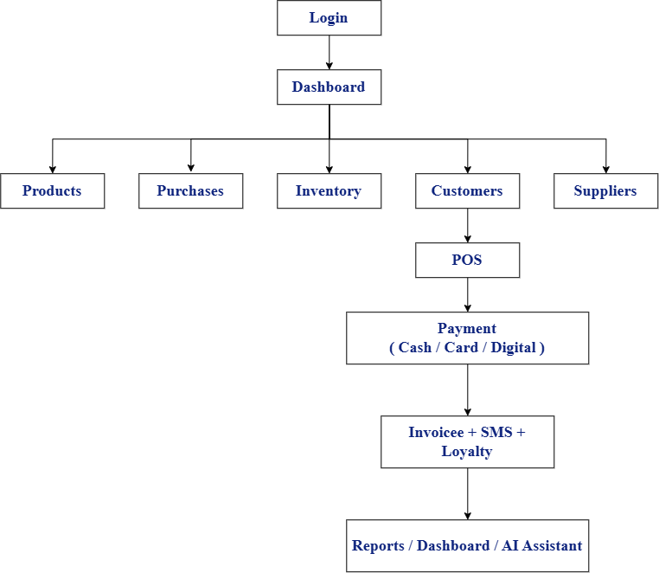

12. Success Criteria
The project is considered successful for this phase when users can:
- Log in and be correctly scoped to their role (Admin / Manager / Cashier).
- Manage products, categories, brands, units, and barcodes.
- Manage suppliers and create purchases with correct discount/VAT/total calculations and supplier due tracking.
- Manage customers' payments.
- Complete a POS sale end-to-end: search/scan products, apply loyalty discount, calculate VAT, accept payment, and generate an invoice.
- See accurate, real-time inventory levels, stock movement history, and low-stock/expiry alerts.
- Configure and apply Tax/VAT rates consistently across purchases, sales, and invoices.
- Earn and redeem tier-based loyalty points and discounts automatically.
- View a dashboard and reports covering sales, purchases, inventory, expiry, and customer/supplier due.
- Ask the AI Manager Assistant natural-language business questions and receive answers grounded in verified system data.
- Rely on the web application and backend working together consistently, with no data loss on normal operations.

13. System Architecture of POS System
System Architecture
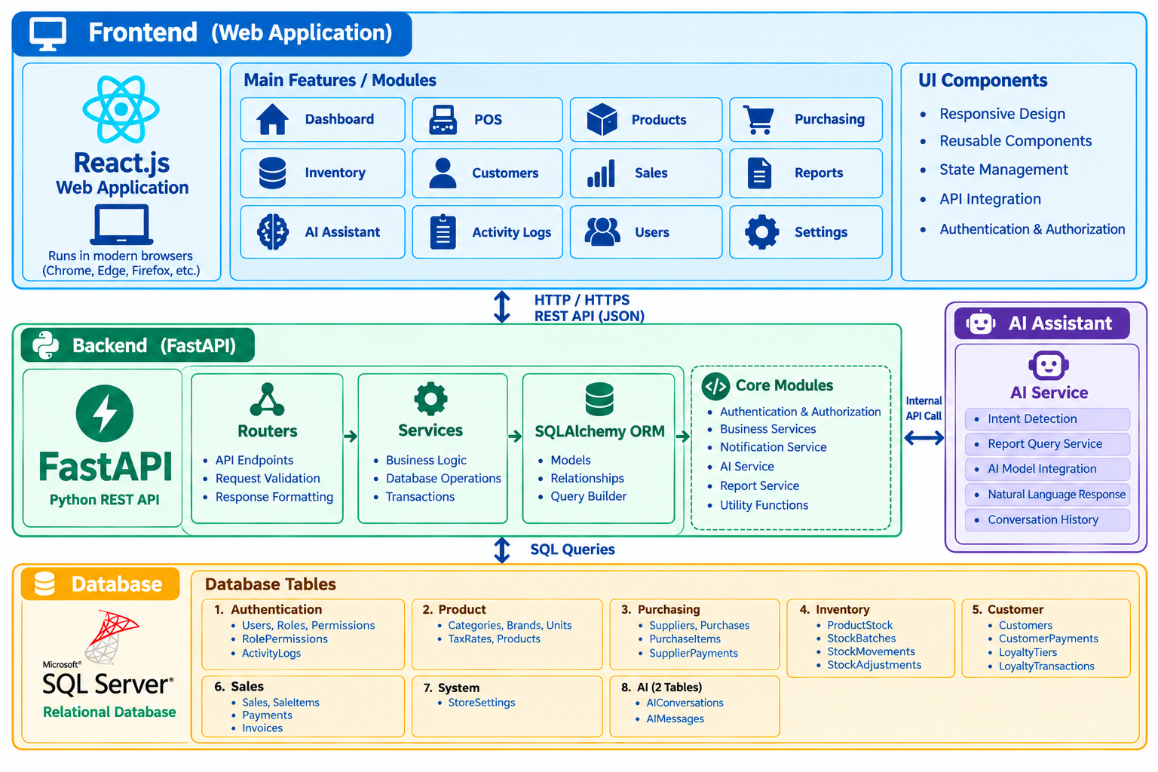

14. Project Architecture of POS System
14.1 Frontend
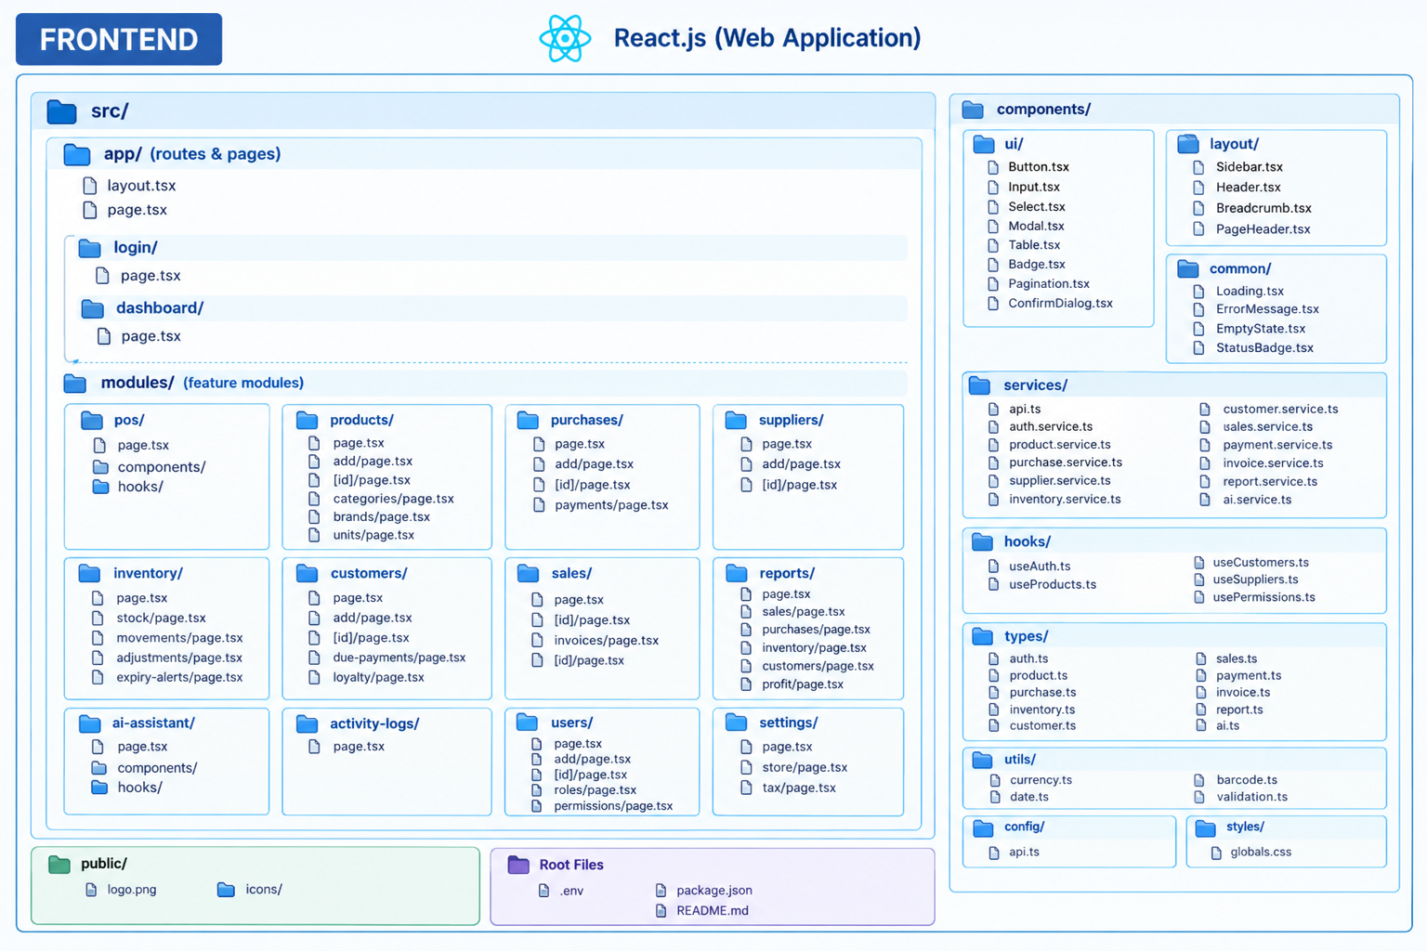

14.2 Backend
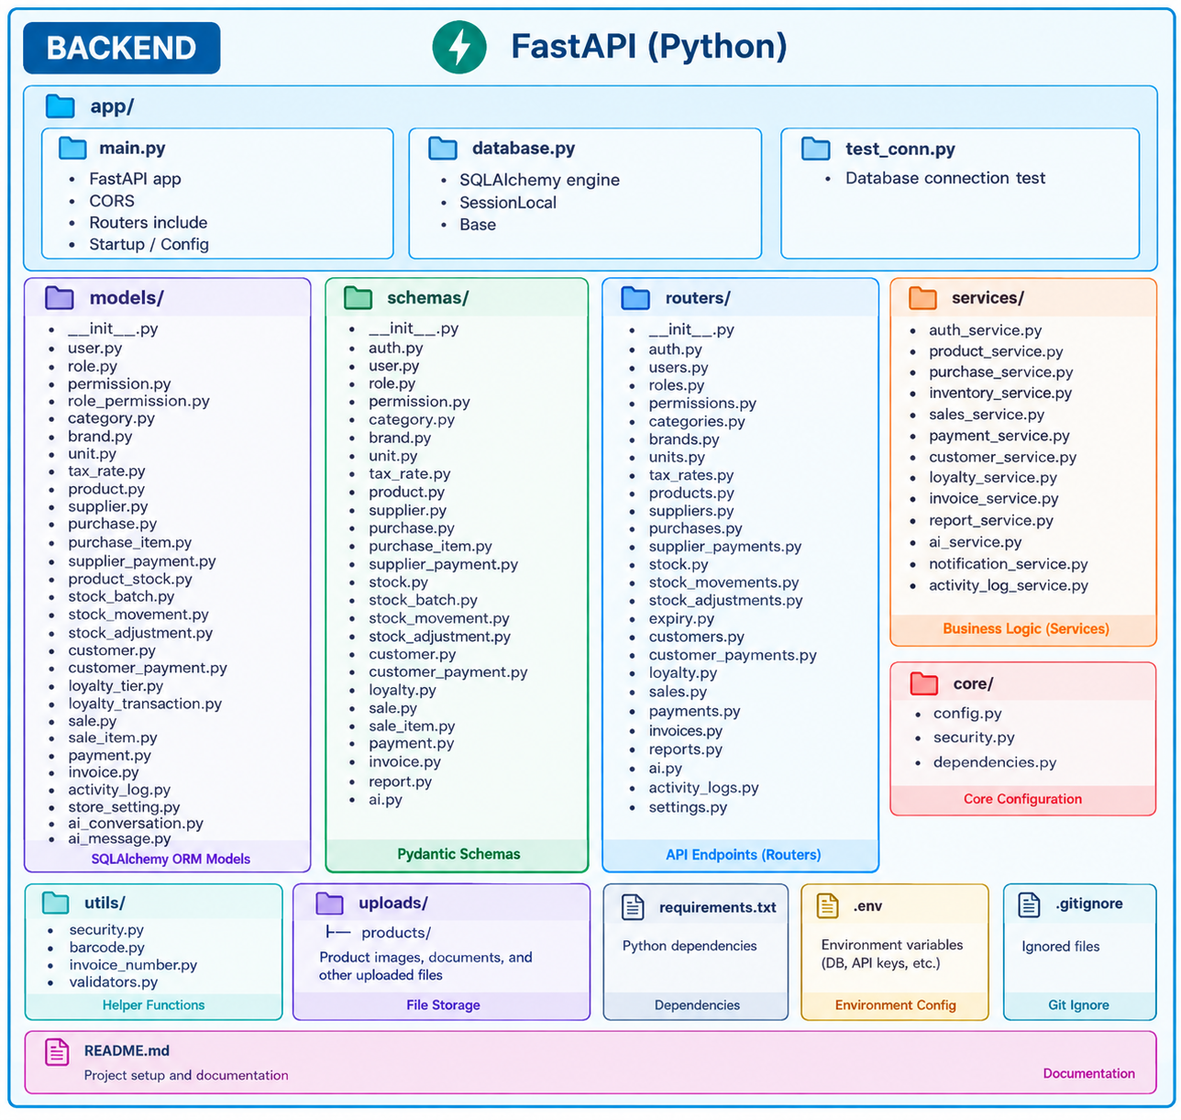

14.3 Relational Database

