**Who’s who in this project**

|  |  |
| --- | --- |
| **Group Member** | **Role** |
| Md. Aktaruzzaman Pramanik | Team leader, scale and evaluation experts |
| Jannatul Ferdus Rima | Coordinator |
| Mehedi Hasan | Art directors, designers |
| Sidratul Islam Tutul | Environment compilers, content experts |
| Muiduzzaman Mohit | Education technologists, education psychologists |
| Md. Imran Kabir | Producer |

***Steps required for accomplishing the project:***

1. **Educational goals of the course:**

* Enjoy mathematics and develop patience and persistence when solving problems
* Understand and be able to use the language, symbols and notation of mathematics
* Develop mathematical curiosity and use inductive and deductive reasoning when solving problems
* Become confident in using mathematics to analyse and solve problems both in school and in real-life situations
* Develop the knowledge, skills and attitudes necessary to pursue further studies in mathematics
* Develop abstract, logical and critical thinking and the ability to reflect critically upon their work and the work of others
* Providing enough knowledge and information for learning Differential Calculus
* Knowing and demonstrating the concepts of Limits, continuity and differentiability, L’Hospital’s rule, Euler’s theorem.
* Select and apply general rules correctly to solve problems including those in real-life contexts.

1. **Coverage and required flow:**

Knowledge and understanding are fundamental to studying mathematics and form the base from which to explore concepts and develop problem-solving skills. Through knowledge and understanding students develop mathematical reasoning to make deductions and solve problems.

The flow of tasks to complete the whole e-content is given below:

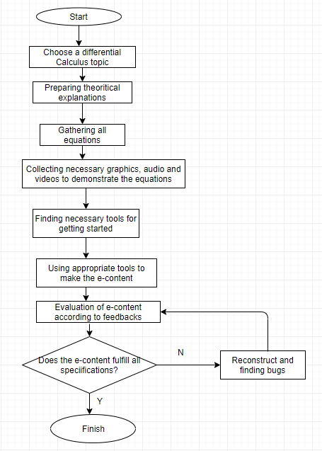

Fig: Flowchart

1. **Evaluation Scale:**

The user will be able to evaluate the performance and services provided by the e-content through a rating system, thus we can understand how well our content is doing.

The users can be able to rate the multimedia presentation by placing a check on the appropriate line.

Excellent _____ Very Good _____ Good _____ Fair _____ Poor _____

Making change according to the feedback on a trial version

1. **The materials to be used in the content:**

* JPEG image
* GIF image
* Graphics
* Audio
* Video
* Animation
* Text

1. **Building the materials in order to produce educational results:**

We will use necessary tools to produce required materials to build our e-content.

Such as, for creating audio presentation we will use Audacity, for making video elements we will use Blender, OpenShot etc.

Similarly we will use other tools for creating graphics, images and animations.

1. **Making changes according to the feedback on a trial version of the e-content**

Feedback is a powerful tool often under-utilized. It can be used to motivate people, help with a persons' development, uncover risks and issues and solve problems. Frequent, honest and relevant feedback helps to foster an environment of open communications.

We will follow the below procedures to receive and make decisions on the feedbacks:

* We won’t be afraid to ask for feedback
* Listening carefully to the feedback
* Not leaping to your own defense
* Checking our understanding and ask questions to clarify any grey areas
* Asking for specific examples of good and bad behaviors
* Allowing ourselves time to take in the feedback
* Defining which points we agree with and those we don't and why
* Looking together for a solution or for a way of making things better
* Thanking the other person for their time and effort in giving us the feedback