**Lab Final Tasks**

**Name:** Johirul Islam Tareq **Section**: O-6 **ID:** 171-15-8736

**Ans: a**

CREATE TABLE diu_student(

Roll int(3),

Name varchar(100),

Gender varchar(50),

Age int(3),

CGPA double(3,2),

Department varchar(10),

City varchar(15),

PRIMARY KEY(Roll)

);

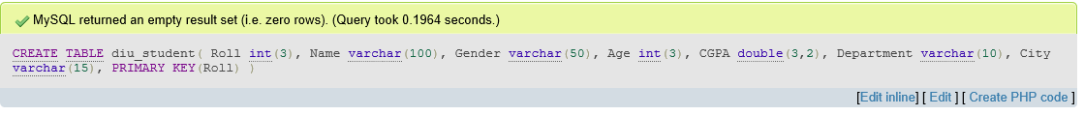

**Ans: b**

INSERT INTO diu_student VALUES (102,'Riya','Female',22,3.40,'EEE','Feni');

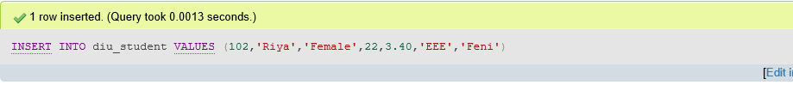

**Ans: c**

SELECT Name, Gender FROM diu_student WHERE Department = 'CSE';

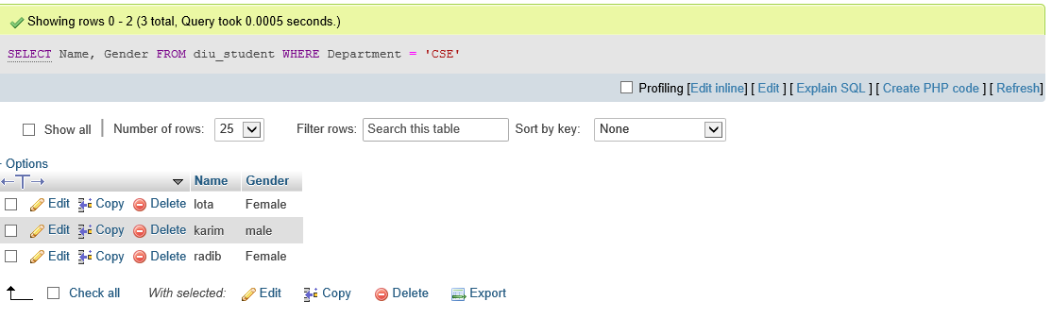

**Ans: d**

SELECT Name, CGPA FROM diu_student WHERE City = 'Dhaka' ORDER BY Name, CGPA;

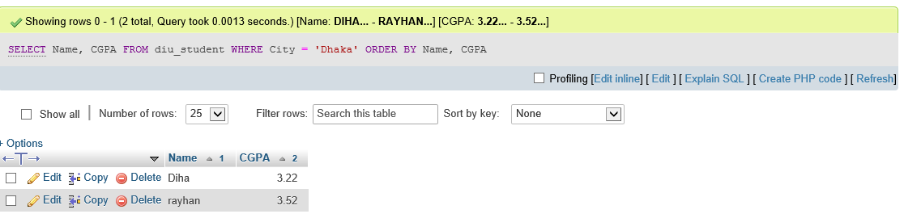

**Ans: e**

**DROP TABLE diu_student;**

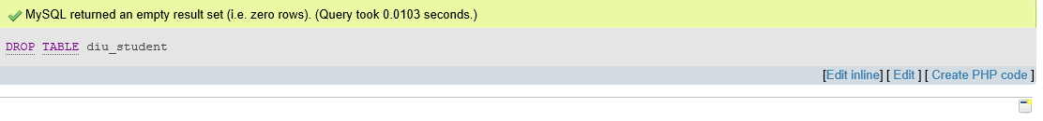

Ans: f

SELECT * FROM diu_student ORDER BY CGPA DESC;

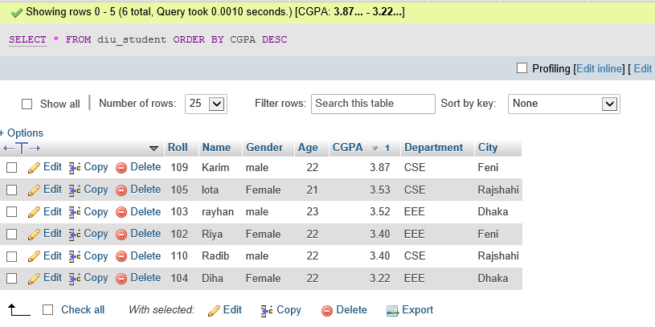

**Ans**: g

SELECT AVG(age), AVG(cgpa) FROM diu_student;

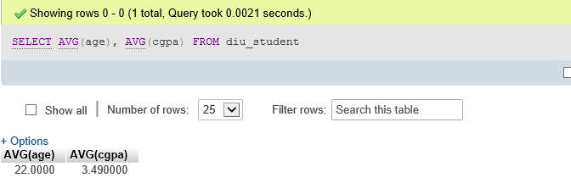

**Ans: h**

RENAME TABLE diu_student to student;

