**Expense Tracker**

Course: J2EE Business Components - ITE-5432-0NA

Professor: **Vitalii Bohudskyi**

Semester: 4th Semester

Project Title: Expense Tracker

Contents

1. Introduction 3

1.1 Purpose 3

1.2 Scope 3

2. Business Case 3

2.1 Business Case Requirements 3

• Problem Statement 3

• Target Audience 3

• Proposed Solution 3

• Scope 4

2.2 Business Case Justification 4

• Relevance 4

• Expected Outcome 4

• Feasibility 4

3. Functional Requirements 5

3.1 Authentication & Authorization 5

3.2 Expense Management (CRUD) 5

3.3 Admin Features 5

3.4 Filters & Visualization 5

3.5 AI Summary (Optional) 5

4. UML Diagrams 6

Class Diagram 6

Sequence Diagram 6

• Login page 6

• Register page 7

• Add expense page 7

• Edit expense page 8

• View all users page (Admin Role) 8

• View All expense page (User Role) 9

• Error page 9

5. Team Composition 9

# Introduction

## 1.1 Purpose

This document outlines the planning and architectural design for a full-stack, Spring-based Expense Tracker Web Application. The system aims to provide international students with an intuitive, multi-currency expense tracking platform, offering AI-driven insights and data visualization for smarter financial management.

## 1.2 Scope

The project is structured into three main phases:

* **Phase I**: Planning and architecture design
* **Phase II**: MVP development using Spring Boot and Thymeleaf
* **Phase III**: Deployment using Podman with performance validation

Technologies used include Java 17+, Spring Boot, Spring MVC, Spring Data JPA, MySQL, REST APIs, and Podman containers

# Business Case

## 2.1 Business Case Requirements

* Problem Statement

International students often face difficulties in managing multi-currency expenses and tracking personal spending while studying abroad. This leads to budget mismanagement and financial stress.

* Target Audience
  + International students studying in different countries with diverse currencies.
  + Students seeking smarter ways to analyze and optimize personal finances.
* Proposed Solution

A secure, multi-user web application built with Spring technologies that:

* + Tracks expenses with category and currency support
  + Visualizes spending trends
  + Offers admin tools for user management
  + Provides AI-generated monthly summaries
* Scope  
  **Core Features (MVP)**:
  + - Secure login and registration
    - Role-based dashboards (User/Admin)
    - CRUD for expenses
    - Filtering by date, category, and currency
    - REST APIs with Swagger documentation
  + **Optional Features**:
    - AI-powered insights (monthly summaries)
    - Charts

## 2.2 Business Case Justification

### Relevance

Directly addresses a common pain point for international students managing daily living costs abroad.

### Expected Outcome

* + Improved budgeting for students
  + Greater financial awareness and self-regulation
  + Admin tools to monitor user activity and manage the platform

### Feasibility

* + Achievable with the current team and timeline
  + Leverages proven Spring Boot and JPA technologies
  + Can be containerized using Podman for consistency in deployment

# Functional Requirements

## 3.1 Authentication & Authorization

* Secure login and registration
* Role-based access for Admin and Users

## 3.2 Expense Management (CRUD)

* Add/Edit/Delete/View expenses with:
  + Category
  + Date
  + Currency
  + Notes
* Validations and user feedback

## 3.3 Admin Features

* View all users
* View individual user dashboards
* Delete user accounts

## 3.4 Filters & Visualization

* Filter expenses by date, category, and currency
* Display category-wise and month-wise charts

## 3.5 AI Summary (Optional)

* Generate a monthly summary using integrated AI services (mocked or optional)

# UML Diagrams

## Class Diagram

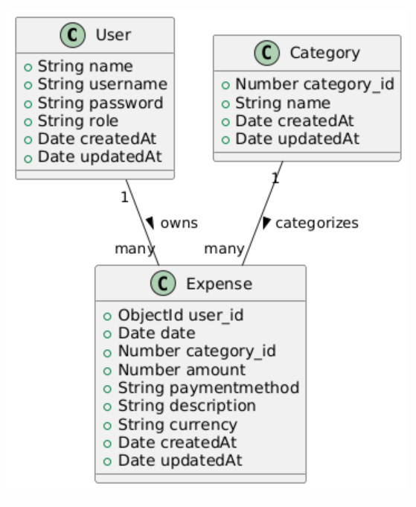

## Sequence Diagram

### Login page

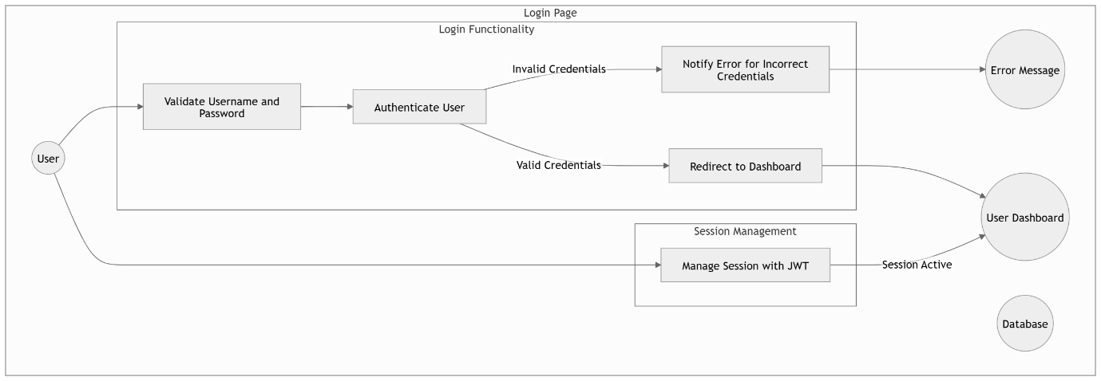

### Register page

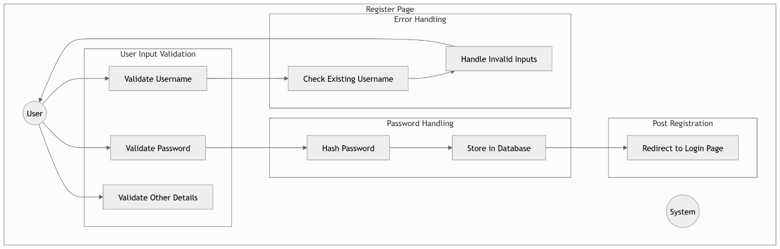

### Add expense page

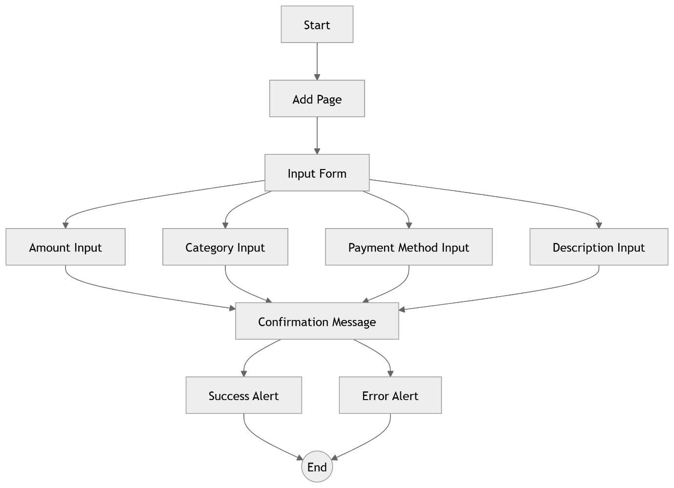

### Edit expense page

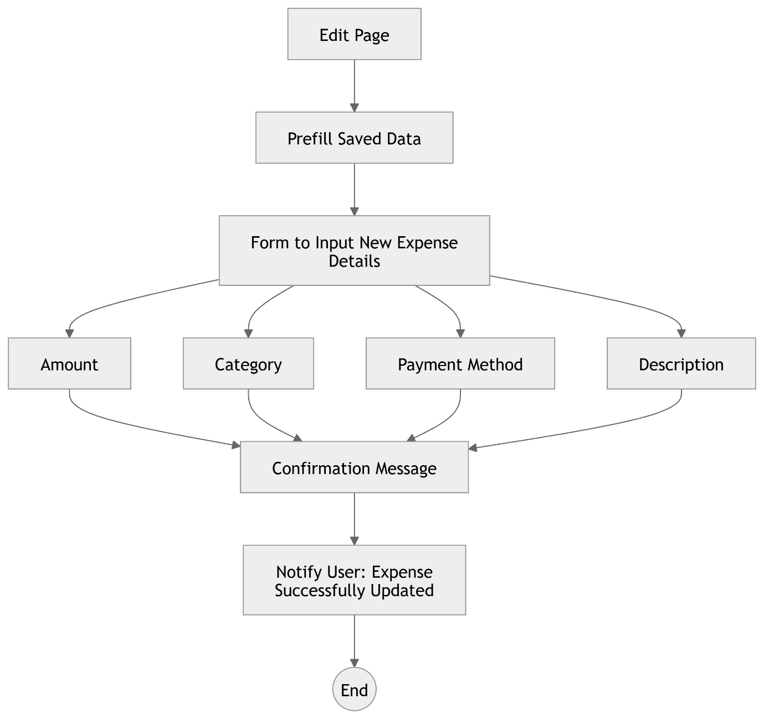

### View all users page (Admin Role)

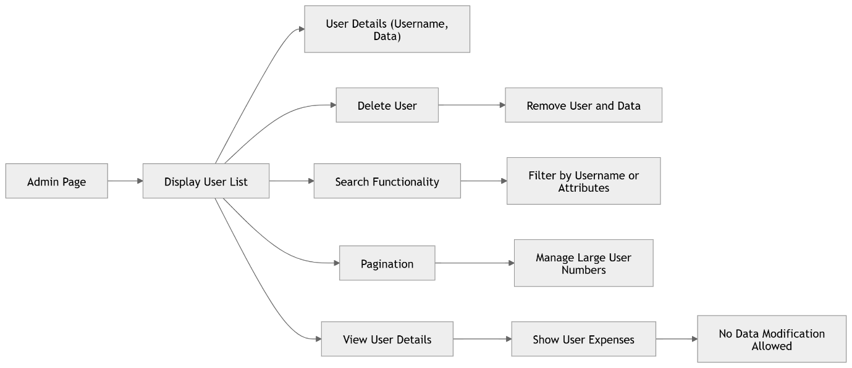

### View All expense page (User Role)

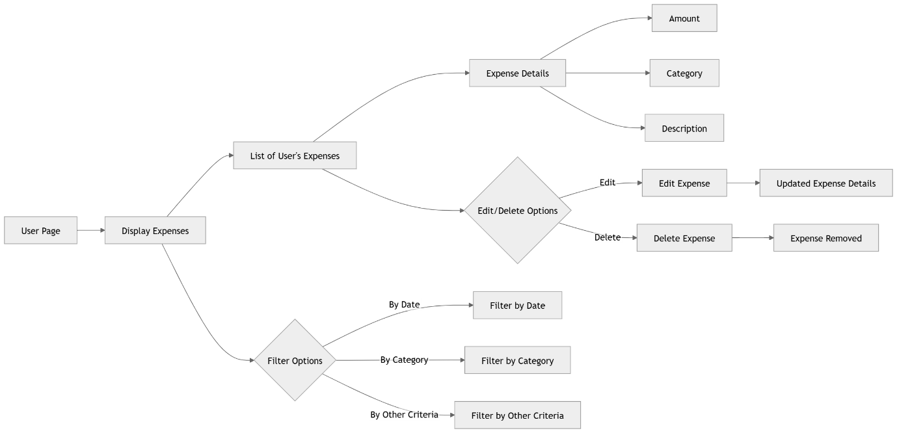

### Error page

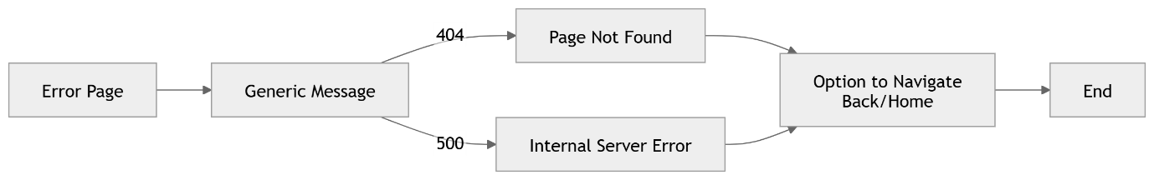

# Team Composition

|  |  |  |
| --- | --- | --- |
| **Name** | **Student ID** | **Role** |
| Urja Tej Bhemat | N01648980 | Team Lead & Developer |
| Sameeha Shaik | N01649346 | Developer |
| Kalwala Siddhartha Reddy | N01649317 | Developer |