Power BI Hands-on Assessment

Siddharth Singh

1. **Data Loading**

Create Database in SQL Server, then create tables and load data into them.

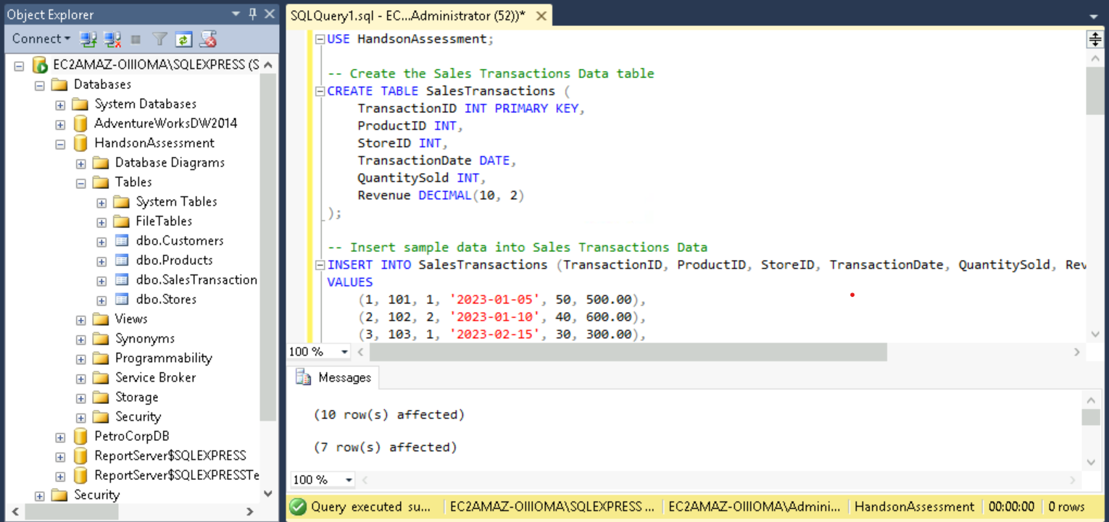

In PowerBI select SQL Server and enter Server Name

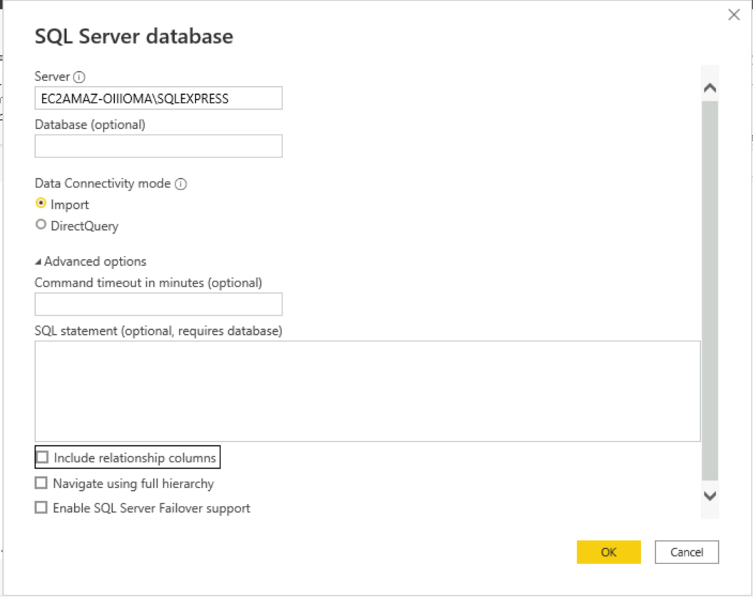

Select the database and select the tables to load the data from

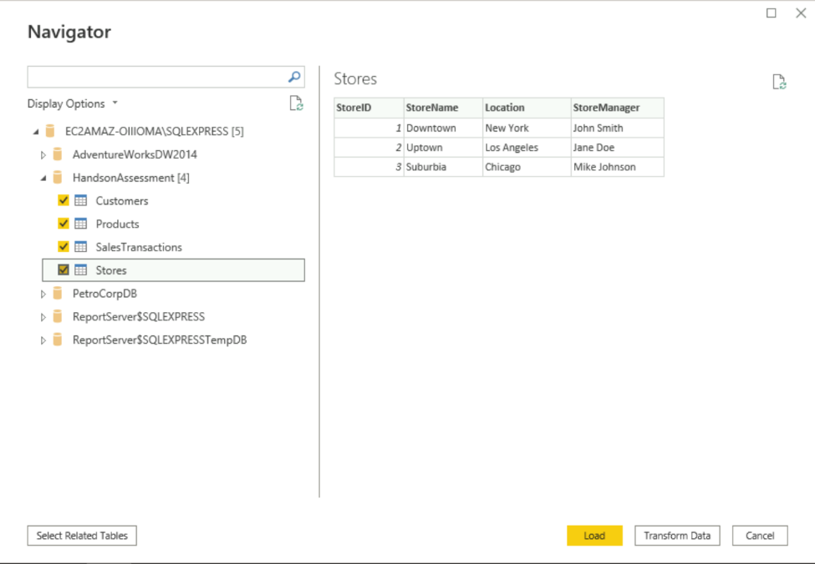

1. **Data Transformation**

Click on Transform Data which open Power Query Editor and select revenue column from SalesTransactions Table. Delete Revenue Column.

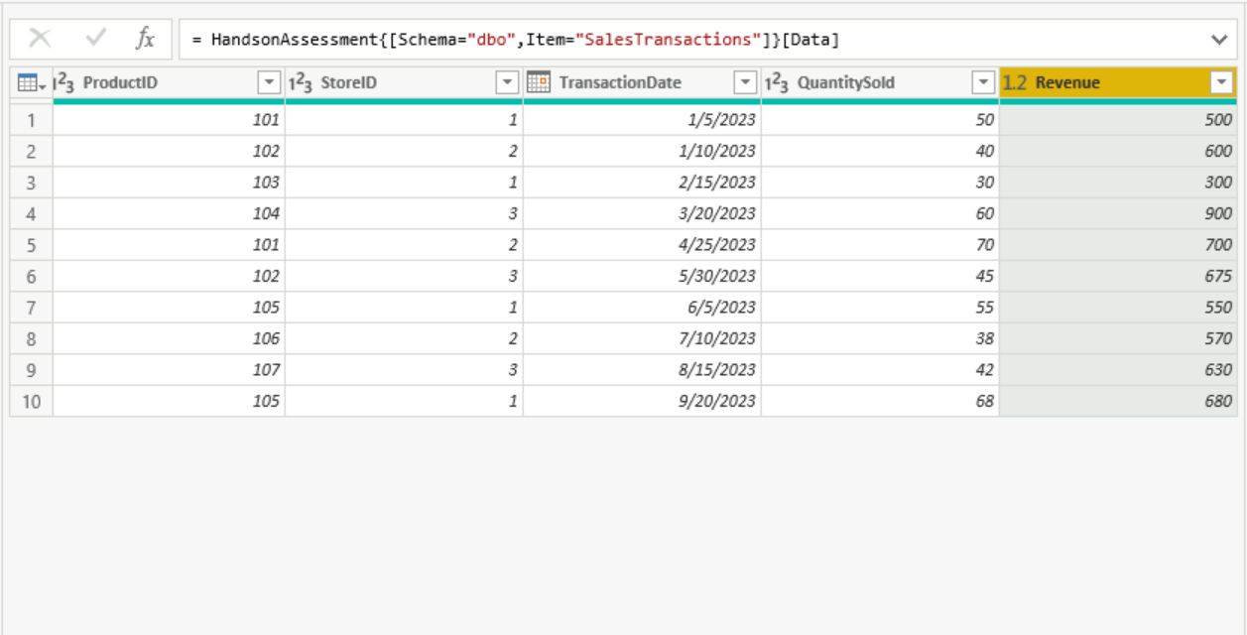

Click on Close and Apply.

Right Click on SalesTransactions and click on New Column and enter the DAX commands as below.



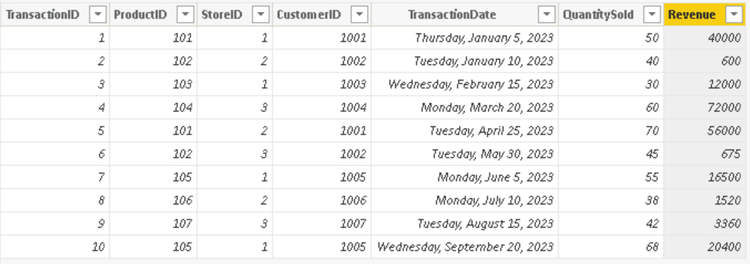

Similarly add Day of the week column in SalesTransactions

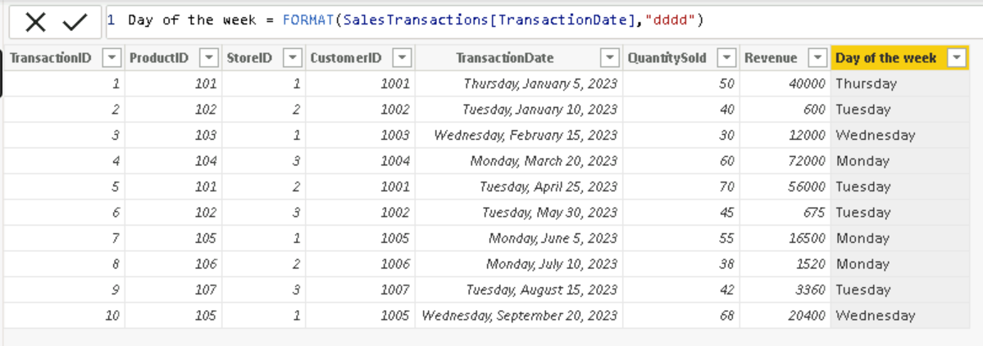

1. **Data Modelling**

Click on Model Tab and click on Manage Relationships. Select New.

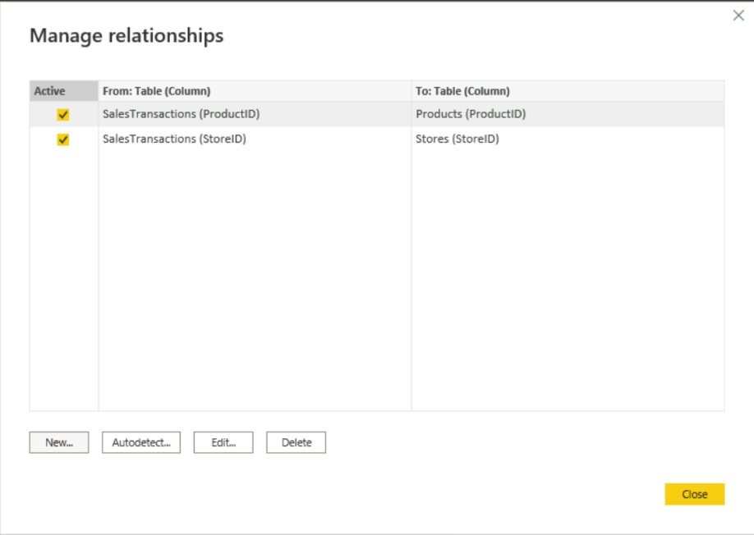

Select SalesTransactions and click on CustomerID. In the other dropdown select Customers and click on CustomerID.

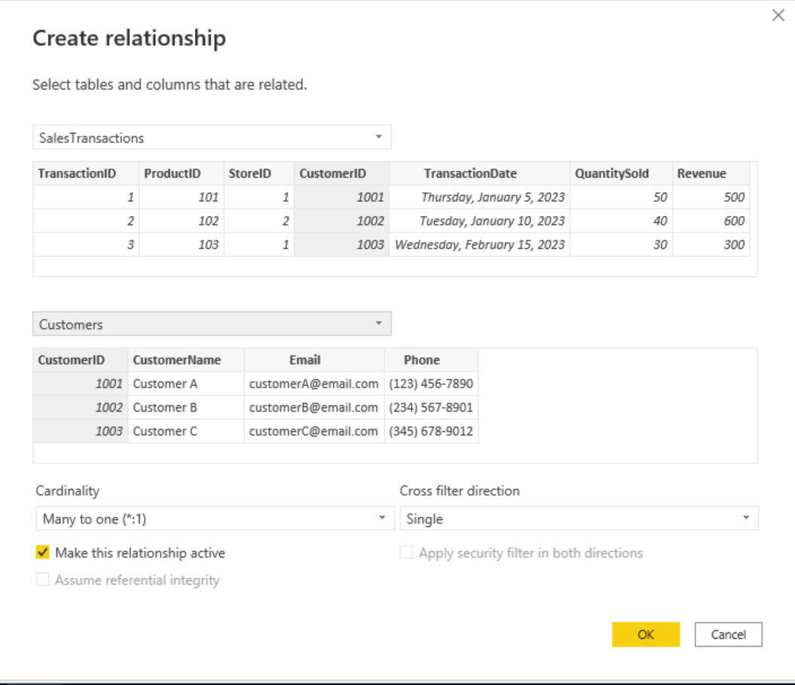

Date Hierarchy

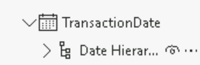

1. **Business Queries and Analysis**
2. Top Spending Customers based on total purchase amount.

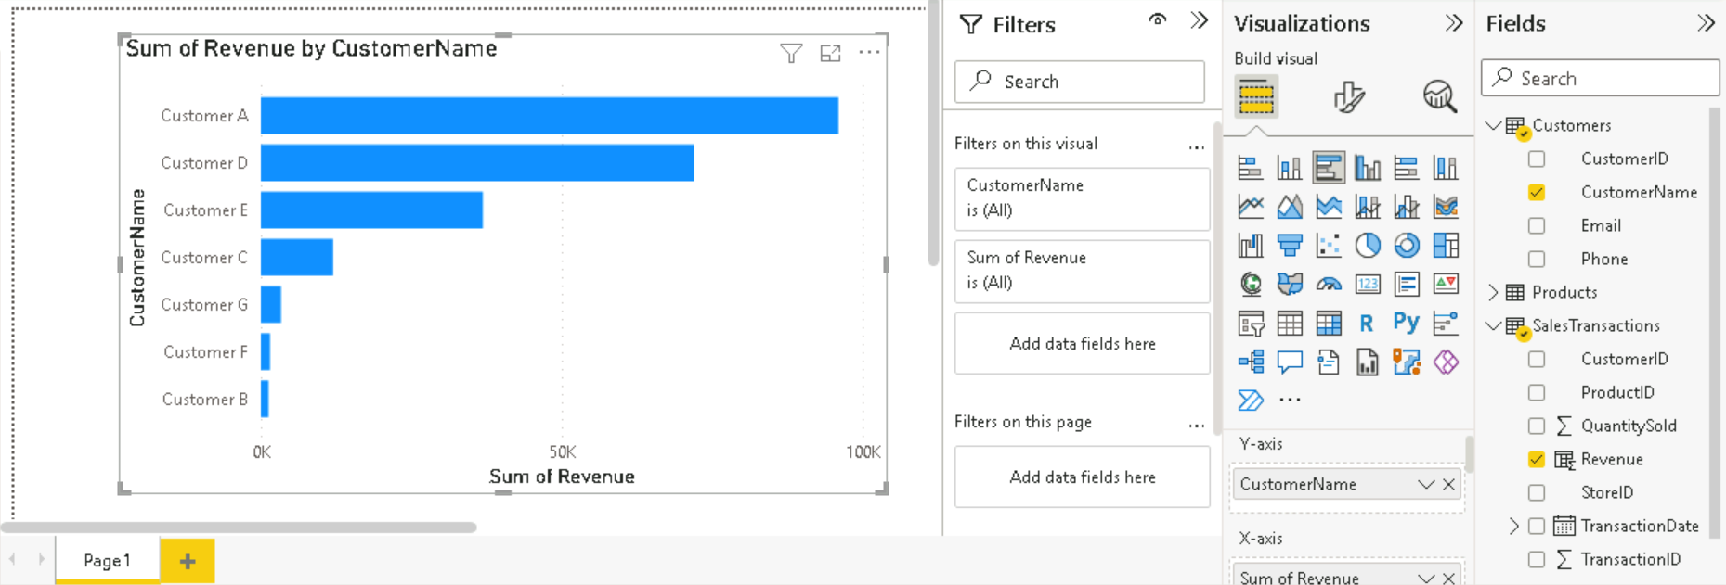

1. How is sales revenue distributed among different store managers?

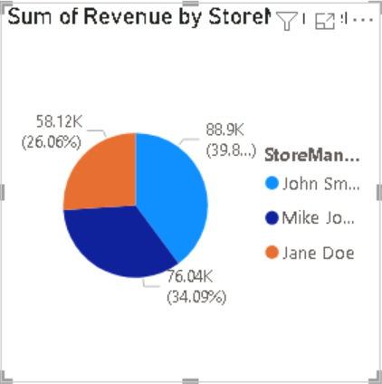

1. What is the average price of products in each category?

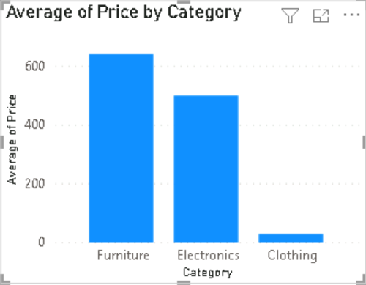

1. Are there specific days of the week when sales are higher?

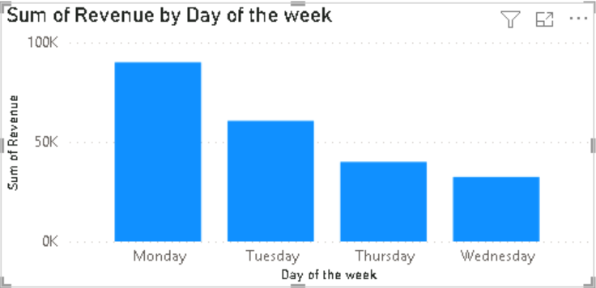

1. How do sales trends vary by product category on a monthly basis?

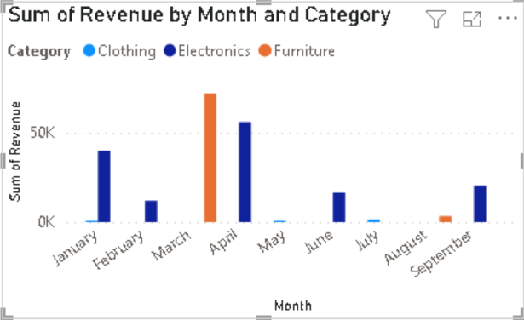

1. What percentage of products account for 80% of total sales revenue?

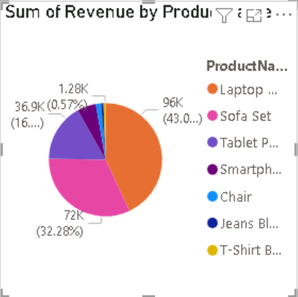

1. Are there any trends in repeat customer purchases?

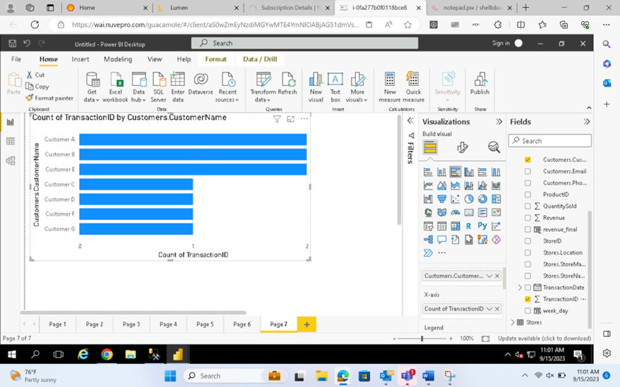

1. Which product categories perform best at each store location?

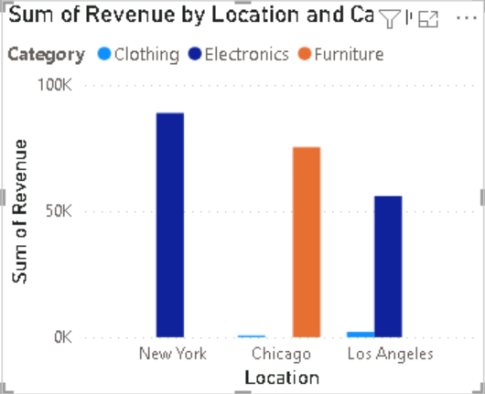

1. Are there any seasonal patterns or trends in sales for specific products or categories?

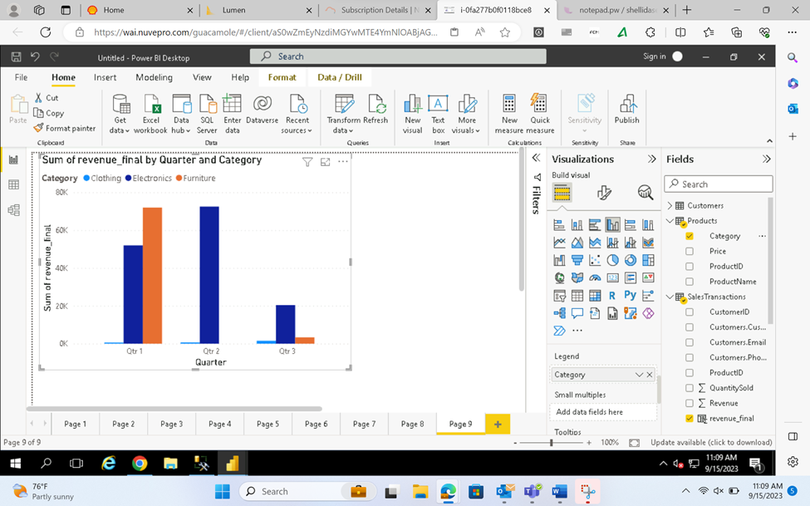

1. Can customers be segmented into high, medium, and low-value segments based on their purchase history.

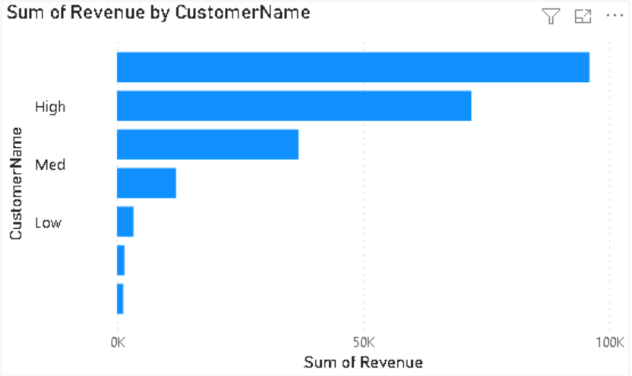

1. **Data Insights and recommendations**

Analysing Patterns:

Regional Variations: Los Angeles and New York show high demand for electronics.

Chicago has a greater amount of Furniture sales

Seasonality: Quarter 1 has the highest sales and sold most amount of sofa sets.

Quarter 2 has the next highest amount of sales and got most revenue from Laptop XYZ

Quarter 3 had least sales and had the most revenue generated by Tablet PQR

Generate Insights: Stock more electronics in Los angeles and New York. Stock mre furniture in Chicago.

Increased sales in the weekdays Monday and Tuesday compared to other days