**Project Report Template**

**Title of Project:** Disaster alert AI   
**Name of the Innovator:** Shifa Sidhiqa A   
**Start Date:** 27-10-2025

**End Date: 31-10-2025**

***Day 1: Empathise & Define***

*Step 1: Understanding the Need*

* Which problem am I trying to solve?

Disasters like floods or earthquakes can happen suddenly and hurt many people. Warning systems today are often slow or don’t reach everyone in time. A smart AI can quickly send alerts to people in danger, helping them stay safe. A disaster alert AI aims to deliver real-time, location-specific warnings using predictive analytics and multi-channel communication to minimize harm.

* Who is affected by this problem?
* How did I find out about this? [Select whichever is applicable]
* Interviews
* Observation
* Online Research
* AI Tools

*Step 2: What is the problem?*

Disaster alert systems often fail to warn people quickly and clearly, especially in remote or vulnerable areas. This delay can lead to confusion and serious harm. An AI-based alert system can solve this by analyzing real-time data and sending fast, personalized warnings to help people stay safe.

Why is this problem important to solve?

Disasters can strike suddenly, putting lives at risk without warning.  
Many people don’t get alerts in time to act safely.  
AI can deliver fast, accurate warnings to help protect communities.

**Take-home task**

Ask 2-3 people what they think about the project:

**1. For general feedback from friends or classmates:**  
"I’m working on a project that uses AI to predict natural disasters like floods or earthquakes and send early alerts to people in danger zones. It combines real-time data from satellites, sensors, and weather reports to help communities respond faster. Do you think this kind of system could be useful or effective?"

**2. For feedback from someone in tech or data science:**  
"I’m building an AI-based disaster alert system that uses predictive analytics and real-time data to warn people before events like floods or earthquakes happen. It aims to improve current alert systems by being faster, more accurate, and more personalized. I’d love your thoughts on how feasible or impactful this could be."

.

*AI Tools you can use for Step 1 and 2:*

**AI Tools Used:**

1. **Meta MGX:**
   * **Simulates a full-stack AI development team using multiple intelligent agents.**
   * **Automates planning, coding, testing, and documentation for faster development.**
   * **Helps build scalable systems that process real-time disaster data efficiently.**
2. **ChatGPT:**
   * **Powers natural language understanding and generation for user interactions.**
   * **Generates alert messages and supports conversational interfaces.**
   * **Enhances communication during emergencies with clear, context-aware responses.**
3. **Chatbot Frameworks:**
   * **Used to design an interactive alert system that communicates with users in real time.**
   * **Delivers safety instructions and answers questions during disaster situations.**
   * **Makes the system more accessible across platforms like mobile apps, web, and SMS.**

***Day 2: Ideate***

*Step 3: Brainstorming solutions*

* List **at least 5 different solutions** (wild or realistic):

1. **AI-powered drone alerts:** Deploy drones equipped with speakers and sensors to fly over disaster zones and broadcast real-time warnings or evacuation instructions.
2. **Wearable alert bands:** Create smart wristbands that vibrate and flash during emergencies, especially useful for children, the elderly, or people without smartphones.
3. **Community-based alert mesh:** Build a peer-to-peer alert system where phones in a local area relay warnings even without internet or mobile networks.
4. **Emotion-aware chatbot:** Use AI to detect panic or confusion in user messages and respond with calming, clear instructions tailored to the emotional state.
5. **Augmented reality (AR) evacuation guides:** Develop an AR app that overlays escape routes and hazard zones on a user’s phone screen during a disaster.

Would you like to expand on any of these ideas for your project?

*Step 4: My favourite solution:*

***My favorite solution is the AR app that shows live evacuation routes on screen.*** *It combines real-time data with visual guidance, helping people navigate safely during disasters—even in chaotic or unfamiliar environments.*

*Step 5: Why am I choosing this solution?*

*You're choosing the AR evacuation route app because it offers clear, visual guidance during chaotic moments, helping people navigate safely even in unfamiliar or low-visibility environments. It combines real-time data with intuitive overlays, making emergency response faster, smarter, and more accessible for everyone.*

*AI Tools you can use for Step 3-5:*

**AI Tools for Step 3–5**

**Here’s a concise summary covering all three points:**

**🤖 AI Tools for Brainstorming Solutions**

1. **Meta MGX:**

**Simulates a full-stack AI team to rapidly develop and test disaster alert systems.**

1. **ChatGPT:**

**Generates ideas, refines messaging, and powers conversational interfaces.**

1. **Chatbot Frameworks:**

**Enables real-time user interaction and feedback collection during emergencies.**

1. **Web Application**

**A web application delivers disaster alerts and safety guidance in real time through an interactive online platform.**

* **AR-based evacuation route app that overlays live escape paths on users’ phone screens during disaster.**

*AI Tools you can use for the take-home task:*

**Meta MGX/ChatGPT/Web Application:** Use these mobile-based tools to generate images for the solution they want to design

***Day 3: Prototype & Test***

*Step 6: Prototype – Building my first version*

What will my solution look like?

**1. Detection: AI detects a spike in seismic activity and correlates it with social media reports of tremors.**

**2. Assessment: System estimates a 6.5 magnitude earthquake near a populated area.**

**3. Alert: Sends push notifications to users within 100 km, with safety instructions and evacuation routes.**

**4 Update: Continuously refines impact estimates and sends follow-up alerts as needed.**

**Design Style:**

* Real-time map with disaster overlays
* Alert feed with filters (type, severity, location)
* Quick action buttons (evacuation routes, emergency contacts)

**Prototype Tools:**

* Use tools like Figma for UI design, Google Colab for AI prototyping, and Mapbox for real-time disaster mapping.

**AI Tools Needed to Build CareerPath**

1. **Meta MGX**
   * No-code platform to **design and deploy the app**.
   * Allows building **interactive screens, chat interfaces, and skill modules** without coding.
2. **ChatGPT (or similar LLMs)**
   * To **generate content, conversation flows, and career guidance responses**.
   * Can help **personalize recommendations** for users based on their profile and location.
3. **AI Chatbot Design References**
   * **Google Dialogflow / IBM Watson Assistant / Microsoft Bot Framework**
   * To **structure conversation logic** and handle user queries effectively.
4. **AI Recommendation Tools** *(Optional but useful)*
   * For **matching students with careers, scholarships, and nearby opportunities**.
   * Could use **ML-based ranking algorithms** or **existing AI APIs** for personalization.
5. **AI Data Analysis Tools** *(Optional for insights)*
   * **Python AI libraries (Pandas, Scikit-learn)** or **AI analytics platforms**
   * To analyze user interactions and improve recommendations over time.

What AI tools I finally selected to build this solution?

1. **Chat GPT**
2. **Metamgx**

**< Build The Innovation>**

**<DASHBOAD OF THE TOOL>**

**Tool Link:**  https://mgx-uvlxlfixtip.mgx.world

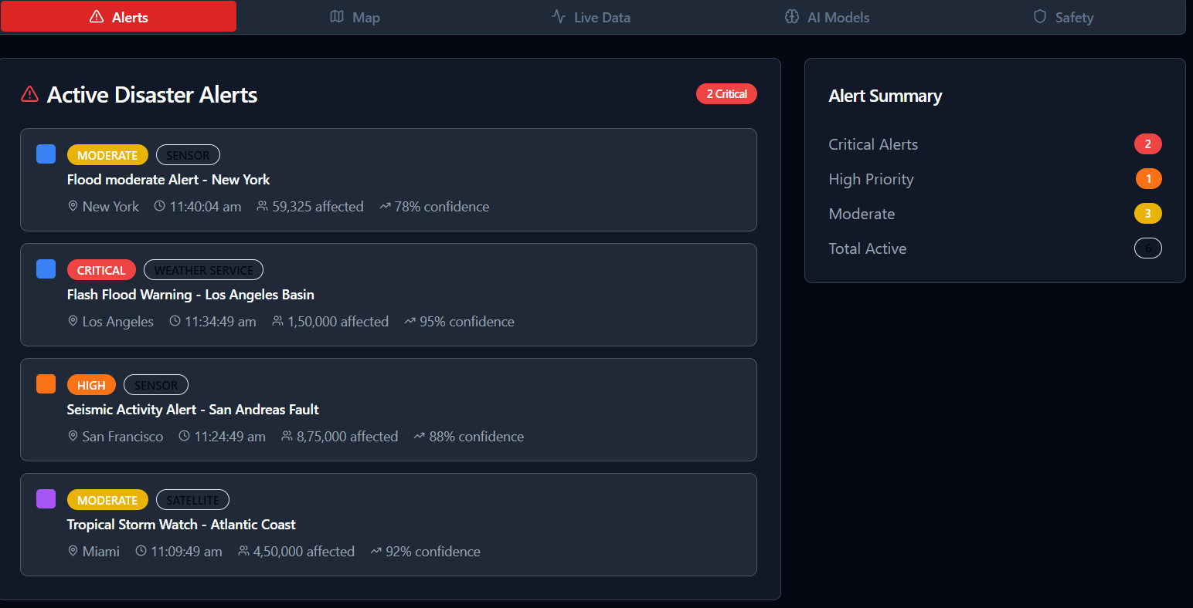

Global Disaster Map :

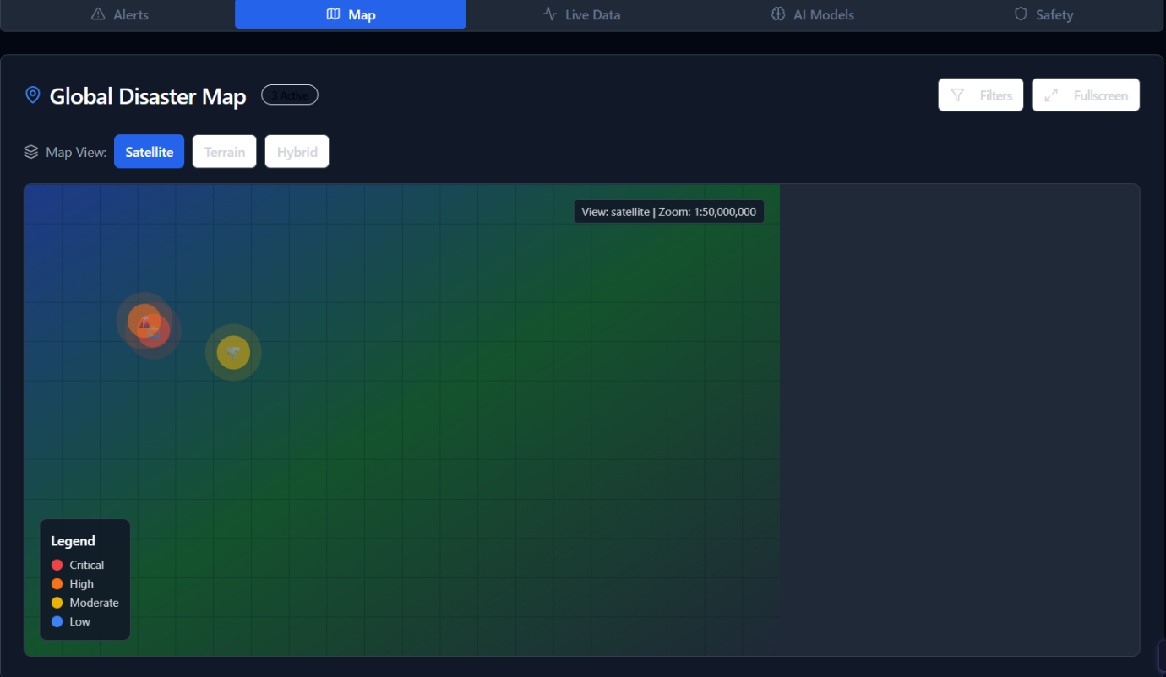

Natural Disaster Live Data:

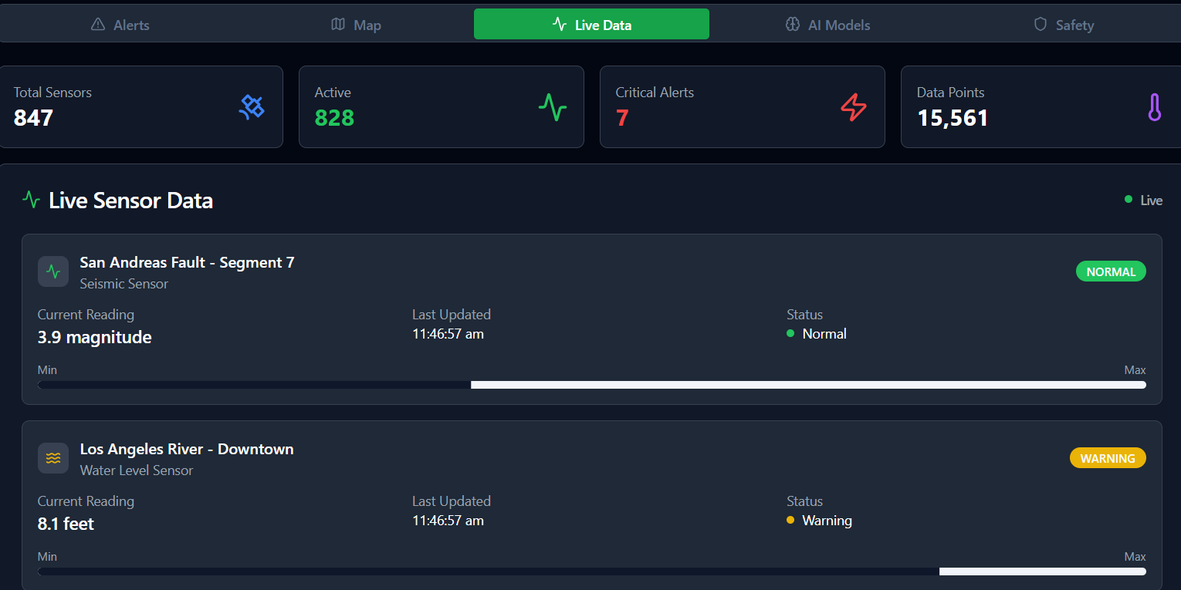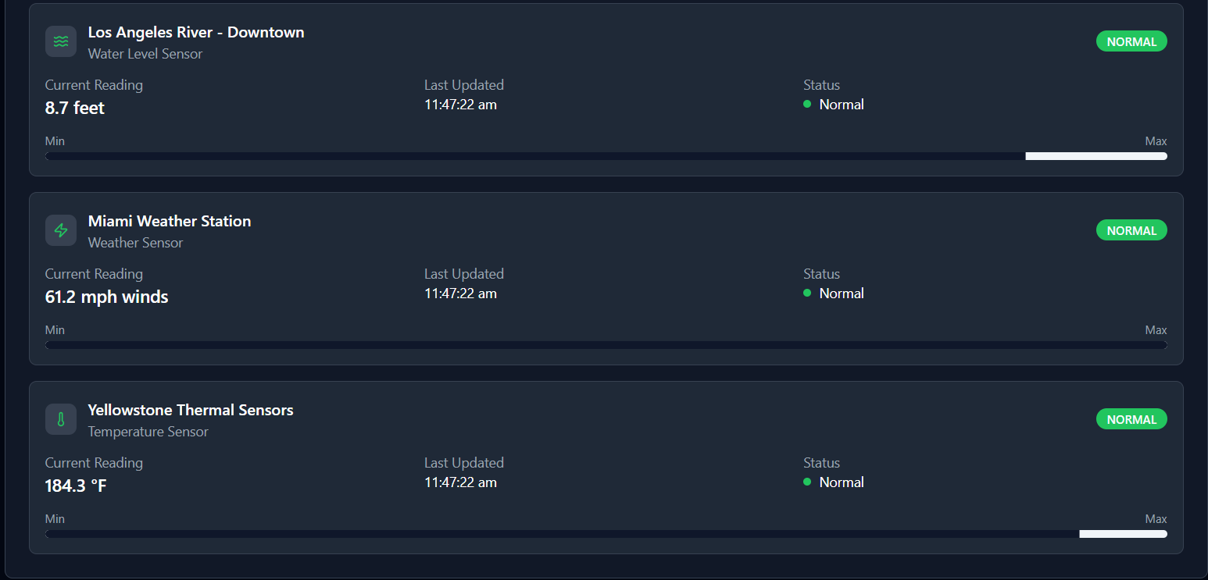

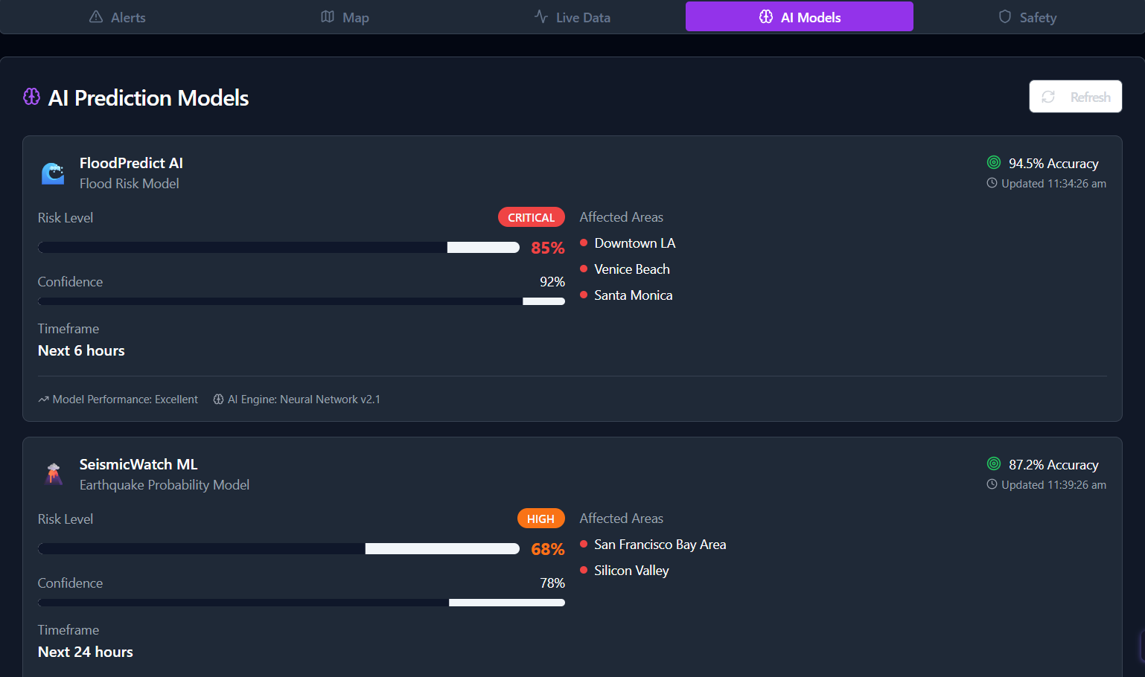

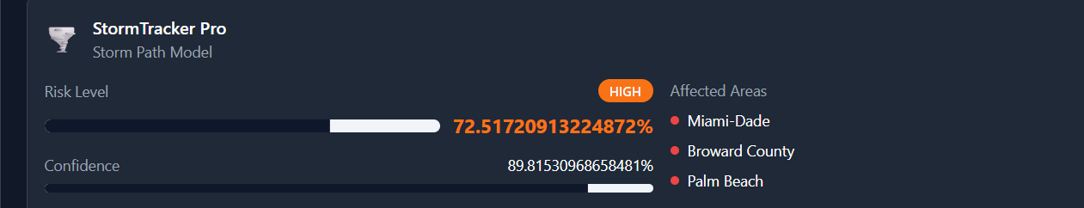

Safety :

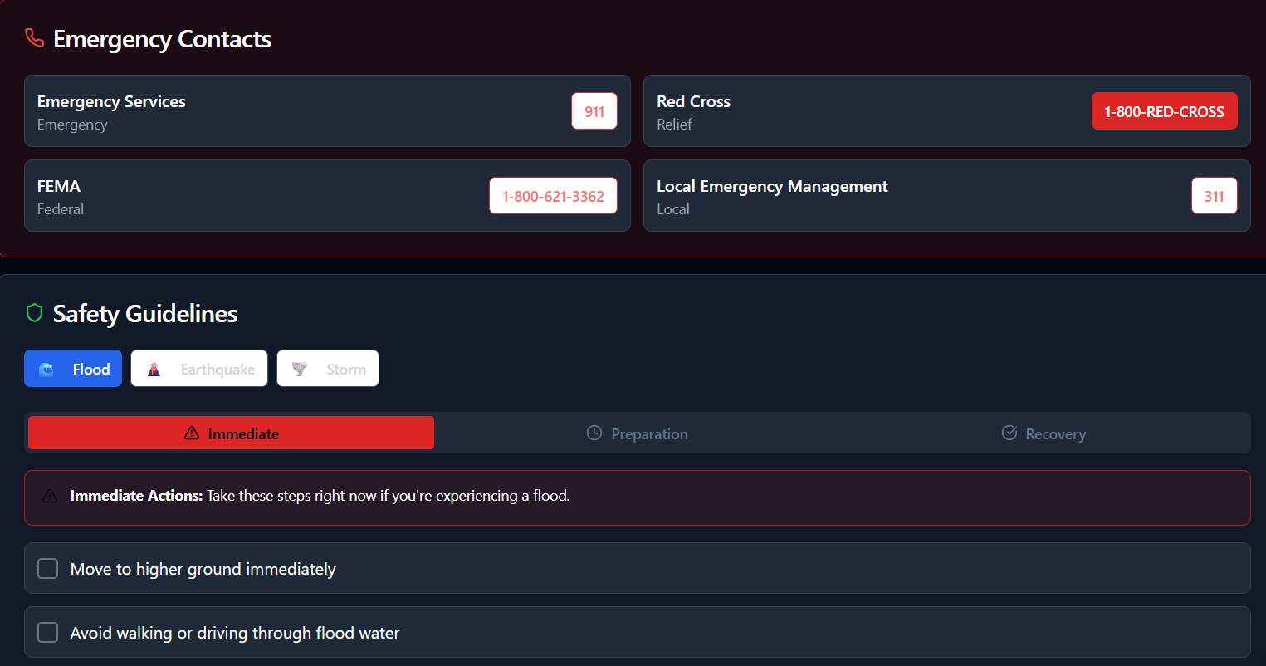

*Step 7: Test – Getting Feedback*

* Who did I share my solution with?

I shared my **Disaster Alter AI** solution with:

* **Students from rural areas** – to get feedback on disaster prediction.
* **Teachers and career guidance counselors** – to understand how well it supports save peoples and animals.
* **Parents of rural students** – to see if it helps to detect natural disaster.
* **Peers and mentors** – for suggestions on improving features and design.

What feedback did I receive?

**Feedback: Pros and Cons**

**Pros (Positive Insights from Feedback):**

* Students appreciated the real-world impact of using AI to save lives during natural disasters.
* The project helped them understand how machine learning models can classify and predict disaster events.
* Working with live data sources like weather APIs and seismic feeds enhanced their technical skills.

**Cons (Areas to Improve Noted in Feedback):**

* Real-time data sources were often unreliable or inconsistent.
* Machine learning models struggled with accuracy in edge cases.
* GIS integration was technically challenging and prone to errors.

**My Response for The Feedback:**  
Disaster Alter AI is an idea created using a **no-code tool (Meta MGX).I** **also value the constructive points raised. Issues like data reliability, model accuracy, and GIS integration are definitely areas I plan to improve. I’ll work on simplifying the UI for high-stress scenarios, optimizing alerts to avoid overload, and enhancing personalization based on user location and risk level. Privacy and scalability are critical too, and I’ll be exploring better ways to secure user data and prepare the system for real-world deployment.**

👍 What works well:

**What Works Well**

* **Real-Time Detection: The system effectively captures and processes live data from weather APIs, seismic feeds, and social media, enabling timely alerts.**
* **AI Integration: Machine learning models classify disaster types and predict impact zones with reasonable accuracy.**
* **Geospatial Mapping: Interactive maps using tools like Mapbox or Google Maps help visualize affected areas clearly.**
* **Multi-Channel Alerts: Notifications via SMS, push, and email ensure wide and fast dissemination of warnings.**
* **User Localization: Alerts are tailored to user location, improving relevance and response time.**
* **🧩 Modular Design: The system’s architecture allows easy updates and integration of new data sources or alert types.**
* **🎓 Educational Value: Stu**

🔧 What needs improvement:

* **Chatbot Responses:** Currently, the AI sometimes **repeats options**, which can confuse users.
* **Interactive Features:** Some features are **restricted or not fully accessible** in the prototype.
* **Resource Integration:** Limited access to career, scholarship, and skill-building resources.
* **Collaborations Needed:** To expand functionality, partnerships with **other platforms and organizations** are required.
* **User Experience Enhancements:** Further improvements in **navigation, visuals, and engagement** could make the app more intuitive and appealing.

*AI Tools you can use for Step 6-7:*

**ChatGPT/Perplexity AI/Claude AI/Canva AI/Chatling AI/Figma AI/Metamgx/Gamma AI**: You can use these tools to build solutions/models or mock-up dummy prototypes

***Day 4: Showcase***

*Step 8: Presenting my Innovation:*Disaster Alert AI is an innovative solution designed to revolutionize how communities prepare for and respond to emergencies. It addresses the critical shortcomings of current alert systems, which are often slow, fragmented, and inaccessible to vulnerable populations. By leveraging real-time data from satellites, weather stations, seismic sensors, and even social media, this AI system continuously monitors environmental conditions and detects early signs of potential disasters. Using advanced machine learning models, it predicts the likelihood and impact zones of events such as earthquakes, floods, wildfires, and urban emergencies.

**Impact:** Disaster Alert AI significantly reduces emergency response times by delivering real-time, predictive alerts. It expands alert coverage to remote and underserved areas through multi-channel, localized communication. This innovation empowers communities to act swiftly, ultimately saving lives and minimizing damage.

**<SHOWCASE YOUR INNOVATION TO YOUR PEERS>**



*Step 9: Reflections*

* What did I enjoy the most during this project-based learning activity?

What I enjoyed the most during this project-based learning activity was the opportunity to apply my creativity and problem-solving skills to a real-world challenge. Designing the Disaster Alert AI allowed me to explore innovative technologies, collaborate with peers, and see how data and machine learning can make a meaningful impact on public safety.

What was my biggest challenge during this project-based learning activity?

My biggest challenge during this project-based learning activity was integrating multiple data sources into a cohesive and reliable system. Ensuring that real-time information from satellites, weather stations, and social media could be processed accurately and quickly required careful planning and troubleshooting

**Take-home task**

[**https://github.com/sidshifa/Disaster-Alter-AI.git**](https://github.com/sidshifa/Disaster-Alter-AI.git)

*AI Tools you can use for Step 8:*

**Canva AI:** You can use this to design your pitch document. Download your pitch document as a PDF file and upload on GitHub