|  |  |  |  |  |  |  |  |  |  |  |  |  |
| --- | --- | --- | --- | --- | --- | --- | --- | --- | --- | --- | --- | --- |
| Name | | | Siying Wang | | | | | | | | | |
|  | | |  | | | | | | | | | |
| Student Number | | | 090466036 | | | | | | | | | |
|  | | |  | | | | | | | | | |
| Email address | | | siying.wang@qmul.ac.uk | | | | | | | | | |
|  | | |  | | | | | | | | | |
| Institute/School | | | Centre for Digital Music, Department of Electronic Engineering and Computer Science | | | | | | | | | |
|  | | |  | | | | | | | | | |
| Primary Supervisor | | | Dr. Simon Dixon | | | | | | | | | |
|  | | |  | | | | | | | | | |
| Initial enrolment date | | | **23 September 2013** | | | | | | | | | |
| Year of study (please circle) | | | **1** | | **2** | | **3** | | **4** | | | **Writing Up** |
| Final Submission date | | | **23 September 2017** | | | | | | | | | |
|  | | |  | | | | | | | | | |
| Thesis Title | | | Linking Score and Audio | | | | | | | | | |
|  | | |  | | | | | | | | | |
| **Main source of studentship funding (e.g. AHRC, NERC, QMUL, self-funded): CSC** | | | | | | | | | | | | |
|  | |  | | | | | | | | | | |
|  | |  | | | | | | | | | | |
| **Requested funding breakdown:** | |  | | | | | | | | | | |
| *Cost category* | *Total amount* | | | *Amount requested from PGRF* | | | | | | *Amount sought from other funders* | | |
| Accommodation | £250(screenshot attached) | | | £250 | | | | | |  | | |
| Conference registration | £300 | | | £300 | | | | | |  | | |
| Subsistence | £150 | | | £150 | | | | | |  | | |
| Travel | £760(screenshot attached) | | | £760 | | | | | |  | | |
| Other research expenses (please specify) | 0 | | | 0 | | | | | |  | | |
|  |  | | |  | | | | | |  | | |
| Visa application | £13.5 | | | £13.5 | | | | | |  | | |
|  |  | | |  | | | | | |  | | |
| *Total* | £1473.5 | | | £1473.5 | | | | | | 0 | | |
|  | | | | | | | | | | | | |
| Have you previously applied to the fund? | | | Yes | | |  | | No | | | **X** | |
| **If ‘Yes’, please state when and amount awarded** *(if any)* | | | **Date** | | |  | | **Amount** | | |  | |

**Brief description of the purpose and significance of these expenses in relation to your research.** If you are applying to support a presentation at a conference please provide the title of your paper or poster, date, location and title of conference and the reasons it is important to present at this particular conference. Do NOT include a detailed description of your thesis, or the presentation's abstract. Include the location and dates of the event.

If you are applying to visit an overseas research institution please describe exactly why the visit is important for your research and the lasting impact, on future collaborations for example.(*Max 500 words)*

I would like to apply the Postgraduate Research Fund to attend the 15th International Society for Music Information Retrieval Conference (ISMIR) between 27th and 31st of October, 2014, in Taipei, Taiwan. I submitted the paper ''Robust Joint Alignment of Multiple Versions of a Piece of Music”, which was co-authored by myself and my supervisor Dr. Simon Dixon and Dr. Sebastian Ewert, as the output of my first year Phd study in Queen Mary.

In this paper, I presented a novel method of music alignment to establish a link between multiple versions of a piece of music which exist in the large music content libraries. It is the first step of my phd project which focuses on audio alignment. The ISMIR conference is the top international conference in Music Informatics that many world's leading researchers attend. It covers a wide ranges of subfields in the area of music information retrieval, including music contents extracting and music signal processing, which are the key part of my phd work. Therefore, it will be a great opportunity for me in the first year of phd study to present my work to the community and the feedbacks which I will receive will help shape my research. Also, it will help to disseminate the research and enhance the international profile of QMUL. Moreover, I can also get inspired by learning about the latest advances in the field.

Please provide **brief** **details of any conferences you have previously attended or presented at**:

None

Please provide details of any **external funding** for which you have applied in relation to these expenses

None

**Signature** (type name if submitting electronically) Siying Wang

**Date 15 May 2014**

**Supporting statement from supervisor**. This statement should include confirmation of the ways in which the intended activity will contribute to the doctoral research and/or knowledge transfer and if external funding has not been secured, why this has not been possible (*Max 500 words*).

**Supervisor's signature** (type name if submitting electronically)

**Date**

**Please return this completed form to:**

Your School/Institute administrator, at the deadline set by them (which will be at least a week before the dates given below) who will then collate and forward on to [qmpgrf@qmul.ac.uk](mailto:qmpgrf@qmul.ac.uk) all the applications from your School/Institute.

**Sign off from Director of Graduate Studies/Research**

**Signature** (type name if submitting electronically)

**Date**

SCHOOL ADMINISTRATORS ARE REQUESTED TO ENSURE THEY HAVE OBTAINED SIGN-OFF BEFORE SUBMITTING ALL APPLICATIONS FROM YOUR SCHOOL TO [qmpgrf@qmul.ac.uk](mailto:qmpgrf@qmul.ac.uk)

**There are three annual deadlines, with the Panel convening to consider applications each term. The final deadlines for the submission of applications from Schools/Institutes are:**

**1 October**

**1 February**

**1 June**

**Snapshot of Travel**

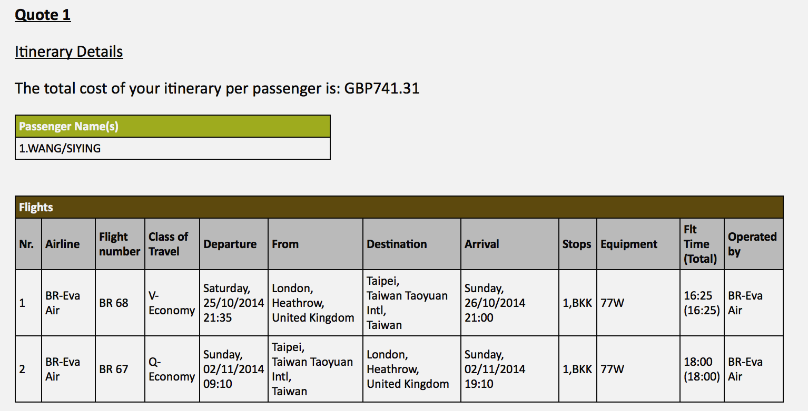

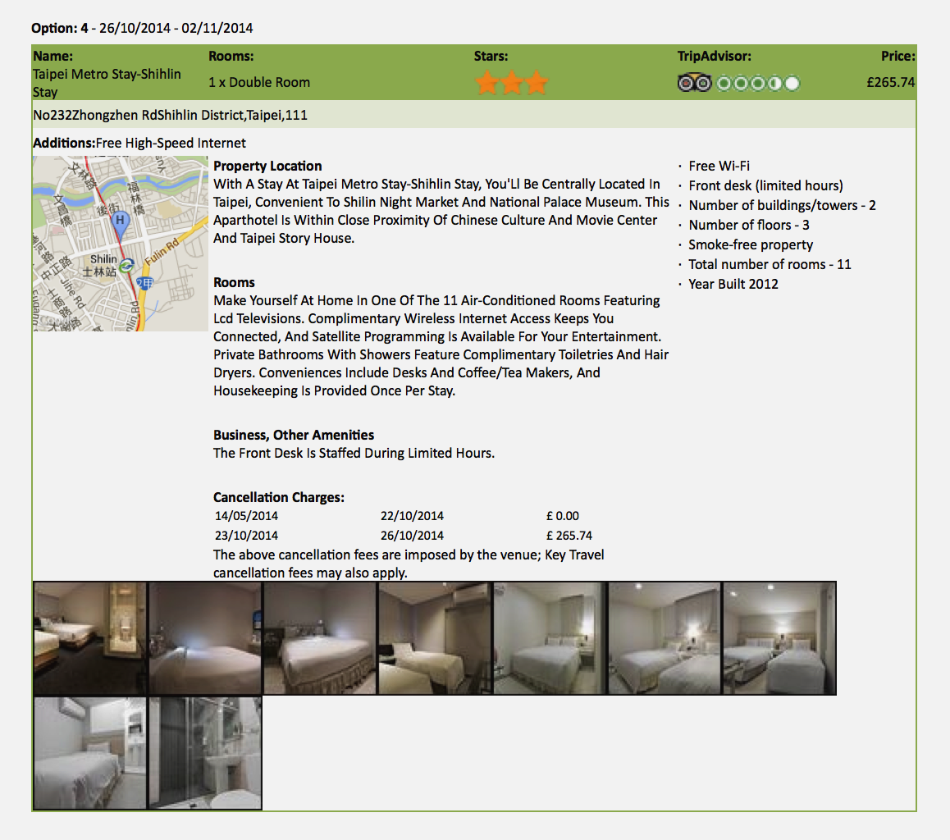

**Snapshot of Accommodation**