NC State University
Department of Electrical and Computer Engineering
ECE 506: Fall 2014
MACHINE PROBLEM 2: SHARED MULTIPROCESSOR CACHE SYSTEM SIMULATOR

by

SIDDHARTH SINGH

INTRODUCTION

In this project, I have implemented one level of cache only with coherence maintained across one level of cache. The system consists of each processor having its own private L1 Cache and shared bus interconnecting all the caches. The system is as shown below :-
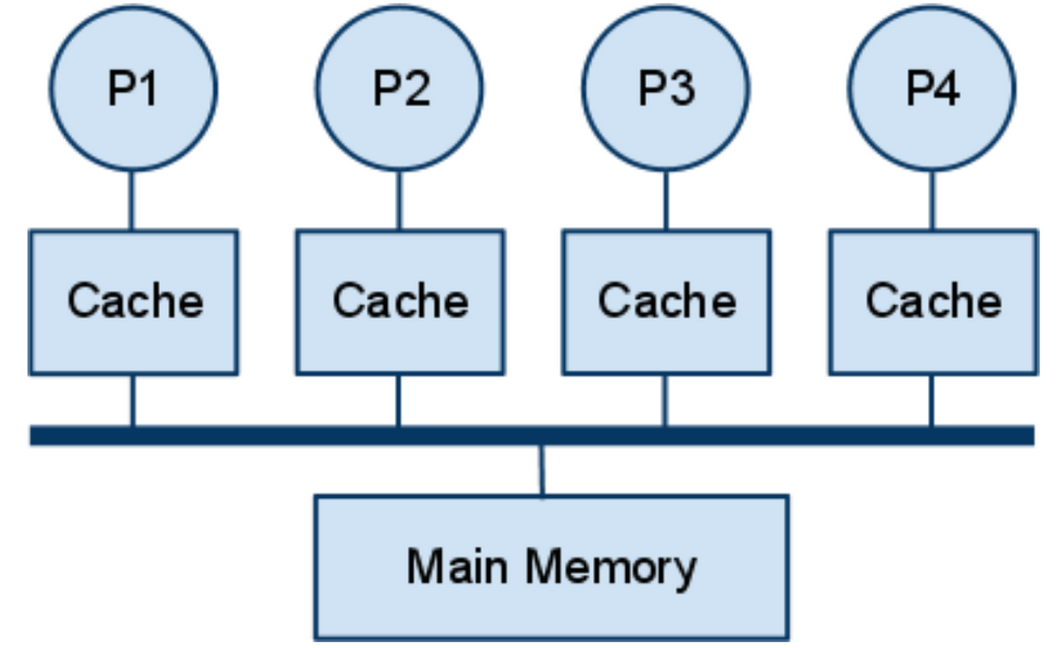

The simulator is designed and supports three different cache coherence protocols namely MSI, MESI and Dragon. This simulator generates a single binary file which can then be used for running different specifications of the shared memory multiprocessor system and selecting the cache coherence algorithm to be used for running the simulator.The report is organised below with statistics of variation for each of the three cache coherence protocol MSI,MESI and Dragon along with relevant figures and observations.

MSI PROTOCOL

CACHE SIZE VARIATION IMPACT ON PERFORMANCE

The performance benchmarks I have chosen are total memory traffic and total miss rate because irrespective of any protocol we see these are two important metrics in benchmarking two different classes of protocols implemented Write invalidation based protocols MSI,MESI and Dirty Sharing /Write Update based algorithm Dragon protocol.
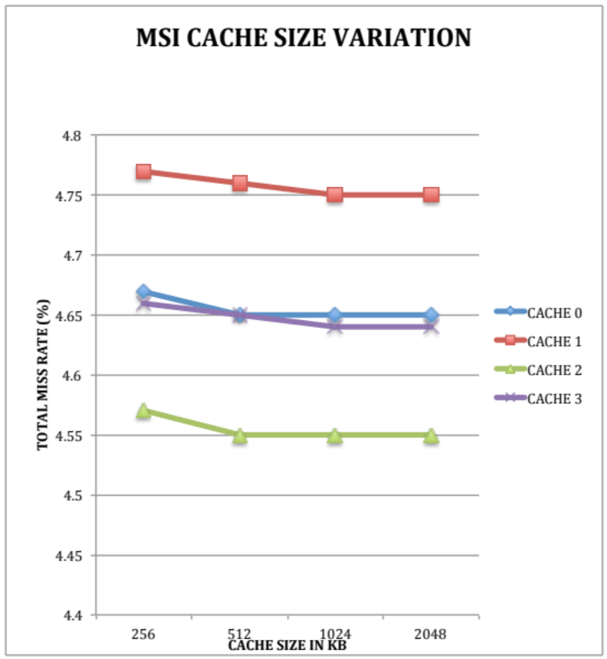

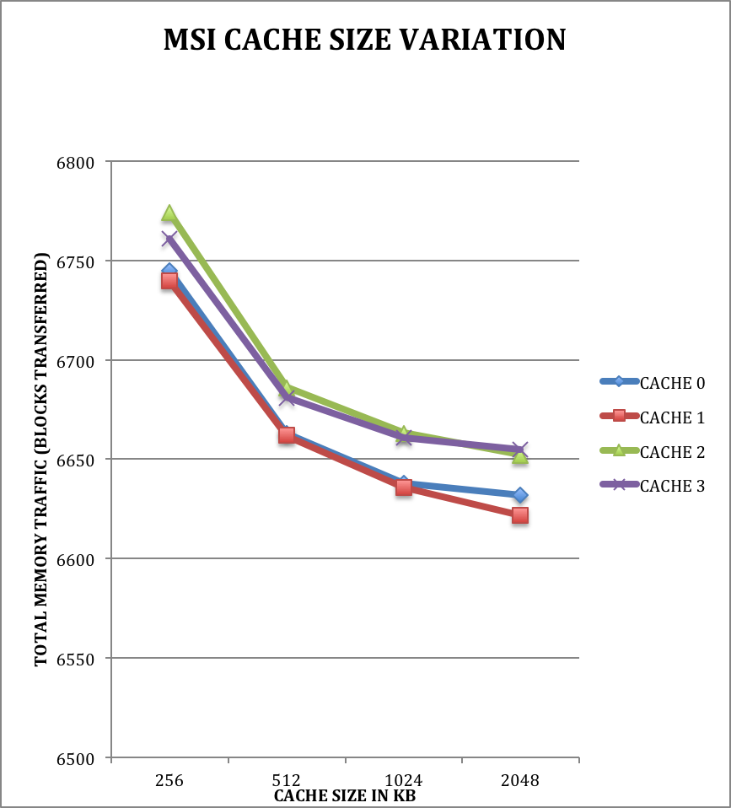

CACHE 256 KB 8 WAY 64B BLOCK | CACHE 0 | CACHE 1 | CACHE 2 | CACHE 3
READS | 112661 | 110830 | 114938 | 113428
READ MISSES | 5775 | 5805 | 5771 | 5813
WRITES | 11942 | 11710 | 12383 | 12108
WRITE MISSES | 39 | 41 | 42 | 39
MISS RATE (%) | 4.67% | 4.77% | 4.57% | 4.66%
WRITEBACKS | 254 | 235 | 278 | 234
CACHE TO CACHE TRANSFER | 0 | 0 | 0 | 0
MEMORY TRANSACTIONS | 6745 | 6740 | 6774 | 6761
INTERVENTIONS | 68 | 47 | 81 | 63
INVALIDATIONS | 2014 | 2034 | 2008 | 2020
FLUSHES | 113 | 92 | 120 | 88

CACHE 512 KB 8 WAY 64B BLOCK | CACHE 0 | CACHE 1 | CACHE 2 | CACHE 3
READS | 112661 | 110830 | 114938 | 113428
READ MISSES | 5757 | 5792 | 5756 | 5796
WRITES | 11942 | 11710 | 12383 | 12108
WRITE MISSES | 39 | 41 | 42 | 39
MISS RATE (%) | 4.65% | 4.76% | 4.55% | 4.65%
WRITEBACKS | 190 | 170 | 205 | 171
CACHE TO CACHE TRANSFER | 0 | 0 | 0 | 0
MEMORY TRANSACTIONS | 6663 | 6662 | 6686 | 6681
INTERVENTIONS | 71 | 47 | 82 | 63
INVALIDATIONS | 2014 | 2034 | 2008 | 2020
FLUSHES | 116 | 92 | 121 | 88

CACHE 1MB 8 WAY 64B BLOCK | CACHE 0 | CACHE 1 | CACHE 2 | CACHE 3
READS | 112661 | 110830 | 114938 | 113428
READ MISSES | 5752 | 5781 | 5752 | 5790
WRITES | 11942 | 11710 | 12383 | 12108
WRITE MISSES | 39 | 41 | 42 | 39
MISS RATE (%) | 4.65% | 4.75% | 4.55% | 4.64%
WRITEBACKS | 170 | 155 | 186 | 157
CACHE TO CACHE TRANSFER | 0 | 0 | 0 | 0
MEMORY TRANSACTIONS | 6638 | 6636 | 6663 | 6661
INTERVENTIONS | 71 | 48 | 82 | 64
INVALIDATIONS | 2014 | 2034 | 2008 | 2020
FLUSHES | 116 | 93 | 121 | 89

CACHE 2 MB 8 WAY 64B BLOCK | CACHE 0 | CACHE 1 | CACHE 2 | CACHE 3
READS | 112661 | 110830 | 114938 | 113428
READ MISSES | 5750 | 5779 | 5751 | 5789
WRITES | 11942 | 11710 | 12383 | 12108
WRITE MISSES | 39 | 41 | 42 | 39
MISS RATE (%) | 4.65% | 4.75% | 4.55% | 4.64%
WRITEBACKS | 166 | 143 | 176 | 152
CACHE TO CACHE TRANSFER | 0 | 0 | 0 | 0
MEMORY TRANSACTIONS | 6632 | 6622 | 6652 | 6655
INTERVENTIONS | 71 | 48 | 82 | 64
INVALIDATIONS | 2014 | 2034 | 2008 | 2020
FLUSHES | 116 | 93 | 121 | 89

Analysis The cache size variation reports a insignificant effect on total miss rate reduction in other words after increasing the cache size from 256 KB to 512 KB there is no improvement in capacity misses according to the benchmark trace “canneal” given to us, there is also no effect on reduction of coherence based misses as number of invalidations remain constant for all the variations. Memory traffic offers a significant improvement at each variation of the cache size variation from 256 KB to 2 MB from lets say 6745 for cache 0(256KB) to 6632(2 MB cache 0) , 6740 for cache1(256 KB) to 6622 cache1(2 MB) , 6774 for cache 2(256 KB) to 6652 (2 MB cache 2) and 6761 (cache 3 256 KB) to 6655 (2 MB cache 3).

CACHE ASSOCIATIVITY VARIATION IMPACT ON PERFORMANCE

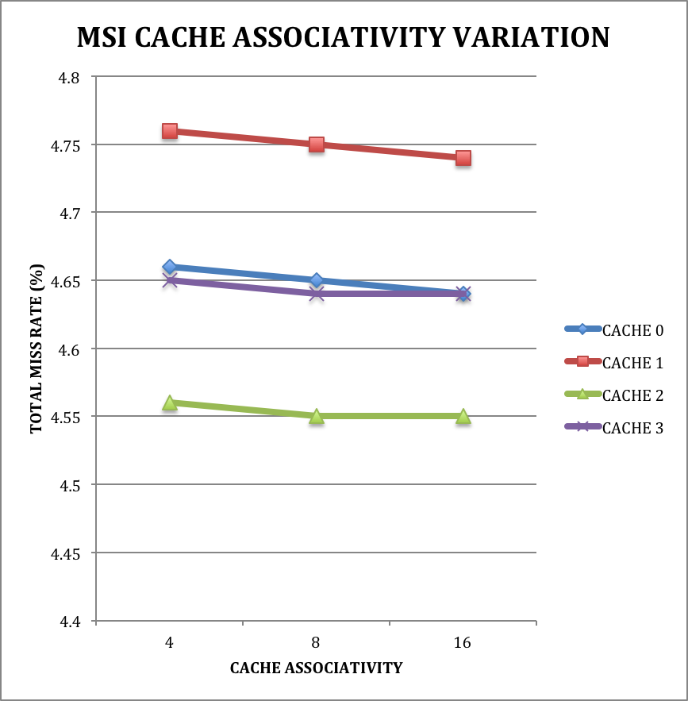

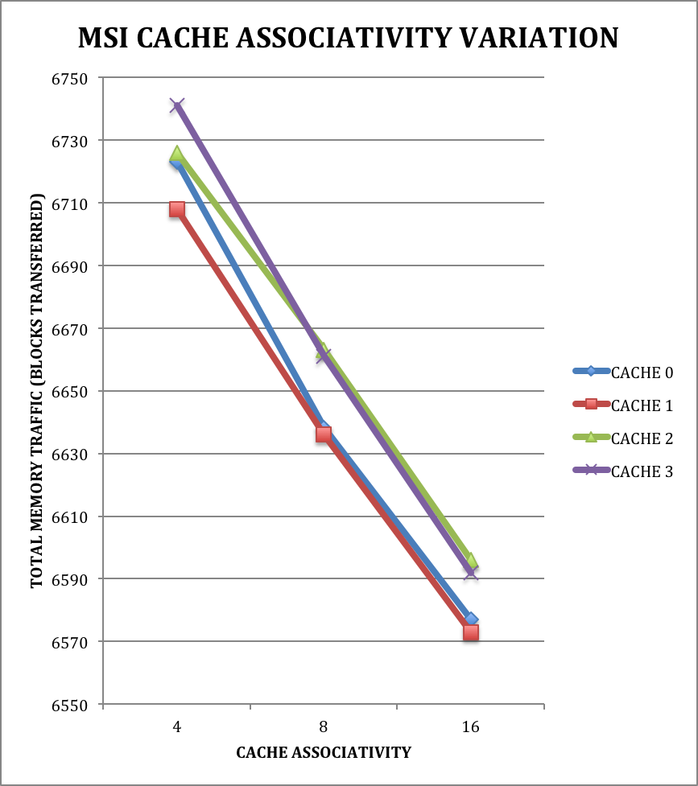

CACHE 1 MB 4 WAY 64B BLOCK | CACHE 0 | CACHE 1 | CACHE 2 | CACHE 3
READS | 112661 | 110830 | 114938 | 113428
READ MISSES | 5768 | 5797 | 5762 | 5803
WRITES | 11942 | 11710 | 12383 | 12108
WRITE MISSES | 39 | 41 | 42 | 39
MISS RATE (%) | 4.66% | 4.76% | 4.56% | 4.65%
WRITEBACKS | 239 | 211 | 239 | 224
CACHE TO CACHE TRANSFER | 4402 | 4434 | 4401 | 4401
MEMORY TRANSACTIONS | 1644 | 1615 | 1642 | 1665
INTERVENTIONS | 1465 | 1431 | 1465 | 1480
INVALIDATIONS | 2014 | 2034 | 2008 | 2020
FLUSHES | 114 | 92 | 120 | 88

CACHE 1MB 8 WAY 64B BLOCK | CACHE 0 | CACHE 1 | CACHE 2 | CACHE 3
READS | 112661 | 110830 | 114938 | 113428
READ MISSES | 5752 | 5781 | 5752 | 5790
WRITES | 11942 | 11710 | 12383 | 12108
WRITE MISSES | 39 | 41 | 42 | 39
MISS RATE (%) | 4.65% | 4.75% | 4.55% | 4.64%
WRITEBACKS | 170 | 155 | 186 | 157
CACHE TO CACHE TRANSFER | 4389 | 4422 | 4393 | 4395
MEMORY TRANSACTIONS | 1572 | 1555 | 1587 | 1591
INTERVENTIONS | 1464 | 1428 | 1464 | 1474
INVALIDATIONS | 2014 | 2034 | 2008 | 2020
FLUSHES | 116 | 93 | 121 | 89

CACHE 1 MB 16 WAY 64B BLOCK | CACHE 0 | CACHE 1 | CACHE 2 | CACHE 3
READS | 112661 | 110830 | 114938 | 113428
READ MISSES | 5741 | 5772 | 5741 | 5780
WRITES | 11942 | 11710 | 12383 | 12108
WRITE MISSES | 39 | 41 | 42 | 39
MISS RATE (%) | 4.64% | 4.74% | 4.54% | 4.64%
WRITEBACKS | 120 | 101 | 130 | 98
CACHE TO CACHE TRANSFER | 4379 | 4415 | 4386 | 4386
MEMORY TRANSACTIONS | 1521 | 1499 | 1527 | 1531
INTERVENTIONS | 1463 | 1426 | 1461 | 1473
INVALIDATIONS | 2014 | 2034 | 2008 | 2020
FLUSHES | 116 | 93 | 122 | 89

Analysis The cache size variation reports a insignificant effect on total miss rate reduction in other words after increasing the cache size from 256 KB to
512 KB there is no improvement in capacity misses according to the benchmark trace “canneal” given to us, there is also no effect on reduction of coherence based misses as number of invalidations remain constant for all the variations. Memory traffic offers a significant improvement at each variation of the cache size variation from 256 KB to 2 MB from lets say 1644 for cache 0(256KB) to 1521(2 MB cache 0) , 1615 for cache1(256 KB) to 1499 cache1(2 MB) , 1642 for cache 2(256 KB) to 1527 (2 MB cache 2) and 1665 (cache 3 256 KB) to 1531 (2 MB cache 3).

CACHE BLOCK SIZE VARIATION IMPACT ON PERFORMANCE

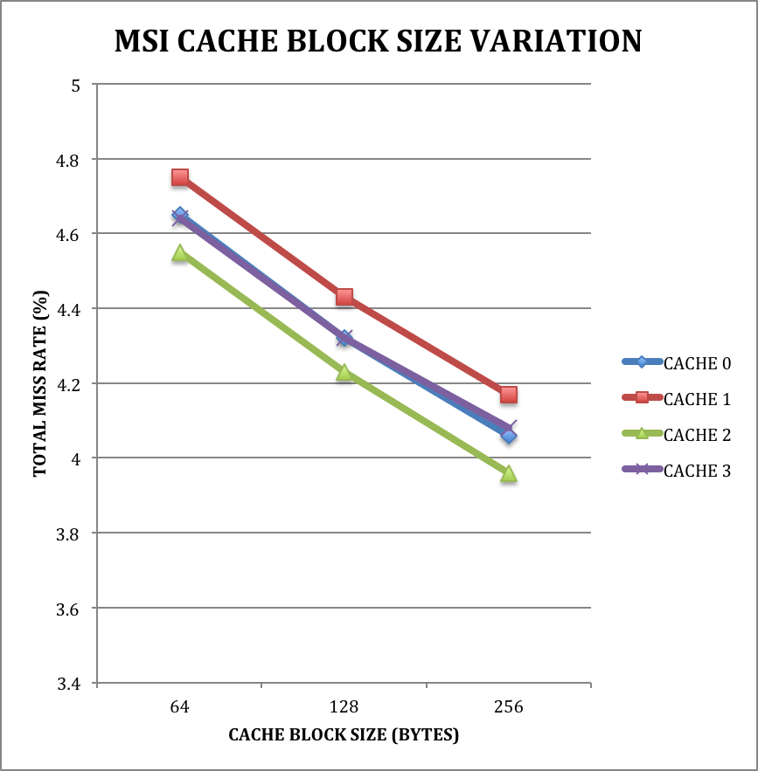

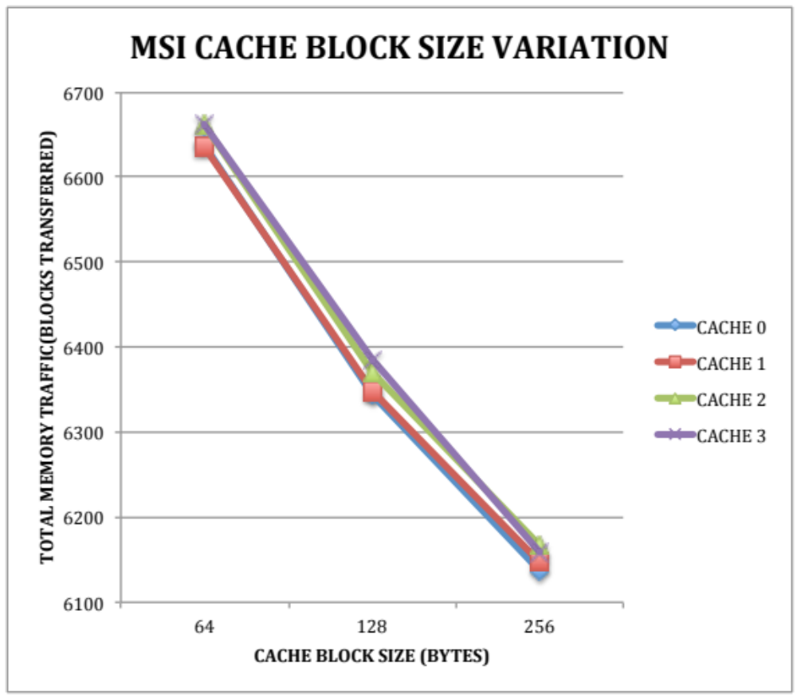

CACHE 1 MB 8 WAY 64B BLOCK | CACHE 0 | CACHE 1 | CACHE 2 | CACHE 3
READS | 112661 | 110830 | 114938 | 113428
READ MISSES | 5752 | 5781 | 5752 | 5790
WRITES | 11942 | 11710 | 12383 | 12108
WRITE MISSES | 39 | 41 | 42 | 39
MISS RATE (%) | 4.65% | 4.75% | 4.55% | 4.64%
WRITEBACKS | 170 | 155 | 186 | 157
CACHE TO CACHE TRANSFER | 0 | 0 | 0 | 0
MEMORY TRANSACTIONS | 6638 | 6636 | 6663 | 6661
INTERVENTIONS | 71 | 48 | 82 | 64
INVALIDATIONS | 2014 | 2034 | 2008 | 2020
FLUSHES | 116 | 93 | 121 | 89

CACHE 1 MB 8 WAY 128B BLOCK | CACHE 0 | CACHE 1 | CACHE 2 | CACHE 3
READS | 112661 | 110830 | 114938 | 113428
READ MISSES | 5340 | 5386 | 5341 | 5384
WRITES | 11942 | 11710 | 12383 | 12108
WRITE MISSES | 39 | 40 | 42 | 39
MISS RATE (%) | 4.32% | 4.43% | 4.23% | 4.32%
WRITEBACKS | 275 | 250 | 283 | 269
CACHE TO CACHE TRANSFER | 0 | 0 | 0 | 0
MEMORY TRANSACTIONS | 6344 | 6347 | 6369 | 6386
INTERVENTIONS | 119 | 84 | 127 | 110
INVALIDATIONS | 2066 | 2089 | 2053 | 2068
FLUSHES | 164 | 129 | 166 | 135

CACHE 1 MB 8 WAY 256B BLOCK | CACHE 0 | CACHE 1 | CACHE 2 | CACHE 3
READS | 112661 | 110830 | 114938 | 113428
READ MISSES | 5023 | 5070 | 5004 | 5084
WRITES | 11942 | 11710 | 12383 | 12108
WRITE MISSES | 39 | 40 | 42 | 39
MISS RATE (%) | 4.06% | 4.17% | 3.96% | 4.08%
WRITEBACKS | 363 | 342 | 383 | 332
CACHE TO CACHE TRANSFER | 0 | 0 | 0 | 0
MEMORY TRANSACTIONS | 6137 | 6147 | 6167 | 6159
INTERVENTIONS | 166 | 133 | 192 | 145
INVALIDATIONS | 2132 | 2157 | 2107 | 2148
FLUSHES | 211 | 178 | 231 | 170

Analysis The cache size variation reports a significant effect on total miss rate reduction there is a improvement as reported in the graph.
Memory traffic offers a significant improvement at each variation of the cache size variation from 256 KB to 2 MB from lets say 6638 for cache 0(256KB) to 6137(2 MB cache 0) , 6636 for cache1(256 KB) to 6147 cache1(2 MB) , 6663 for cache 2(256 KB) to 6167 (2 MB cache 2) and 6661 (cache 3 256 KB) to 6159 (2 MB cache 3).

MESI PROTOCOL

CACHE SIZE VARIATION IMPACT ON PERFORMANCE

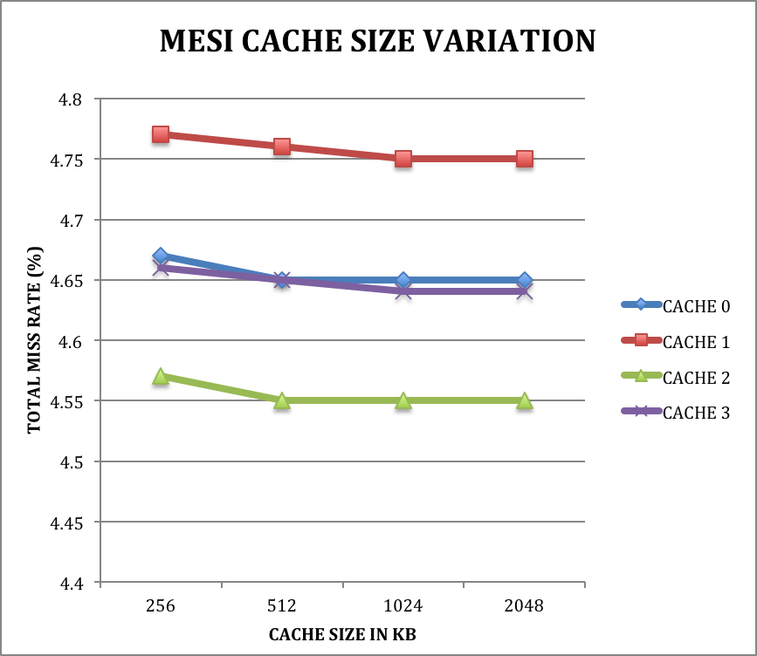

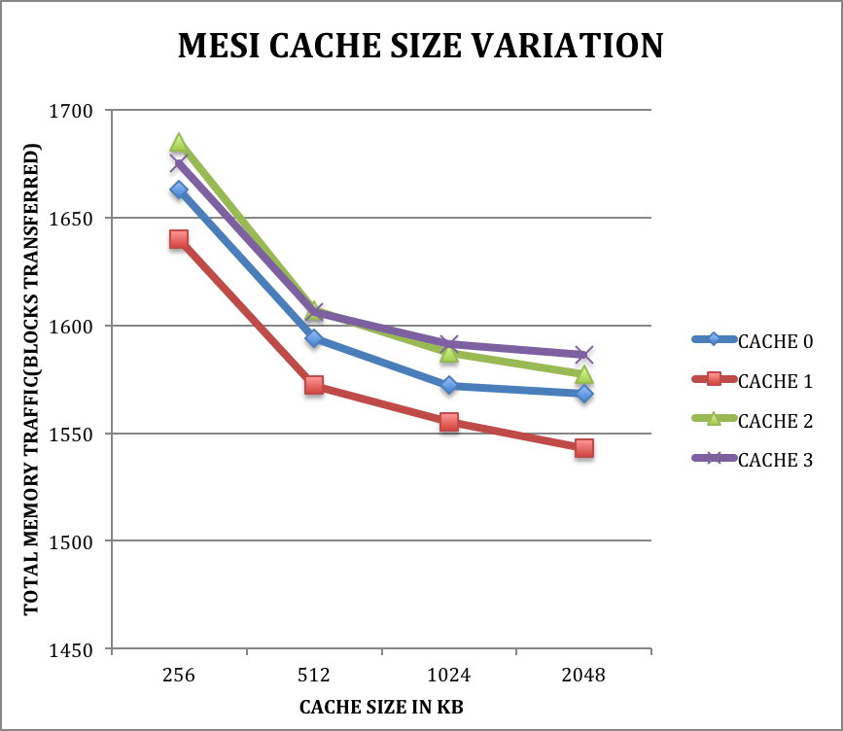

CACHE 256 KB 8 WAY 64B BLOCK | CACHE 0 | CACHE 1 | CACHE 2 | CACHE 3
READS | 112661 | 110830 | 114938 | 113428
READ MISSES | 5775 | 5805 | 5771 | 5813
WRITES | 11942 | 11710 | 12383 | 12108
WRITE MISSES | 39 | 41 | 42 | 39
MISS RATE (%) | 4.67% | 4.77% | 4.57% | 4.66%
WRITEBACKS | 254 | 235 | 278 | 234
CACHE TO CACHE TRANSFER | 4405 | 4441 | 4406 | 4411
MEMORY TRANSACTIONS | 1663 | 1640 | 1685 | 1675
INTERVENTIONS | 1468 | 1432 | 1469 | 1479
INVALIDATIONS | 2014 | 2034 | 2008 | 2020
FLUSHES | 113 | 92 | 120 | 88

CACHE 512 KB 8 WAY 64B BLOCK | CACHE 0 | CACHE 1 | CACHE 2 | CACHE 3
READS | 112661 | 110830 | 114938 | 113428
READ MISSES | 5757 | 5792 | 5756 | 5796
WRITES | 11942 | 11710 | 12383 | 12108
WRITE MISSES | 39 | 41 | 42 | 39
MISS RATE (%) | 4.65% | 4.76% | 4.55% | 4.65%
WRITEBACKS | 190 | 170 | 205 | 171
CACHE TO CACHE TRANSFER | 4392 | 4431 | 4396 | 4400
MEMORY TRANSACTIONS | 1594 | 1572 | 1607 | 1606
INTERVENTIONS | 1466 | 1429 | 1465 | 1474
INVALIDATIONS | 2014 | 2034 | 2008 | 2020
FLUSHES | 116 | 92 | 121 | 88

CACHE 1MB 8 WAY 64B BLOCK | CACHE 0 | CACHE 1 | CACHE 2 | CACHE 3
READS | 112661 | 110830 | 114938 | 113428
READ MISSES | 5752 | 5781 | 5752 | 5790
WRITES | 11942 | 11710 | 12383 | 12108
WRITE MISSES | 39 | 41 | 42 | 39
MISS RATE (%) | 4.65% | 4.75% | 4.55% | 4.64%
WRITEBACKS | 170 | 155 | 186 | 157
CACHE TO CACHE TRANSFER | 4389 | 4422 | 4393 | 4395
MEMORY TRANSACTIONS | 1572 | 1555 | 1587 | 1591
INTERVENTIONS | 1464 | 1428 | 1464 | 1474
INVALIDATIONS | 2014 | 2034 | 2008 | 2020
FLUSHES | 116 | 93 | 121 | 89

CACHE 2 MB 8 WAY 64B BLOCK | CACHE 0 | CACHE 1 | CACHE 2 | CACHE 3
READS | 112661 | 110830 | 114938 | 113428
READ MISSES | 5750 | 5779 | 5751 | 5789
WRITES | 11942 | 11710 | 12383 | 12108
WRITE MISSES | 39 | 41 | 42 | 39
MISS RATE (%) | 4.65% | 4.75% | 4.55% | 4.64%
WRITEBACKS | 166 | 143 | 176 | 152
CACHE TO CACHE TRANSFER | 4387 | 4420 | 4392 | 4394
MEMORY TRANSACTIONS | 1568 | 1543 | 1577 | 1586
INTERVENTIONS | 1464 | 1428 | 1464 | 1474
INVALIDATIONS | 2014 | 2034 | 2008 | 2020
FLUSHES | 116 | 93 | 121 | 89

Analysis The cache size variation reports a insignificant effect on total miss rate reduction there is no performance improvement as opposed to usage of large cache structure used in our system thus it will be bad decision to augment our system with larger caches. Memory traffic offers a significant improvement at each variation of the cache size variation from 256 KB to 2 MB from lets say 1663 for cache 0(256KB) to 1568(2 MB cache 0) , 1640 for cache1(256 KB) to 1543 cache1(2 MB) , 1685 for cache 2(256 KB) to 1577 (2 MB cache 2) and 1675 (cache 3 256 KB) to 1586 (2 MB cache 3).
CACHE ASSOCIATIVITY VARIATION IMPACT ON PERFORMANCE

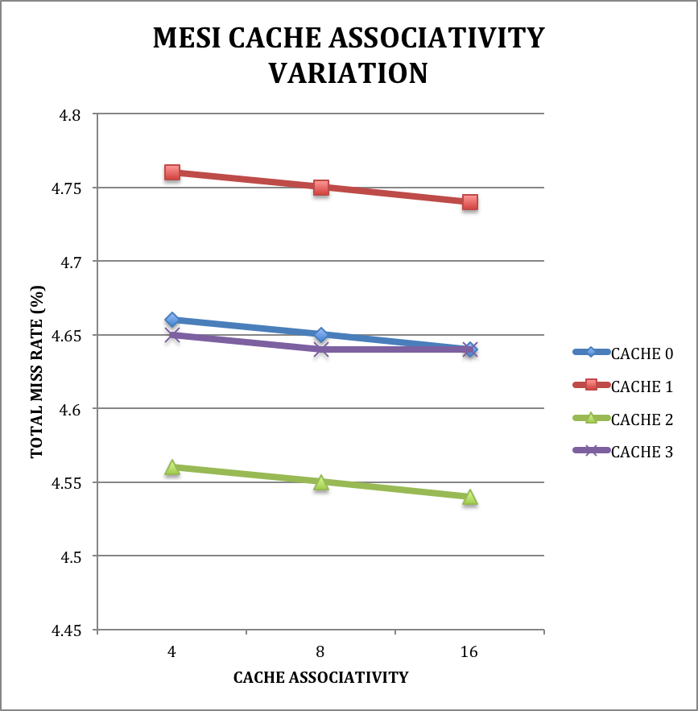

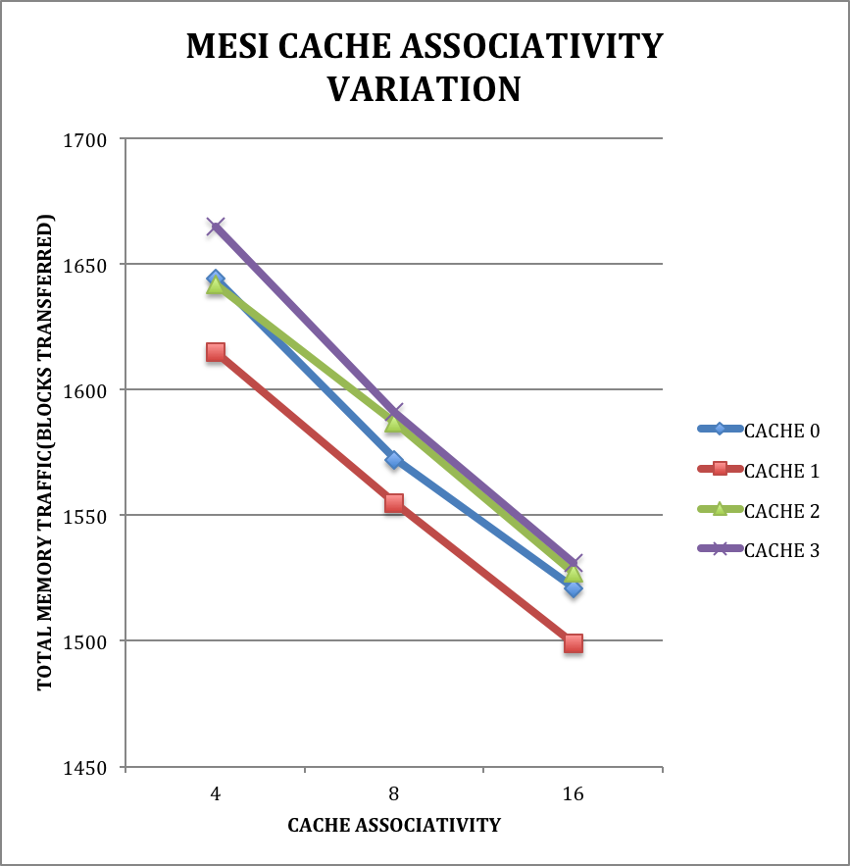

CACHE 1 MB 4 WAY 64B BLOCK | CACHE 0 | CACHE 1 | CACHE 2 | CACHE 3
READS | 112661 | 110830 | 114938 | 113428
READ MISSES | 5768 | 5797 | 5762 | 5803
WRITES | 11942 | 11710 | 12383 | 12108
WRITE MISSES | 39 | 41 | 42 | 39
MISS RATE (%) | 4.66% | 4.76% | 4.56% | 4.65%
WRITEBACKS | 239 | 211 | 239 | 224
CACHE TO CACHE TRANSFER | 4402 | 4434 | 4401 | 4401
MEMORY TRANSACTIONS | 1644 | 1615 | 1642 | 1665
INTERVENTIONS | 1465 | 1431 | 1465 | 1480
INVALIDATIONS | 2014 | 2034 | 2008 | 2020
FLUSHES | 114 | 92 | 120 | 88

CACHE 1MB 8 WAY 64B BLOCK | CACHE 0 | CACHE 1 | CACHE 2 | CACHE 3
READS | 112661 | 110830 | 114938 | 113428
READ MISSES | 5752 | 5781 | 5752 | 5790
WRITES | 11942 | 11710 | 12383 | 12108
WRITE MISSES | 39 | 41 | 42 | 39
MISS RATE (%) | 4.65% | 4.75% | 4.55% | 4.64%
WRITEBACKS | 170 | 155 | 186 | 157
CACHE TO CACHE TRANSFER | 4389 | 4422 | 4393 | 4395
MEMORY TRANSACTIONS | 1572 | 1555 | 1587 | 1591
INTERVENTIONS | 1464 | 1428 | 1464 | 1474
INVALIDATIONS | 2014 | 2034 | 2008 | 2020
FLUSHES | 116 | 93 | 121 | 89

CACHE 1 MB 16 WAY 64B BLOCK | CACHE 0 | CACHE 1 | CACHE 2 | CACHE 3
READS | 112661 | 110830 | 114938 | 113428
READ MISSES | 5741 | 5772 | 5741 | 5780
WRITES | 11942 | 11710 | 12383 | 12108
WRITE MISSES | 39 | 41 | 42 | 39
MISS RATE (%) | 4.64% | 4.74% | 4.54% | 4.64%
WRITEBACKS | 120 | 101 | 130 | 98
CACHE TO CACHE TRANSFER | 4379 | 4415 | 4386 | 4386
MEMORY TRANSACTIONS | 1521 | 1499 | 1527 | 1531
INTERVENTIONS | 1463 | 1426 | 1461 | 1473
INVALIDATIONS | 2014 | 2034 | 2008 | 2020
FLUSHES | 116 | 93 | 122 | 89

Analysis The cache size variation reports a insignificant effect on total miss rate reduction there is no performance improvement as opposed to usage of large cache structure used in our system thus it will be bad decision to augment our system with larger caches. Memory traffic also does not offer a significant improvement in reduction thus in my choice increasing associativity above a certain number would only increase the complexity of our hardware design and will not help us in getting any real benefits out of the power consuming complex hardware.

CACHE BLOCK SIZE VARIATION IMPACT ON PERFORMANCE

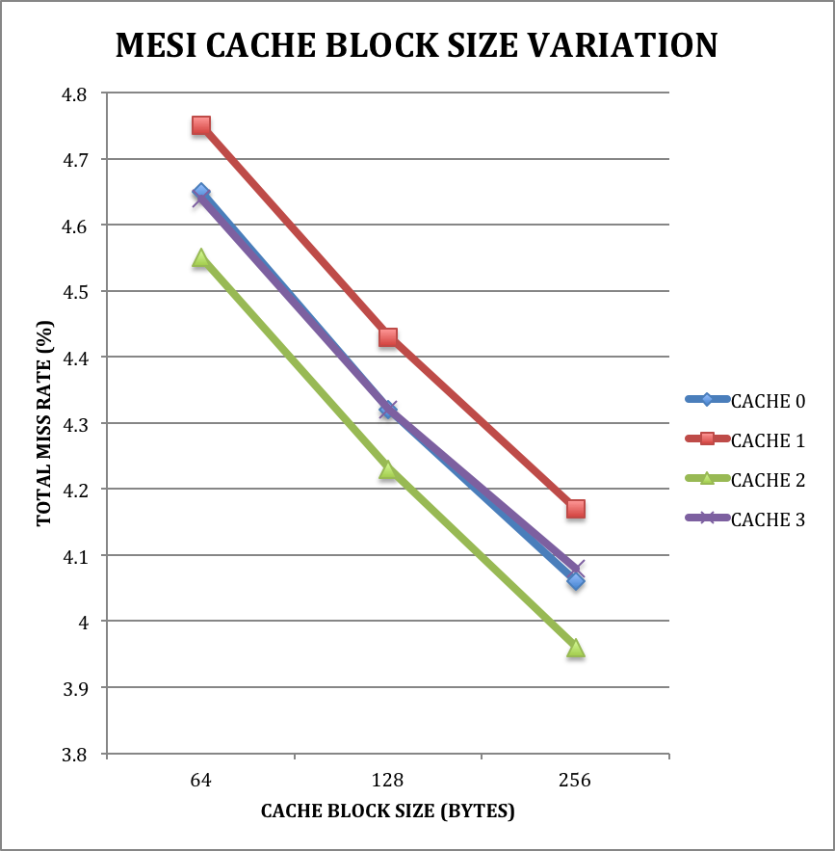

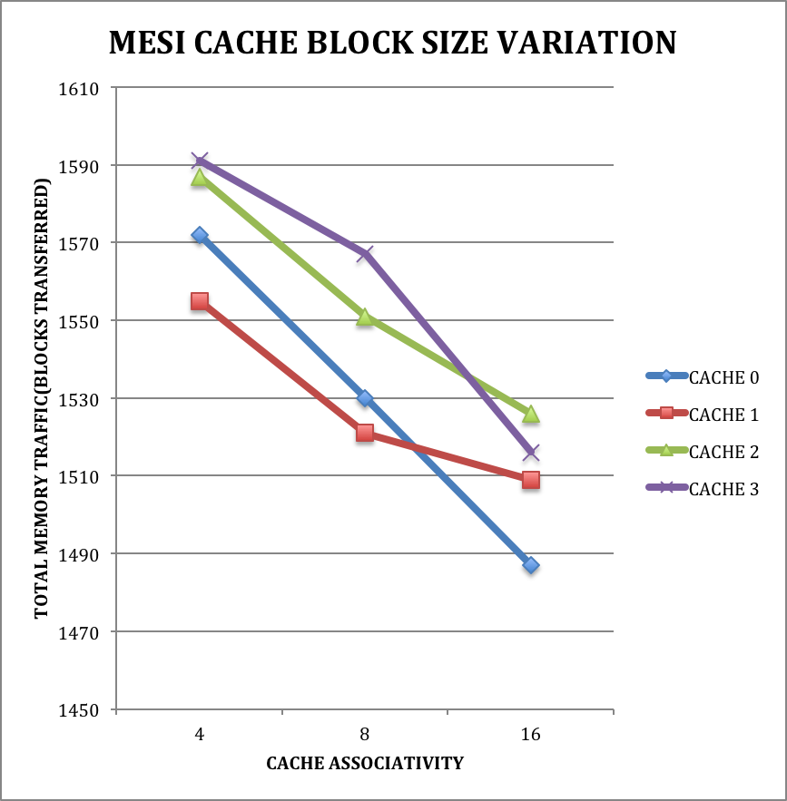

CACHE 1MB 8 WAY 64B BLOCK | CACHE 0 | CACHE 1 | CACHE 2 | CACHE 3
READS | 112661 | 110830 | 114938 | 113428
READ MISSES | 5752 | 5781 | 5752 | 5790
WRITES | 11942 | 11710 | 12383 | 12108
WRITE MISSES | 39 | 41 | 42 | 39
MISS RATE (%) | 4.65% | 4.75% | 4.55% | 4.64%
WRITEBACKS | 170 | 155 | 186 | 157
CACHE TO CACHE TRANSFER | 4389 | 4422 | 4393 | 4395
MEMORY TRANSACTIONS | 1572 | 1555 | 1587 | 1591
INTERVENTIONS | 1464 | 1428 | 1464 | 1474
INVALIDATIONS | 2014 | 2034 | 2008 | 2020
FLUSHES | 116 | 93 | 121 | 89

CACHE 1 MB 8 WAY 128B BLOCK | CACHE 0 | CACHE 1 | CACHE 2 | CACHE 3
READS | 112661 | 110830 | 114938 | 113428
READ MISSES | 5340 | 5386 | 5341 | 5384
WRITES | 11942 | 11710 | 12383 | 12108
WRITE MISSES | 39 | 40 | 42 | 39
MISS RATE (%) | 4.32% | 4.43% | 4.23% | 4.32%
WRITEBACKS | 275 | 250 | 283 | 269
CACHE TO CACHE TRANSFER | 4124 | 4155 | 4115 | 4125
MEMORY TRANSACTIONS | 1530 | 1521 | 1551 | 1567
INTERVENTIONS | 1367 | 1337 | 1377 | 1385
INVALIDATIONS | 2066 | 2089 | 2053 | 2068
FLUSHES | 164 | 129 | 166 | 135

CACHE 1 MB 8 WAY 256B BLOCK | CACHE 0 | CACHE 1 | CACHE 2 | CACHE 3
READS | 112661 | 110830 | 114938 | 113428
READ MISSES | 5023 | 5070 | 5004 | 5084
WRITES | 11942 | 11710 | 12383 | 12108
WRITE MISSES | 39 | 40 | 42 | 39
MISS RATE (%) | 4.06% | 4.17% | 3.96% | 4.08%
WRITEBACKS | 363 | 342 | 383 | 332
CACHE TO CACHE TRANSFER | 3938 | 3943 | 3903 | 3939
MEMORY TRANSACTIONS | 1487 | 1509 | 1526 | 1516
INTERVENTIONS | 1283 | 1284 | 1321 | 1309
INVALIDATIONS | 2132 | 2157 | 2107 | 2148
FLUSHES | 211 | 178 | 231 | 170

Analysis The cache size variation reports a significant effect on total miss rate reduction. Memory traffic also offers a significant reduction for all the respective cache’s. The phenomenon unique in this case is this that just increasing the block size would not be a good idea as if we observe the invalidations counter it increases from 64 Byte configuration to 256 bytes due to coherence misses thus in my opinion usage of a better protocol like Dragon protocol would ultimately result in optimization of those coherence misses as dragon is based upon write update/dirty sharing concept of operation thus a higher block size with Dragon would help us reap maximum benefits.

DRAGON PROTOCOL

CACHE SIZE VARIATION IMPACT ON PERFORMANCE

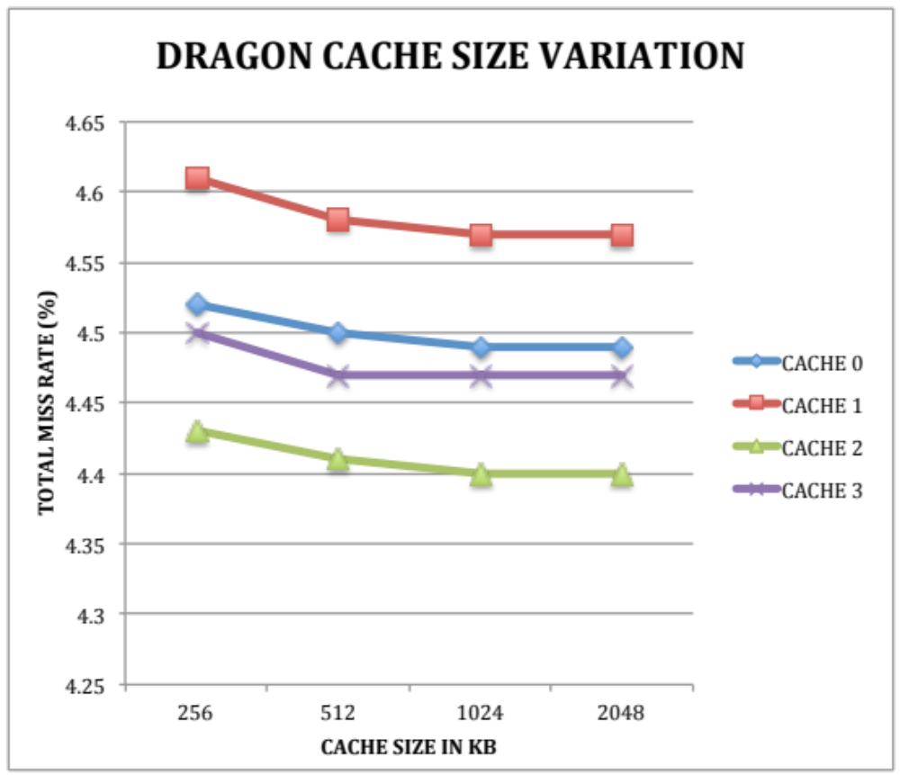

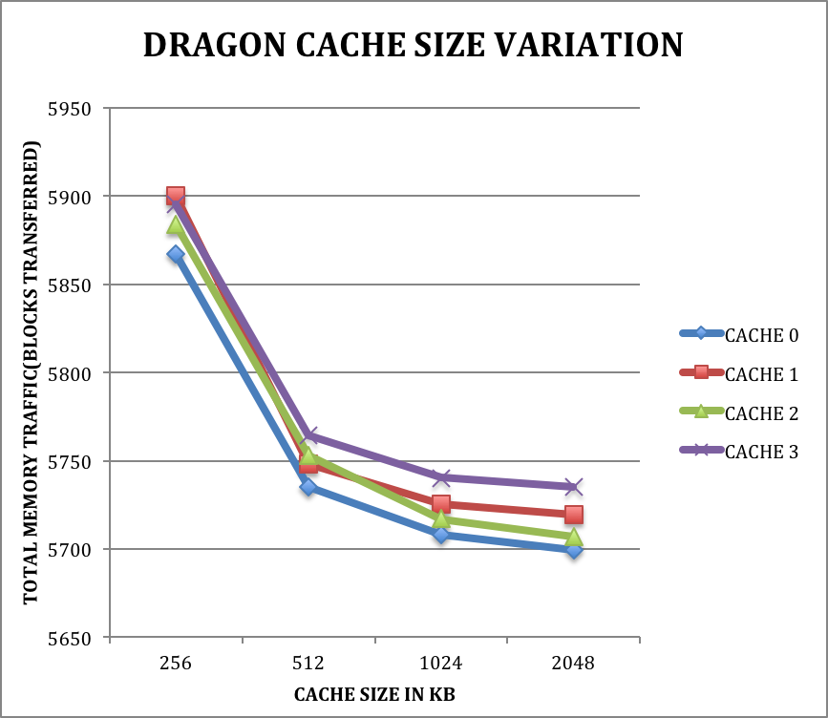

CACHE 256 KB 8 WAY 64B BLOCK | CACHE 0 | CACHE 1 | CACHE 2 | CACHE 3
READS | 112661 | 110830 | 114938 | 113428
READ MISSES | 5635 | 5646 | 5644 | 5652
WRITES | 11942 | 11710 | 12383 | 12108
WRITE MISSES | 3 | 2 | 2 | 0
MISS RATE (%) | 4.52% | 4.61% | 4.43% | 4.50%
WRITEBACKS | 229 | 252 | 238 | 243
CACHE TO CACHE TRANSFER | 0 | 0 | 0 | 0
MEMORY TRANSACTIONS | 5867 | 5900 | 5884 | 5895
INTERVENTIONS | 1405 | 1396 | 1398 | 1430
INVALIDATIONS | 0 | 0 | 0 | 0
FLUSHES | 3 | 9 | 6 | 9

CACHE 512 KB 8 WAY 64B BLOCK | CACHE 0 | CACHE 1 | CACHE 2 | CACHE 3
READS | 112661 | 110830 | 114938 | 113428
READ MISSES | 5601 | 5610 | 5610 | 5617
WRITES | 11942 | 11710 | 12383 | 12108
WRITE MISSES | 3 | 2 | 2 | 0
MISS RATE (%) | 4.50% | 4.58% | 4. 41% | 4.47%
WRITEBACKS | 131 | 136 | 141 | 147
CACHE TO CACHE TRANSFER | 0 | 0 | 0 | 0
MEMORY TRANSACTIONS | 5735 | 5748 | 5753 | 5764
INTERVENTIONS | 1400 | 1388 | 1389 | 1418
INVALIDATIONS | 0 | 0 | 0 | 0
FLUSHES | 3 | 9 | 6 | 6

CACHE 1MB 8 WAY 64B BLOCK | CACHE 0 | CACHE 1 | CACHE 2 | CACHE 3
READS | 112661 | 110830 | 114938 | 113428
READ MISSES | 5595 | 5604 | 5604 | 5611
WRITES | 11942 | 11710 | 12383 | 12108
WRITE MISSES | 3 | 2 | 2 | 0
MISS RATE (%) | 4.49% | 4.57% | 4.40% | 4.47%
WRITEBACKS | 110 | 119 | 111 | 129
CACHE TO CACHE TRANSFER | 0 | 0 | 0 | 0
MEMORY TRANSACTIONS | 5708 | 5725 | 5717 | 5740
INTERVENTIONS | 1398 | 1387 | 1387 | 1417
INVALIDATIONS | 0 | 0 | 0 | 0
FLUSHES | 3 | 9 | 6 | 6

CACHE 2 MB 8 WAY 64B BLOCK | CACHE 0 | CACHE 1 | CACHE 2 | CACHE 3
READS | 112661 | 110830 | 114938 | 113428
READ MISSES | 5591 | 5603 | 5601 | 5608
WRITES | 11942 | 11710 | 12383 | 12108
WRITE MISSES | 3 | 2 | 2 | 0
MISS RATE (%) | 4.49% | 4.57% | 4.40% | 4.47%
WRITEBACKS | 105 | 114 | 104 | 127
CACHE TO CACHE TRANSFER | 0 | 0 | 0 | 0
MEMORY TRANSACTIONS | 5699 | 5719 | 5707 | 5735
INTERVENTIONS | 1396 | 1387 | 1387 | 1416
INVALIDATIONS | 0 | 0 | 0 | 0
FLUSHES | 3 | 9 | 6 | 6

Analysis The cache size variation reports a insignificant variation on cache miss rate variation however this offers the best performance in terms of lowest miss rate seen for all the cache protocols. The memory traffic reduction is seen as cache size is varied. The dragon protocol however incurs from heavy memory traffic penalty due to high number of memory traffic as compared to MESI protocol however as compared to significantly still less than MSI protocol. Thus it is clearly a tradeoff between incurring memory traffic versus miss rate reduction however not all memory traffic result in longer memory latency.

CACHE ASSOCIATIVITY VARIATION IMPACT ON PERFORMANCE

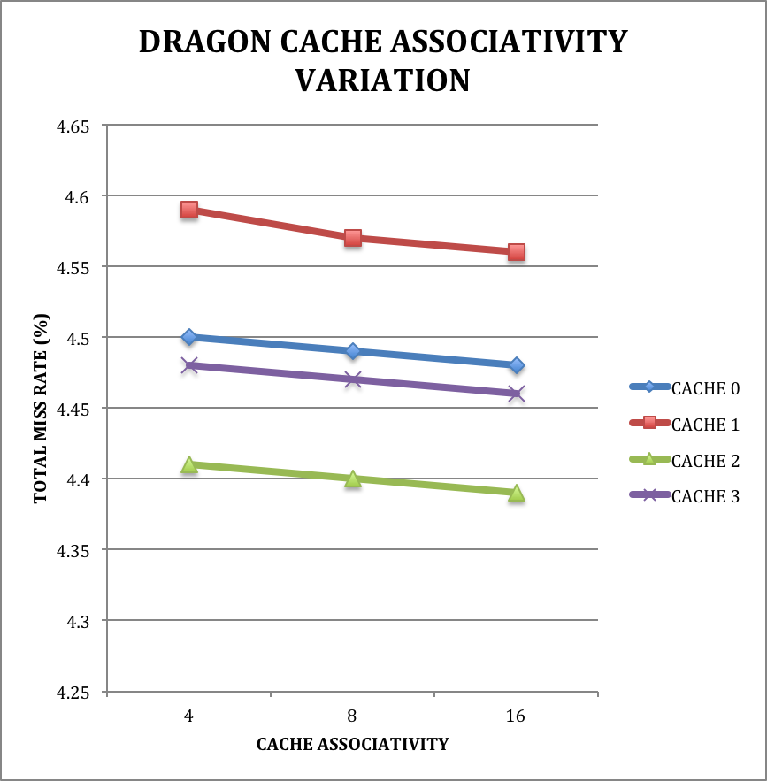

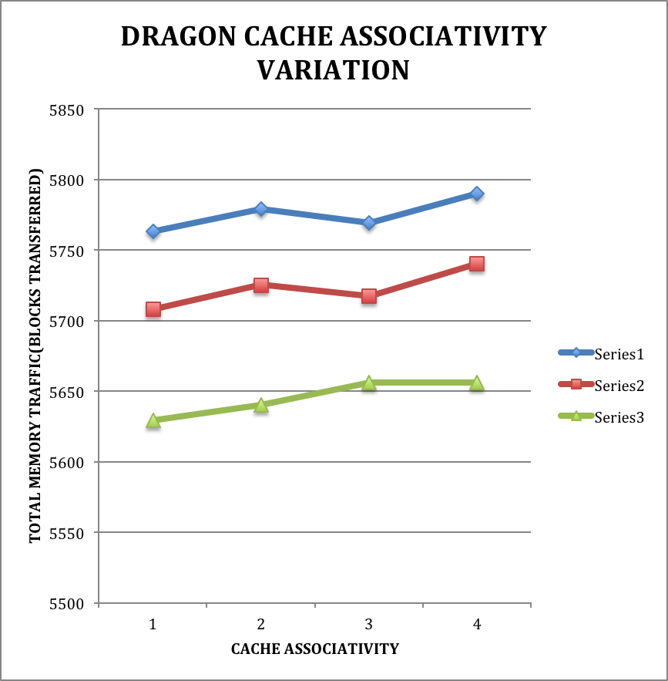

CACHE 1 MB 4 WAY 64B BLOCK | CACHE 0 | CACHE 1 | CACHE 2 | CACHE 3
READS | 112661 | 110830 | 114938 | 113428
READ MISSES | 5609 | 5619 | 5619 | 5626
WRITES | 11942 | 11710 | 12383 | 12108
WRITE MISSES | 3 | 2 | 2 | 0
MISS RATE (%) | 4.50% | 4.59% | 4.41% | 4.48%
WRITEBACKS | 151 | 158 | 148 | 164
CACHE TO CACHE TRANSFER | 0 | 0 | 0 | 0
MEMORY TRANSACTIONS | 5763 | 5779 | 5769 | 5790
INTERVENTIONS | 1400 | 1392 | 1388 | 1424
INVALIDATIONS | 0 | 0 | 0 | 0
FLUSHES | 3 | 9 | 6 | 6

CACHE 1MB 8 WAY 64B BLOCK | CACHE 0 | CACHE 1 | CACHE 2 | CACHE 3
READS | 112661 | 110830 | 114938 | 113428
READ MISSES | 5595 | 5604 | 5604 | 5611
WRITES | 11942 | 11710 | 12383 | 12108
WRITE MISSES | 3 | 2 | 2 | 0
MISS RATE (%) | 4.49% | 4.57% | 4.40% | 4.47%
WRITEBACKS | 110 | 119 | 111 | 129
CACHE TO CACHE TRANSFER | 0 | 0 | 0 | 0
MEMORY TRANSACTIONS | 5708 | 5725 | 5717 | 5740
INTERVENTIONS | 1398 | 1387 | 1387 | 1417
INVALIDATIONS | 0 | 0 | 0 | 0
FLUSHES | 3 | 9 | 6 | 6

CACHE 1 MB 16 WAY 64B BLOCK | CACHE 0 | CACHE 1 | CACHE 2 | CACHE 3
READS | 112661 | 110830 | 114938 | 113428
READ MISSES | 5576 | 5586 | 5586 | 5593
WRITES | 11942 | 11710 | 12383 | 12108
WRITE MISSES | 3 | 2 | 2 | 0
MISS RATE (%) | 4.48% | 4.56% | 4.39% | 4.46%
WRITEBACKS | 50 | 52 | 68 | 63
CACHE TO CACHE TRANSFER | 0 | 0 | 0 | 0
MEMORY TRANSACTIONS | 5629 | 5640 | 5656 | 5656
INTERVENTIONS | 1395 | 1382 | 1383 | 1411
INVALIDATIONS | 0 | 0 | 0 | 0
FLUSHES | 3 | 9 | 6 | 6

Analysis The cache assocoiativity variation reports a insignificant variation on cache miss rate variation however this offers the best performance in terms of lowest miss rate seen for all the cache protocols. The memory traffic reduction is seen as cache size is varied. Thus it will be a bad design choice to increase cache associativity.

CACHE BLOCK SIZE VARIATION IMPACT ON PERFORMANCE

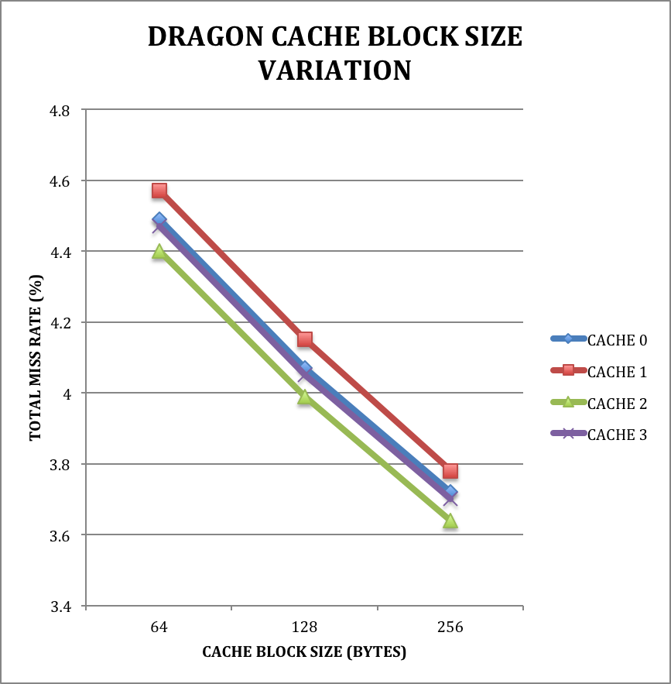
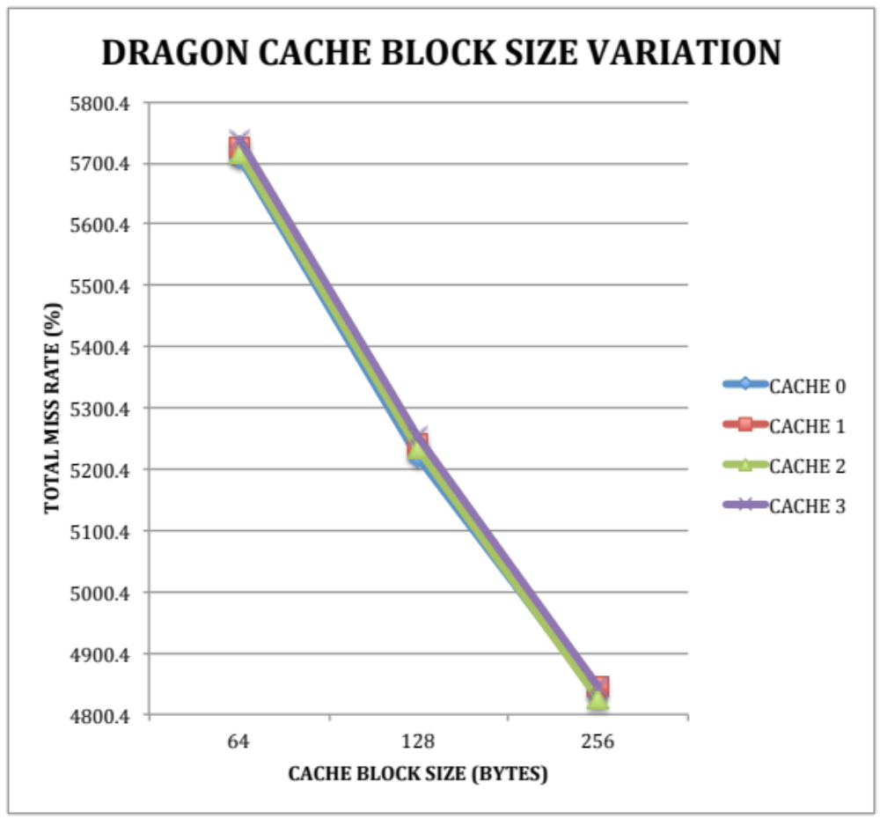

CACHE 1MB 8 WAY 64B BLOCK | CACHE 0 | CACHE 1 | CACHE 2 | CACHE 3
READS | 112661 | 110830 | 114938 | 113428
READ MISSES | 5595 | 5604 | 5604 | 5611
WRITES | 11942 | 11710 | 12383 | 12108
WRITE MISSES | 3 | 2 | 2 | 0
MISS RATE (%) | 4.49% | 4.57% | 4.40% | 4.47%
WRITEBACKS | 110 | 119 | 111 | 129
CACHE TO CACHE TRANSFER | 0 | 0 | 0 | 0
MEMORY TRANSACTIONS | 5708 | 5725 | 5717 | 5740
INTERVENTIONS | 1398 | 1387 | 1387 | 1417
INVALIDATIONS | 0 | 0 | 0 | 0
FLUSHES | 3 | 9 | 6 | 6

CACHE 1 MB 8 WAY 128B BLOCK | CACHE 0 | CACHE 1 | CACHE 2 | CACHE 3
READS | 112661 | 110830 | 114938 | 113428
READ MISSES | 5069 | 5080 | 5080 | 5086
WRITES | 11942 | 11710 | 12383 | 12108
WRITE MISSES | 3 | 1 | 2 | 0
MISS RATE (%) | 4.07% | 4.15% | 3.99% | 4.05%
WRITEBACKS | 148 | 158 | 151 | 169
CACHE TO CACHE TRANSFER | 0 | 0 | 0 | 0
MEMORY TRANSACTIONS | 5220 | 5239 | 5233 | 5255
INTERVENTIONS | 1256 | 1266 | 1257 | 1287
INVALIDATIONS | 0 | 0 | 0 | 0
FLUSHES | 3 | 9 | 6 | 9

CACHE 1 MB 8 WAY 256B BLOCK | CACHE 0 | CACHE 1 | CACHE 2 | CACHE 3
READS | 112661 | 110830 | 114938 | 113428
READ MISSES | 4628 | 4633 | 4630 | 4640
WRITES | 11942 | 11710 | 12383 | 12108
WRITE MISSES | 3 | 1 | 2 | 0
MISS RATE (%) | 3.72% | 3.78% | 3.64% | 3.70%
WRITEBACKS | 201 | 211 | 194 | 205
CACHE TO CACHE TRANSFER | 0 | 0 | 0 | 0
MEMORY TRANSACTIONS | 4832 | 4845 | 4826 | 4845
INTERVENTIONS | 1125 | 1175 | 1143 | 1176
INVALIDATIONS | 0 | 0 | 0 | 0
FLUSHES | 3 | 11 | 9 | 9

Analysis The cache associativity variation reports a significant variation on cache miss rate reduction. This variation also offers a significant reduction in memory traffic thus in my opinion it offers the best performance.

Overall analysis seeing the above protocols for MESI and Dragon we can clearly see that it is a tradeoff between Memory traffic and Miss rate reduction. In Dragon protocol we observe a heavy memory traffic due to its nature of Write Update/ Dirty sharing while it offers best performance in terms of Miss rate reduction. MESI protocol offers a heavy improvement in terms of memory traffic almost of one fifth of traffic

