An Internship Report
On
AI-Driven-WebApp-Development
Submitted
To
School of Computer Science and Engineering
IILM University, Greater Noida, U.P.
In partial fulfilment of the requirement of degree of
B-Tech (CSE)

By
25SCS1003002795
SIDDHANT SAURAV
Batch: 2025-2029

CANDIDATE'S DECLARATION

I, SIDDHANT SAURAV, do hereby declare that the internship report titled “AI-Driven-WebApp-Development” has been completed by me to fulfil the requirement for the award of the degree of Bachelor of Technology in Computer Science and Engineering. All the references have been quoted and I have not taken as such any material from any other source. I affirm that this report is my own and has not been submitted to any other institute for any degree/diploma requirement, and further I shall be solely responsible for any kind of copyright violation in this regard.

Signature:-

Student Name: SIDDHANT SAURAV
Roll No.: 25SCS1003002795

ACKNOWLEDGEMENT

I am using this opportunity to express my gratitude to everyone who supported me throughout the Internship Program. I am thankful for their aspiring guidance, invaluably constructive criticism and friendly advice during this work. I am sincerely grateful to them for sharing their truthful and illuminating views on a number of issues related to this work.

I would like to thank LENOVO Leap, associated with AICTE, for providing me the opportunity and the structured platform to learn and gain hands-on exposure in the domain of AI-Driven-WebApp-Development. I am also thankful to IILM University, Greater Noida, and the faculty of the School of Computer Science and Engineering for their continuous support and encouragement.

I express my gratitude to my parents for their blessings.

Signature:-

Student Name: SIDDHANT SAURAV
Roll No.: 25SCS1003002795

Internship Completion Certificate

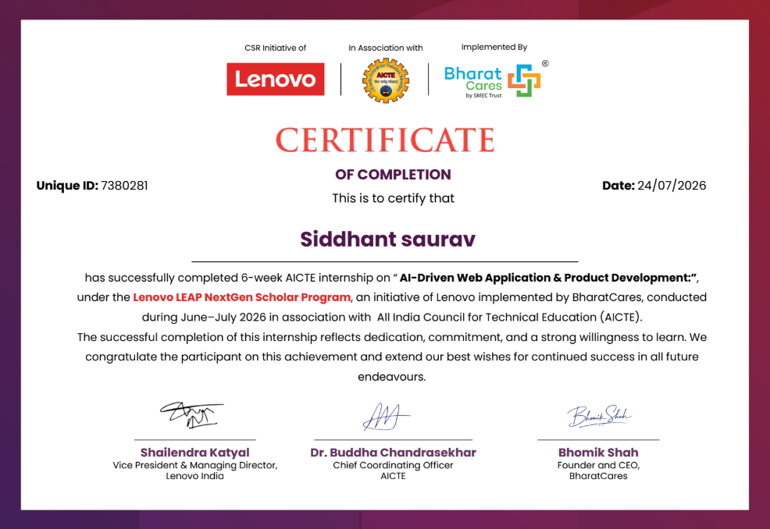

TABLE OF CONTENTS
Chapter No. | Chapter Name | Page Nos.
 | Cover Page | ----
1. | Candidate’s Declaration
2. | Acknowledgment
3. | Internship Completion Certificate
4. | Project Description  4.1 Introduction  4.2 Organization Profile  4.3 Problem Statement  4.4 Project Objectives  4.5 Scope of the Project  4.6 Technologies and Tools Used  4.7 System Architecture  4.8 Methodology  4.9 Expected Outcomes  4.10 Certificates of completion and other  communication mail proof must be attached
5. | Bibliography/References

Chapter 4: Project Description
4.1 Introduction
CarbonTrack is a full-stack web application developed to help users calculate, monitor, and reduce their personal carbon footprint. The application enables users to register, securely log in, calculate carbon emissions from everyday activities such as transportation, electricity consumption, food habits, water usage, and waste generation. Users can track historical data, set sustainability goals, and visualize their environmental impact through an interactive dashboard.
This project was developed as an Internship Capstone Project during the Lenovo LEAP NextGen Scholar Program, a 6-week AICTE internship conducted during June–July 2026 in association with All India Council for Technical Education (AICTE) and implemented by BharatCares. The project is aligned with the United Nations Sustainable Development Goal (SDG) 13 – Climate Action, which calls for urgent action to combat climate change and its impacts.
4.2 Organization Profile
The internship was conducted under the Lenovo LEAP NextGen Scholar Program, a CSR initiative of Lenovo India, in association with AICTE (All India Council for Technical Education) and implemented by BharatCares (SMEC Trust). The program is designed to provide undergraduate students with industry-relevant skills and hands-on experience in emerging technology domains.

Lenovo Group Limited is a Fortune Global 500 multinational technology company headquartered in Beijing, China, and Morrisville, North Carolina, USA. Lenovo designs, develops, manufactures, and sells personal computers, tablets, smartphones, workstations, servers, electronic storage devices, IT management software, and smart televisions. Lenovo is one of the world’s largest personal computer vendors by unit sales.
.

4.3 Problem Statement
Climate change is a major global challenge, and daily activities contribute significantly to carbon emissions.
Most individuals do not know their personal carbon footprint or have easy tools to track it.
Existing carbon calculators often provide one-time estimates without continuous tracking or detailed insights.
- There is a need for a user-friendly web application that can:
- Calculate emissions from transport, energy, food, and waste.
- Track carbon footprint over time.
- Set personalized reduction goals.
- Provide data-driven insights and reports.
- Core Problem: How can technology help individuals measure, monitor, and reduce their carbon footprint through an intuitive, data-driven application?
4.4 Project Objectives
- Develop a data-driven carbon tracking platform to measure individual emissions across five key domains: Transportation, Electricity, Food, Water, and Waste.
- Implement secure and reliable data management using JWT authentication, bcrypt encryption, RESTful APIs, and MySQL to protect and efficiently manage user and emission data.
- Design an analytical dashboard that transforms emission data into daily, weekly, and monthly trends, carbon scores, activity summaries, and visual insights.
- Enable data-based sustainability management through historical records, customizable reduction targets, progress monitoring, and automated weekly/monthly/yearly reports.
- Build a responsive and scalable solution using Node.js, Express.js, HTML5, CSS3, JavaScript, and Chart.js, supporting informed environmental decisions and UN SDG 13 – Climate Action.
4.5 Scope of the Project
The scope of CarbonTrack includes the following functionalities:
In Scope:
- User registration and authentication with secure login/logout.
- Carbon footprint calculation from five categories (Transportation – Car, Bus, Bike, Train; Electricity; Food; Water; Waste).
- Interactive dashboard with real-time emission statistics and Chart.js visualizations.
- CRUD operations for carbon emission entries (Create, Read, Update, Delete).
- Goal management with create, update, delete, and progress tracking.
- Report generation for weekly, monthly, and yearly periods.
- User profile management (view profile, edit profile, change password).
- Responsive web design compatible with desktop and mobile browsers.

Out of Scope (Future Enhancements):
- Email notifications and alerts.
- Mobile application (Android/iOS).
- AI-based sustainability suggestions and carbon emission prediction.
- Cloud database integration.
- PDF export of reports.
- Enhanced analytics dashboard with advanced visualizations.

4.6 Technologies and Tools Used
The following technologies, frameworks, libraries, and tools were used in the development of CarbonTrack:

Frontend Technologies:
Technology | Purpose
HTML5 | Structure and semantic markup of web pages
CSS3 | Styling, layout, and responsive design
JavaScript (ES6) | Client-side logic, DOM manipulation, API calls
Chart.js | Interactive data visualization (charts and graphs)

Backend Technologies:
Technology | Purpose
Node.js | Server-side JavaScript runtime environment
Express.js | Web application framework for routing and middleware
JWT (jsonwebtoken) | Token-based user authentication
bcryptjs | Secure password hashing
dotenv | Environment variable management

Database:
Technology | Purpose
MySQL | Relational database management system for data storage

Development Tools:
Tool | Purpose
Visual Studio Code | Code editor and IDE
Git | Version control system
GitHub | Remote repository hosting and collaboration
MySQL Workbench | Database design and management GUI
Postman | API testing and documentation

4.7 System Architecture
CarbonTrack follows a three-tier client-server architecture with a clear separation of concerns. The application is built using the MVC (Model-View-Controller) architectural pattern, ensuring modularity, maintainability, and scalability.
Architecture Overview:
1. Presentation Layer (Frontend): Built with HTML5, CSS3, and JavaScript. The frontend communicates with the backend through RESTful API calls using the Fetch API. Chart.js is used for interactive data visualization on the dashboard.
2. Application Layer (Backend): Implemented using Node.js and Express.js. The backend handles request routing, business logic, authentication, input validation, and database operations. It exposes RESTful endpoints for the frontend to consume.
3. Data Layer (Database): MySQL serves as the relational database, storing user accounts, carbon emission entries, sustainability goals, and generated reports. The schema includes four primary tables: users, carbon_entries, goals, and reports.
Project Directory Structure:
CarbonTrack/
├── frontend/
│ ├── css/ (auth.css, calculator.css, dashboard.css, etc.)
│ ├── js/ (auth.js, calculator.js, dashboard.js, etc.)
│ ├── images/ (hero.png, register.svg)
│ ├── pages/ (login.html, register.html, dashboard.html, etc.)
│ └── index.html
├── backend/
│ ├── config/ (db.js)
│ ├── controllers/ (authController.js, carbonController.js, etc.)
│ ├── middleware/ (authMiddleware.js)
│ ├── models/ (userModel.js, carbonModel.js, etc.)
│ ├── routes/ (authRoutes.js, carbonRoutes.js, etc.)
│ ├── utils/ (carbonFactors.js, validation.js)
│ ├── server.js
│ └── package.json
├── database/
│ └── schema.sql
├── vercel.json
└── README.md

Data Flow:
User → Frontend (HTML/CSS/JS) → REST API (Express.js) → Controller → Model → MySQL Database → Response → Frontend → User

Database Schema:
Table 1: users
Field | Type | Description
id | INT (PK, AUTO_INCREMENT) | Unique user identifier
full_name | VARCHAR(100) | User's full name
email | VARCHAR(100) UNIQUE | User's email address
password_hash | VARCHAR(255) | bcrypt hashed password

Table 2: carbon_entries
Field | Type | Description
id | INT (PK, AUTO_INCREMENT) | Unique entry identifier
user_id | INT (FK) | Reference to users table
transport | FLOAT | Transport emission (kg CO₂)
electricity | FLOAT | Electricity emission (kg CO₂)
food | FLOAT | Food emission (kg CO₂)
water | FLOAT | Water emission (kg CO₂)
waste | FLOAT | Waste emission (kg CO₂)
total_carbon | FLOAT | Total calculated emission

Table 3: goals
Field | Type | Description
id | INT (PK, AUTO_INCREMENT) | Unique goal identifier
user_id | INT (FK) | Reference to users table
goal | VARCHAR | Goal description
target | FLOAT | Target emission value
deadline | DATE | Goal deadline
status | VARCHAR | Goal status (active/completed)

Table 4: reports
Field | Type | Description
id | INT (PK, AUTO_INCREMENT) | Unique report identifier
user_id | INT (FK) | Reference to users table
report_type | VARCHAR | Type (weekly/monthly/yearly)
generated_at | TIMESTAMP | Report generation timestamp

RESTful API Endpoints:
Authentication:
Method | Endpoint | Description
POST | /api/auth/register | Register a new user
POST | /api/auth/login | Login and receive JWT token

Carbon Entries:
Method | Endpoint | Description
POST | /api/carbon/add | Add a new carbon entry
GET | /api/carbon/history | Get user's emission history
PUT | /api/carbon/update/:id | Update an existing entry
DELETE | /api/carbon/delete/:id | Delete a carbon entry

Goals:
Method | Endpoint | Description
POST | /api/goals/add | Create a new goal
GET | /api/goals | Get all user goals
PUT | /api/goals/update/:id | Update a goal
DELETE | /api/goals/delete/:id | Delete a goal

Reports:
Method | Endpoint | Description
GET | /api/reports/weekly | Generate weekly report
GET | /api/reports/monthly | Generate monthly report
GET | /api/reports/yearly | Generate yearly report

Dashboard & Profile:
Method | Endpoint | Description
GET | /api/dashboard/summary | Get dashboard summary data
GET | /api/profile | Get user profile
PUT | /api/profile/update | Update user profile
PUT | /api/profile/password | Change user password

4.8 Methodology
The development of CarbonTrack followed the Agile Software Development Methodology with iterative development cycles. The project was completed in the following phases
- Requirement Analysis – Studied SDG 13 and identified user needs and project requirements.
- System Planning – Analyzed existing solutions and defined project scope, features, and architecture.
- UI & Database Design – Created interface wireframes and designed the MySQL database schema.
- Backend Setup – Developed the Node.js and Express.js backend using the MVC architecture.
- Authentication & Security – Implemented JWT authentication, bcrypt hashing, input validation, and error handling.
- API Development – Built RESTful APIs for carbon entries, dashboard, goals, reports, and user profiles.
- Frontend Development – Created responsive pages using HTML, CSS, and JavaScript.
- Data Visualization – Integrated Chart.js to present emission trends and analytical insights.
- Integration & Testing – Connected frontend and backend, tested APIs with Postman, performed end-to-end testing, and fixed bugs.
- Deployment & Documentation – Prepared the application for deployment, maintained the codebase on GitHub, and documented the complete project
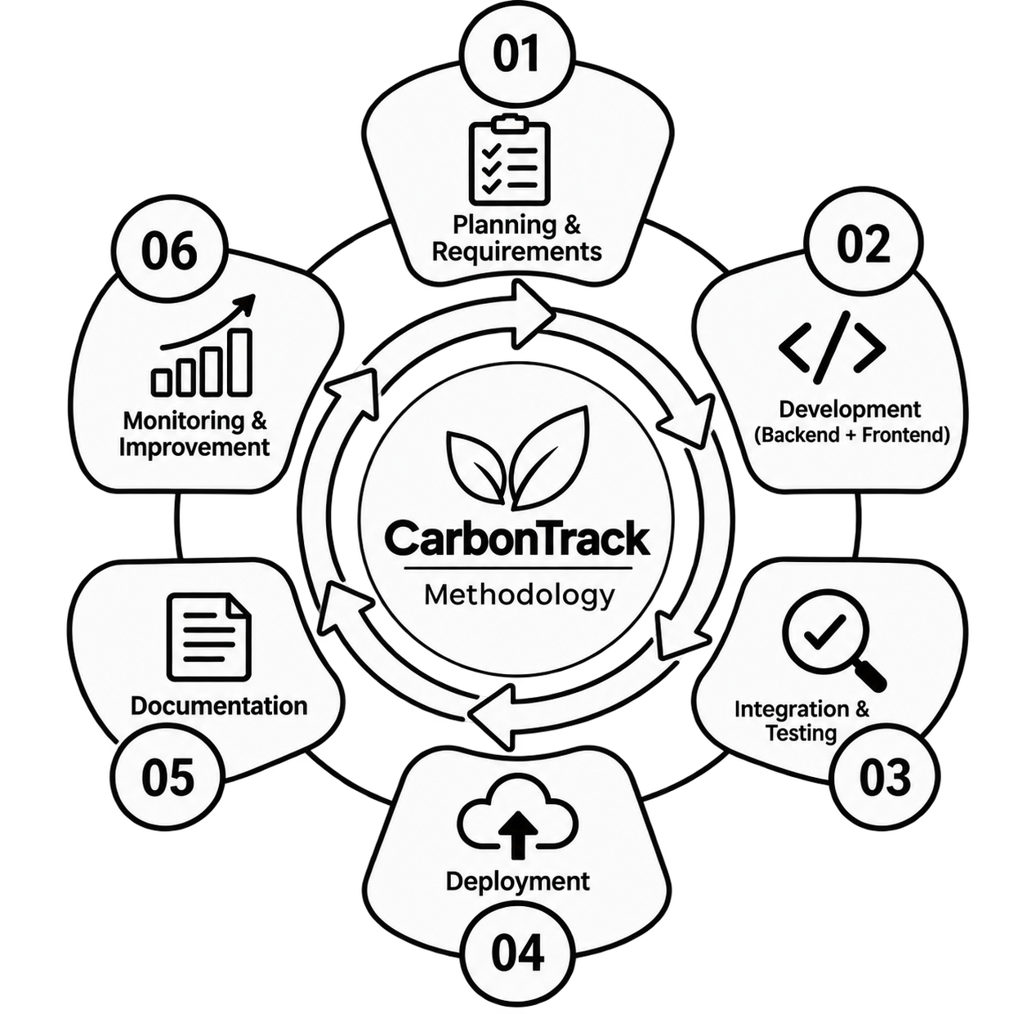.

4.9 Expected Outcomes
The expected outcomes of the CarbonTrack project are:
- Functional CarbonTrack platform for calculating emissions across five major activity categories.
- Secure user authentication with JWT and bcrypt-based password protection.
- Data-driven dashboard with daily, weekly, and monthly emission trends and visual analytics.
- Emission history and goal tracking for monitoring, managing, and reducing personal carbon footprint.
- Automated reporting and insights to identify emission patterns, promote sustainable behavior, and support UN SDG 13 – Climate Action.
- Practical full-stack implementation using HTML, CSS, JavaScript, Node.js, Express.js, MySQL, REST APIs, and MVC architecture.

4.10 Certificates of Completion and Communication Proof
- Internship Completion Certificate issued by Lenovo LEAP NextGen Scholar Program (attached on Page 4).
- AICTE internship completion acknowledgment.
- Communication emails and correspondence with mentors during the internship period.
- GitHub repository link: https://github.com/sidspy-bug/carbontrack
- Live link: https://carbontrack-fyqt.vercel.app/
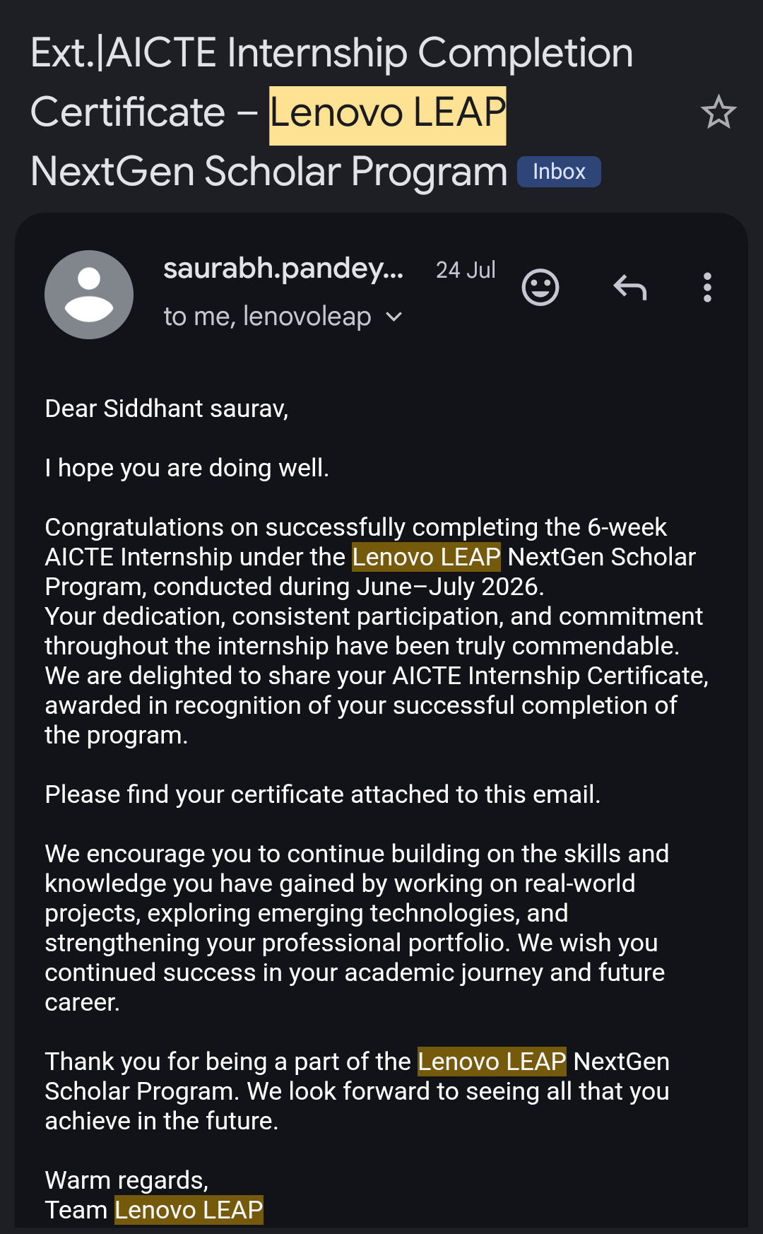
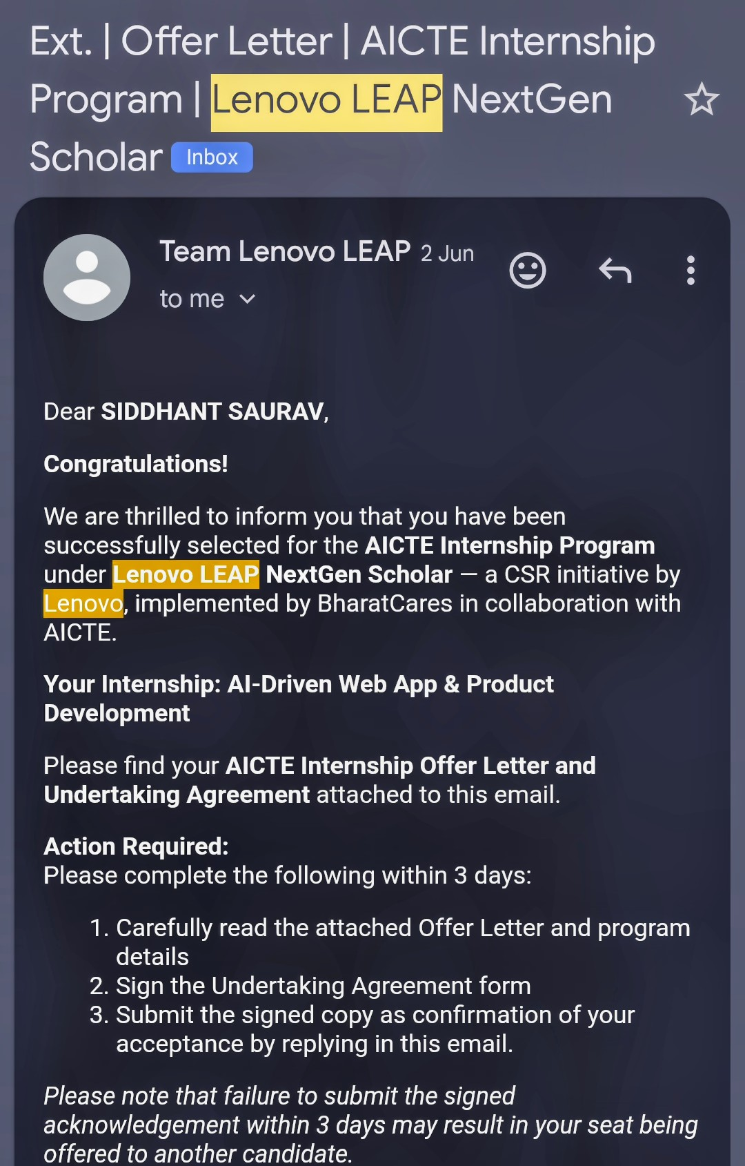
Chapter 5: Bibliography/References

[1] Node.js Foundation, "Node.js Documentation," https://nodejs.org/en/docs/. Accessed: July 2026.
[2] Express.js, "Express.js – Fast, Unopinionated, Minimalist Web Framework for Node.js," https://expressjs.com/. Accessed: June 2026.
[3] MySQL, "MySQL 8.0 Reference Manual," https://dev.mysql.com/doc/refman/8.0/en/. Accessed: June 2026.
[4] Chart.js Contributors, "Chart.js – Simple yet Flexible JavaScript Charting," https://www.chartjs.org/docs/latest/. Accessed: July 2026.
[5] Mozilla Developer Network (MDN), "HTML: HyperText Markup Language," https://developer.mozilla.org/en-US/docs/Web/HTML. Accessed: June 2026.
.[6] United Nations, "Sustainable Development Goal 13: Climate Action," https://sdgs.un.org/goals/goal13. Accessed: June 2026.
[7] Google Fonts, "Google Fonts – Making the Web More Beautiful," https://fonts.google.com/. Accessed: July 2026.
[8] Postman, "Postman – API Platform for Building and Using APIs," https://www.postman.com/. Accessed: June 2026.
[9] GitHub, Inc., "GitHub – Where the World Builds Software," https://github.com/. Accessed: June 2026.
[10]Vercel, "Vercel – Develop. Preview. Ship.," https://vercel.com/docs. Accessed: July 2026.

