How to run the simulation + localization

Step 1: Copy the files RSSI_broadcast.c and RSSI_receiver.c to your shared folder so they can be imported into Contiki.  
  
Step 2: Copy the files RSSI_broadcast.c and RSSI_receiver.c from your shared folder **inside Contiki**, to the path */home/computation/Contiki/examples/rime/*

Step 3: Open the Cooja simulator and load the provided simulation file.  
  
Step 4: Run the Simulation for approximately 10 seconds. Save the mode output file as *Simulation1.txt* and copy it to your shared folder inside Contiki.

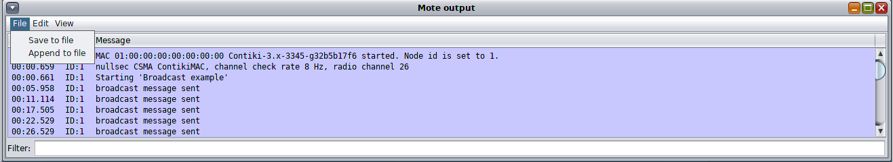

Step 5: Open in Matlab the *Localization.m* file. Press ‘Import data’ and select the *Simulation1.txt* file from the location that you saved it in.

Step 6: Once the *Simulation1.txt* file is loaded, a window such as in the picture below will appear.  
Make sure to select only colum B and C, and change the Output Type to ‘String Array’. Once that is done, press on ‘Import Selection.

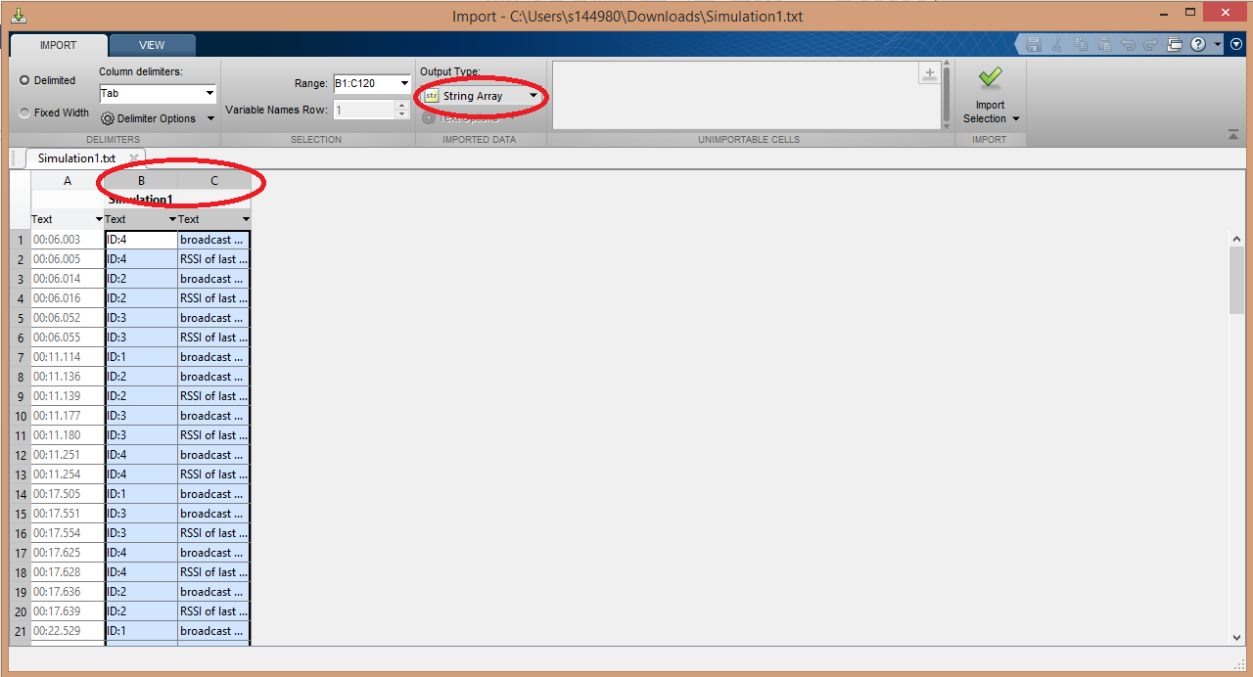

Step 7: Run the Matlab script. A figure with the nodes location should pop up. Also, in the Workspace, variables *x* and *y* represent the location of the source node.