
Faculty of Science

Course: CSCI 3230U: Web Application Development
Lab: #6
Topic: JavaScript

Overview
For this lab, you will add DHTML behavior to an existing web page (lab6.html). The HTML page contains a table, which you should make clickable like a spreadsheet program.

Instructions
Clickable Column Headers
In our table, we want the column headers (TH elements) to be clickable. Write an event handler for the column headers (not one for each, but one that works for all of them) that (when clicked) highlights each cell in that column with a background colour of ‘lightBlue’.

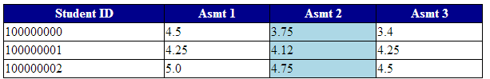
Figure 1: The table when the ‘Asmt 2’ column header has been clicked

Clickable Rows
We also want the first cell in each row (TD elements) to be clickable. Write an event handler for these cells (not one for each, but one that works for all of them) that (when clicked) highlights each cell in that row with a background colour of ‘lightBlue’.

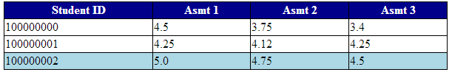
Figure 2: The table when the ‘100000002’ cell has been clicked

Clickable Cells
Finally, we also want the other cells (also TD elements) to be clickable. Write an event handler for these cells (not one for each, but one that works for all of them) that (when clicked) highlights the cell itself with a background colour of ‘lightBlue’.

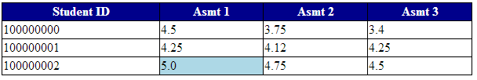
Figure 3: The table when the cell ‘5.0’ has been clicked

How to Submit
Submit the HTML, CSS, and JavaScript files in a ZIP file, with a name following the same pattern as previous labs: Lab6_FirstNameLastName_StudentNumber.zip (e.g. Lab6_RandyFortier_100539147.zip) to the appropriate Lab drop box on Blackboard. The TA may allow you to submit the lab in person. If so, you can do that, but you are still required to submit the file on Blackboard for posterity.

