
Faculty of Science

Course: CSCI 3210U: Internet-based Media
Course component: Final exam lab exam

Overview
This lab exam is to be completed and submitted to Blackboard before the lecture period has finished. You can use the Internet, textbook, or any other non-human resource that you want during this time.

Part 1
Recommended time: 40 minutes

For this lab exam, you will create a simple form (using jQuery Mobile), which uses HTML5 validation on the client side, and submits to the server-side where it is validated (server-side) and inserted into the database. The database table you will need will be as follows:

Code Listing 1: The database schema for part 1
CREATE TABLE IF NOT EXISTS `accounts` (
`id` int(11) NOT NULL AUTO_INCREMENT,
`FirstName` varchar(100) NOT NULL,
`LastName` varchar(100) NOT NULL,
`Phone` varchar(12) NOT NULL,
PRIMARY KEY (`id`)
) ENGINE=InnoDB DEFAULT CHARSET=latin1 AUTO_INCREMENT=2 ;

In the end, the form should look like that shown in figure 1, below.

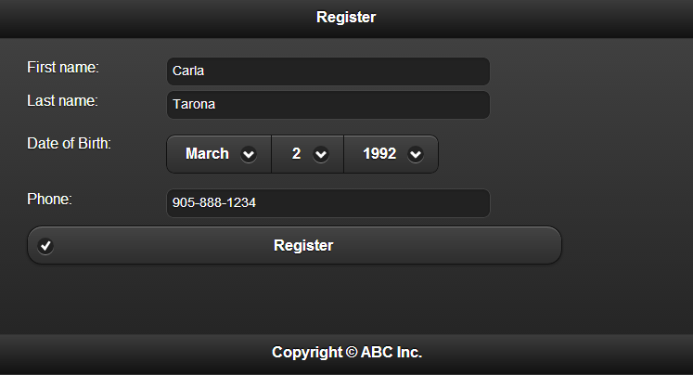
Figure 1: The registration form

Both client-side and server-side validation will use similar rules:
- The first and last name and phone number are required
- The first and last name must have at most 25 characters
- The phone number must use the format: 000-000-0000

The PHP side should validate the above rules, and perform an SQL INSERT, using PDO and prepared statements with named variables, to insert the data into your database. The output will simply be the number of rows that were created by your database operation, as shown in figure 2, below.

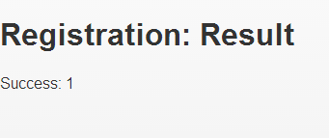

Figure 2: The output of the registration form handling page

Part 2
Recommended time: 80 minutes

For this part of the lab exam, you will create an AJAX-enabled web application to implement a suggest (or autocomplete) feature. The page will use jQuery to submit an AJAX request to the server (a PHP page) every time the user types something in the text field (use key events). The text that the user has typed will be sent along with the AJAX request, using GET parameters.

The PHP page will first load all keywords from the database, using the schema given below. Then, in PHP (not WHERE clause in SQL), filter the results to only include keywords that contain the text provided by the user. Output the list of matching keyword strings as a JSON array.

Back in the original page, when the AJAX response comes back, display a DIV below the text field, which contains each matching keyword returned by the PHP page. Use a #f0f0f0 as the background colour for every 2nd entry, in CSS (white for the remainder). Configure CSS also to highlight the entry directly under the mouse as lightGray. When clicked, the text in the text field will be replaced with that keyword, and the suggestion DIV will be hidden.

Code Listing 2: The database schema and some sample data for part 2
CREATE TABLE IF NOT EXISTS `keywords` (
`id` int(11) NOT NULL AUTO_INCREMENT,
`keyword` varchar(200) NOT NULL,
PRIMARY KEY (`id`)
) ENGINE=InnoDB DEFAULT CHARSET=latin1 AUTO_INCREMENT=10 ;
INSERT INTO `keywords` (`id`, `keyword`) VALUES
(1, 'apple'),
(2, 'apricot'),
(3, 'coconut'),
(4, 'lychee'),
(5, 'mango'),
(6, 'pear'),
(7, 'pineapple'),
(8, 'prickly pear'),
(9, 'strawberry');

When the autocomplete form has no text in the text field, it should look like figure 3, below.

Figure 3: The autocomplete form, with no text typed

When the autocomplete form has text in the text field, it should match figure 4, below:
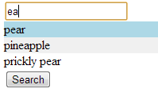
Figure 4: The autocomplete form, with text typed (mouse hovering over the first item)

If you were to go directly to the PHP page, the output should match figure 5, below:

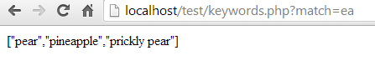
Figure 5: The back-end PHP of this AJAX application

How to Submit
Collect all of your files (HTML, CSS, JavaScript) and put them into a single ZIP file (e.g. FinalExam_LabExam_RandyFortier_100539147.zip), which should be submitted to Blackboard, using the drop box for this lab exam.

